|  |  |  |
| --- | --- | --- |
| St Julie Catholic Primary School – History | | |
| Enquiry Question:  Why should we study the Maya? | Year: 6 | Logo_smallStrand: A Non-European Society that provides a contrast  to British History |

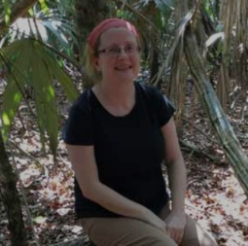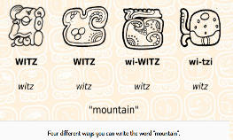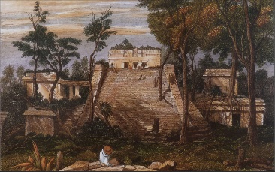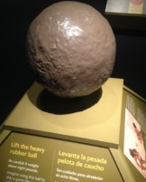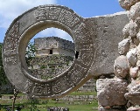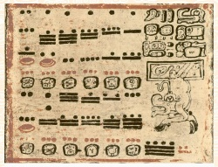

**Disciplinary Skills**

I can analyse sources to investigate Maya skills.

I can investigate sources to support my judgements & justifications about Maya life.

Archaeologist:

Dr Diane Davies

**Substantive Knowledge (Sticky Knowledge)**

The Maya created an incredible civilization in the rainforest of Guatemala, Mexico and Belize in Central America from 2000 BC-AD 1500’s.

The Maya wrote what we call hieroglyphs. These are different to Egyptian hieroglyphs as Maya writing is phonetic and so a complete writing system.

The Maya followed a 52-year calendar round (made up of the sacred year and solar year) The two cycles reached the same point after a period of 52 years.

They used only three symbols to represent all numbers. A dot has a value of 1, a line (or bar) a value of 5 and a shell the value of 0.

These symbols are thought to represent items that the Maya people might have first used to count with, such as pebbles, sticks and shells.

The Maya played the earliest team sport in the world, a ballgame (Pok-ta-Pok) using a rubber ball and the players could only hit the ball using their hips, elbows or knees. They were never allowed to use their hands, feet or head.

In 1839, an American explorer called Lloyd Stevens discovered the Maya 'lost city in the jungle'. Unfortunately, it was before the establishment of photography, so a British artist called Frederick Catherwood drew pictures to show what they discovered.

[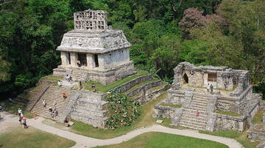](https://www.google.co.uk/url?sa=i&rct=j&q=&esrc=s&source=images&cd=&ved=2ahUKEwiK66v7yqvmAhUYA2MBHdp-DusQjRx6BAgBEAQ&url=https://www.ancient.eu/Maya_Civilization/&psig=AOvVaw2Q7x5nddRP5XTGJDkUIq-L&ust=1576084633846314)

Temple of the inscriptions - Palenque

**Our Enquiry Questions.**

1. Where and when did the Maya live?
2. What was Maya writing like?
3. How did the Maya tell the time?
4. What numbers did the Maya use in Maths?
5. Did the Maya play football like us?
6. How do we know about the Maya?

|  |  |
| --- | --- |
| **Key Vocabulary** | |
| civilisation | The stage of human social and cultural development and organization that is considered most advanced. |
| indigenous | Originating or occurring naturally in a particular place; native. |
| architecture | The style in which a building is designed and constructed, especially with regard to a specific period, place, or culture. |
| hieroglyphics | A stylised picture of an object representing a word, syllable, or sound, as found in ancient and certain other writing systems |
| archaeology | The study of human history and prehistory through the excavation of sites and the analysis of artefacts and other physical remains. |
| Mesoamerican | Relating to or characteristic of the region of Meso-America or its inhabitants. |

**What should I already know?**

* About Stone Age Britain
* Egyptian hieroglyphics