St Julie Catholic Primary School - Geography
Enquiry Question: Why are Mountains important? | Year: 6 | Strand: Locational & Place Knowledge,  Human & Physical geography
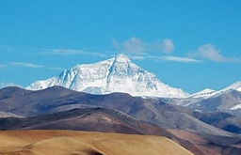
Disciplinary Skills
I can make reasoned judgements about the effects of mountain tourism.
I can evaluate the types of mountain formations.

Vocabulary
peak | Is the highest point of any mountain
valley | A long depression, or ditch in the Earth’s surface that lies between ranges, hills or mountains
terrain | Is a general term for a stretch of land, especially with regard to its physical features
Tectonic plates | The Earth’s outer layer, made up of large outer pieces called plates.
Fold mountains | Fold mountains are formed when two plates collide
cliff | Tall steep rocks that were created by erosion and have vertical faces

Mount Everest
Substantive Knowledge (Sticky Knowledge)
- Mountains make up 1/5 of the world’s landscape
- Mount Everest is the highest mountain and is 8,850m high
- There are mountains under the sea
- 80% of our fresh water originates from mountains
- Generally, mountains are higher than 600m, if they are less, they are called hills
- Mountains can be rocky, have trees growing on them, high mountains have a snow peak
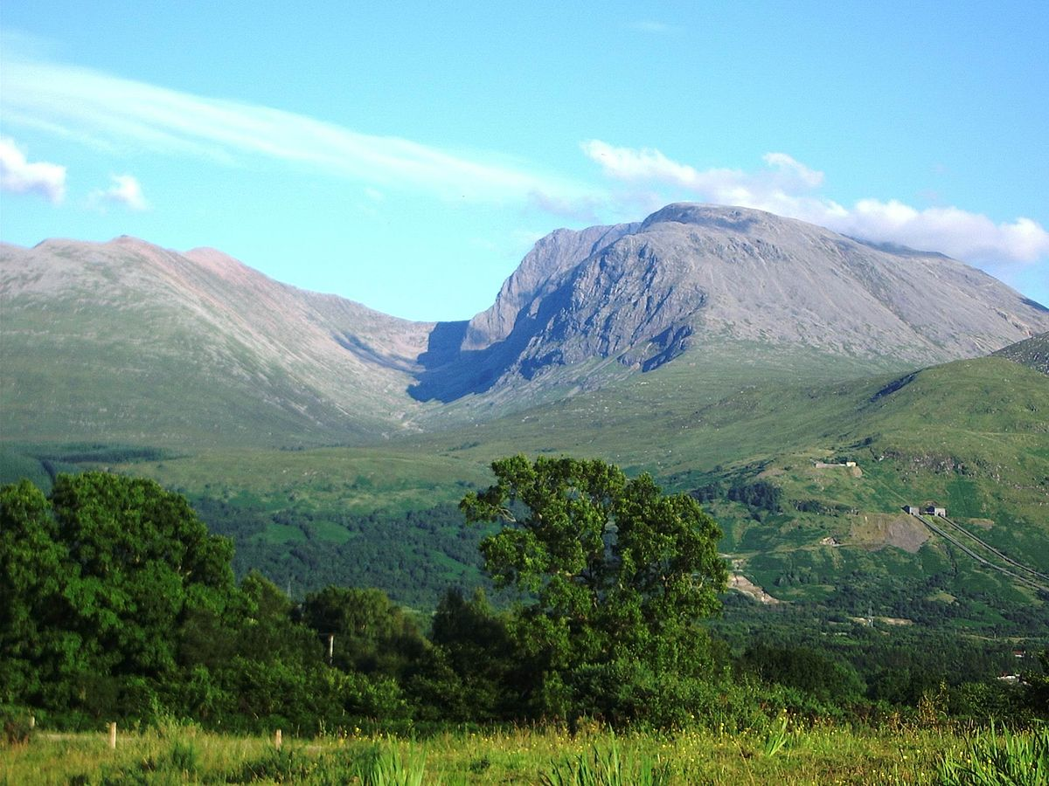
What should I already know?
- Countries within the world
- To use a map to locate regions in the U.K & world
- Name some of the human and physical features of geographical regions
- The topography of the Lake District and some of its mountains or hills
Ben Nevis, Scotland (1,345 metres above sea level), Grampian Mountains)
Our Enquiry Questions.
- How is a mountain formed and what are the types of mountains?
- How can I locate the mountains in the U.K?
- Where is Mount Everest?
- What is an underwater mountain?
- What is the terrain of certain mountains, including Russia?
- What are the effects of tourism on Mountains such as Everest?

