St Julie Catholic Primary School - Geography
Topic: Locational & Place Knowledge | Year: 6 | Strand: Human and Physical Geography
Geographical Skills and Fieldwork
- I can compare maps, atlases, globes, and digital mapping to locate and explore National Parks around the world.
- I can analyse and draw conclusions to describe features of human and physical geography of National Parks.
- I can use a key to make deductions about landscape/ industry/ features to study National Parks in the U.K and the world.

What will I learn during this topic?
- To be able to locate the 15 National Parks of Great Britain using maps.
- To describe the human and physical topography of a National Park – The Lake District.
- To be able to identify human, physical geographical features of different National Parks – U.K. and worldwide. (The Lake District, Brecon Beacons, Yosemite)
- To be able to identify how and why National Parks are utilised.
- To understand the effects of tourism on a National Park.
- To compare the features and uses of National Parks from other destinations around the world.

Vocabulary
Topography | Topography is the study of the shape and features of land surfaces.
National Park | A national park is a boundary of land in use for conservation purposes. Often it is a reserve of natural, semi-natural, or developed land.
Conservation | The protection of plants and animals, natural areas, and interesting and important structures and buildings, especially from the damaging effects of human activity.
Tourism | Are the activities of people travelling to and staying in places outside their usual environment? for leisure

Substantive Knowledge (Sticky Knowledge)
- Be able to locate National Parks in the U.K and around the World.
- Be able to identify human and physical features of a National Park.
- To identify how and why a National Park is utilised.
- Identify positive and negative effects of tourism on a National Park.
Human or Physical Features?
https://nationalparks.uk/

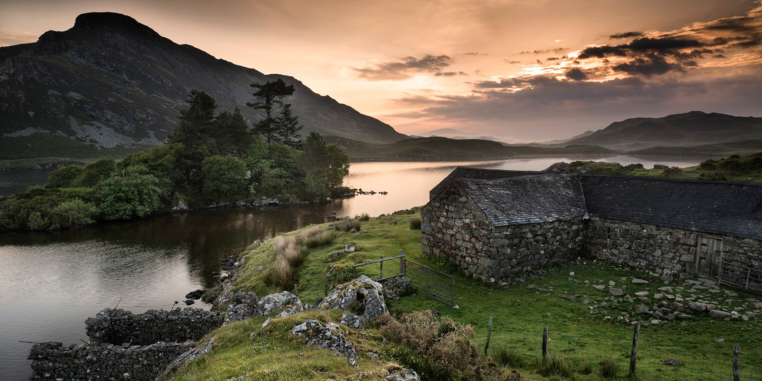
What should I already know?
- Countries within the United Kingdom
- To use a map to locate regions in the U.K
- Name some of the human and physical features of geographical regions

