|  |  |  |
| --- | --- | --- |
| St Julie Catholic Primary School - Art | | |
| ART – Summer Term | Year: 6 | **Unit Title: Colour – National Parks** |



|  |  |
| --- | --- |
| Vocabulary | |
| **Abstract** | **Does not represent reality in art but uses shapes colours & textures.** |
| **Vivid** | **Intense deepness or bright colour.** |
| **Harmonious** | **Colours that work together.** |
| **Saturation** | **Intensity - the dominance of hue in the colour.** |
| **Perspective** | **3 or 2 dimensional.** |
| **Luminous** | **Brightly coloured.** |

What should I already know?

* I can show control of paint in my final

artwork including blending shades together.

* I can consider mood in relation to

colour. I can represent extreme heat

and extreme cold through colour.

* I can mix a variety of shades of the

same colour.

* I can use paint to express light/tone in

a subject to give a 3D impression.

**Carolyn Brettell and David Hockney**

**Colour – National Parks**

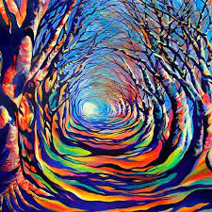

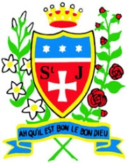

**Skills recap:**

* How to choose effective colours to create impact.
* How can I consider the layout and design of an art piece?
* How I can use scale/proportion to impact the viewer.

**Art Skills**

* Can I apply paint with care and consider colour choices to improve accuracy or dramatic effect in my representation?
* Can I create a detailed composition, considering the background and foreground?

**How do I create colour landscape art?**

1. Research & practice the skills of the artists.
2. Combine colour and control my use of medium.
3. Use tone, shade and vary colours.
4. Photograph & display your finished colour art.

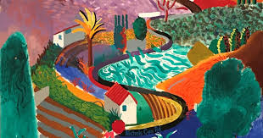

**Carolyn Brettell and David Hockney**

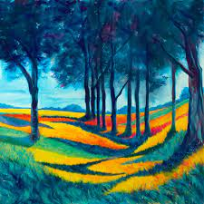 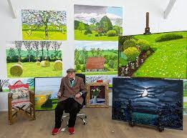

* Brettell is a British contemporary landscape artist.
* She was brought up in Africa and Greece, so the vibrant colours inspire her.
* Hockney is an English painter, draftsman, printmaker, stage designer, and photographer.
* He is important contributor to the pop art movement of the 1960s, he is considered one of the most influential British artists of the 20th century.

**Curriculum links:**

Geography - What is a National Park? Science - Light



