St Julie Catholic Primary School - DT
DT – Autumn Term | Year: 6 | Unit Title: Textiles an eco-shopping bag.
Vocabulary
Computer Aided Design | Technology used to design products.
Criteria | Precise goals that a project must achieve to be successful.
Innovative | Featuring new methods that are advanced and original.
Lamination | The layering-up of materials to collectively improve the performance of a product.
Functionality | Being suited to serve a purpose.
Prototype | The first model of a product.

What should I already know?
- Experience of using 2D & 3D shapes in product construction.
- Experience of using of basic tools e.g., scissors, hole punches with construction materials e.g., combining textiles.
- Experience of different methods of joining textiles Y4 e.g., stitching, finishing techniques.
Can I make a functional/eco shopping bag for supermarket customers?
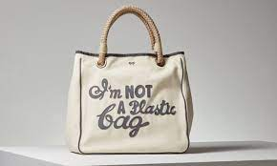

Skills recap:
- select from and use a range of tools and equipment to perform practical tasks e.g., cutting, shaping, joining and finishing.
- select from and use a wide range of materials and textiles according to their characteristics
DT Skills
- use research and develop design criteria to inform the design of innovative, functional, appealing products that are fit for purpose, aimed at individuals or groups.
- generate, develop, model and communicate their ideas through discussion, annotated sketches, cross-sectional and exploded diagrams, prototypes, pattern pieces and computer-aided design.
Curriculum links:
Mathematics – Use appropriate standard and non-standard measures. Knowledge of 2-D and 3-D shapes & patterns.
Science – Working scientifically, properties of materials, planning an investigation.
Computing – Using computer aided design, selecting and combining software & design to create patterns.

How do I create an eco-shopping bag?
- Can children investigate, analyse and evaluate existing everyday shopping bags?
- Can children choose appropriate materials and explore different ways of combining them for a particular purpose?
- Can children draw labelled 2D & 2D diagrams of their designs?
- Can children follow their designs to create their eco shopping bag?
- Can children join materials together appropriately to create a functional product?
- Can children evaluate their product?

Anya Hindmarch
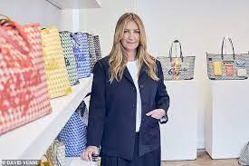
- An eponymous British fashion designer.
- Designs are inspired by functional fashion, design philosophy which is "British, humorous and personalised.”
- Entrepreneurial inspired by .
- Her products have high quality workmanship.

