St Julie Catholic Primary School - DT
DT – Spring Term | Year: 6 | Unit Title: Electrical/protection Systems-Alarm.
Vocabulary
Artefact | An object of cultural or historical interest.
Sensor | A device that responds to a physical stimulus (such as heat, light, sound, pressure, magnetism, or a particular motion) and transmits an impulse
Electronic Circuit | A series of components connected through wires.
Mechanism | A system of working parts.
Components | A part of an alarm system.

What should I already know?
- Experience of building structures, exploring how they can be made stronger, stiffer, and more stable.
- Experience of exploring and using mechanisms & basic circuits e.g., levers, sliders, wheels, and axles in their products.
- Experience of selecting from and using a wide range of materials and components
Can I make an alarm to protect an artefact?
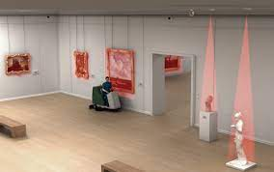

What security do museums have?
Modern security technologies protect artefacts.
Who was Thomas Edison?
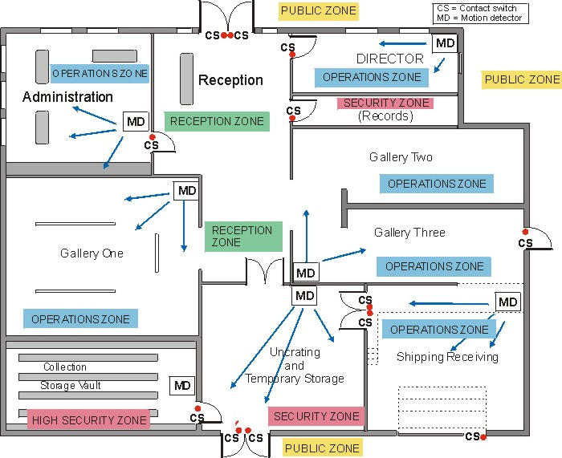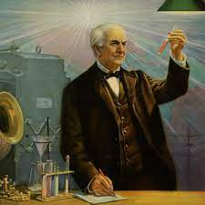
- Innovative ideas
- Video surveillance
- Motions detectors
- Intruder alarms

Skills recap:
- Select and use components in their constructions.
- Build structures, explore and use mechanisms.
DT Skills
- Understand and use electrical systems in their products for example, series circuits incorporating switches, bulbs, buzzers and motors.
- Apply their understanding of computing to program, monitor and control their products.
How do I make an alarm to protect an artefact?
- Can children investigate, analyse and evaluate how museums protect artefacts (LED, sensors, security)?
- Can children explore diverse ways of protecting artefacts (LDR’s, switches)?
- Can children draw labelled 2D & 2D diagrams of their designs (circuits)?
- Can children follow their designs to make an alarm to protect an artefact(control)?
- Can children make an alarm by using circuits and include components?
- Can children evaluate their product?

Curriculum links:
Mathematics – Measure, 2D & 3D shapes.
Science – Apply knowledge and understanding of complex switches, circuits, conductors & insulators.
Computing – Programming and control, use technology for research & design.

