St Julie Catholic Primary School - DT
DT – Summer Term | Year: 6 | Unit Title: Food- Chicken Caesar salad wrap
Vocabulary
Cultural Foods | Foods that represent a region or a belief.
Nutrition | Food necessary for health & growth.
Diversity (diet) | A variety of foods consumed by  someone’s beliefs or religion.
Seasonality | Foods grown by the times or weather of a region.
Affordability | Cost of a diet relative to household income.

What should I already know?
- Have knowledge & understanding about food, hygiene, nutrition, healthy eating, and a varied diet.
- Be able to use appropriate equipment & utensils.
- Experience of foods that celebrate culture and seasonality.
- Understand where food comes from.

Can I make a chicken Caesar salad wrap for a diverse diet?
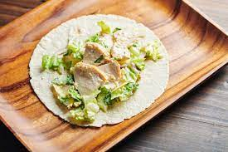

What foods are culturally diverse?

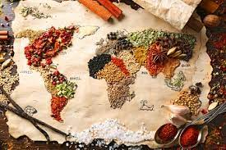
- Investigate cultural foods from around the world.
- Food for special events/seasons/festivals.
- Cultures/celebrating diversity.
- Growing, rearing food & sustainability.
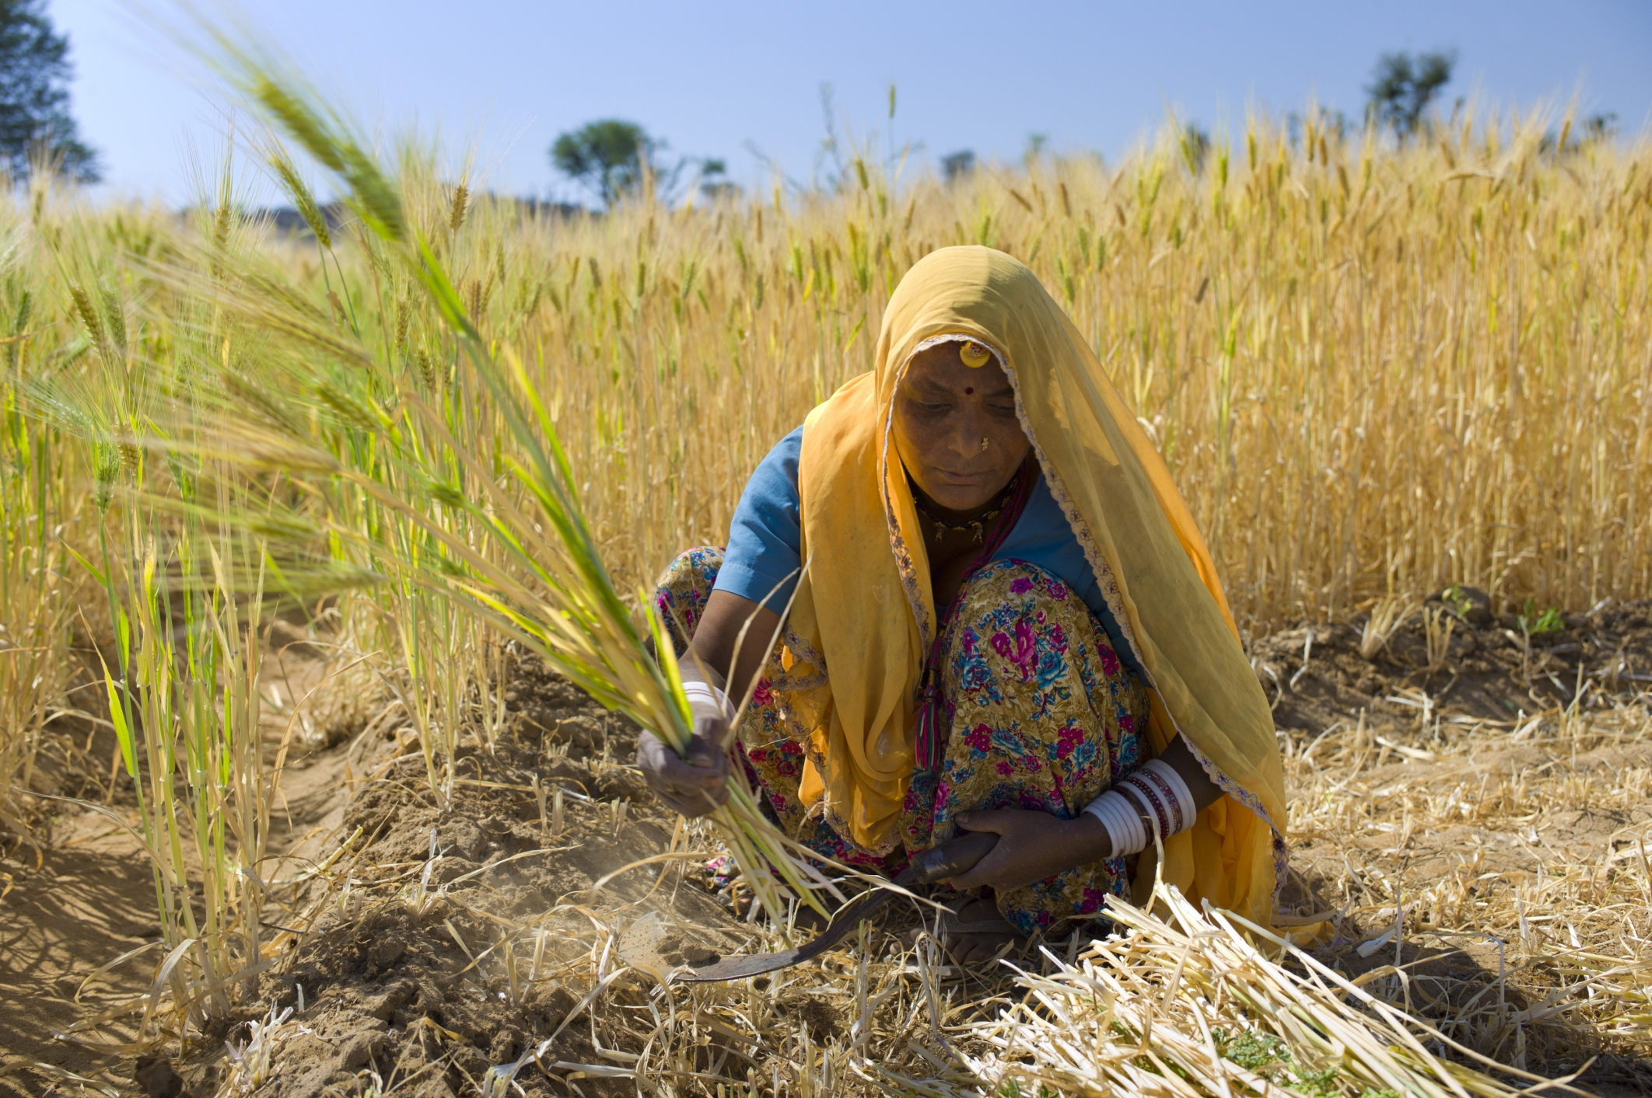

How do I make a Chicken Caesar salad wrap for a diverse diet?
- Can children investigate, analyse and evaluate how diverse cultures consume different food types?
- Can children explore diverse ways of combining foods for dietary requirements?
- Can children make a set of ingredients for a chicken Caesar salad wrap?
- Can children explore various cutting, chopping & measuring techniques?
- Can children follow a recipe to make a chicken Caesar salad wrap?
- Can children evaluate their product?

Skills recap:
- Select from and use a range of tools and equipment to perform practical tasks e.g., measuring, chopping, peeling.
- Select from a wide range of ingredients.
DT Skills
- Select from and use a wider range of tools and equipment to perform practical food preparation tasks.
- Understand and apply the principles of a healthy and varied diet
- Prepare and cook a variety of savoury dishes using a range of cooking techniques.
- Understand seasonality and know where and how a variety of ingredients are grown, reared, caught and processed.
Curriculum links:
Mathematics – Measure mass g/kg, use conversions.
Science – The body, Diet, Nutrition, Food Groups.
Computing – Researching cultural food diversity.

