Key vocabulary
light | We can see objects because our eyes can sense light.
dark | Darkness is the absence of light.
light source | Some objects emit their own light and are sources of light.  the sun lightbulbs candles
transparent | A material that is completely see through so all the light can pass through.
translucent | A material that lets some light through but not all of it.
opaque | A material that light cannot pass through. You cannot see through it.
shadow | These are formed when an object blocks light.
reflect | When light bounces off a surface.
mirror | A sheet of glass or metal that reflects light.
Sunlight
- The light from the sun can be dangerous.
- It can damage our eyes.
- We must never look directly at the sun.
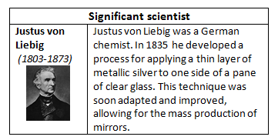
- We can protect our eyes by wearing sunglasses or sunhats in bright sunlight.

Why do we need light?
We need light to see things.
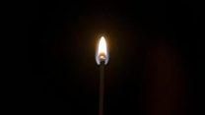
If it’s completely dark then there is no light.

The more light there is, the easier it is to see objects.
Shadows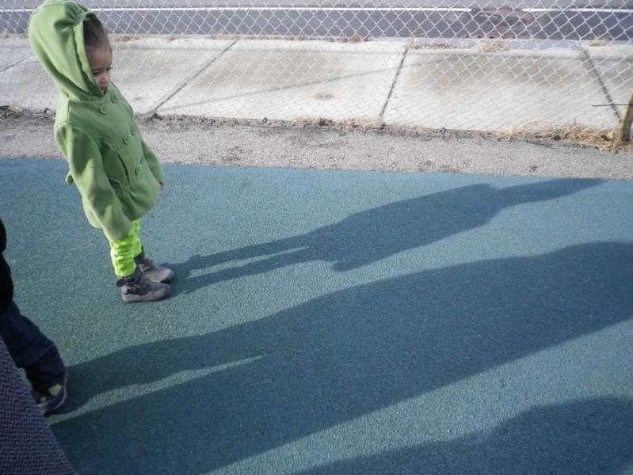 | Shadows are formed when an opaque object blocks the light.  The child is blocking the sun’s light.
We can change the size of the shadow by changing the position of the:  - light source  - object  - surface where the shadow is being made. | 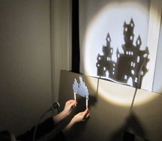
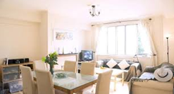
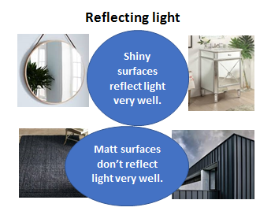
What will I learn during this topic?
Recognise that they need light in order to see things and that dark is the absence of light.
Notice that light is reflected from surfaces.
Recognise that light from the sun can be dangerous and that there are ways to protect their eyes.
Recognise that shadows are formed, when the light from a light source is blocked by opaque object.
Find patterns in the way that the sizes of shadows change.

