Key vocabulary
force | A force is a push or a pull.
magnetic force | An invisible force that attracts magnetic metals.
magnet | Magnets attract magnetic materials. Iron, nickel, cobalt and materials that contain these (e.g. stainless steel) are magnetic.
attract | To pull towards.
repel | To push away.
poles | Magnets have two poles, a north pole and a south pole.
contact force | Many forces need contact to act:
non-contact force | Magnetic force does not need contact and can act at a distance.
What will I learn during this topic?
Some forces need contact between two objects – magnetic forces can act at a distance.
Magnets attract and repel some materials. Predict whether they attract or repel
Compare/ group various materials on the basis of attraction to a magnet; and identify some magnetic materials.
Magnets have two poles

Objects moving on surfaces:
 |  | Ice skates have a sharp blade. This helps them move better on ice.
 |  | It is much harder to walk on ice in trainers.
A bowling green is closely mown so the grass is short and the balls roll easily.

Significant scientist
Michael Faraday (1791-1867)  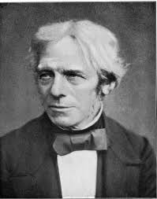 | Michael Faraday was an English scientist.  In 1831, he discovered electromagnetic induction. This was a very important discovery for the future of science and technology.

Types of magnets:
Bar  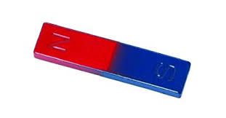 | Ring  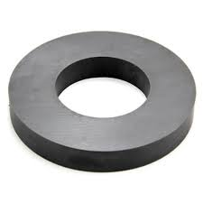  We can sort and classify materials as:
Button  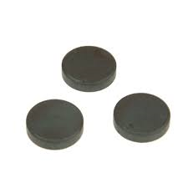 | Horseshoe  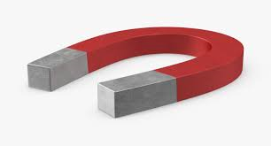
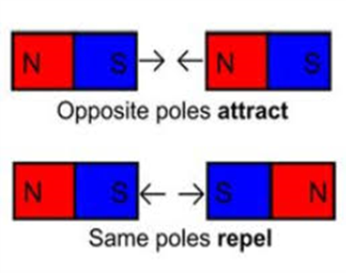
Magnets have two poles

A magnet does not need to touch an object to attract it.

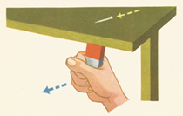

A magnet attracts magnetic materials.
These metals are magnetic:
iron nails  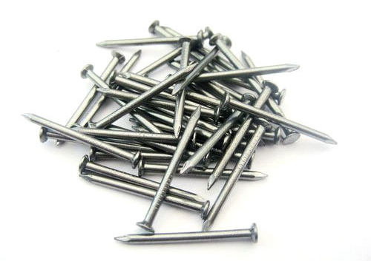 | Nickel
 | 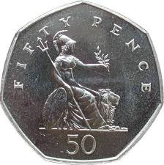 | 50p coins contain nickel
stainless steel  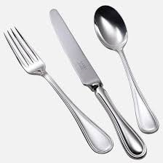 | steel  