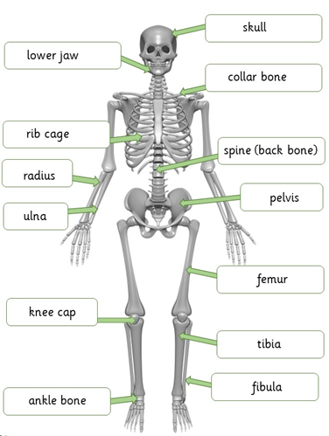
Significant scientist
Wilhelm Conrad Rontgen  (1845-1923)  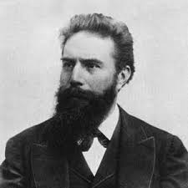 | Wilhelm Rontgen was a German physicist who discovered X-rays in 1895.  The skull protects our brain.  He was awarded many honours and won the Nobel Prize for physics in 1901.
Key vocabulary
nutrients | Useful substances that help animals and plants grow.
carbohydrates | These are the foods that give us energy. They are found in sugary and starchy foods.
proteins | These are important so the body can grow, repair and build muscle.
vitamins and minerals | Substances found in foods which keep us healthy. These are found in fruit and vegetables.
fibre | This lets food pass quickly through your body. It helps keep your digestive system in good working order.
skeleton | This supports and protects the body, allowing it to move.
bones | The hard parts inside your body which form your skeleton.
muscles | These are attached to bones and help us move.  One piece of food can provide a range of nutrients.
joints | The place where 2 bones meet.

Animals need to eat food to get the nutrients they need.
The bones and muscles in our legs:
help us to move
help us to stand

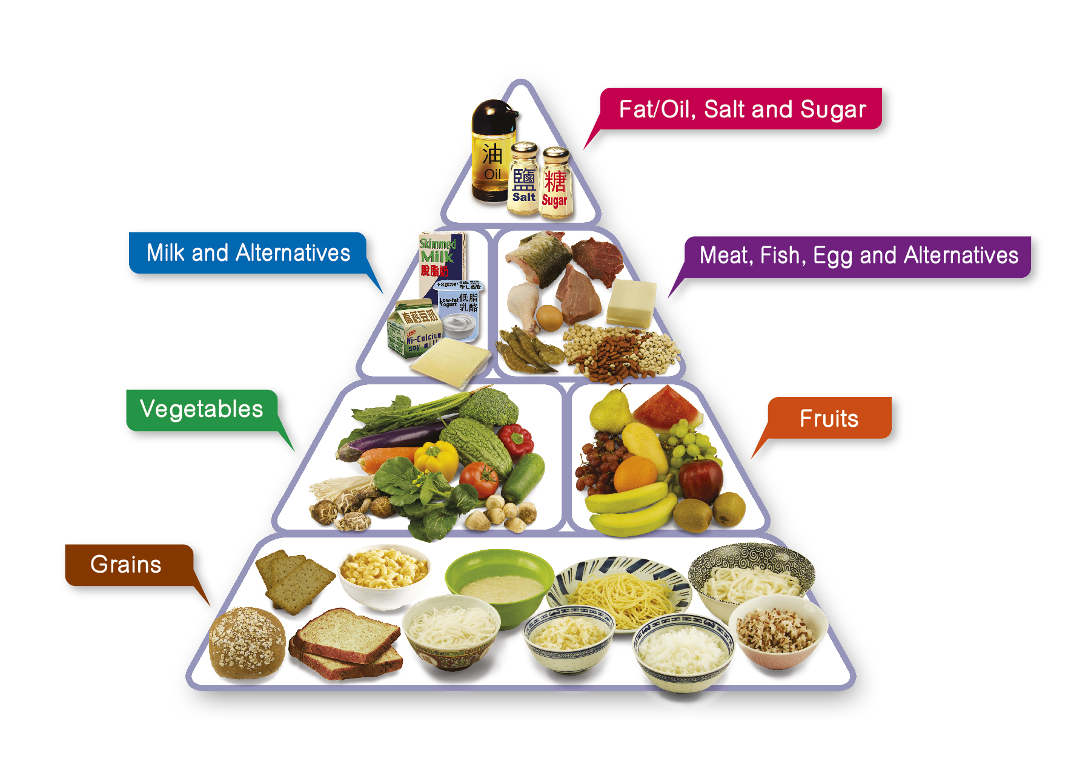
By the end of this topic I will:
- Know that animals cannot make their own food
- Know that animals and humans need to eat in order to get nutrients
- Know that food contains a range of nutrients: carbohydrates, proteins, vitamins, minerals, fats, sugar, Water and fibre
- Know that a balanced diet of these nutrients are required for a healthy diet
- Know that a piece of food will often contain a range of nutrients
- Know that humans and some other animals have skeletons and muscles for support, protection and movement.
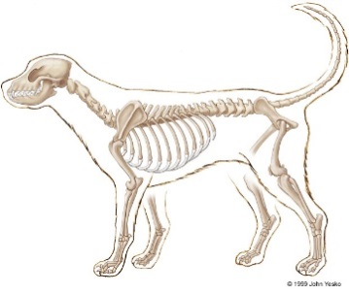
What should I already know?
- Basic parts of the human body
- Carnivores/herbivores and omnivores
- Senses and the corresponding organs.
- Basic needs of animals inc humans.
- Importance of exercise and hygiene.
What similarities/ differences can you see?
What should I already know?

- Senses and the corresponding organs

