|  |  |  |
| --- | --- | --- |
| St Julie Catholic Primary School - Art | | |
| ART – Autumn Term | Year: 2 | **Unit Title:Printing – Natural Materials** |



**Rachel Dein**

**Printing- Natural materials**

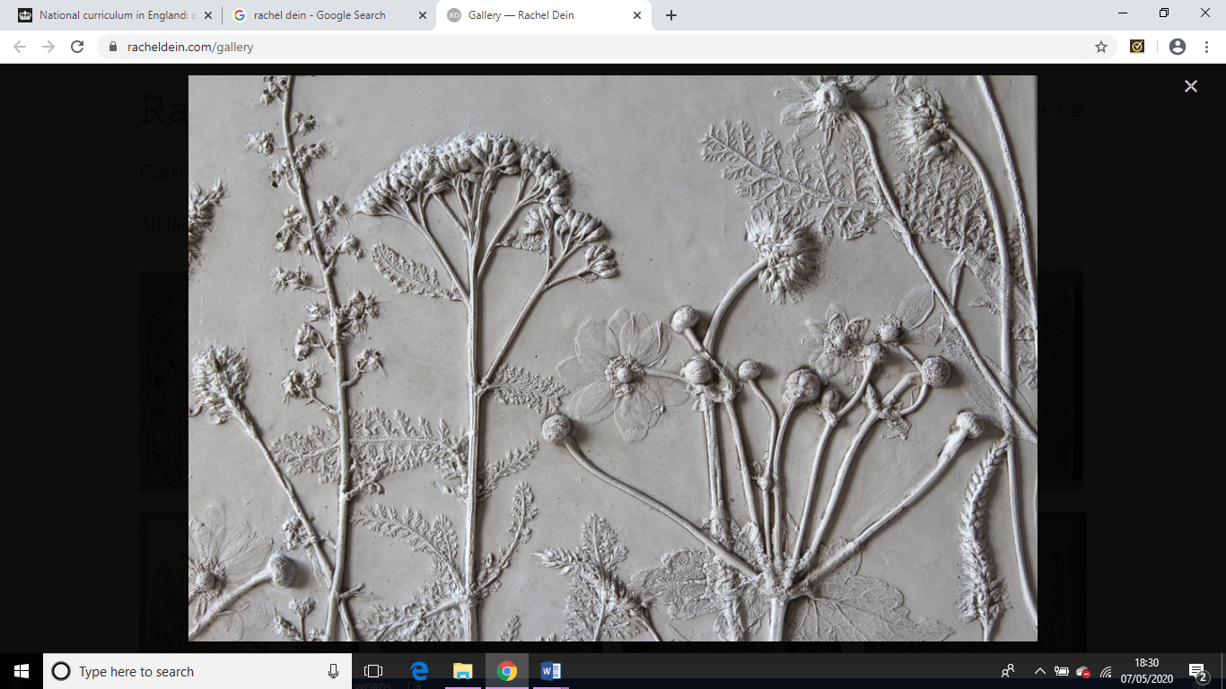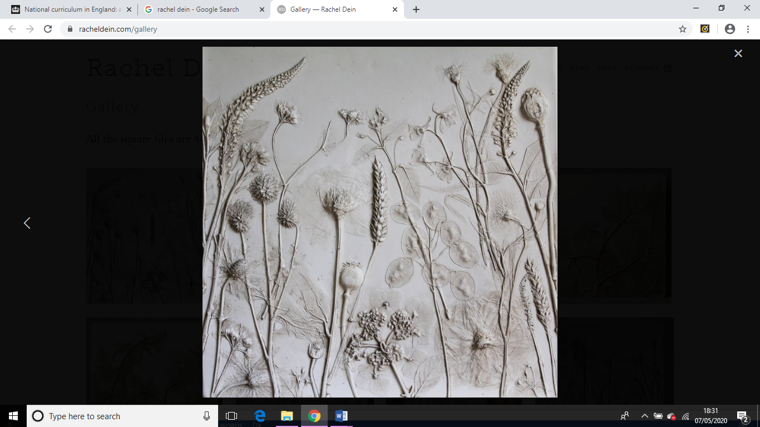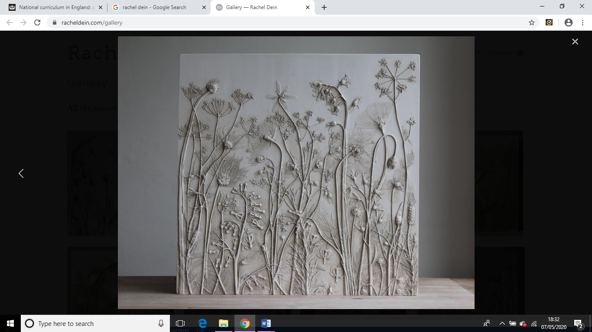

|  |  |
| --- | --- |
| Vocabulary | |
| clay | a natural earthy material that is used for making bricks, pottery, etc. |
| design | to plan and fashion the form and structure of an object, work of art, decorative scheme, etc. |
| imprint | a mark made by pressure; a mark or figure impressed or printed on something. |
| natural | Formed by nature |
| textured | the visual and especially tactile quality of a surface: |
| tools | an instrument that is usually held with the hands and helps one to do something. |
| pressure | A steady force upon a surface |

What should I already know?

* I can use your hands to mould a material into different simple shapes.
* I can create a representation of a subject using mouldable material.

**Vocabulary** - Mould, shape, mark, line, press, nature, flower, plant, roll, squeeze, composition.

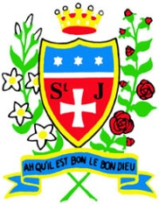

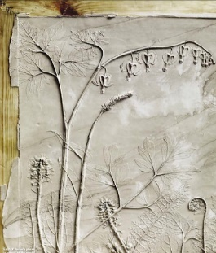

**Curriculum links:**

Science - Plants

Geography -Landscapes

**Art Skills**

* How to roll clay to create a square tile of equal thickness.
* How to create different textures using clay by making marks.
* How to create different textures by adding additional clay to a tile.

**How do I create artwork like Rachel Dein?**

* Exploring mark making and printing- natural objects.
* Explore texture on a clay tile.
* Exploring imprinting into clay using plants and flowers.
* Use natural materials to imprint

into my own tile

design.

**Rachel Dein**

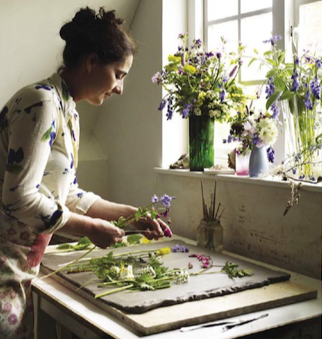

* Rachel Dein is a British artist living in London.
* Rachel Dein creates artwork using nature to imprint and then cast.
* Rachel Dein imprints into clay.
* Clay can be moulded to create different textures.
* Characteristics of clay and its limits as a material



