|  |  |  |
| --- | --- | --- |
| Colour | | |
| ART – Spring Term | Year: 2 | **Unit Title: Colour – Green Spaces** |

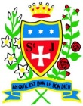

|  |  |
| --- | --- |
| Vocabulary | |
| Primary colour | The three basic colours of the spectrum from which all other colours can be made **(red, yellow, and blue)** |
| Secondary colour | A colour resulting from the mixing of two primary colours **(orange, purple and green)** |
| bright | Bright colors are colors that command attention due to their hue, brightness or both |
| warm | **Warm colour** is used to describe any colour that is vivid or bold. Warm colours include red, yellow and orange |
| dull | Not bright, not interesting or exciting. |
| tones | How light or dark something is. |

**Paul Klee**

**Colour – Green Spaces**

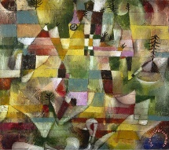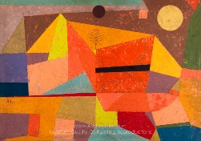

What should I already know?

* I can use my finger to apply paint to paper in different ways.
* I can select appropriate colours for different paintings.
* I can select colours.
* I can blend colours.
* I can recognise Primary colours and use them to mix secondary colours.
* I can make different marks on paper using paint.

**Vocabulary** - All primary colour names and secondary colour names, mix, blending, characteristics, hue.

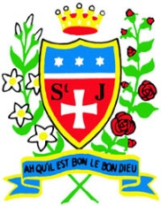

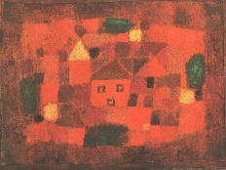

**Paul Klee**

**Curriculum links:**

Geography –Eccleston –Green Spaces

**Art Skills**

* Can I recognise different tones of one colour (tertiary)?
* Can I mix colours effectively using paint?
* Can I blend colours effectively? Paint, coloured pencil, pastels.
* Can I use appropriate colours to create a desired effect?

**Knowledge**

[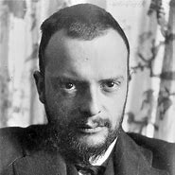](https://www.bing.com/images/search?view=detailV2&ccid=TgyJUF7S&id=A827AD54B263AB15A2D92EB12839AC5A05241EA2&thid=OIP.TgyJUF7S_EFP_zL0xEHOcgHaHa&mediaurl=https://th.bing.com/th/id/R.4e0c89505ed2fc414fff32f4c441ce72?rik%3doh4kBVqsOSixLg%26riu%3dhttp%3a%2f%2fjeannebucherjaeger.com%2fwp-content%2fuploads%2f2016%2f06%2fPaul_klee.jpg%26ehk%3dmJKQzu7br8ZalLyTL3U%2f8%2bkYa6tU%2fd29SI1WEhz%2bVG4%3d%26risl%3d%26pid%3dImgRaw%26r%3d0&exph=1600&expw=1600&q=paul+klee&simid=608002549911209345&FORM=IRPRST&ck=9FF1E8B8C31A0B56E1D655C4BD7A0E92&selectedIndex=3&adlt=strict)

* Paul Klee was born in Switzerland.
* Paul Klee was an abstract artist influenced by other modern artists.
* Primary colours can be combined to make secondary colours.

red + blue = purple

blue + yellow = green

yellow + red = orange

* Tertiary colours = different tones of one colour.

**How do I create artwork like Paul Klee**

* Research primary, secondary and tertiary colours.
* Experiment with colour mixing and blending colours effectively.
* Investigate shapes in a photograph of Eccleston – create simplified version with 2D shapes.
* Collage with

textiles/paper

/tissue/foil/felt

* Plan final

composition



