|  |  |  |
| --- | --- | --- |
| St Julie Catholic Primary School - Art | | |
| ART – Summer Term | Year: 2 | **Unit Title: Drawing - Seaside** |

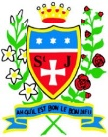

What should I already know?

-I can draw using my finger in sand.

-I can hold a pencil and make a mark.

-I can draw an enclosed shape with a pencil.

-I can make a representation of a subject using a pencil.

-I can make a variety of marks with a pencil.

-I can hold my pencil in different ways to make different marks.

-I can produce an observational drawing of a subject.

**Prior Vocabulary** - Pencil, tracing, rubbing, mark, straight, wavy, texture, drawing, artist, hatching, cross-hatching, stippling, blending, experiment.

|  |  |
| --- | --- |
| Vocabulary | |
| shape | An area defined by a line that starts and ends at the same point. Shapes are 2D. |
| Pattern | An arrangement of shapes, lines or colours that can be repeated or used again and again. |
| Shadow | **A dark area on a bright surface**. It is caused by something blocking a source of light |
| Observation | To look and record what you see |
| Composition | The way the parts of something, like a drawing, are put together or ordered. |
| Proportion | The relationship in size of two things or sets of things |
| Texture | How something feels or looks (visual texture). |

**Pablo Picasso Amiria Gale**

**Still Life Drawing**

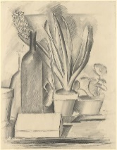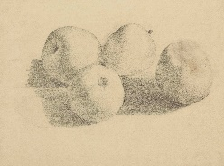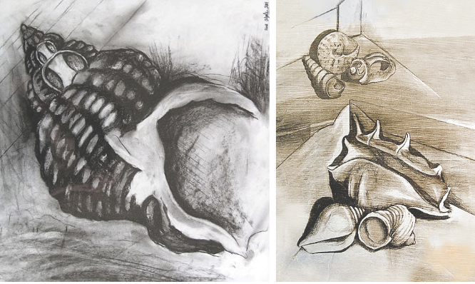

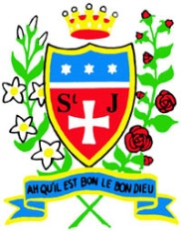

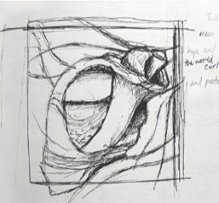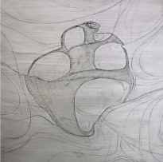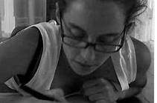

**How do I create artwork like Picasso and Gale?**

**-Research artists**

**-Observations of the seaside**

**-Explore mark making**

**techniques using different**

**materials**

**-Drawing of different groups**

**of natural seaside materials**

**-Drawing of shells using new**

**techniques. (shadow,**

**proportion, texture)**

**Art Skills**

* Can I make a variety of marks with pencil and pastels?
* Can I produce an accurate drawing from direct observation?
* Can I consider proportion in my drawing?
* Can I express texture in my drawings?

**Knowledge**

.

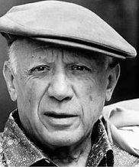

Pablo Picasso.

-Pablo Picasso was a Spanish artist.

-He was born in 1881 and died in 1973.

-Picasso is one of the greatest and most influential artists of the 20th century.

**Curriculum links:**

Science - Materials

Geography -Seaside

Amiria Gale

-Amiria Gale is an artist and teacher from New Zealand.

-Her shell paintings are inspired from growing up near to the beach.



