St Julie Catholic Primary School - Geography
Where in the United Kingdom is Eccleston? | Year: 1 | Strand: Human and Physical Geography
Key Vocabulary
Village | A community with a small population, usually in a rural area.
Town | A large collection of buildings and houses. Larger than a village but smaller than a city.
City | A built-up area with a large population. It usually has a cathedral or a university.
Country | Land that is controlled by a government. Countries can be large or small.
Capital City | The city where a country’s government works. It isn’t always the largest city.
Landmark | A feature (e.g. a building, or a large tree) that is easy to see and can help a person find the way to a place near it.
Population | The number of people who live in an area

What should I already know?
- The name of our school and that it is made up of two buildings.
- Our school grounds has Physical and human features.
- Our school is located on Brooklands Road.
Where in the United Kingdom is the village of Eccleston?

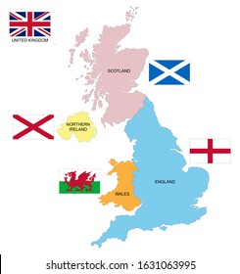
Sticky Knowledge
- St Julie’s school is located in the village of Eccleston.
- Eccleston is in the town of St. Helens.
- St Helens is in the United Kingdom.
- The United Kingdom is made up of 4 nations:
England
Scotland
Wales
Northern Ireland.
- The capital city of England is London.
Eccleston in St. Helens

Geography Skills
- I can recognise and identify physical and human features of Eccleston.
- I can compare and contrast features / landmarks of Eccleston and London

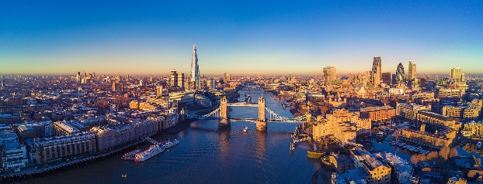
London

