How does the Weather Affect People’s Lives?
St Julie Catholic Primary School - Geography
Topic: Year: 1 | Strand: Human and Physical and Geographical Skills
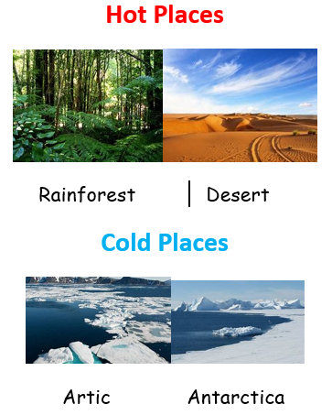
Vocabulary
Equator | The Equator is an invisible line that splits the Earth into two halves
Rainforests | Rainforests are close to the Equator. They are hot and wet places and perfect for all kind of life
Dessert | A place with very little rainfall.
North Pole | The North Pole lies in the middle of the Arctic Ocean and it’s waters are always frozen due to the cold temperatures.
South Pole | The South Pole is situated in the middle of the continent Antarctica.
Antarctica | Antarctica is a very cold continent

What should I already know?
- Know different types of weather.
- Identify the nations of the UK and their capital cities.
- Recognise some human and physical landmarks

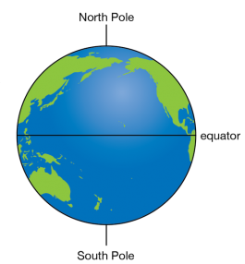
Sticky Knowledge
- The world has hot places and cold places.
- Hot places can be found near the Equator.
- Cold places can be found near the North and South Pole.
- Some deserts are hot but some deserts are cold.
- Houses in Eccleston and Kenya are made from different materials.
- Kenya has less rainfall than Eccleston,

Geographical Skills
I can identify hot and cold places on a world map.
I can compare the weather of the UK and Kenya.
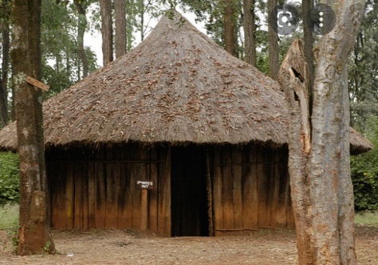
Masai houses in Kenya are built differently to ones in Eccleston because of the weather.

St Julie Catholic Primary School - Geography
Topic: Year: 1 | Strand: Human and Physical and Geographical Skills

