St Julie Catholic Primary School - Geography
Our Local Area | Year: 1 | Strand: Human and Physical Geography
Key Vocabulary
Aerial view | a view from above
Map | a drawing of a particular area such as a city, a country or a continent
Key | uses colours or symbols to represent important places or landmarks on a map.
Address | a place where a person or place can be found.
Human feature | somethings created by people (e.g. houses, roads, church, etc)
Physical feature | something that occurs naturally (e.g. rivers, hill, lake, etc)

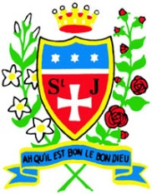
What is the geography of our school?
What should I already know?
- The name of our school
- Our school has an infant building and an outdoor play area.

Sticky Knowledge
- Human features of our school are the infant and junior buildings, playground and chimney.
- Natural / physical features of our school are the field, trees and Mill Brook.
- Around our school you can find roads, houses, churches and fields.
- The address of our school is Brooklands Road.
- An aerial map is looking down from above.
- A key helps us to find places on a map.

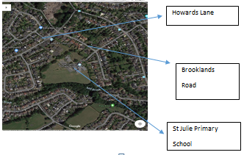

Geography Skills
- I can recognise human and physical features.
- I can describe the location of features in and around our school.

