St Julie Catholic Primary School - DT
DT – Summer Term | Year: 1 | Unit Title: Mechanisms: Sliders and Levers
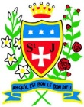
Vocabulary
lever | A mechanism- A bar which turns around a point
pivot | A point about which a lever turns
slider | A mechanism- a knob or lever that is moved up or down/ side to side to control something
wheel | A rotating mechanism
mechanism | Parts acting together to make an action happen
rotate | To move in a circle round a centre

Can I design a pop-up story book to read to Reception Class during story time?

What should I already know?
- basic cutting and sticking skills.
- Basic folds and joins to add strength and durability
Prior vocabulary:
- cut, stick, explore, design, evaluate, books, pictures, make
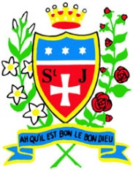

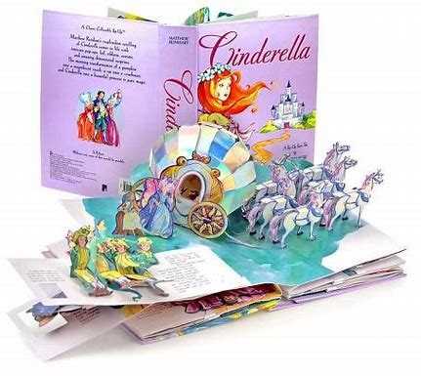

Skills recap:
Folding to strengthen, choosing appropriate materials by their properties. Applying adhesive and cutting skills (fine motor). Importance of the design process- refer to plan and design throughout.

DT Skills:
- design purposeful, functional, appealing products for themselves and other users based on design criteria
- generate, develop, model and communicate their ideas through talking, drawing, templates, mock-ups and, where appropriate, information and communication technology.
- select from and use a range of tools and equipment to perform practical tasks [for example, cutting, shaping, joining and finishing
- select from and use a wide range of materials and components, including construction materials, textiles and ingredients, according to their characteristics
- explore and evaluate a range of existing products
- evaluate their ideas and products against design criteria

Curriculum links:
Art: Colour/ photography
English: Traditional tales
How do I create a moving picture for a pop-up book?

-I can create a sliding mechanism.
- I can use levers to create a moving mechanism.
- I can investigate and create wheel mechanisms.
- I can design a picture with a moving mechanism.
- I can make a moving picture based on a design.
- I can evaluate a moving picture.

Colette Fu
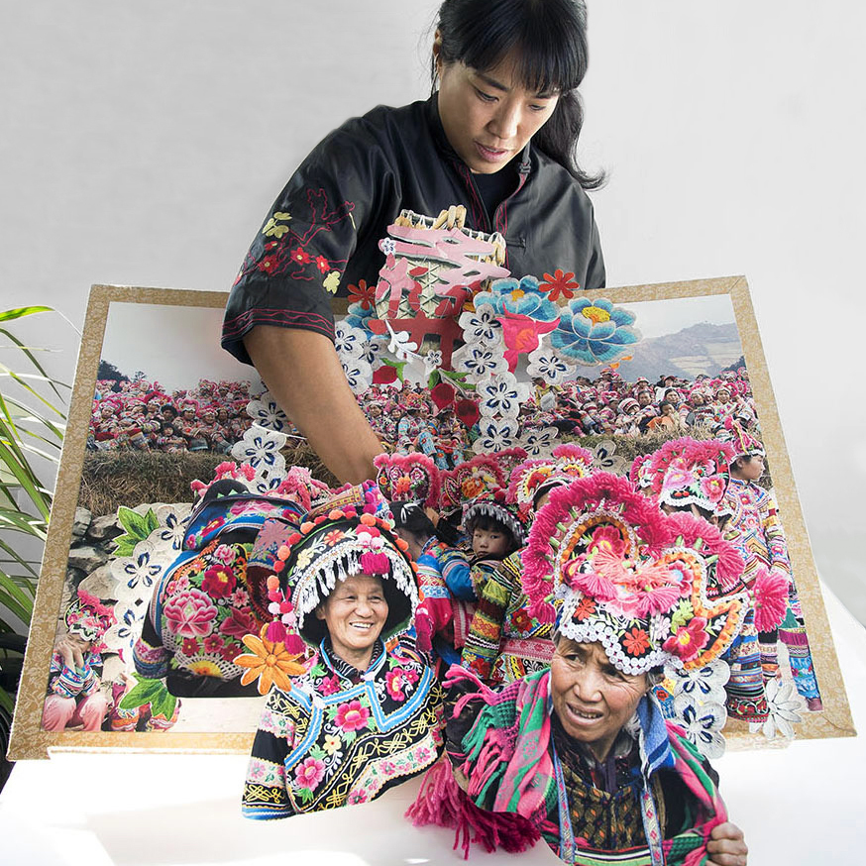
-Colette Fu is an American Chinese book artist, paper engineer and photographer.
-She uses her photography in her work.
-She creates colourful, detailed, 3D greetings cards too and created the worlds largest pop-up book in 2017.
