|  |  |  |
| --- | --- | --- |
| St Julie Catholic Primary School - Art | | |
| ART – Autumn Term | Year: 1 | **Unit Title: Sculpture- Seasonal changes.** |



**Andy Goldsworthy**

**Natural Sculpture**

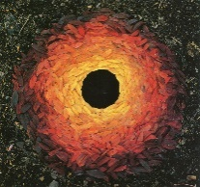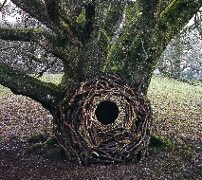

|  |  |
| --- | --- |
| Vocabulary | |
| Sculpture | An art form made in 3D |
| Natural Objects | Materials found in nature |
| Temporary | Lasts for a short time |
| Permanent | Lasts for a long time |
| Manmade | Materials made by human beings |

What should I already know?

* I can create a model using recycled materials.
* **Vocabulary** - Join, stick, glue, cut, tear, shape, size

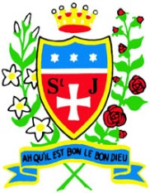

**Skills recap:**

* How to collect natural objects for a sculpture.
* How to arrange objects to create an effective composition.
* How to explore different colours in artwork.

**Art Skills**

* How to experiment with light and colour.
* How to manipulate natural found objects for a desired effect.
* How to consider the steps required in order to create a desired effect.
* How to be inspired by nature and natural forms.

**How do I create sculptures like Goldsworthy?**

1. Collect natural materials
2. Find a space to create your sculpture
3. Carefully put your materials in your chosen pattern/image
4. Photograph your finished sculpture

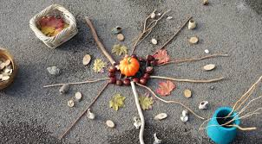

**Curriculum links:**

Geography Science

* Our local area- school and Eccleston - Seasonal changes
* Weather - Materials around school

**Andy Goldsworthy**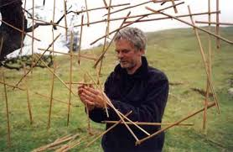

* -Andy Goldsworthy is a British sculptor
* -He likes to create his sculptures in natural places, using only natural materials.
* -The materials used in his art often include brightly coloured flowers, icicles, leaves, mud, pinecones, snow, stone, twigs, and thorns.
* -He sometimes uses power tools and help from others.



