|  |  |  |
| --- | --- | --- |
| St Julie Catholic Primary School - Art | | |
| ART – Spring Term | Year: 1 | **Unit Title: Drawing- Self portraits** |

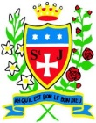

**What should I already know?**

I can draw using my finger in sand.

I can hold a pencil and make a mark.

I can draw an enclosed shape with a pencil.

I can make a representation of a subject using a pencil.

**Vocabulary**: draw, line, shape, mark, pencil, hold, curve, artist, portrait.

|  |  |
| --- | --- |
| Vocabulary | |
| **portrait** | A drawing, painting, engraving or photograph showing only the face or head and shoulders. |
| **tracing** | A copy of a drawing or design made by tracing. |
| **texture** | The feel or look of a surface. |
| **hatching** | Shading with closely drawn lines. |
| **stippling** | Using small dots when drawing, painting, or engraving. |

**Kara Walker**

**Arnold Machin**

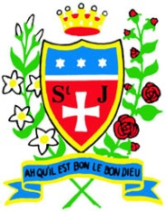

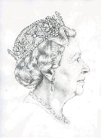

**Kara Walker**

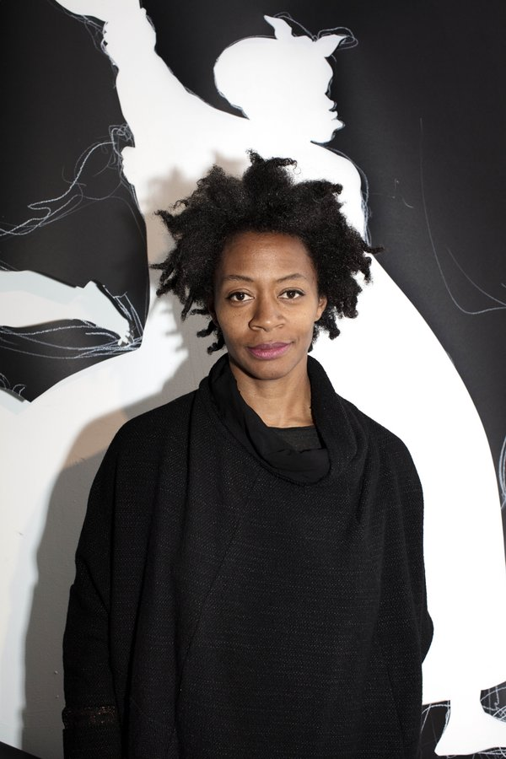

-Kara Walker is an American artist.

-She is best known for her room-size black cut-paper silhouettes.

-She uses paper, card, drawings, and paintings to create her artwork.

**Arnold Machin**

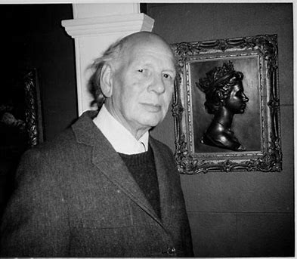

-Arnold Machin was an artist and sculptor

-He is most famous for creating Queen Elizabeth’s profile for British coinage from 1968 to 1984.

-The design was also used on British postage stamps.

**How do I draw a portrait?**

-Experiment by making marks with different mediums.

-Observe a variety of portraits across age ranges.

-Look how features change over time.

-Choose your favourite drawing medium.

-Remember to observe what you are drawing.

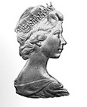

**Curriculum links:**

* **History:** Monarchs- Changes within our living memory.
* **Science:** Animals and humans- How we age.

**Skills Recap:**

* How to hold a pencil in order to make different marks (tripod grip, fist, handlebar).
* How to make a variety of marks with a pencil.
* The different marks made by different drawing materials.

**Art Skills:**

* How to make a variety of marks with a pencil such as hatching, cross hatching, stippling, scribbling, and blending.
* The effect made by drawing onto different materials.
* How to draw a face in proportion.
* How to critically reflect on a piece of artwork and suggest amendments.



