|  |  |  |
| --- | --- | --- |
| St Julie Catholic Primary School - Art | | |
| ART – Summer Term | Year: 1 | **Unit Title: Colour- Collage/ Habitats** |



**What should I already know?**

* I can use my finger to apply paint to paper in different ways.
* I can select appropriate colours for different paintings.
* **Vocabulary:** Red, blue, yellow, green, orange, mix, join, stick, cut, tear, shape, size.

**Daniel Mackie**

**Colour/ Collage- Habitats**

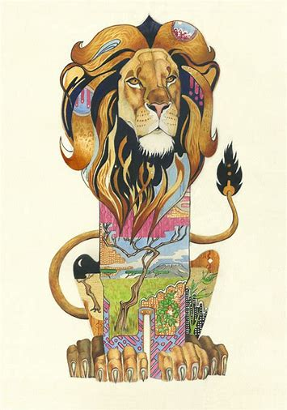

|  |  |
| --- | --- |
| **Vocabulary** | |
| **habitat** | The natural environment of an animal. |
| **Primary Colours** | The three main colours from which other colours can be made. |
| **crumple** | To press, crush or bend out of shape. |
| **overlap** | To cover part of something/ lap over. |
| **collage** | Pasting different materials together onto a surface. |



**Curriculum Links:**

Science: Habitats, Animals including humans.

Geography: Local environment.

**Skills recap:**

* How to identify and name different colours.

**New skills:**

* Recognise Primary colours and use them to mix secondary colours.
* Make different marks on paper using paint.
* Cut and tear materials.
* Combine different materials effectively in one artwork.
* Create a representation of a subject using collage.

**How do I create art like Daniel Mackie?**

-Explore making new colours by mixing primary colours together.

-Draw and paint different animals and their habitats.

-Practise different compositions using collage.

-Choose an animal design and create your finished piece using your new skills.

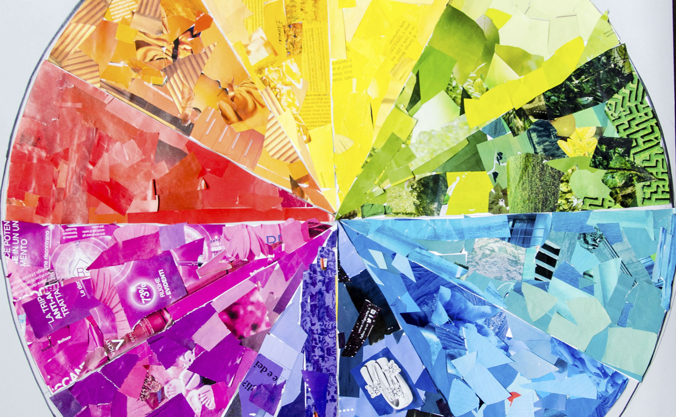

**Daniel Mackie**

Daniel Mackie is British illustrator.

He likes to create art based on animals and their natural habitats.

His colourful designs are also used on many items such as greetings cards, tea towels, coasters and stationery.



