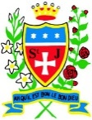
Year 3 - Our Reading Spine

At St. Julie’s Catholic Primary School, we want it to be a place where children are read to, enjoy listening to high-quality books and share their enjoyment of stories through discussion.

Our 'Reading Spine' is one element of the approach we take to foster a love for reading in our children. The spine is a core of books that create a living library inside our children's minds. It is a store of classics and essential reads that help our children engage at a deeper level and enter the world of the story. We have produced our very own 'Reading Spine' for every year group; giving children access to these high-quality texts.
Ultimately, while our children are continuing to enjoy a range of books throughout their school journey, they are also learning to become meta-cognitive readers.

We use the reading spine books in every year group over the school year. From your child starting in Reception at St. Julie’s Catholic Primary School, to leaving in Year 6, they will have been immersed into 50 of the most fantastic books available to children!

Year 3 - Reading Spine

Autumn Term | Please Mrs Butler, Allan Ahlberg  The earthquake challenge, Bear Grylls  The Boy with the Bronze Axe, Kathleen Fidler | 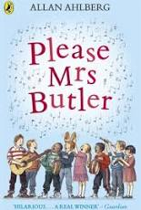  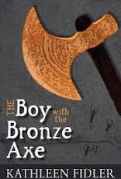
Spring Term | Charlotte’s Web by E.B. White  The Great Kapok Tree by Lynne Cherry  Ariki and the Island of Wonders by Nicole Davies | 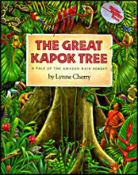  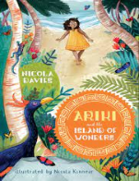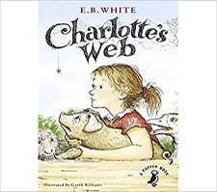
Summer Term | The Secrets of a Sun King, Emma Carroll | 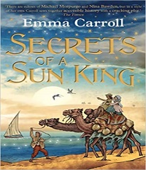

The books from the ‘Reading Spine’ will be shared with the children during the year

