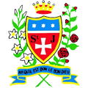

School games

It is fabulous to see so many schools in St Helens taking part in the School Games Inter-School Sports Competitions. St Julie’s have made a tremendous start to the year. Congratulations to the children in Years 3, 4, 5 and 6 for showing what teamwork means in recent events. Amazing performances were given by Years 3 / 4 in Dodgeball and Years 5 / 6 in Football.

Well done to Year 5 (boys and girls) and Year 6 (girls) for coming third and first respectively in their football competitions. Great performances and fabulous teamwork!

Thank you to all of the staff for their continued support and commitment.

