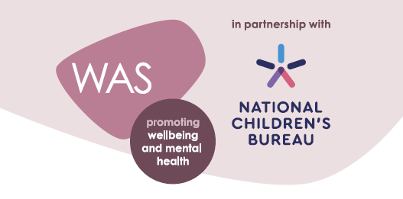
Introduction to the Award
Developed in partnership with the National Children’s Bureau (NCB), the Wellbeing Award for Schools is intended to help schools prepare and equip themselves to promote emotional wellbeing and positive mental health across the whole-school community. NCB’s vision is an education system where good emotional wellbeing and mental health are at the heart of the culture and ethos of all schools, so that pupils, with the support of their teachers, can build confidence and flourish. Evidence shows us that wellbeing is of central importance to learning and attainment, with high levels of wellbeing associated with improved academic outcomes. Conversely, pupils who have mental health problems are more likely to have academic difficulties at school and experience social disadvantage later in adult life.
To achieve this vision of wellbeing at the heart of learning, NCB advocates the use of a ‘whole-school approach’ where all aspects of the school experience are harnessed to promote the emotional wellbeing and mental health of pupils and staff. It is an approach where emotional wellbeing and mental health is everybody’s business.
There is continuing evidence of the impact of the pandemic on the emotional wellbeing and mental health of children, their families and school staff. Bereavement, social isolation, increases in domestic abuse, increases in financial hardship and poverty, the loss of opportunities for staff to spot emerging needs in pupils, the suspension of school-based services and the reluctance of children, families and staff to seek medical help during lockdowns all contributed to both acute and longer-term challenges to emotional wellbeing and mental health. A high percentage of children and young people with pre-existing mental health needs say that their mental health deteriorated during the pandemic, and, for some, for whom working at home reduced their anxiety, there have been challenges in getting back into school and re-establishing regular attendance. Additional pressures arising since the return to school are further increasing financial hardship. Recovery needs to address both the immediate and the longer-term challenges and ensure that the wellbeing of pupils, staff and the wider school community is a priority.
The Wellbeing Award for Schools is a welcome opportunity to recognise the exceptional work that schools do in this area. The key features of a whole-school approach form the basis of the award, and it provides schools with a benchmark of best practice against which to test themselves. We believe that this celebration of success will encourage more schools to adopt an approach that puts emotional wellbeing and mental health at the heart of what they do.

Principles behind the Award
There are four key principles driving the ideas and recommendations behind the award:
- Emotional wellbeing and mental health are a continuum. Related issues can range from positive attitudes and behaviour, through to experiences of emotional distress and mental disorder.
- Schools already experience and manage emotional issues on a daily basis; the objective is to minimise the impact of such issues and maximise the effectiveness of any responses.
- Emotional wellbeing covers a range of dimensions, such as resilience, character building, relationships and self-esteem, etc. Understanding both developmental and mental health awareness is critical.
- Creating a positive school culture requires a whole-school approach that is led from the top while involving all in the school community.
Embarking on the award process does not imply that your school is failing in this area, but rather that you have recognised the needs and demands of your school are changing and you are committed to responding to these. Much of this change will be apparent in the issues that schools face on a daily basis. Seen through the lens of academic achievement and attainment, our appreciation of the positive and negative impact of emotional and mental health challenges improves.

