Dear Parents and Carers,


Advent
Advent is a time of preparation, reflection and welcoming Jesus
into our lives. It is a great time for the family to spend time at home thinking of all they have to be grateful for and praying together for their hopes for the future.
This Sunday is the third Sunday of Advent and we focus on the joy that the birth of Jesus brought to the world.
Please see the St Julie’s Kindness Advent Calendar that was emailed to you for a daily act of kindness during the week ahead.


Christmas carol services
Thank you to those who came to listen to the Reception carols on Wednesday and Year 4 on Thursday. It was wonderful for the children to be able to perform in front of an audience and certainly reminded us all of the true meaning of Christmas.
Next week the remaining classes will each be performing a carol service in the school hall, dates as follows:
Monday 12th December 2:45pm – Year 1
Tuesday 13th December 2:45pm – Year 6
Wednesday 14th December 2:45pm – Year 5
Thursday 15th December 2:45pm – Year 3
Family members are very welcome. We are not selling tickets but appreciate a donation towards class funds.
Please do not use phones to take photos or record. Thank you.


Year 2 Nativity and Christmas Carol Services
Everyone is invited to join us in St Julie’s Church for the performance of the Nativity by Year 2 on Thursday 15th December at 11:15am. The whole school will be joining in with the Carols and the traditional retelling of the birth of Jesus, bringing us the true meaning of Christmas.


PFA Christmas Fair – this Sunday, Parish Hall
Please come along to the PFA Christmas fair this Sunday, 11th December from 2pm until 5pm. There will be games and activities for all the family, festive refreshments, Christmas cards and gifts on sale and of course Father Christmas will be stopping off at St Julie’s for children to visit him in his Grotto.


Thank you so much for the donations received today – we will keep collecting next week.
St Julie’s school has a history of supporting Our Warm Welcome in providing support for the refugees in St Helens. We call upon your kindness and in support of our Live Simply mission this year of living in solidarity with people in poverty ask if you could help in the weeks leading up to Christmas by donating the following items:
Tinned Tuna, Pineapples and Tomatoes
Basmati Rice and Pasta
Household Cleaning items and toiletries.
At this particular time the charity also need MEN’S SHOES.
Please send any donations into school and they will be collected by Our Warm Welcome. Thank you.


Saints Community Development Foundation
On Wednesday we were delighted to be visited by the saints players, Sione Mata’utia and Louie McCarthy-Scarsbrook, who were visiting schools in the local area to pass on their Christmas greetings to all the children and their families.
We have a fantastic prize worth over £60 to raffle which would make an amazing Christmas present! The prize is a Family Match Ticket for 2 adults and 2 children for the home game versus Wakefield on Friday 31st March 2023 in the 2023 Super League season.
To be in with a chance of winning please send in an envelope with your child’s full name and class on it and containing the £3 raffle entry fee by Friday 16th December, 3:30pm. Good luck!


Parent Governor election
We received 2 nominations for the one parent governor vacancy and will therefore be holding a secret ballot.
Thank you to the candidates who put themselves forward. They are:
Shane Whoriskey and Steven Wyatt
Ballot papers were emailed to all parents this week. You may vote for one of the candidates. Each parent can submit one ballot paper, regardless of the number of pupils you have attending the school. As indicated on the ballot paper you should vote by marking an ‘X’ alongside the name(s) of the parent(s) you support.

Once you have marked the ballot paper you should seal it in an envelope. This should then be put in the ballot box, which can be found in the school foyer by Monday 19th December. Ballot papers are also available from the school office.


CAFOD fundraising during Advent
Thank you for the donations received following the Santa Dash last week. So far we have raised £228.25 across the school. Each class is raising money during advent to buy a Cafod World Gift to help families overseas to develop sustainable ways of living. Next week I will be sending out a Live Simply newsletter which will tell you what each class has bought with the money they have raised. See the link for further details https://worldgifts.cafod.org.uk/


The Royal British Legion Poppy Appeal
Thank you for supporting the Poppy Appeal – your donations raised £222.90 this year.

The Golden Table
Each week in assembly a Lunchtime Supervisors Award and Mrs Finney’s Kitchen Award are presented to children who have shown outstanding behaviour and good manners during lunchtime. At the end of each half term their names go into a draw for a Golden Ticket.
On Thursday the winners of this half term’s Golden Tickets were invited to eat their lunch at the Golden table with special Christmas treats. Well done to the children - they certainly enjoyed their gold star treatment.
Thank you to all our lunchtime supervisors and kitchen staff who care for all the children, ensuring they are happy and well-fed at lunchtime.

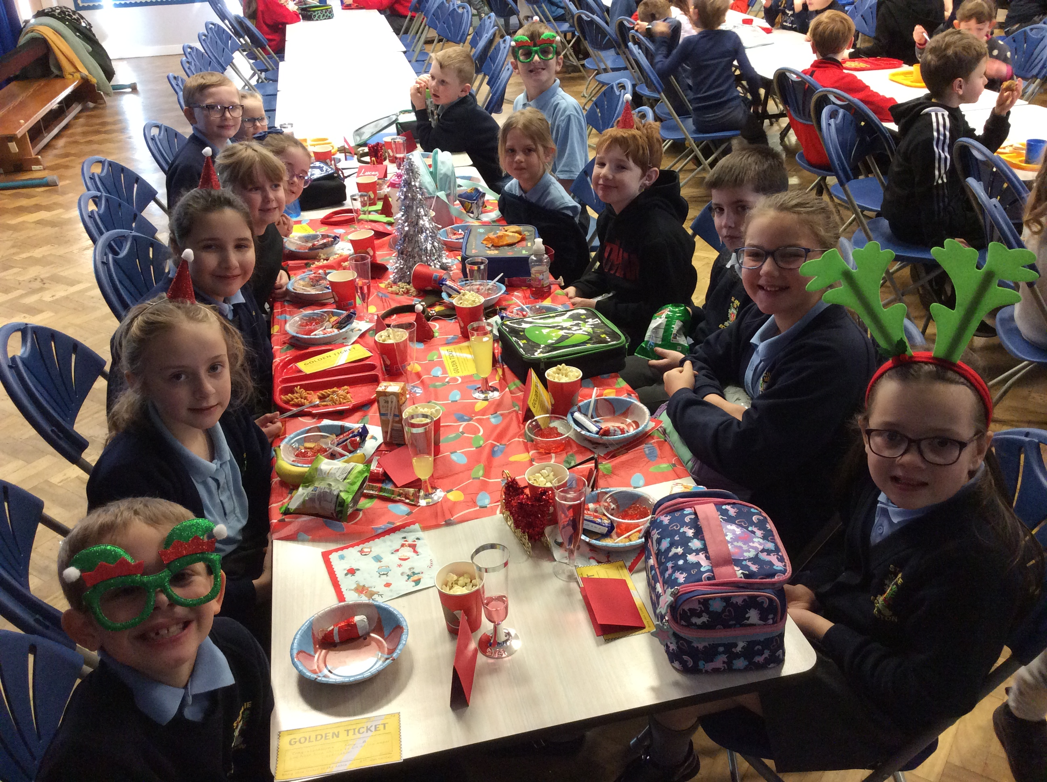

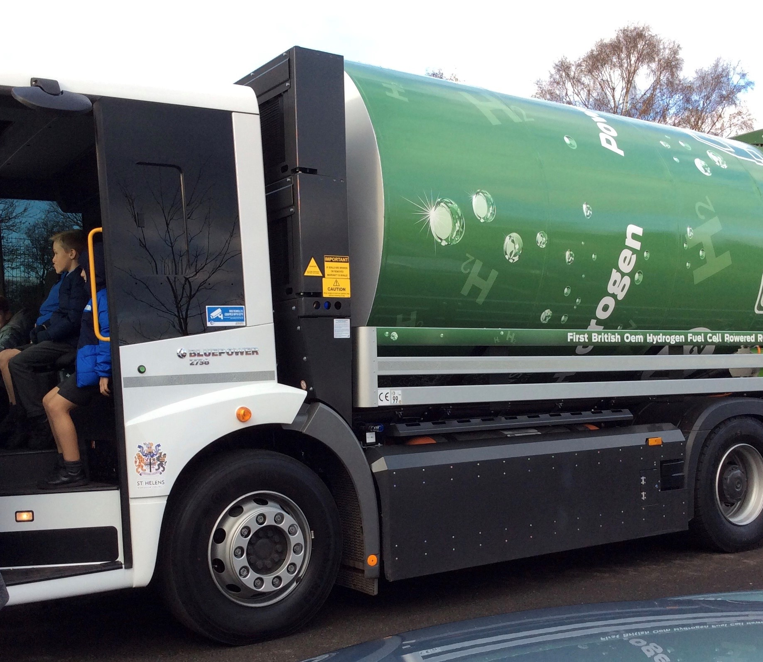

Go Green – Hydrogen powered truck
St Helens Chamber came into school this week to talk to Year 5 about the St Helens Go Green initiative. They were taught about greenhouse gases and made their Net Zero pledges. In the afternoon we were visited by St Helens’ only hydrogen fuelled truck – an alternative to fossil fuels.

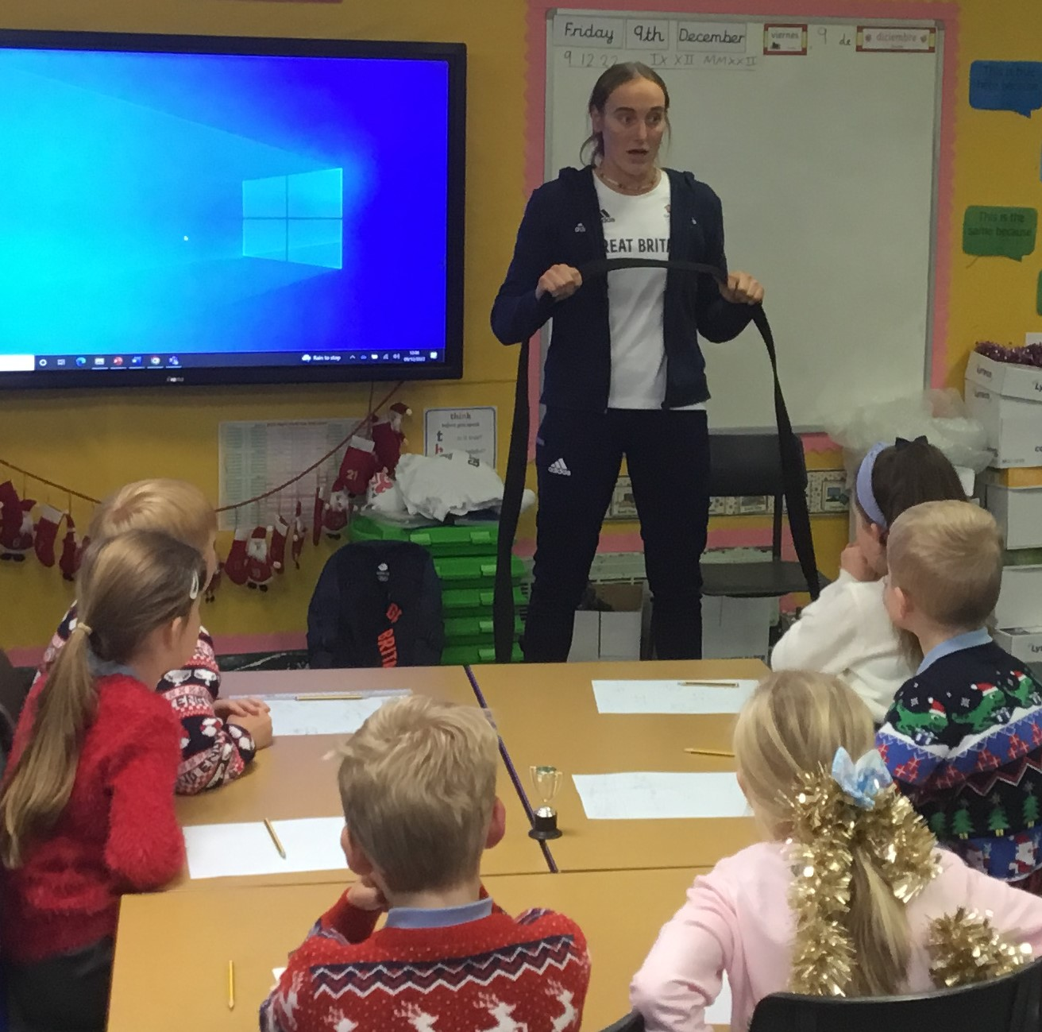

Olympic star visits St Julie’s
Year 4 were thrilled today to get a visit from a past pupil who is also an Olympic athlete. Lucy Renshall is currently the number one Judo champion in the world in her category. Lucy competed in the Tokyo Olympics and spoke to the children about her experiences, how she prepares and trains for competitions and the successes she has had. Lucy began by taking part in the Judo club when she was a pupil at St Julie’s and has followed her dream to become a world class competitor – proving that you can be what you want to be!

Attendance
Excellent attendance at school is important to allow a child to fulfil their potential. I am confident in your support in ensuring that your child strives for 100% attendance each week.
Each week we will report on attendance figures for each year group.

Year Group | % Attendance for w/e 09.12.22
Year R | 97.78
Year 1 | 93.82
Year 2 | 87.14
Year 3 | 98.86
Year 4 | 97.78
Year 5 | 92.81
Year 6 | 93.14

Well done to Year 3 who had the highest attendance this week with 98.86%.
Our whole school attendance this week is 94.48%


Time-keeping
Please ensure children arrive at school in time for the start of the school day. Children must be in class for 8:50am.
At the end of the day, please ensure you are on time for pick-up at 3:20pm.

Parking around school
Once again, I urge everyone dropping off and collecting children from school to be considerate to other road users and to children and adults. The safest way is to arrive in plenty of time, park away from school and walk the short distance with your child.
Do Not park/stop on corners, zig-zags, across driveways.
When manoeuvring be considerate of children and adults walking.



Easyfundraising By downloading this app you can collect FREE funds for St Julie’s every time you shop online!
Just visit easyfundraising.org.uk, search for St Julie Catholic Primary PFA and follow the simple steps to sign up. Then start shopping using the links to over 2,000 retailers including Amazon, John Lewis, M&S, Argos, Next, ASOS and many more. Every time you shop, you’ll earn a donation for the school at no additional cost to you! Start donating as you do your Christmas shopping!



St Julie’s Awards of the Week

 | Star for showing core value of Unity. | Book explorer | Marvellous mathematician
Reception | Joseph | Sophie J | Arthur
Year 1S | Lennie R |  | Theo H
Year 1J | Jack C | Josie K
Year 2 | George M | Holly B | Gabriella D
Year 3 | Alivia H | Lucy B | Luca P
Year 4 | Mia P | Lily Y | Matthew T
Year 5 | Amelie H | Noah G | Katy C
Year 6 | James C | Rosie Mc | Isabella D

Diary w/c 12.12.22 NO CLUBS this week
Monday Year 1 Carol Singing 2:45pm

Tuesday Year 5 to De La Salle to watch ‘Days Like These: A Rock and Roll
Musical Extravaganza’ 11:15am
Year 6 Carol Singing 2:45pm

Wednesday Christmas Dinner day
Year 5 Carol Singing 2:45pm

Thursday Nativity in Church at 11:15am – Year 2
Reception visit to Eccleston Library
Year 3 Carol Singing 2:45pm
Friday

Further dates for your Diary
Monday 19 December - Junior Christmas Party day
Tuesday 20 December - Infant Christmas Party day
Wednesday 21 December - School closes for Christmas break.

Please see the flyer attached “What parents and carers need to know about the app HiPal” from National Online Safety.

Winter Holiday and Activity Programme
The Holiday Activities and Food (HAF) programme is aimed at providing nutritious food and enriching activities for primary and secondary school aged children who are eligible for benefit related free school meals during the Easter, Summer and Christmas school holidays for children and young people aged 4 – 18 years who are eligible for and receiving benefits-related free school meals (FSM), and their families. Children and young people who are in receipt of a support plan via Early Help, Child In Need, Children We look after, EHCP or receives additional hours at school then they are also eligible for the HAF programme.
Throughout the winter holidays eligible children and young people can access a variety of free activity sessions and all of these sessions will include a nutritious meal.
For more information on the exciting activities and opportunities that are available, dates and times please follow the link below or call Central Link Children’s Centre on 01744 673445.
HAF Winter Timetable 2022 (PDF) [21MB]
We are requesting that parents/carers book their child’s place for the winter holiday activities as soon as possible, as numbers are limited (each provider can provide full details of their available sessions upon request). Please contact the delivery partner directly to book a place. Activity links will go live at 9.00am on Monday 5th December 2022.



“A caring family school, where we learn, grow and walk in the footsteps of Jesus.”


St Julie pray for us, protect us and bless us.



