ST JULIE CATHOLIC PRIMARY SCHOOL

ECCLESTON

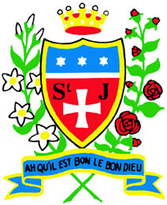

Religious Education Policy

Reviewed by Governing Body and staff
Spring term 2023
ST JULIE CATHOLIC PRIMARY SCHOOL
MISSION STATEMENT:
A caring, family school where we learn, grow and walk in the footsteps of Jesus.

In consequence of our school mission it is a fundamental aim of St. Julie’s to be an inclusive school. To be a school which:
- Is a caring community
- Provides and respects equal opportunities
- Offers partnership between school, parents and parish
- Reflects upon the teachings of Christ and puts them into practice
- Values all of the school community
- Its members show respect for themselves, each other and their learning environment.

We define an inclusive school as one where:
- Everyone, irrespective of age, gender, ability or disability, race or religion is encouraged and given equal opportunity to participate in the full life of the school
- All of the school community are given the opportunity and support to achieve their true potential
- All of the school community, and the contributions they make to the life of the school, are valued; everyone is treated with mutual respect, care and consideration
- Everyone feels empowered to play a full and effective role in the school.

Introduction
The purpose of Religious Education at St Julie’s School is to nurture the Catholic Faith, and its teachings, in our children. By helping them to live this faith, we hope to encourage our children to develop a better relationship with God and others around them.

Religious Education (R.E) should promote pupils’ cultural, mental, emotional, spiritual and physical development and prepare children for the opportunities and responsibilities that are to come. This should be in the context of a moral and ethical Christian framework.

R.E is a core subject at St Julie’s School. It is delivered mainly through the religious education programme ‘Come and See’, but is also encouraged through links with home, the Parish Church, the local community and other subject areas, especially PSHE. We believe that all aspects of R.E should be woven into the fabric of school life. We recognise that everyone at St Julie’s School, staff, children and parents are on their own personal journey of faith.

Aims and Objectives
The outcome of excellent religious education is religiously literate and engaged young people who have knowledge, understanding and skills- appropriate to their age and capacity- to reflect spiritually, and think ethically and theologically, and who are aware of the demands of religious commitment in everyday life.

Religious Education Curriculum Directory for Catholic Schools 2012

The following aims and objectives are taken from the Curriculum Directory for Catholic Schools published for the Bishops’ Conference by the Catholic Education Service. They underpin the effective delivery of religious education in St Julie’s primary school.

Aims
Curriculum religious education at St Julies aims to promote
- knowledge and understanding of Catholic Faith and Life;
- knowledge and understanding of the response of faith to the ultimate questions about human life, its origin and purpose;
- the skills required to engage in examination and reflection upon religious belief and practice

Objectives
The objectives of curriculum religious education at St Julie’s are:
- to develop knowledge and understanding of the mystery of God and of Jesus Christ, of the Church, and the central beliefs which Catholics hold;
- to develop awareness and appreciation of Catholic belief, understanding of its impact on personal and social behaviour and of the vital relationship between faith and life, life and death;
- to encourage, study investigation and reflection by pupils
- to develop appropriate skills: for example, ability to listen; to think critically, spiritually, ethically and theologically; to acquire knowledge and organise it effectively; to make informed judgements; to foster appropriate attitudes: for example, respect for truth; respect for the views of others;
awareness of the spiritual, of the moral responsibility, of the demands of religious commitment in everyday life and especially the challenge of living in a multicultural, multi faith society.
(Curriculum Directory P.10)

The Religious Education Programme
To fulfil our aims and objectives we use the ‘Come and See’ programme of Religious Education recommended by the Archdiocese of Liverpool.

Overview of content
Each year group follows a series of topics based on the themes below. These follow a one year cycle and are outlined on the chart in appendix 1. ‘Come and See’ is developed each term through the three themes of Church, Sacrament and Christian Living. The themes are developed each term in the light of:
Autumn- an understanding of Creation
Spring – an understanding of Incarnation
Summer – an understanding of Redemption and the work of the Holy Spirit.
.
The Process
The process for delivering the topics in ‘Come and See’ has three stages – Explore, Reveal and Respond - which enable pupils to develop knowledge, understanding, skills and attitudes.
Before commencing each topic the teachers reflect upon the ‘Before We Begin’ notes. As time allows, we carry out a whole school reflection on these notes to share thoughts and ideas.

Other Faiths
We believe that learning about other faiths and cultures is essential for a better
understanding of their own faith and culture.

Everyone will study Judaism during the Autumn Term. In the Spring or Summer term (whichever is longer) children will study a different faith according to their year group. (See appendix 2 for details)

Teaching RE
RE is regarded as a Core subject at St Julie’s. However, its delivery extends beyond the class timetable. The spiritual and moral development of the children is underpinned by the whole ethos of the school. The distinctive nature of St Julie’s school should be such that all aspects of school life should proclaim the school’s mission and cannot therefore be conveniently compartmentalized into one area of the curriculum. RE then, is a cross-curricular subject which demands the same rigour and challenge in its specific subject but which should impinge on all other teaching and aspects of school life.

Approach to teaching RE in Foundation Stage
RE is delivered through the following provision:
- Whole class core input (teacher led)
- Adult directed group activities (teacher or assistants work with groups of children).
- Continuous provision (child centred learning across the areas of learning in the foundation stage).

Through engaging, practical, integrated activities children can learn more about themselves, other people and the world around them. They can develop their religious knowledge, skills and understanding. RE makes an active contribution to the areas of learning outlined in the foundation curriculum but has a particular and important contribution to:
- Personal, social and emotional development
- Communication and language
- Literacy
- Understanding the world
- Art and Design.

Approach to teaching RE in Key Stages 1 and 2
Children from Years 1 to 6 study ‘Come and See’ through the structure of Explore, Reveal and Respond.

Explore and Reveal comprises of the following sections:
- Learning focus: the overall focus of the session.
- Content: some suggestions to input to develop the focus
- Key questions: questions which will encourage children to wonder and reflect upon what they have heard or seen.
- Activities: children will engage a range of activities in order to support and extend their learning and understanding. Where appropriate, these activities will be differentiated.

Respond is the same in Foundation Stage as in Key stages 1 and 2. This gives children to respond to what they know and understand by three means:
- Remember,
- Rejoice (through songs, prayers and readings)
- Renew (children might consider how they apply their learning to everyday life)

Planning
A time allocation of 10% curriculum time is given to RE. This does not include assemblies or hymn practices. The allocation is thus:

Foundation Stage and Key stage 1: 2 hours
Key stage 2: 2 hours 30 minutes.

Long term planning is outlined in the themes and topics framework (appendix1).

Medium term planning is outlined on the year-appropriate page of the ‘Come and See’ website, an example of which is in appendix 2. The aim is to cover each topic in four weeks.
It is the responsibility of the coordinator to ensure that all staff are presented with medium term planners, outlining significant dates, the teaching of Other Faiths and formal assessments

Short term planning is recorded on the school planning sheets. Driver Words should help to inform the teacher as children move through their learning. See Appendix 3 for Driver words. Each lesson is to be dated, and differentiated activities indicated. A brief evaluation of each unit should be indicated at the end of each topic. When planning, the ‘Driver Words,’ and the Topic expectations will help structure tasks. Teachers should ask ‘What must I do in this topic to enable the pupil to achieve….’

The coordinator is responsible for monitoring planning on a regular basis and ensuring coverage and differentiation.

ASSESSMENT
Assessment is focused by the overall aims and objectives of Religious Education ‘Come and See’ page 27 and the Religious Education Curriculum Directory for Catholic Schools and Colleges pages 65-66. In ‘Come and See’, it is related to the concepts, skills and attitudes to be developed through the exploration of the themes and the learning outcomes for each topic. Assessment establishes what pupils know, understand and can do. It does not assess faith or the practice of faith. Assessment in ‘Come and See’ emphasises a wide range of achievement. At St Julie’s we assess in a variety of ways using formal and informal assessments. We aim to have a system of assessment which:

- Is clear and easy to follow and linked to the learning objectives
- Is positive and formative and informs future planning
- Is also summative and allows diagnostic analysis
- Encourages and enables pupil self-assessment
- Provides feedback to pupils

Informal assessment
In addition to formal assessments, assessment is an ongoing process. Should staff take particular note of a child’s comment of work, this can be logged in the ARR folder for consideration of overall level later in the year.

Formal assessment
Assessment follows the guidelines provided by the Archdiocesan Education Team. There is one formally assessed and moderated Come and See topic per term.
- Each term, every child must be assessed formally, as indicated on the assessment cycle sheet.
- Assessment tasks are on the Archdiocesan website but will also be distributed by the coordinator.
- A staff moderation meeting is to be held termly.
- Samples of work from each formally assessed topic must be given to the coordinator for whole school moderation. These will be kept in the school moderation portfolio.
- It is still useful for the children to record achievement at the REMEMBER stage of the process to record new learning by using a concept map (2 different colours).
- Individual assessments should also take into account information gained from discussions, observations, class work and assessments etc.
- Marking of work should be positive, encouraging and developmental, using the language of the Driver Words to move learning forward.
- Reception class will develop a portfolio of annotated work from each topic including photographic evidence needed.
- Assessment should be used as the basis for reporting to parents at the end of the year.

Floor books and moderation portfolios
Each class is to develop a floor book over the course of the year. It will reflect examples of work not evident in pupil books and might include:

- Photographs, e.g. drama, role play, displays, visits, visitors
- Samples of art work
- Written work not recorded in exercise books.
The floor book is to be passed on to the next teacher and follow the class through school. This is a reference point for the staff and pupils for previous learning. It should be revisited to recall linked topics.

In addition, the coordinator will keep a portfolio of leveled and moderated samples of work. Each sample of work needs a context sheet with a statement of attainment and justification. Early Years can use photographs but should have a statement of attainment with it.

Recording/ Reporting
At the end of each topic, assessments for each pupi should be recorded on the school’s assessment recording grids. These will form the basis for an overall judgement at the end of the year. Formal assessments, class work and discussion should also be taken into consideration when making a judgment about attainment.

Reports to parents/carers should indicate progress and achievement.

In order to inform parents of RE topics, a newsletter is issued each term, including:
- possible activities for parents to share at home with their children
- dates of religious significance

Evaluation of teaching and learning
The R.E Coordinator will monitor work through regular observations, book scrutiny, displays, pupil interviews and by collecting samples of work for a school portfolio. Planning is submitted to the coordinator termly. The standard of work will be compared with expected learning outcomes. This information is presented to the governors annually in a report.

Self-evaluation At St. Julie’s we believe that self assessment is fundamental to developing the child as an independent learner. Children, at all times, should be encouraged to self-evaluate their work. This can be done in a variety of ways during the ‘remember, renew’ stages:
- Concept mapping (see above)
- Learning Tree (Leaves),
- Pictorially
- The infants have devised a series of self evaluation sheets for each topic which are cumulative.
- At the end of a lesson using strategies such as, ‘thumbs up/ down’ or ‘traffic lights’

Equality and Inclusion Statement
At St Julie Primary School we aim to provide equality of opportunity for all children whatever their age, ability, gender, race, religion, or background. We aim to create an environment that values each pupil and enables them to achieve their full potential. As an educationally inclusive school the teaching and learning, achievements, attitudes and well-being of every pupil matters, and our inclusive practice means that all learners are supported. We provide a broad and balanced curriculum that is accessible to all learners, providing the opportunity for all pupils to achieve their potential. As such we plan and resource our learning, in line with our whole school policies, to enable all pupils to make good and sustained progress in Religious Education. In our planning we take due regard of factors such as classroom organisation, learning materials and the learning environment.
The opportunities and experiences we provide enable all our pupils to participate fully and give their best across all aspects of school life. We place great value on the quality of relationships within our school community. We aim to develop a culture of inclusion and diversity in which success is celebrated and all those connected to the school feel proud of their identity and able to participate fully in school life. We appreciate that children may have special educational needs throughout, or at any time during their school career. At St Julie Primary School we aim to facilitate the full inclusion of pupils with special educational needs. We will tackle discrimination by the positive promotion of equality and the creation of an environment which champions respect for all.
Withdrawal
The school does not have a policy of withdrawal from Religious Education for any reason. Should a parent feel that it is necessary to withdraw their child, we request that the parents should discuss this with the Headteacher and RE coordinator.

Staff Induction
It is important that all adults working with the ‘Come and See’ scheme have a thorough understanding of its themes and process. The following outline will direct individuals for help:
ECTs, will initially plan with the coordinator, who will also arrange for training as appropriate.
Supply teachers, where possible, will be provided with planning by the classroom teacher. However, for longer term supply, the coordinator will give guidance and support as necessary.

Worship
Central to our ethos are the opportunities for prayer and worship which lie at the heart of our faith. We will endeavour to promote and encourage these at every level, together with the skills and attitudes necessary to live out the Christian message in the modern world.

Children have the opportunity to engage in worship in many different formats and prayer styles. They are given opportunities through:

Daily Acts of Worship: The children attend Key stage and whole school Collective Worship as outlined in the Collective Worship policy.

Worship Welcomers are pupils in Y1 and KS2 who support daily acts of worship. Supported by an adult they will have an increasing role in this process as they progress through school. The school follows themed acts of worship each week, with readings provided by the coordinator. These themes are published on the website in order that adults at home may reflect on these readings should they choose to do so.
Children are encouraged to learn traditional prayers, appropriate to their age and engage in personal / spontaneous prayer.

Celebrations of Holy Mass: Mass is celebrated as a whole school throughout the year, on the following occasions: Holydays of obligation; Eucharistic Celebration; School Leavers’ Mass: Class masses (KS2)

Other occasions: At Christmas time the Christmas feast is celebrated with a Nativity Play/Carol Service which is performed in the Church at the end of the Christmas term.
The feast of Easter is celebrated with a service which may take several forms:-
A Passion Play / Service
Stations of the Cross
A Service of Sorrow.
Each year we hold a Welcome Service to greet new families and a Harvest Festival Assembly.

Revised: 2023
Next review: 2026

APPENDICES

- Topic overview
- Other Faith teaching
- Driver words
- Collective worship timetable
- Other school policies related to RE
- List of resource

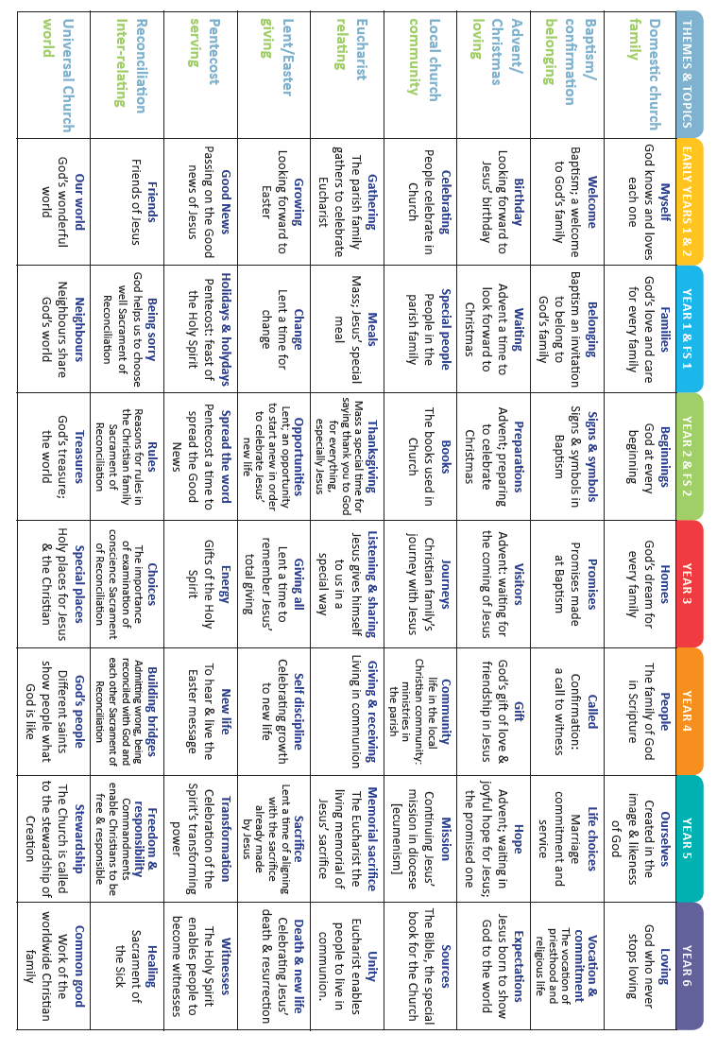
Topic / theme overview

Appendix 2

OTHER FAITH TEACHING

In accordance with ‘Come and See’, the school has adopted the following programme of multi faith teaching:
Judaism (2.5 hrs): Autumn 1
R - Hanukkah
Other Faith Teaching
Judaism:
Y1 - Abraham and Moses
Y2 - Shabbat
Y3 - The Synagogue
Y4 - The Torah
Y5 - Pesach
Y6 - Yom Kippur

Other Faiths (2.5 hrs): Spring/ summer (determined by length of the term)
R - Islam
Y1 - Sikhism
Y2 - Hinduism
Y3 - Islam
Y4 - Hinduism
Y5 - Sikhism
Y6 - Islam

Integral to the school’s multi faith week is the promotion of different cultures, exploring not only the teaching objectives of ‘Come and See’, but also the art, dance, music food and traditions of different cultures. This has been supported with a variety of visits and visitors to the school.

Appendix 3
Driver words

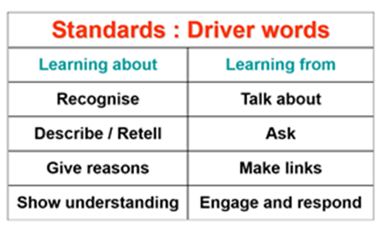

Appendix 4
Collective Worship

Monday - KS2 Collective worship and assembly led by Deputy.

Tuesday -

Wednesday KS1 Collective Worship

Thursday - KS2 Collective worship

Friday - KS1 and KS2 collective worship led by Headteacher or Deputy

Appendix 5

Other School policies related to the RE policy:

Collective Worship
Special Needs / Inclusion
Equal Opportunities
Policy for the teaching of Relationships and Sex Education
Personal, Social and Health Education
Good Behaviour / Anti-bullying policy
Equality Policy

Appendix 6
RESOURCES

Teacher online resource
Come and See R, Y1, Y2, Y3, Y4, Y5, Y6

Faith Alive Rowanne Pasco, John Redford
This is Faith Francis J. Ripley
Documents of Vatican II Walter M. Abbott

Pupil Books
Church Story 1 Big Book
Church Story 2 Big Book
Church Story 3 class set

God’s Story 1 Big Book
God’s Story 2 Big Book
God’s Story 3 Class set

Bibles/ Missals
Good News Bibles
The Jerusalem Bible
New World Alan T. Dale
The Catholic Children's Bible Paul Hamlyn
Bible Stories David Kossoff

The Sunday Missal Collins
The Weekday Missal Collins

Family Mass Themes Sister Monica Mary
More Family Mass themes " "

Assemblies
The Junior Assembly Book D.Vause, L. Beaumont
The Tinderbox Assembly Book Sylvia Barratt
New Stories for Junior Assembly Tony Jasper
Assemblies for Primaries A. G. Patson
The Everyday Book Mary Batchelor
Assemblies Round the Year Beverley Birch
Active Assemblies S. Dinsdale, A. Tracey

Other Faiths
Artefact resource boxes for:
Judaism
Isalm
Hinduism
Sikhism

Living Festival Series;
Christmas Antony Ewens
Divali Howard Marsh
Guru Nank's Birthday Margaret Davidson
Easter Norma Fairburn, Jack Priestley
Ramadan & Id-ul-fitr Janis Hanniford
Passover Lynne Scholefield

ICT Resources

Come and See Internet resources
Church’s Story ( KS 1& 2) CD ROM- site licence
God’s Story (KS 1 & 2) CD ROM – site licence
Religious Education Writing frames CD ROM – single user licence
(Also photocopiable book)

Hymns:
John Burland
Rejoice (tapes) Hymns Old and New
Songs of the Spirit 1, 2, 3 and 4 Celebration Hymnal
Acclaim the King Songs of the New Spirit
Carol Gaily Carol Someon'e Singing Lord
Merrily to Bethlehem Infant Praise
Music from Taize I and II God's Rainbow
Morning Has Broken

