Dear Parents/carers,

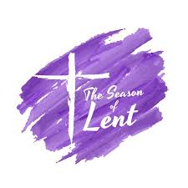
Our Lenten Journey
On Wednesday we entered into the holy season of Lent. Please look on the RE pages of our website to see how you can celebrate this special time at home as a family.

Lent is a special time when we remember Jesus' journey into the desert and our walk with Him as we journey to Easter.

Try and give up a few moments of each day to pray, to give thanks and to say "Hello" to God.

Live Simply Lent challenge
This year, we have taken up the challenge to 'Live Simply'. We would like our school family to take the opportunity of Lent to review our pledge to live more simply and appreciate our world. Please look at the Lent Challenge on the school website and join as we try to live simply.
Over the next few weeks, the staff, children and governors will be reviewing our Live Simply promises. We will be placing our pledges on pebbles in the prayer garden as a reminder of our commitment to creation.


Lent Fund raising
Lent is traditionally a time of fundraising. Each class will be involved in fundraising activities to support our local charity, Nugent. We also look forward to the return of 'Tuna Tuesday' when pupils are asked to donate tins of tuna, which are sent to a local food bank. We are aware that finances are becoming increasingly tight for all and appreciate any donations that can be made.
If you can, please send in a tin of tuna on a Tuesday this half term. Thank you.

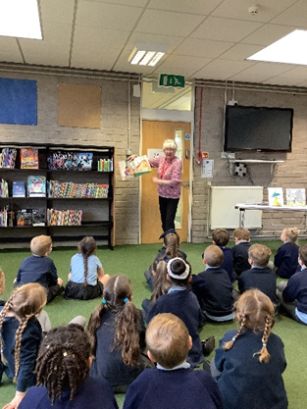

Year 1 Book BASH visit to Eccleston library

On Monday morning this week the children attended a session linked to BASH (Book Awards St Helens) at Eccleston Library. Our Y1 children have been introduced to 5 new books written by a wide-range of authors. They have the chance to read them all and then vote for their favourite. Please do ask the children about these books when they are at home with you.


School Games - New Age Kurling competition
On Wednesday a team from Year 2 took part in a New Age Kurling competition along with teams from other local schools. In assembly this morning they received their certificates and told us how they skilfully played the game and scored points. Congratulations to Bobby, Jackson H, Thomas O, Ben M, Olivia, Hollie and Zara who represented St Julie’s so well.


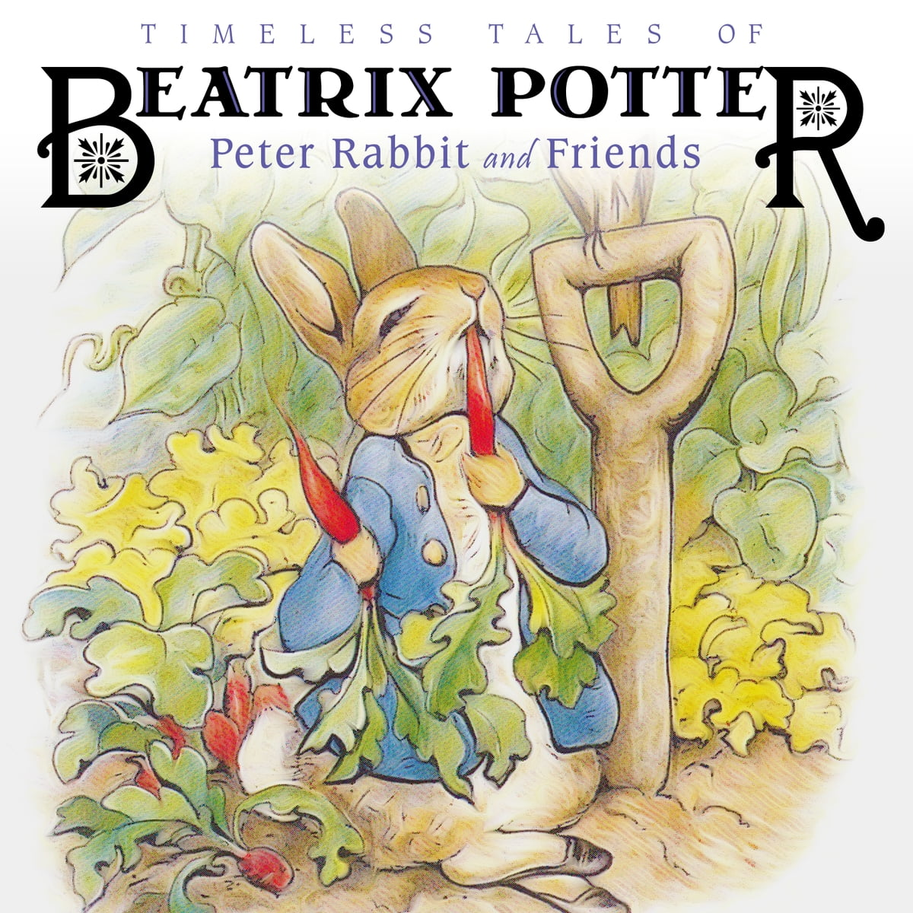
Book Week including World Book Day
At St Julie’s we celebrate our love of reading throughout the year but during the week commencing 27th February we will be holding a themed Book Week and joining the rest of the country in celebrating World Book Day 2022.
During the week children in the Juniors will focus on William Shakespeare while children in Infants will look at the works of Beatrix Potter.

On Thursday 2nd March, World Book Day, the children will be thinking about their own favourite authors and can come to school dressed as a book character or they can come with their favourite bedtime book dressed in pyjamas or a onesie (warm clothes underneath and shoes for outdoors) No football kits please. If a child does not wish to dress up then they can come in their school uniform.
Year 5 will be visiting the Planetarium on World Book day so will be wearing their school uniform. They can wear their chosen World Book Day outfit when they visit Eccleston Library for the Year 5 Book BASH event on Thursday 9th March so that they don’t miss out.


The Reading Ambassadors have asked that we hold a book swap on Thursday so could each child bring in one book in good condition that they are happy to swap (forever!) for another book.


Share a Story sessions
The children of St Julie’s are enthused by their love of books and find great pleasure in their reading. Once again, we would like to invite parents/carers to come into school to share a story – or more – with their child in the school hall.
The first of these sessions will begin on Wednesday 1st March for the Reception class. One adult is invited to come to school via the front entrance on Brooklands Road at 2:40pm to join their child for a cosy reading session. School will provide the books and don’t worry if you can’t make it, there will be school staff around to make sure all children can have a fun reading time.
Further sessions are:
Thursday 2nd March – Year 3
Friday 3rd March – year 4
Monday 6th March – Year 1
Tuesday 7th March – Year 6
Thursday 9th March – Year 2

St Julie’s Subject Ambassadors
The views of our children are essential in continuing to enrich our curriculum and our Subject Ambassadors play an important role in this. We would like to keep you informed of the work that the Ambassadors do with the Subject Lead of each curriculum area.
This week the History ambassadors met with Mrs Mannion:

All representatives from Years 2 – 6 present.
We discussed the importance of History in our school, all of the children were keen to agree that at St Julie History is very important.
‘We have lots of History lessons’ ‘History is important because it’s good to learn about the past’ ‘Our History lessons are very interesting, you learn things you never knew’ ‘I love learning about the past where we live and seeing how things have changed and things that are still here’ ‘I like learning about how Britain has changed and the different invasions’ ‘It is important but also fun to learn about the past’

The children were able to talk about their current History learning as well as previous learning. When the Year 2 children were talking about the Great Fire of London, children from other year groups were joining in with facts they remembered. Year 6 also pointed out the link between their medical breakthroughs unit learning about the Bubonic plague and how they had also used part of Samuel Pepys diary as a source. The KS2 children could recall their learning of British History in chronological order and agreed it was easier to remember this by teaching in order form Year 3.
Suggestions/Things to think about:
- Ways to commemorate King Charles III Coronation as a big event in History – this will become important history in the future.
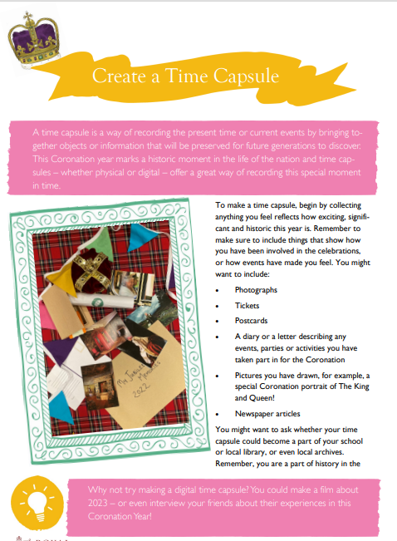
- Create Time Capsule - Ideas
    - Artwork/ pictures
    - photos of how school celebrates (street party?)
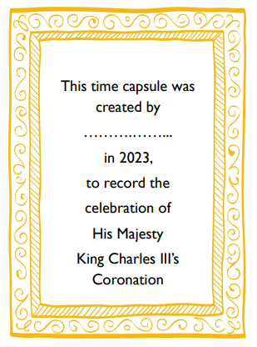
    - Coins
    - Speech bubble memories of children
    - Photos of activities they like to do in
the year 2023.

do in the year 2023.

Names in Uniform!
A reminder that all items of school uniform must have your child’s name in them – including PE kit and joggers. As we are halfway through the year, some of the names have faded or washed out. Please check and write over them again. Thank you.
We still have lots of spare uniform available from the school office in all sizes.


St Julie’s Science Fair
We are delighted to announce our next Science Fair. This has now become a traditional part of St Julie’s Science Week. The event will take place over two afternoons:
KS1 & Early Years: Tuesday 21st March
KS2: Thursday 23rd^{th} March

The children are encouraged to investigate an area of science of particular interest to them at their age-appropriate level and present their findings to the school. Children may submit joint entries. Children are encouraged to present their investigations in a creative way.
The project is to be prepared at home. We welcome, and encourage, parental support. Please ensure that when helping your child that they have a good understanding of what they are doing and will be able to explain their project to other children and adults in school.

PLEASE NOTE: the science fair will take place in the hall immediately after the school day. Parents, grandparents and carers are more than welcome to attend to support their children and celebrate the wonderful work of our scientists.

Please complete the entry form sent home today and return to Mrs McCahey by Thursday 16th March.


Excellent attendance at school is important to allow a child to fulfil their potential. I am confident in your support in ensuring that your child strives for 100% attendance each week.
Holidays during term time will not be authorised. Prior to the pandemic our whole school attendance for the year was 98% so this is the target we are aiming for this year.
Each week we will report on attendance figures for each year group.
Punctuality
Please make sure that you arrive at the school gates in plenty of time for your child to get to their classroom. Children are expected to be in class by 8.50am. Children arriving after 8:50am will be marked as “Late” in the register.

Year Group | % Attendance for w/e 24.02.2023
Year R | 94.44
Year 1 | 100.0
Year 2 | 97.71
Year 3 | 98.00
Year 4 | 95.56
Year 5 | 96.88
Year 6 | 96.29

Well done to Year Y1 who had the highest attendance this week with 100%. Fantastic!
Our whole school attendance this week is 96.98%


This week’s flyer from National Online Safety is, “What parents and carers need to know about Spotify.”


Practical Cookery Workshops
In line with the National Curriculum Design and Technology Programmes of Study for Food and Nutrition every class experiences a practical cooking session provided by “Apple of my Eye.” Year 1 will have their sessions on Monday 6th March.
We ask for a payment of £6.80 per child to cover the cost of instruction, equipment and ingredients which can be paid via School Money.


St Julie’s School Values
Whilst the children know that each of our core values helps us to follow in the footsteps of Jesus, each half term we focus particularly on one of the core values. This half term we are thinking about love:
Love is showing kindness and forgiveness to all. We show love towards everyone around us and everything that God has created.


St Julie’s Awards of the Week

 | Star for showing core value of Love. | Book explorer | Marvellous mathematician
Reception | Reggie | Georgie | Charlotte
Year 1 | Theia C | Raphie B | Penelope W
Year 2 | Holly B | Bobby B | William Mc
Year 3 | Joseph W | Benji L | Veronica H
Year 4 | Marley R | Teddie C | Amelia B
Year 5 | Albie A | Heidi D | Lucas C
Year 6 | Rosie Mc | Grace L | Hollie W

PFA Spring events

Friday 10th March - Infant Film afternoon 3:20 – 5:00
Friday 17th March - Junior Film afternoon 3:20 – 5:00

Please see the PFA newsletter emailed with this bulletin.

All Weathers Lottery The PFA is registered with ‘All Weathers Lottery’. Tickets are £1 for each line per week and you can purchase as many lines as you wish. The weekly draw takes place each Monday with a top prize of £25,000.
The PFA receives 50% of all ticket sales. Please see the link to sign up on your child’s class Teams page, and please share with family and friends. The more sales, the more money for the children.

Club Page  allweatherslottery.com | 

Diary w/c 27.02.23 Book Week

MONDAY Y3/Y4 Indoor Athletics 3:20 – 4:15
Y2/Y3 Inventors club 3:20 – 4:15
Governors’ Personnel Committee 4:30pm

TUESDAY NEU strike day (Y6 open am only, Y4 and Y2 closed)
Year 6 Learn to Work programme session 5
Y4/Y5/Y6 Table Tennis 3:20 - 4:15
WEDNESDAY Share a Story session – Reception 2:40pm
Y3/Y4/Y5/Y6 Craft club 3:20 – 4:15
Y3/Y4/Y5 Cheerleading 3:20 - 4:15
Y1/Y2 Construction club 3:20 - 4:15

THURSDAY World Book Day
Y5 trip to Liverpool Museum - Planetarium
Share a Story session – Year 3
Y4 Lost in Music 3:20 – 4:15
Y1 Phonics play 3:20 - 4:15

FRIDAY Share a Story session – Year 4

Further dates for your Diary
Monday 6 March Year 1 Apple of my eye cookery session
Monday 13 March Year 2 Apple of my eye cookery session
Tuesday 21 March Year 3 Apple of my eye cookery session
Monday 27 March Year 5 Apple of my eye cookery session
Friday 31 March School closes for Spring break
Monday 17 April School opens for Summer term
Friday 26 May School closes for half term break
Wednesday 7 June School reopens
Thursday 8 June Year 4 Sacramental meeting session 7 – 6pm in Church hall
Monday 12 June Year 6 Apple of my eye cookery session
Saturday 17 June Year 4 First Holy Communion Mass
Saturday 24 June Year 4 First Holy Communion Mass
Wednesday 19 July School closes for Summer break

“A caring family school, where we learn, grow and walk in the footsteps of Jesus.”

