Dear Parents/carers,


Nugent Care “Good Shepherd” Appeal:

During Lent we are asked to prepare ourselves for the events of Holy Week through prayer, fasting and alms giving. In school we have spoken about how we can help those in our local area through raising money for the Good Shepherd fund. The children have come up with their own ideas for how they can fund raise in their own class for the Good Shepherd.
Thank you to those who have been sending in donations on “Tuna Tuesday” which will continue until the end of term. We will then pass on your donations to Our Warm Welcome.

Share a Story sessions
This week Share a Story sessions were held for Year 1, Year 6, Year 5 and Year 2. Grown-ups and children enjoyed a relaxing time in the hall, snuggling up on the bean bags to share a cosy reading session (chairs and benches available for those of us who struggle these days to get up off the floor!) The comments from parents and grandparents were heart-warming, showing pleasure at the chance to take a break and share time in school with their child/grandchild and share the pleasure of reading together.

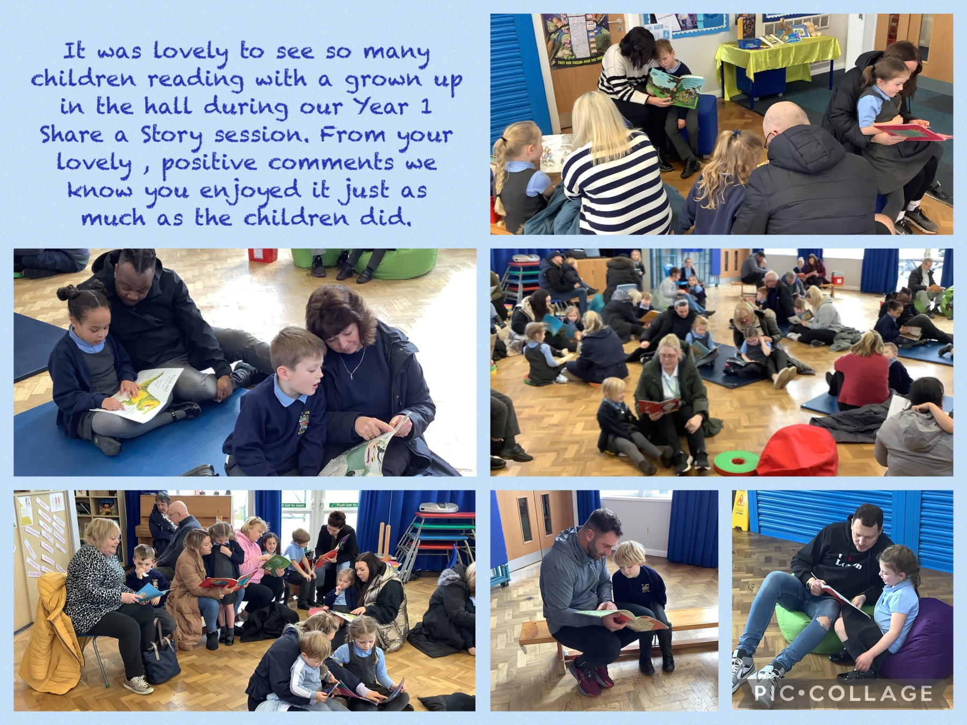


Eucharistic Adoration during Lent
During Lent we would like to offer children and their families the opportunity to spend some quiet time of reflection in front of the Eucharist at St Julie’s church. Fr Michael and children from each year group will lead the reflection each week from 3:30 – 4pm. Please take some time out from the hurly burly to come along:
Friday 10 March 2023 - Y4
Wednesday 15 March 2023 - Y3
Wednesday 22 March 2023 - Y6

St Julie’s Subject Ambassadors
The views of our children are essential in continuing to enrich our curriculum and our Subject Ambassadors play an important role in this. We would like to keep you informed of the work that the Ambassadors do with the Subject Lead of each curriculum area.
This week the Geography ambassadors met with Mrs Kernick:
Years 2-6 were represented by both Geography Ambassadors.
We discussed why geography is an important part of our school curriculum at St Julie. “Geography helps us find out more about our world, where things are and how our world works.”
The children were keen to share how geography links with their learning in other subjects such as history and science. “When we talk about different places in history, we use maps to find out where places are and how they have changed.” “Science and geography both help us to see how people are effecting our world and think about ways we can help to make good changes.”
All the children could remember key aspects of their geography learning this year “We looked at rainfall and temperature measurements to see why deserts are so dry.” “I liked learning about how mountains are made and that Mount Everest is 8848m tall.” “I have learned the names of the continents and oceans.”
The children recalled their learning in geography in other years and many of them said how interesting they found their learning about sustainability and earthquakes.
The children talked about the large world maps displayed in each classroom and how each class use them to help them learn more about where places are. They asked if there were any online games they could use to help them learn more about where places are in the world and Mrs Kernick said she would look into this.
Finally, we talked about possible ideas we could use to help us raise money to buy some new geography resources. At the moment these are top secret and we will talk about them more in our next meeting.

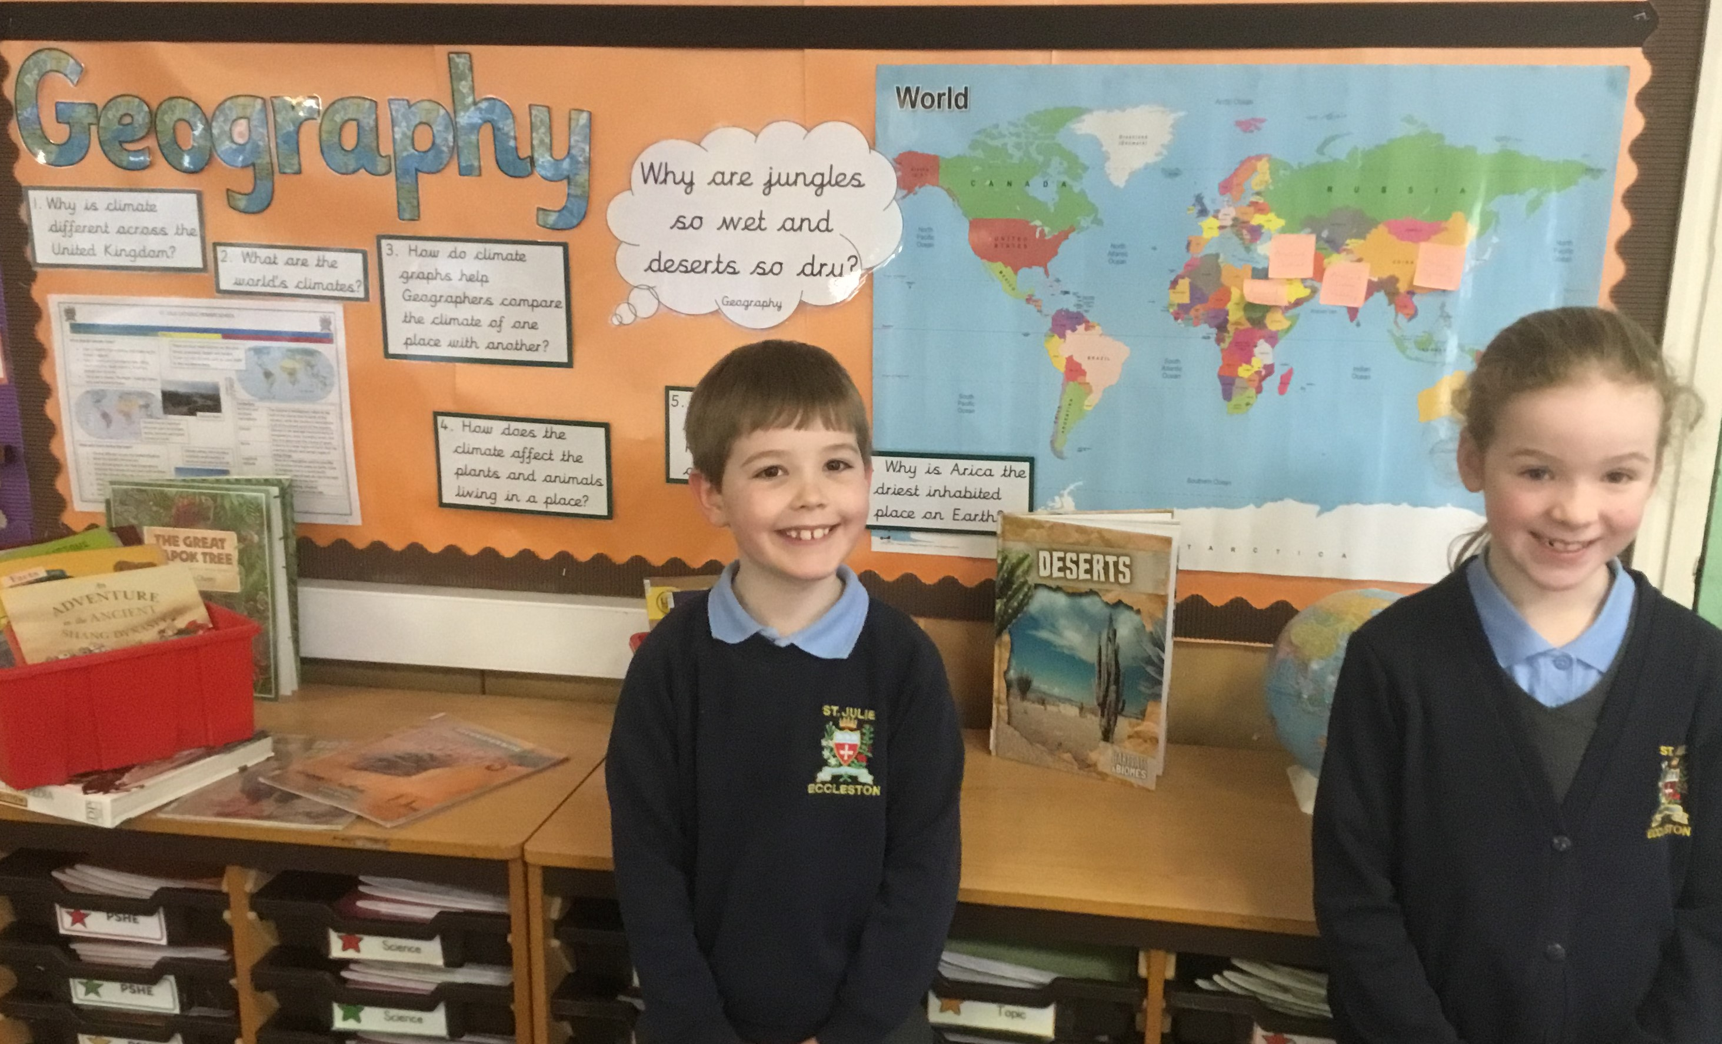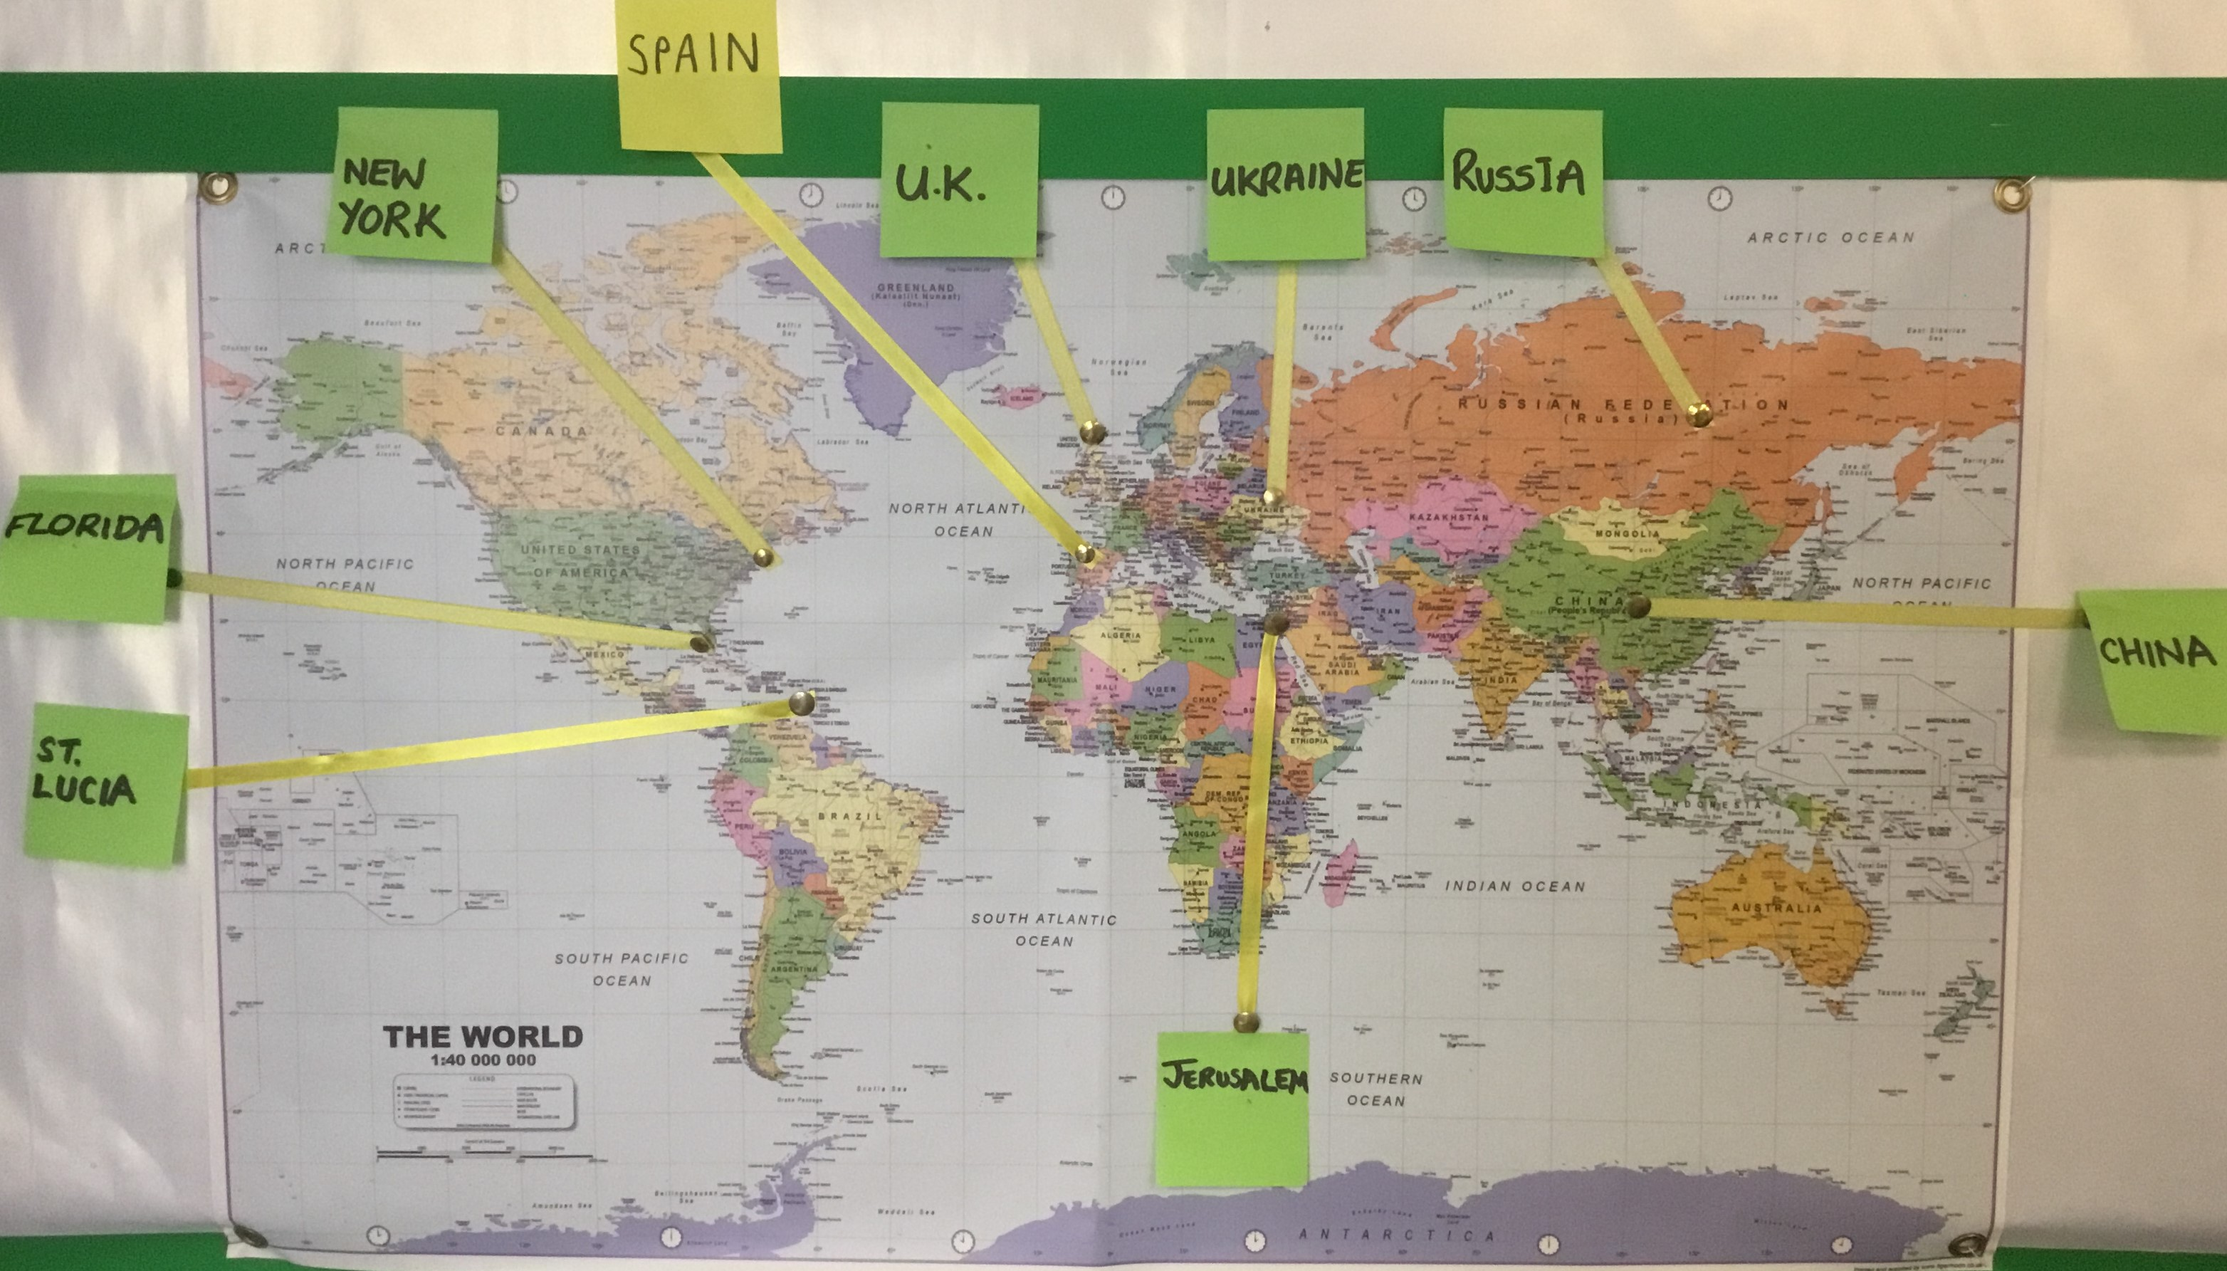


Do you use your science learning in your job?
Amongst the many activities planned for science week, Mrs McCahey our Science Subject Leader, would like to be able to offer the children across school the opportunity to hear about careers that people do that involve science. If you would like to come into school to talk about how you use science in your real-life job, please contact the school office. We would love to be able to inspire our children to take their science learning further and hear about how science can be useful in a future career.


St Julie’s Science Fair
We are delighted to announce our next Science Fair. This has now become a traditional part of St Julie’s Science Week. The event will take place over two afternoons:
KS1 & Early Years: Tuesday 21st March
KS2: Thursday 23rd^{th} March

The children are encouraged to investigate an area of science of particular interest to them at their age-appropriate level and present their findings to the school. Children may submit joint entries. Children are encouraged to present their investigations in a creative way.
The project is to be prepared at home. We welcome, and encourage, parental support. Please ensure that when helping your child that they have a good understanding of what they are doing and will be able to explain their project to other children and adults in school.

PLEASE NOTE: the science fair will take place in the hall immediately after the school day. Parents, grandparents and carers are more than welcome to attend to support their children and celebrate the wonderful work of our scientists.

Please complete the entry form sent home today and return to Mrs McCahey by Thursday 16th March.


School Building Works
Last June the Infant building had a new roof and now much needed work to replace the roof on the junior building is beginning. The roof will be replaced in phases beginning with Year 6 and Year 5, Year 3 and Year 4.
This work is mostly funded through the Archdiocese building fund which is made up of contributions from parents and carers in Catholic schools throughout the Liverpool Archdiocese.
Parents/carers are asked to contribute to this fund via the School Levy – a donation of £10 per family each year.
Many thanks to those who have already paid their contribution – if you haven’t, it will be showing on School Money.


Year 6 SATs Meeting
On Wednesday 22nd March, Miss Carr and Mrs Clayton will be holding a meeting for parents and carers in Year 6 to provide further information about the Year 6 Standard Attainment Tests (SATs) that take place during May. The teachers will go through what the tests entail, give you some examples of what questions your children will be expected to answer and talk about how both you as parents and us as a school can best support your children through this time. The meeting will be held in the classroom at 4:30pm and there will be an opportunity to ask questions.

Year 2 SATs Meeting
On Friday 24th March, Mrs Mannion will be holding a meeting for parents and carers in Year 2 to provide information about Year 2 Standard Attainment Tests (SATs) that take place during May. Mrs Mannion will go through what the tests entail, give you some examples of what questions your children will be expected to answer and talk about how both you as parents and us as a school can best support your children through this time. The meeting will be held in the classroom at 4:30pm and there will be an opportunity to ask questions.

Year 1 Phonics Screening Check meeting
On Friday 31 March, the Year 1 team will be holding a meeting for parents and carers of children in Year 1 to provide information about the about the Year 1 Statutory Phonics Screening Check that takes place in June. The teachers will go through what the Phonics check entails and talk about how both you as parents and us as a school can best prepare your children. The meeting will be held in the classroom at 4:30pm and there will be an opportunity to ask questions.


Excellent attendance at school is important to allow a child to fulfil their potential. I am confident in your support in ensuring that your child strives for 100% attendance each week.
Holidays during term time will not be authorised. Prior to the pandemic our whole school attendance for the year was 98% so this is the target we are aiming for this year.
Each week we will report on attendance figures for each year group.
Punctuality
Please make sure that you arrive at the school gates in plenty of time for your child to get to their classroom. Children are expected to be in class by 8.50am. Children arriving after 8:50am will be marked as “Late” in the register.

Year Group | % Attendance for w/e 10.03.2023
Year R | 95.93
Year 1 | 95.71
Year 2 | 94.86
Year 3 | 95.71
Year 4 | 98.33
Year 5 | 96.25
Year 6 | 93.71

Well done to Year Y4 who had the highest attendance this week with 98.33%. Fantastic!
Our whole school attendance this week is 95.79%


This week’s flyer from National Online Safety is, “What parents and Carers need to know about iPads.”

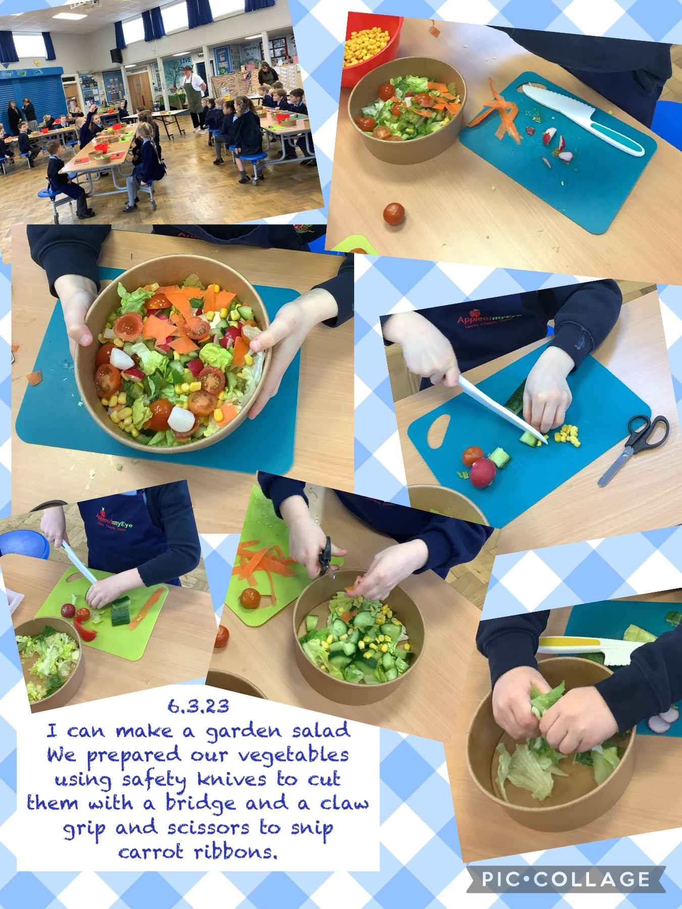

Practical Cookery Workshops
In line with the National Curriculum Design and Technology Programmes of Study for Food and Nutrition every class experiences a practical cooking session provided by “Apple of my Eye.” This week Year 1 enjoyed their cookery workshop and next week Year 2 will have their sessions on Monday 13th March.
We ask for a payment of £6.80 per child to cover the cost of instruction, equipment and ingredients which can be paid via School Money.


St Julie’s Awards of the Week

 | Star for showing core value of Love. | Book explorer | Marvellous mathematician
Reception | Teddy F | Easton M | Florence L
Year 1S | Zac T | Jaxon M
Year 1J | Mikey D |  | Josie K
Year 2 | Gabriella D | Thomas O | James K
Year 3 | Georgia M | Zachary C | Alexa D
Year 4 | Josie - Mo F | Bertie B | Elsie C
Year 5 | Sophia S | Daniel B | Lucas P
Year 6 | David B | Muhammed A | Matthew A



PFA Spring events

Friday 17th March - Junior Film afternoon 3:20 – 5:00
Friday 31st March – Coffee morning following Easter Passion Service - parents are invited into the school hall between 10.15 – 11.15am for refreshments in exchange for donations to the PFA.

Easter Bonnet Competition – All children are invited to take part in the Easter bonnet competition. Bonnets should be brought into school along with £2 per entry payment on Thursday 30th March for judging. Prizes will be awarded to the winners.

Infant Easter Colouring Competition - £2 per entry. Sheets will be sent home in due course in book bags with more information.
Junior Great British Bake Off – all cake entries to be brought into school Friday 31st March for judging – the cakes will then be served to the parents after the Easter Service (details above).

All Weathers Lottery The PFA is registered with ‘All Weathers Lottery’. Tickets are £1 for each line per week and you can purchase as many lines as you wish. The weekly draw takes place each Monday with a top prize of £25,000.
The PFA receives 50% of all ticket sales. Please see the link to sign up on your child’s class Teams page, and please share with family and friends. The more sales, the more money for the children.

Club Page  allweatherslottery.com | 

Diary w/c 13.03.23

MONDAY Year 2 Apple of my eye cookery session
Year 4 visit to Liverpool Philharmonic
Y3/Y4 Indoor Athletics 3:20 – 4:15
Y2/Y3 Inventors club 3:20 – 4:15

TUESDAY Year 6 Faith in Action day in school
Y4/Y5/Y6 Table Tennis 3:20 - 4:15
WEDNESDAY NEU strike day (Y6 open am only, Y4 and Y2 closed)
Y3/Y4/Y5/Y6 Craft club 3:20 – 4:15
Y3/Y4/Y5 Cheerleading 3:20 - 4:15
Y1/Y2 Construction club 3:20 - 4:15
Eucharistic Adoration led by Year 3 – 3:30 – 4pm

THURSDAY NEU strike day (Y6 open am only, Y4 and Y2 closed)
Y4 Lost in Music 3:20 – 4:15
Y1 Phonics play 3:20 - 4:15
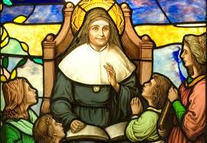
FRIDAY Year 3 Forest School
PFA Junior film afternoon 3:20 – 5pm

Further dates for your Diary
Tuesday 21 March Year 3 Apple of my eye cookery session
Tuesday 21 March World Poetry Day
Tuesday 21 March Year 4 Eccleston Library visit
Tuesday 21 March Infants’ science fair after school
Wednesday 22 March Eucharistic Adoration led by Year 6
Wednesday 22 March Lost In Music performance at the Town Hall
Thursday 23 March Junior Science Fair after school
Friday 24 March Year 2 visit to Eccleston Library
Friday 24 March Year 5 Forest School
Monday 27 March Year 5 Apple of my eye cookery session
Monday 27 March Year 1 Forest School
Tuesday 28 March Year 3 visit to Eccleston Library
Friday 31 March Passion Service led by Year 5 in Church 9:30am
Friday 31 March Year 1 Phonic Screening Check meeting 4:30pm
Friday 31 March School closes for Spring break
Monday 17 April School opens for Summer term
Friday 26 May School closes for half term break
Wednesday 7 June School reopens
Thursday 8 June Year 4 Sacramental meeting session 7 – 6pm in Church hall
Monday 12 June Year 6 Apple of my eye cookery session
Saturday 17 June Year 4 First Holy Communion Mass
Saturday 24 June Year 4 First Holy Communion Mass
Wednesday 19 July School closes for Summer break

“A caring family school, where we learn, grow and walk in the footsteps of Jesus.”

