Dear Parents/carers,


Year 4 First Holy Communion Celebration – Thursday 13th July
As a school community we will be gathering together to celebrate the First Holy Communion of our Year 4 class. Parents, family and friends are invited to share this celebration with us on Thursday 13th July at St Julie’s Church at 9:30am. The children will wear their school uniform.

A reminder that Sunday Mass is at 9:30am at St Julie’s Parish Church every week – Fr Michael would love to see our children at the Mass with their families.

Year 6 De La Salle Transition week
Next week our Year 6 pupils who will be joining our feeder high school, De La Salle, in September will be spending the whole week in their new school. There is a mixture of excitement and nerves from the children but we wish them a happy time next week as they have a taste of the lessons and get used to their surroundings.

New intake for Reception September 2023
Next Wednesday we will welcome our new starters for Reception in September as they come to school for a stay and play session with Mrs Ashcroft.

Year 2 Transition meeting
There will be a short transition meeting for current Year 2 parents as their child leaves the infants to start the juniors. The meeting will be in the Year 3 classroom on Thursday 13th July straight after school. The teacher will explain the Junior routines and expectations and how you can help to prepare your child for Year 3. The children will be looked after in the hall while the meeting takes place.

End of Year reports
School reports will be sent out on Monday 10th July to provide you with an overview of your child’s achievements and progress over this academic year. If you have any questions or comments we will be holding our drop-in Open Evening after school on Tuesday 11th July from 3:20pm until 4:15pm.


Music Tuition performances
Mr Gaynor and Mrs Wellens who have been providing instrumental tuition in school this year invite parents/grandparents to a short performance in school on Tuesday 4th July at 2:45pm in the school hall.
The Year 4 children who have been learning to play a string instrument this year invite their parents/grandparents to watch their performance on Thursday 6th July at 3pm in the school hall.

St Julie’s Care Club – Summer club
The Care Club are running a Summer Club in school for 3 weeks of the school holidays starting Monday 24th July until Friday 11th August. Full details are on the flyer sent with this bulletin. The deadline for bookings is Friday 14th July.

Live Simply Art Competition
Thank you so much for the amazing entries for this competition. The artwork was a wonderful reflection of God's beautiful world. When judging a competition, it is often said how difficult it is to select a winner - this was most certainly the case, given the amazing standard of entries. However, we are delighted to announce that Charlotte in Reception was awarded first prize for her beautiful butterfly photograph.

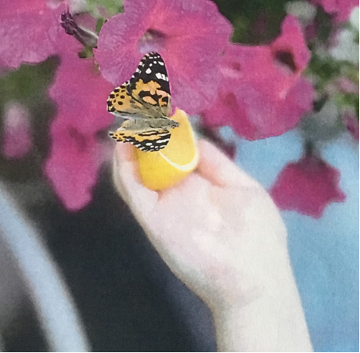


Live Simply Fair-Trade competition
KS2 have looked at the work of Fair-Trade in assembly and how we can 'Live in solidarity'. To promote Fair-Trade, could we ask families to swap ONE item on their shopping list to a Fair-Trade product. To encourage this, KEY STAGE 2 children have been asked to bring in a photo of themselves at home, holding a Fairtrade product. These will be entered into a raffle for a prize.

St Vincent de Paul (SVP) shop is open
The first SVP charity shop in St Helens is now open at 175 Cambridge Road, WA10 4HA selling good quality clothes and goods. The shop is open from 9 – 5pm, Monday to Saturday.


Year Group | % Attendance for w/e 30.06.2023
Year R | 96.07
Year 1 | 98.29
Year 2 | 98.29
Year 3 | 97.71
Year 4 | 98.06
Year 5 | 94.55
Year 6 | 96.00

Well done to Years 1 and 2 who had the highest attendance this week!
Our whole school attendance this week is 97.00%

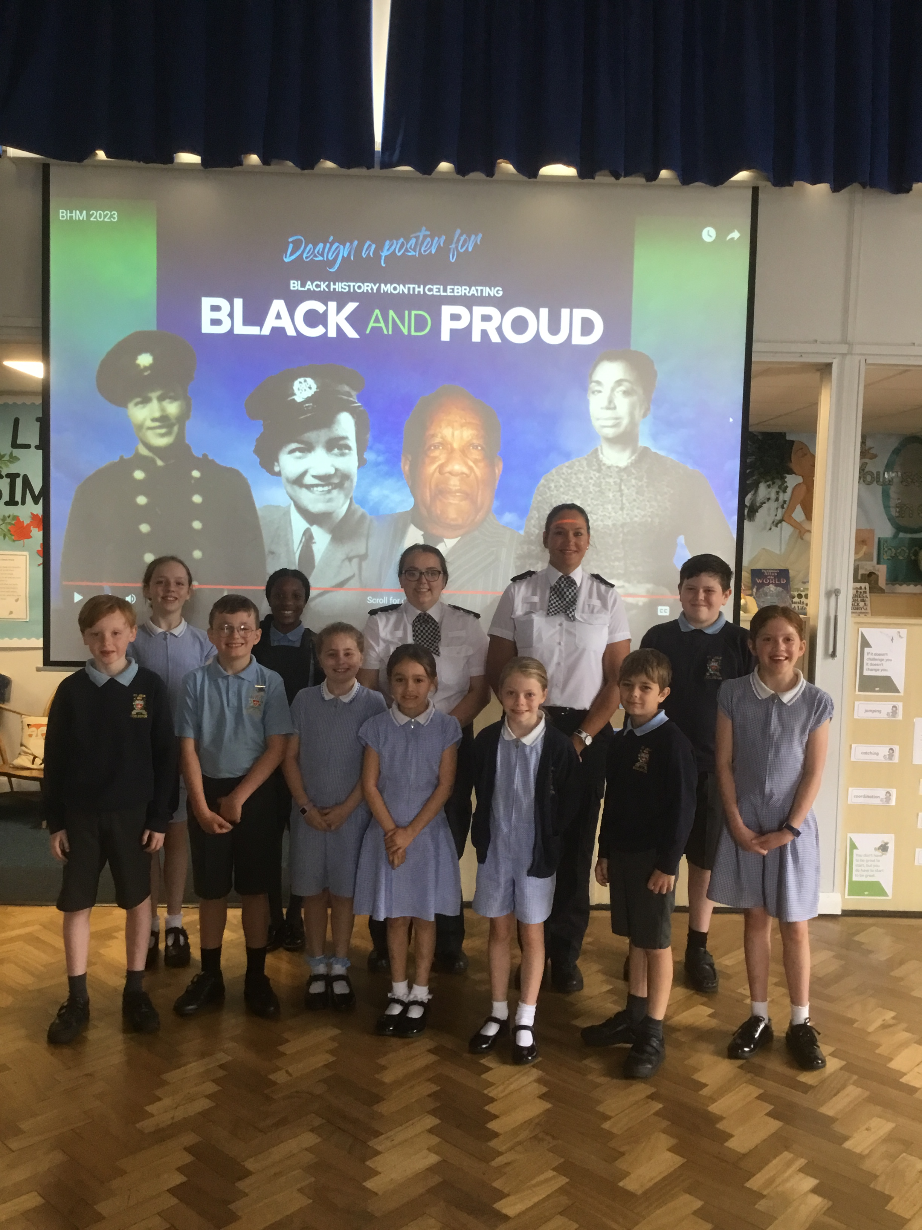

Black and Proud – visit from Merseyside Police
On Tuesday 2 Merseyside Police Officers delivered an assembly to the whole school to promote a competition been run ahead of Black History month in October.
This year’s Black history month Art competition is “BLACK AND PROUD.” The competition has been organised jointly by Merseyside Police and partners spanning the 5 boroughs of Merseyside (St Helens, Wirral, Sefton, Liverpool, Knowsley) and is supported by the International Slavery Museum Liverpool.
Primary school pupils from across Merseyside are invited to design a poster to celebrate Black History.
The wining school from each borough will have the artwork branded on Police vehicles across Merseyside and a tour of the International Slavery Museum with the winning artworks been displayed at the museum.
The children at St Julie’s will be working on their designs during Arts Week.


This week’s flyer from National Online Safety is about: “Amino.”

St Julie’s School Values
Whilst the children know that each of our core values helps us to follow in the footsteps of Jesus, each half term we focus particularly on one of the core values. This half term we are thinking about hope:
Hope is something we show through positive aspirations in our learning and friendships. We always aim to be the best we can be.

St Julie’s Awards of the Week

 | Star for showing core value of hope. | Book explorer | Marvellous mathematician
Reception | Sophie P | Caleb B | George H
Year 1S | Callum F |  | Theo H
Year 1J | Luke H | Thea W
Year 2 | Bobby B | Callum F | James K
Year 3 | Max H | Harrison M | Jasmine H
Year 4 | Zak P Tommy D | Robert E | Poppy T
Year 5 | Lucas P | Charlie L | Bella M
Year 6 | Isla B | Louie L | Rosie Mc

Diary w/c 03.07.23 Arts Week

MONDAY De La Salle transition week for Year 6
Summer crafts club 3.20 – 4.45 pm

TUESDAY 2:45 Children’s Guitar and Keyboard performance in hall for parents (Schools Music Service)
Multi Sports - Years 3,4,5,6 3.20 – 4.15 pm

WEDNESDAY Strike day: Year 2 and Year 4 closed all day. Y6 remaining at St Julie’s collect at 12
New intake for Reception September 2023 visits
Year 3 Forest School
Cheerleading Years 3,4,5,6 3.20 – 4.15 pm
Sewing Year 3 & Year 5 3.20 – 4.15 pm
Computing club Year 1 3.20 – 4.15 pm
PFA meeting 6pm in school: planning for next year

THURSDAY Year 5 trip to Blue Planet Aquarium
3pm Year 4 strings performance for parents in hall
Computing Group Year 2 3.20 – 4.15 pm

FRIDAY Strike day: Year 2 closed all day. Y6 remaining at St Julie’s collect at 12
Year 4 trip to Chester

Further dates for your Diary
Monday 10 July Year 1 Collective Worship
Tuesday 11 July Year 6 Forest School
Reception class collective worship
Open night 3:20 – 4:15pm
Wednesday 12 July Year 4 Forest School
Reception trip to Greenacres
Thursday 13 July New intake for September: Teddy Bears’ Picnic 9:30 – 10:30am
Year 5 Forest School
Year 6 Leavers’ Celebration event 2:00pm (Parents and grandparents)
Year 2 Class collective worship 3pm
Year 2 transition meeting 3:30pm in Year 3 classroom
Friday 14 July Year 6 multi-sport festival at Ruskin
Year 1 Forest School
Year 2 trip to Southport Eco Centre
Monday 17 July Year 6 Leavers’ Mass 6pm
Wednesday 19 July School closes for Summer break

“A caring family school, where we learn, grow and walk in the footsteps of Jesus.”

