Dear Parents,

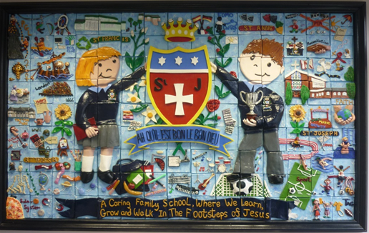
Welcome Back!
A very warm welcome back to school, I hope you had an enjoyable summer. The children all look refreshed and have made a great start to their learning and the staff are all excited about the wonderful opportunities ahead of us this year.
We would like to give a big welcome to all our Reception children who started their St Julie’s journey on Tuesday and have been staying until after their lunch. They all looked smart in their new school uniforms and settled well in their new classroom. We are looking forward to seeing the children again next week when they attend full time.

St Julie’s school mission and core values
In assembly this morning we started the school year by reviewing our school mission statement and core values with all staff and children. Everyone agreed that our mission statement, “A caring family school where we learn, grow and walk in the footsteps of Jesus,” is lived out every day in our school and truly reflects how we treat each other. We also thought about how our six core values guide our footsteps:


During the school year we will focus on one of our core values each half term starting with Respect. Our Star of the Week award will be for a child in each class who that week has shone brightly for showing Respect.
Over the week we have also been talking about how we can show that we are “smart and ready for Learning.” This begins with us being on-time for school and in school every day and wearing our correct uniform. The picture shows you the other important actions we discussed. Ask your child what they mean…

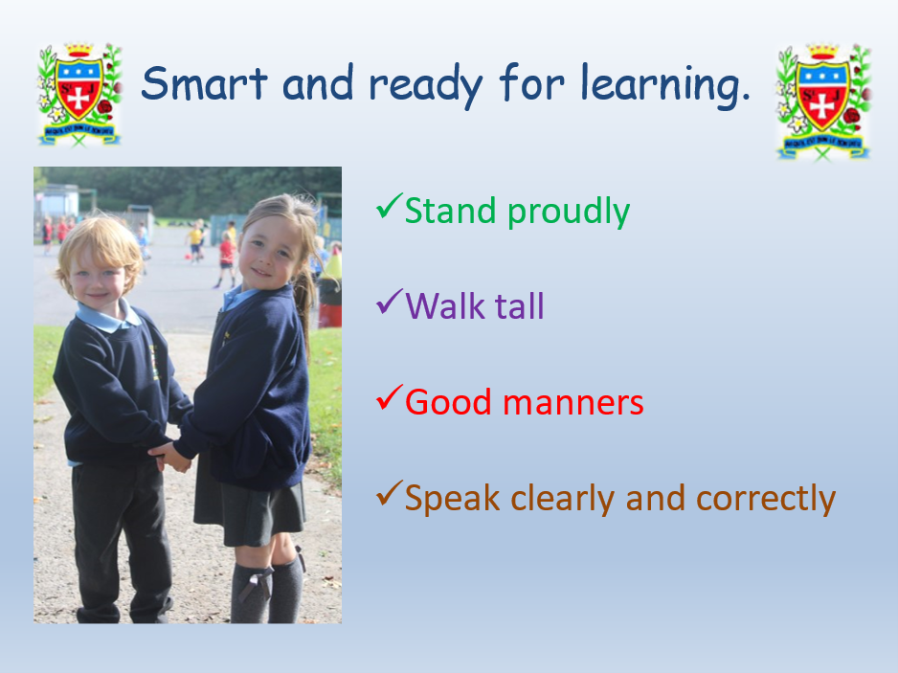

Start of the year reminders:

Earrings A reminder that earrings CANNOT be worn in school. If a child is wearing earrings or any other form of jewellery they will be asked to remove it for health and safety reasons. A message was posted in the July bulletin that if a child is having their ears pierced, we advise that this is done at the start of school summer holiday so that the ears are sufficiently healed to enable earrings to be removed for school. Thank you.

Pre-loved St Julie’s uniform
A reminder that we have many items of pre-loved school uniform in school. If you require any pieces of uniform please call at the school office where we have uniform sorted into age groups. If you can, a small donation of any amount would be useful for school funds.

School lunch changes
A reminder that the school catering staff ask for 2 weeks’ notice of a change from packed lunch to hot meal or vice versa.

Packed lunches
For children having a packed lunch I encourage you to not send in too much food. We are a Healthy School and so a sandwich/wrap, fruit and one small treat is sufficient. Children can bring in a healthy snack for break times and infant children continue to receive milk and fruit.


Food Allergies
Please take care not to include nut based products in lunch boxes as we have several children in school who suffer from nut allergies. We encourage the children to bring a healthy snack of fruit or toast for break time (no cereal bars please). If your child is bringing grapes, please ensure that they are sliced down the middle lengthways.


Water bottles
Please remember to send a water bottle in to school with your child so that they can remain hydrated throughout the day. Juice is not permitted.

Asthma inhalers
Forms have been given out to those children who we have been notified use an inhaler. Please update the form for this year and return to school as soon as possible. If your child no longer uses an inhaler please inform school so we can remove them from the register.
Administering medicine in school: If children do need prescribed medication to be given whilst in school it can be administered providing the correct paperwork is completed which is available from the school office. However, school cannot administer the first dose of any medication due to potential allergic reactions. Only prescribed medication can be administered in school.


Tissues
We would be grateful if every child could bring in a box of tissues for their class. These will be kept as a stock by the teacher to get us through the year. Bless you!!

Please ensure names are in all school uniform – it is extremely difficult to find lost items if there are no names in them.


Year Group Meetings for parents
As we start the new school year you are invited to attend a meeting led by the class teacher to outline the approach to teaching mathematics and reading for the year group and how you can support your child in their reading journey. We believe that children should have access to as many reading opportunities as possible, to read widely and deeply, and that being read to should continue throughout primary school so that all children can experience the sheer joy of reading, read books with powerful themes, books by modern authors as well as great works of literature.
The meetings will be held in your child’s classroom and should last no longer than 30 minutes. It would be great if all children are represented by an adult attending and you will have the opportunity to ask questions:

Tuesday 13th September 4:30pm Year 6
5:00pm Year 1

Wednesday 14th 4:30pm Year 4

Thursday 15th 4:30pm Year 2
5:00pm Year 5
The Year 3 meeting will be held the following week – date to be confirmed. The Reception class meeting will be held on Thursday 21st September.


The PFA AGM will be held in school on Wednesday 20th September at 6pm in school.
A nomination letter for roles of Chair, Secretary and Treasurer has been attached with this bulletin and paper copies are available from the school office. Please complete and return to school by Friday 15th September.
Please come along on the evening of 20th September at 6pm to find out what the PFA is all about – they are always looking for support in any way you can and for fresh ideas. All are welcome!

Home School Agreement
Home School Agreements will be sent out during the week. Please ensure that you read it and that you also share it with your child as these form part of our behaviour policy. Once read, please sign the agreement and return it to school. Thank you.

As some of our parents may be aware our friends at Bleak Hill School very sadly lost one of their Year 6 pupils over the summer holidays – his name was Harry Cardwell and he was 10 years old. We do have staff and parents from St Julie’s that have been personally affected by this tragic loss and to show our support we would like to share with you a link to the “Harry Cardwell Star Tribute Fund” which has been set up to raise funds to go towards various things in memory of Harry. Please use the link below which gives more information on how to donate. Our thoughts and prayers are with the family.

https://harrycardwell.muchloved.com

Instrumental Tuition at St Julie's Catholic Primary School for Junior children.
A message from the Schools Music Service:
We are delighted to let you know that The Schools Music Service will be returning to provide instrumental music tuition in your school from this term onwards.
We currently offer classes on clarinet, flute, guitar, keyboard and violin in school, in small group half hour sessions, during the school day.
It is our belief that music greatly enriches the life of a child, both academically and socially.
If you would like more information about classes here is a link to our website where you can see how everything works - www.schoolsmusicservice.co.uk
If you know what instrument your child would like to learn, or you have learned with us before, you can register for classes on our website and I will sort everything out for you.
Please watch our short video for more information.
Also, if your child has had music tuition with us in the previous academic year, please ensure that you have made a new application for this year's tuition to put them back onto the teacher's pupil list.
Our teachers are extremely excited to be coming back to your school and we look forward to meeting you all soon.


Punctuality
Thank you to all those parents/carers and grandparents who have ensured that the children are in school on time this week; we have had very few late marks this week.
The children can come in from 8:40am but MUST be in their classroom for 8:50am when the register is called.
From next Monday if your child is marked as late, you will receive a text reminder about being in school on time.


Attendance
Excellent attendance at school is important to allow a child to fulfil their potential. I am confident in your support in ensuring that your child strives for 100% attendance each week.
Holidays during term time will not be authorised.
Each week we will report on attendance figures for each year group.

Year Group | % Attendance for w/e 08.09.23
Year R | 97.98
Year 1 | 93.30
Year 2 | 100.0
Year 3 | 97.14
Year 4 | 97.50
Year 5 | 99.65
Year 6 | 98.48

Well done to the children in Year 2 who have made a fantastic start to the new school year!
I am delighted to say that our whole school attendance this week is 97.72%




St Julie’s Awards of the Week

 | Star for showing Respect | Book explorer | Marvellous mathematician
Year 1 | Easton M | Caleb B | Charlotte C
Year 2 | Ella W | Penelope W | Joel R
Year 3 | Olivia P-A | Fraser W | Freddie R
Year 4 | Thomas B | Molly T | Benji L
Year 5 | Archie H | Ivan W-S | Alexander F-P
Year 6 | Kai B | Daniel H | Lucy F

After School Clubs
Our programme of after school clubs for Year 1 up to Year 6 will begin week commencing Monday 18th September. A full list of clubs available will be sent home next week for you to sign up to.

Diary w/c 11.9.23

Monday

Tuesday 4:30pm Y6 Parent Reading Meeting
5:00pm Y1 Parent Reading Meeting

Wednesday 4:30pm Y4 Parent Reading Meeting

Thursday Year 4 swimming lesson
4:30pm Y2 Parent Reading Meeting
5:00pm Y5 Parent Reading Meeting

Friday

“A caring family school, where we learn, grow and walk in the footsteps of Jesus.”


St Julie pray for us, protect us and bless us.

