Dear Parents,

Year Group Meetings
Thank you to all those parents/carers who were able to attend the curriculum information meetings held in classes this week. For those who were unable to make it, the teachers have put the Powerpoints used on the class Teams page and on the website on the relevant class page. If you have any further questions please email or phone the school office.


Reception class Reading Meeting
Parents/Carers are invited to attend a meeting led by the class teacher to outline the approach to teaching reading and how you can support your child in their reading journey. We believe that children should have access to as many reading opportunities as possible, to read widely and deeply, and that being read to should continue throughout primary school so that all children can experience the sheer joy of reading, read books with powerful themes, books by modern authors as well as great works of literature.
The meeting will be held in the classroom on Thursday 21st September at 4:30pm. It is essential that all children are represented by an adult attending and you will have the opportunity to ask questions.

The Year 3 Year Group Meeting will be held in the classroom on Thursday 21st September at 5:00pm.


The PFA AGM will be held in school on Wednesday 20th September at 6pm in school.
As I have said before, our school receives one of the lowest budgets in St Helens due to the area we are in so we do rely heavily on funds raised by the PFA for additional resources and funding of activities for our children. We really do need your help!
Please come along on the evening of 20th September at 6pm to find out what the PFA is all about – they are always looking for support in any way you can and for fresh ideas. All are welcome!

After-school clubs
From next week we will begin our programme of after-school clubs. A letter was emailed with a list of the clubs on offer this half term. The clubs are run voluntarily by staff so please be aware that clubs may need to be cancelled at short notice if for any reason the member of staff is not available. We do not run clubs for Reception children as we feel the school day is long enough for them at this time.
The cost of each club is £4.00 per session and must be paid on School Money – it can be paid in instalments, but you must have paid before each session for your child to be on the register for the club. Where clubs have a set limit of children who can safely attend and are oversubscribed, your child may be given a turn at a later date. The clubs we offer are determined by the goodwill/availability of volunteers to run them. Payment must be received before your child can start the club. All children must be collected on time by an adult from the school foyer.
Please see the weekly diary below for details of each club.


Young Voices
The Young Voices club is led by Mrs Kernick during which the children learn a range of different songs and actions ready for a performance on 6th February 2024 at the Manchester Arena. On the day of the performance the children will leave school at lunch time by coach for a rehearsal along with other schools from across the North West who make up the choir, before the performance at 7pm in the evening and then be returned to school at around 10pm. Family will be able to buy tickets to watch the evening performance if they wish to come along. It is a fantastic opportunity for the children to sing and perform as part of the largest children’s choir in the world – and makes a cherished memory for all those who take part.
Mrs Kernick has asked me to mention that although the club is currently running on a Monday it may need to change to a Wednesday in the future depending on family commitments.


Tissues
We would be grateful if every child could bring in a box of tissues for their class. These will be kept as a stock by the teacher to get us through the year. Bless you!!

Instrumental Tuition at St Julie's Catholic Primary School for Junior children.
A message from the Schools Music Service:
We are delighted to let you know that The Schools Music Service will be returning to provide instrumental music tuition in your school from this term onwards.
We currently offer classes on clarinet, flute, guitar, keyboard and violin in school, in small group half hour sessions, during the school day.
It is our belief that music greatly enriches the life of a child, both academically and socially.
If you would like more information about classes here is a link to our website where you can see how everything works - www.schoolsmusicservice.co.uk
If you know what instrument your child would like to learn, or you have learned with us before, you can register for classes on our website and I will sort everything out for you.
Please watch our short video for more information.
Also, if your child has had music tuition with us in the previous academic year, please ensure that you have made a new application for this year's tuition to put them back onto the teacher's pupil list.
Our teachers are extremely excited to be coming back to your school and we look forward to meeting you all soon.
Music lessons will commence during the week beginning 25th September.

Music Ensemble
St Helens Council Music Service are delighted to share their range of ensemble for 23/24 that they continue to provide FREE for all students who live in the Borough. Any students that learn a musical instrument, from the real beginners right through to the more advanced musicians are welcome. The Vocal Group on Tuesdays is open to any student who enjoys or would like to explore singing. Please see the attached flyer for dates and full details.
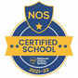

This week’s flyer from National Online Safety is about: “Top tips for setting boundaries around gaming.”

Home School Agreement
Home School Agreements have been sent out. Please ensure that you read it and that you also share it with your child as these form part of our behaviour policy. Once read, please sign the agreement and return it to school. Thank you.

Sports Ambassadors
Mrs Clayton, our PE subject leader, met with the Sports Ambassadors this week for the first meeting of the new school year. They discussed ways to make our playtimes more active and how to get children more active outside of school. We will keep you updated with how their ideas develop over the next few weeks. The week commencing 25th September is Cycle to School Week so the ambassadors will be involved in a KS2 assembly to promote active travel.
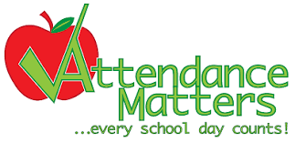
Attendance
Excellent attendance at school is important to allow a child to fulfil their potential. I am confident in your support in ensuring that your child strives for 100% attendance each week.
Holidays during term time will not be authorised.
Each week we will report on attendance figures for each year group.

Year Group | % Attendance for w/e 15.09.23
Year R | 100
Year 1 | 97.86
Year 2 | 100
Year 3 | 99.71
Year 4 | 99.43
Year 5 | 98.89
Year 6 | 99.41

Well done to the children in Year R and Year 2 who have made a fantastic start to the new school year!
Our whole school attendance this week is 99.33%




St Julie’s Awards of the Week

 | Star for showing Respect | Book explorer | Marvellous mathematician
Year 1 | Henry H | Florence L | Arthur K
Year 2 | Daniel R | Theo H | Hugo H
Year 3 | Jaxon C | Darcey C | Sam B
Year 4 | Alexa D | Ryan G | Aveah D
Year 5 | Mia P | Bertie B | Matilda W-S
Year 6 | Atarah M | Lucas C | Eleanor F

Diary w/c 18.9.23

Monday Y1/Y2Multi-sports club 3:20 – 4:15
Y5/6 Young Voices choir 3:20 - 4:15

Tuesday KS2 Multi-sports club 3:20 – 4:15

Wednesday NHS Heights and weight in school – Reception and Y6
Y2 Computing club 3:20 - 4:00
Y1 Lego/Construction club 3:20 - 4:15
KS2 Sewing club 3:20 - 4:15
6pm PFA meeting and AGM

Thursday Year 4 swimming lesson
KS2 Cheerleading 3:20 - 4:15
4:30pm Reception Parent Reading Meeting
5:00pm Y3 Parent Year Group Meeting

Friday

Primary School Admissions
The website will open for parents who wish to apply online: www.sthelens.gov.uk/admissions on 18th September 2023.
Children who turn 5 between 1 September 2024 and 31 August 2025 are eligible to apply for a place in primary school. The deadline for submission of primary school applications is 15 January 2024. The Archdiocese have asked us to remind parents seeking a reception class place at our school, even if you have a sibling in the school, of the need for baptism prior to application and to take prompt action if baptism has not already taken place.

Secondary School Admission
Children in Y6 should apply for a secondary school place by 31 October 2023. This year application forms have been given out via school. They should be completed and returned to school: they will then be passed to the School Admissions Section at St Helens Council.

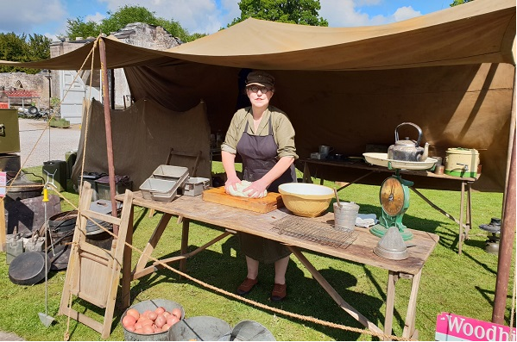
Heritage Open Days: The Smithy Heritage Centre in Eccleston, 16th & 17th of September
“To tie in with the current exhibition about Stefan Skura the Polish soldier who settled in the local area we will be looking at all things WW2 on Saturday the 16th with Frank and Angela of the Pegasus WW2 display team who will be setting up a WW2 kitchen and you can taste the food that they make.
Sunday the 17th we will be celebrating all things Polish and especially remembering Wojtek the bear
https://edencamp.co.uk/blog/forgotten-friday-the-bear-soldier-of-the-second-world-war/

With the support of Merseyside Polonia and John Paul the ll Polish School in Liverpool there will be storytelling, free family craft activities and we are holding a teddy bears picnic in honour of Wojtek, so, we are encouraging children to come along with their own teddy bear for the event.
The Sunday will also see the return of The Great Eccleston Bake Off which will be judged once more by the ladies of St Helens Women's Institute.”
Opening times for both days is 12 - 5pm
More information is available at smithyheritagecentre.org.uk



