
Remembrance Day
Our children have spent the last week learning about and reflecting on the sacrifices made by so many brave men and women during times of conflict. In school they have completed lots of different activities, thoughtful poems, artwork and writing and have created some lovely poppy displays. This morning Year 5 had a visit from Kevin Dyer, the new creative writing tutor for the Library Service’s Arts team. After a reading of ‘In Flanders Fields’ by John McCrae the children wrote their own war poems and diary extracts. Some of the children chose to read aloud their work which showed great emotion and empathy. The Reception class had their own Remembrance Service in the school grounds, proudly holding their poppies:

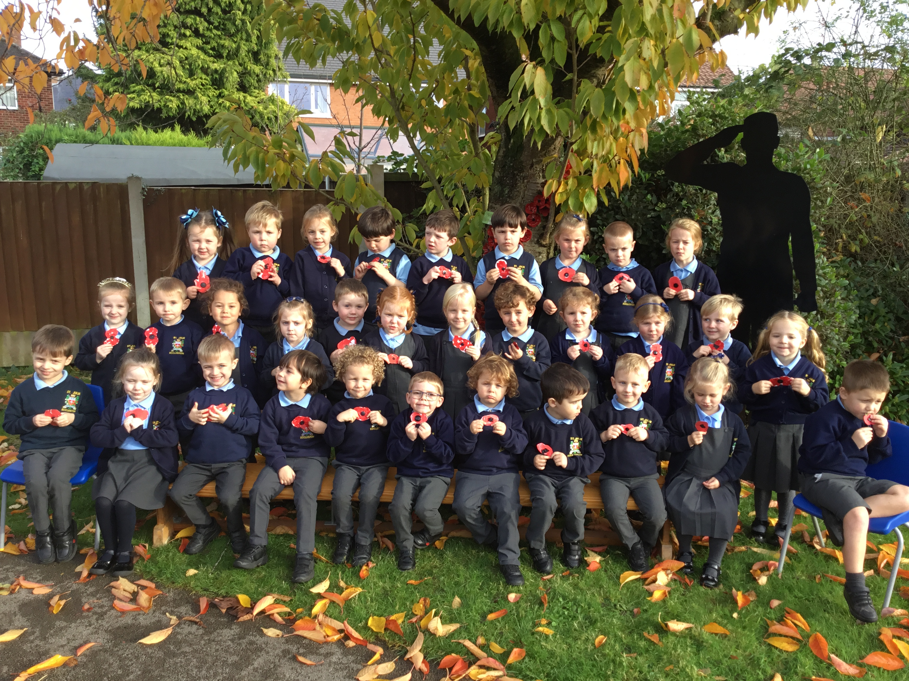

November is the month of the Holy Souls
Traditionally, during the month of November, we remember and pray for those who have died and gone before us. Thank you to those who have sent in the name of their loved ones which have now been included in our Remembrance Book for the month of November. The Remembrance Book will be taken up to the altar with the Offertory on Sunday at Mass and also during the Class Mass for Years 3 and 6 next Thursday.
The Royal British Legion Poppy Appeal
We still have poppies, wristbands, reflectors, zip pulls and snap bands available from the school office for a donation of £1 per item in aid of the Royal British Legion poppy appeal.

Faith In Action
On Thursday this week Year 6 went to De La Salle to launch their journey on achieving the Faith In Action award. During the year the children will be reflecting on how they live out our St Julie’s Core Values and our mission of following in the footsteps of Jesus and recording the activities and actions they have taken.


Anti-bullying week – wear Odd Socks to school on Monday
Next week is national Anti-Bullying Week 2023 and the theme this year is: Make a noise about bullying.
We will start with Odd Socks Day to mark the first day of Anti-Bullying Week. The children are encouraged to wear odd socks to school on Monday to highlight that we are all unique and that it is good to be different.
Parents can join in too!
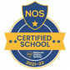
The “Make a noise about bullying,” theme will involve activities to encourage young people to consider what bullying means to us, how banter can turn into something more hurtful, and what we can do to stop bullying – how each of us should make a noise and speak out about face to face bullying and bullying online. From the playground to Parliament, we know we won’t always get along with everyone and we don’t always agree, but we can choose respect and unity – out St Julie’s core values.

This week’s flyer from National Online Safety is about: “What parents & carers need to know about how to combat online bullying.”

Children in Need
The children are invited to come in wearing spots on Friday 18th November in return for a donation for Children in Need to be made via School Money. The amount can be overtyped to allow you to donate what you feel is appropriate. This will be set up from next Monday. Spotty accessories with their school uniform may be worn: Pudsey ears, spotty ties, spotty tops, socks, bows etc. School shoes must be worn – no boots or trainers.
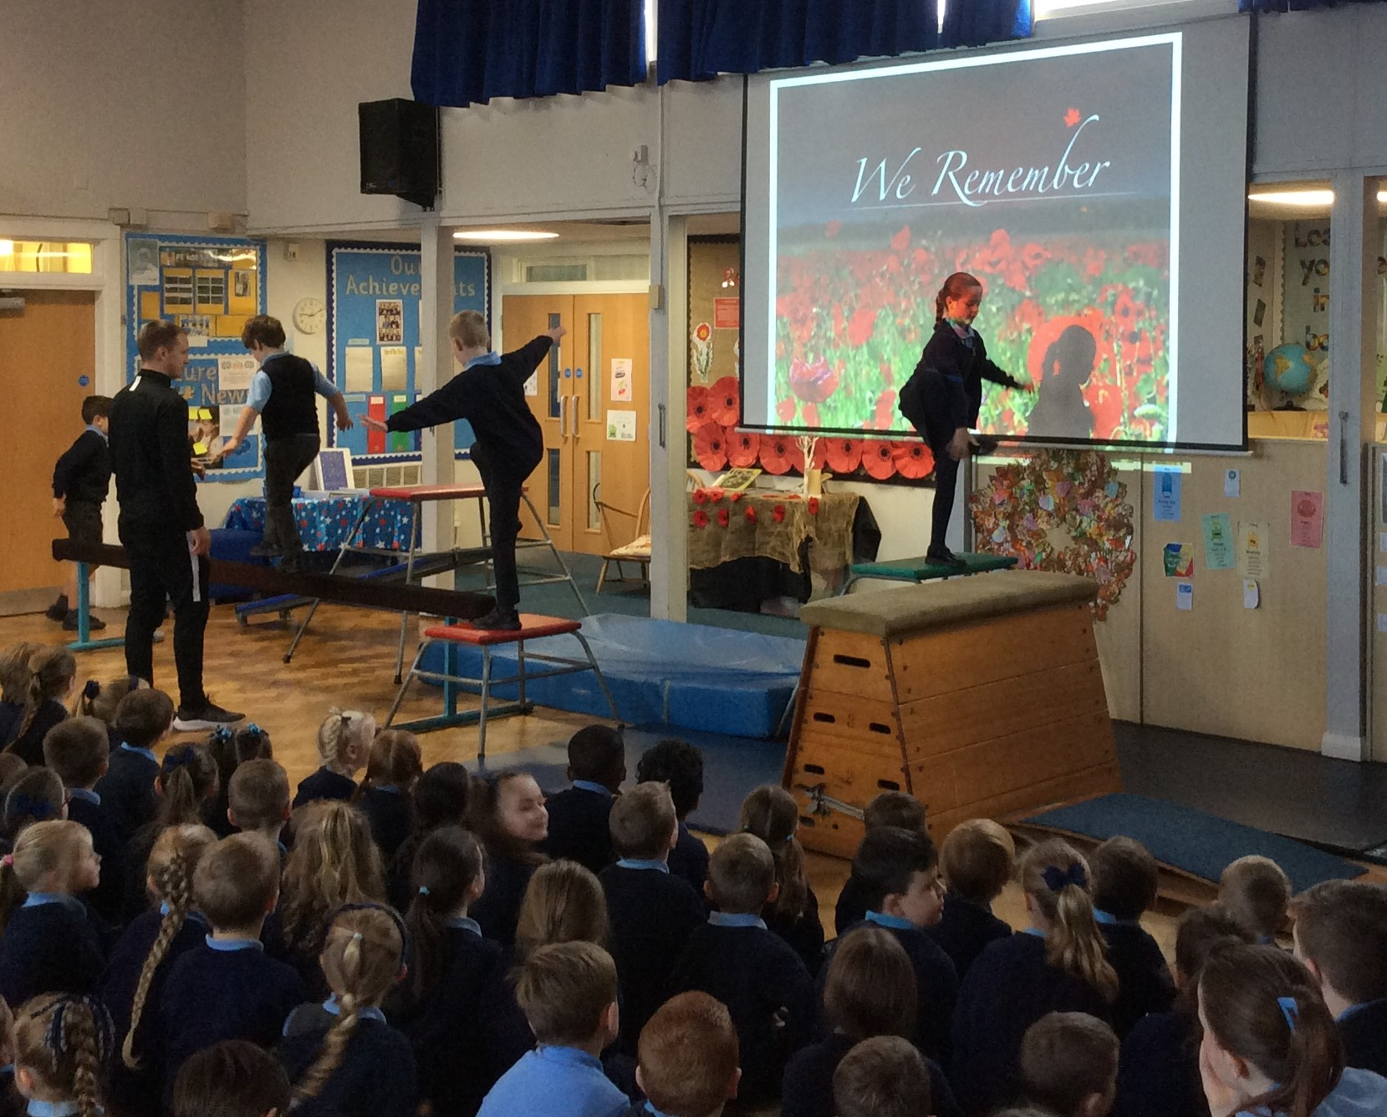
New gymnastics club
This week saw the start of our gymnastics clubs before school provided by Gilchrist Sports Coaching. The children who came along had a fantastic time as they used a wide variety of equipment to develop their skills and improve their fitness - all accompanied by pop music for a lively start to their day!
Some of the children provided a demonstration with Mr Gilchrist in assembly this morning. There are still some places available for both sessions:
Monday 8am for Years 1, 2 and 3.
Wednesday 8am for Years 4, 5 and 6.
Please see the flyer attached for details of how to sign up and pay.


School Photographs - Monday 27th November
The school photographer will be coming into school on Monday 27th November to take photographs of the children. All children will have their photo taken for our school Sims system. The photographer will take individual photographs of each child and also group photos of siblings but you are not obliged to purchase a photograph.
Proof copies of the photographs along with an order form will be sent home as soon as they are available.


Year 2 Nativity and Christmas Carol Services
Everyone is invited to join us in St Julie’s Church for the performance of the Nativity by Year 2 on Wednesday 20th December at 2pm. The whole school will be joining in with the Carols and the traditional retelling of the birth of Jesus, bringing us the true meaning of Christmas.
The other classes will each be performing a carol service in the school hall, dates as follows:
Wednesday 6th December 2:45pm - Year 4 with strings

Thursday 7th December 2:50pm – Year 6
Monday 11th December 2:50pm – Year 3
Tuesday 12th December 2:50pm – Year 5
Wednesday 13th December 2:50pm – Year 1
Thursday 12th December 2:50pm – Reception


Christmas Jumper Day – Friday 8th December
Children grow so quickly that often a Christmas jumper is only worn a couple of times before a child has outgrown it. To help reduce costs at what is a very expensive time of year we would like to be able to offer pre-loved Christmas Jumpers from the school foyer. If you have a Christmas jumper in good condition, please could you send it into school, washed and with a hanger – these will then be available to take from the school foyer for a small donation. Thank you.


PFA News – please also see the PFA November newsletter attached.
Thank you to all those who came to the Autumn fair. The total amount raised was a fabulous £599.50!
We are working towards purchasing 20 new iPads for the children with cases and a charging trolley which will cost £6,600.00.
With funds raised from Summer events and last half term’s events, the PFA have raised a total of £4,600.00 so far. We are so close to that target and it would be wonderful to be able to buy the children the new iPads in January 2024.
So we need your help to make our Christmas events a huge success…


The PFA would be grateful for donations of chocolate for the Christmas Bingo taking place on Thursday 30th November and bottles for the Christmas fair.
On Friday 24th November we will be holding an “own clothes” day in return for a donation of chocolate and/or a bottle.

This term’s events include:
Thursday 30th November - Christmas Bingo 6:30pm Parish Hall
Friday 1st December - Christmas light switch on 4:30pm in school hall
Friday 8th December - Christmas Fair 3-5pm Parish Hall
Next PFA meeting: Thursday 16th November, 4:30pm in school. All welcome.

Autumn Challenge 2023 – Children’s University
If you completed any of the Autumn challenges, please don’t forget to send in your work or a photograph for accreditation. The children love to see their activities displayed on the Children’s University wall.





St Julie’s Awards of the Week

 | Star for showing Unity | Book explorer | Marvellous mathematician
Reception | Isabelle | Bella | Alexander
Year 1 | Cameron | Rose | Vienna
Year 2 | Amaya | Logan | River
Year 3 | Thomas G | Gabriella | Seth
Year 4 | Alice | Luca | Rory
Year 5 | Isla | Sophia | Bonnie
Year 6 | Eleanor | Sophia | Isaac

Attendance
Excellent attendance at school is important to allow a child to fulfil their potential. I am confident in your support in ensuring that your child strives for 100% attendance each week.
Holidays during term time will not be authorised.
Each week we will report on attendance figures for each year group.

Year Group | % Attendance for w/e 10.11.23
Year R | 95.15
Year 1 | 94.29
Year 2 | 96.57
Year 3 | 96.00
Year 4 | 95.43
Year 5 | 98.33
Year 6 | 94.41

Well done to Year 5 who had the highest attendance this week.
Our whole school attendance this week is 95.74%

School Meals increase
From 1st November St Helens Council school meals have increased to £2.60 per meal.

Diary w/c 13.11.2023

Monday Wear odd socks to school, work and at home today!
8am Gymnastics Year 1, 2, 3
Y1/Y2/KS2 Multi-sports club 3:20 – 4:15
Y5/6 Young Voices choir 3:20 - 4:15

Tuesday Year 3 Forest School (wear outdoor clothes and waterproof coat)
KS2 Multi-sports club 3:20 – 4:15

Wednesday 8am Gymnastics Year 4, 5, 6
KS2 Sewing club 3:20 - 4:15 (owed from last half term)
Y1/Y2 Computing club 3:20 - 4:15
Y3/Y4 Lego/Construction club 3:20 - 4:15

Thursday Y6/Y3 Class Mass 9:20am
Y4 Sacramental programme session 2 3:20 – 4pm

Friday Children In Need day – wear spotty clothes/accessories with uniform

Further dates for your Diary
Thursday 23 November - Y5/Y4 Class Mass 9:20am
Friday 24 November - Y6 Viking experience day at Tatton Park
Monday 27 November - Apple of my eye cookery session Year 4
Monday 27 November - School photographer
Wednesday 29 November - Y3 Meet the Archaeologist afternoon
Thursday 30 November – PFA Christmas Bingo (Parish Hall)
Friday 1 December - Year 5 Forest School
Friday 1 December - PFA Christmas light switch on at school
Wednesday 6 December - Year 4 Carols and strings performance
Thursday 7 December - Eccleston Library tree lighting: Year 4 choir
Thursday 7 December - Year 6 Carols
Thursday 7 December - Y4 Sacramental programme session 3 after school
Friday 8 December - Christmas Jumper day and Santa Dash
Friday 8 December - PFA Christmas Fair (Parish Hall)
Monday 11 December - Year 3 Carols
Tuesday 12 December - Year 5 carols
Wednesday 13 December - Christmas Dinner day
Wednesday 13 December - Year 1 Carols
Thursday 14 December - Reception class Carols
Thursday 14 December - Y4 First Forgiveness in St Julie’s Church 5pm
Monday 18 December - Junior Christmas Party day
Monday 18 December - Christmas Crafts after school club Y1 to Y6
Tuesday 19 December - Infant Christmas party day
Wednesday 20 December - Nativity Service in church to be led by Y2 2pm
Thursday 21 December - School closes for Christmas break.

New intake for September 2024
If you have a child due to start school in September 2024 we will be holding a new intake meeting on Monday 20th November 2023 at 2pm. There will be an opportunity to have a look around our school and speak to the Headteacher, Mrs Hodgson.

Primary School Admissions
The website is now open for parents who wish to apply online: www.sthelens.gov.uk/admissions
Children who turn 5 between 1 September 2024 and 31 August 2025 are eligible to apply for a place in primary school. The deadline for submission of primary school applications is 15 January 2024. The Archdiocese have asked us to remind parents seeking a reception class place at our school, even if you have a sibling in the school, of the need for baptism prior to application and to take prompt action if baptism has not already taken place.

“A caring family school, where we learn, grow and walk in the footsteps of Jesus.”

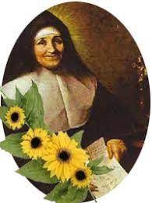

St Julie pray for us, protect us and bless us.

