
Children in Need
The children enjoyed wearing their spotty clothes and accessories today and were able to talk about how they were raising money for children around the country who would benefit from support for lots of different reasons. As always, your children are thoughtful and caring for those around them. Thank you for the donations received today which will be sent on to the charity. Donations for Children in Need can still be made via School Money.

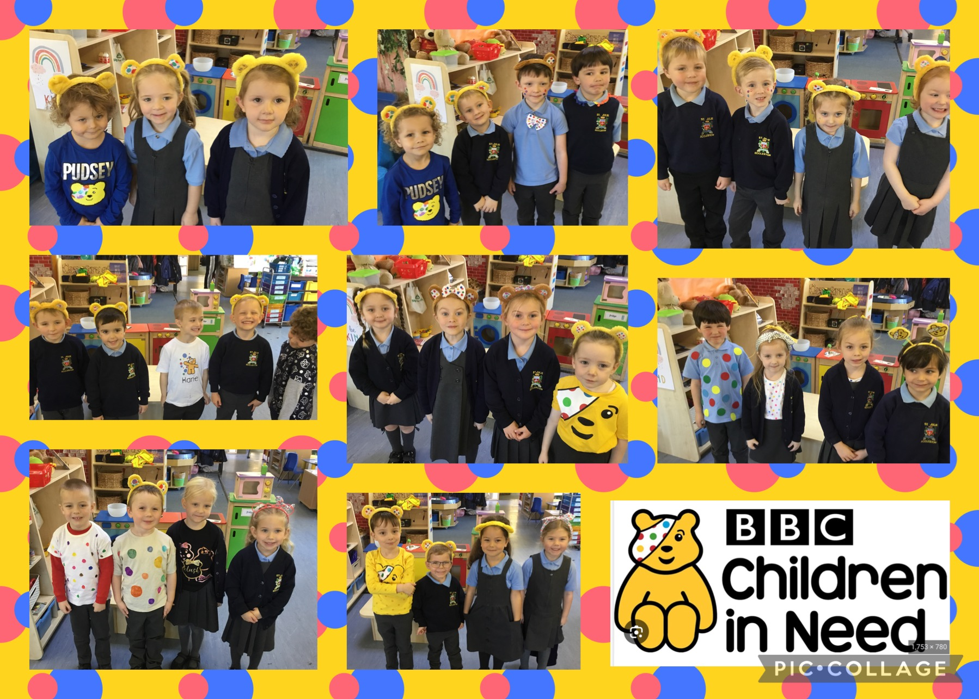


School games events
Last week a team of some of our Year 3 and Year 4 girls took part in a football competition at Ruskin, playing against teams from other St Helens schools. They had a great time competing and showed fantastic skill and teamwork in achieving 3rd place in the competition. Congratulations to Sofia R, Holly, Olivia and Nuala from Year 3 and Alexa, Florence, India, Molly and Sophia J from Year 4.
Yesterday, a team from Year 3 went along to Broadway to play Boccia. They enjoyed developing their technique and skills and represented St Julie’s brilliantly. Well done to Liberty-Rose, Hattie, Dominic, Bobby, Olly and Lucas – fantastic ambassadors for St Julie’s.


School Photographs - Monday 27th November
The school photographer will be coming into school on Monday 27th November to take photographs of the children. All children will have their photo taken for our school Sims system. The photographer will take individual photographs of each child and also group photos of siblings but you are not obliged to purchase a photograph.
Proof copies of the photographs along with an order form will be sent home as soon as they are available.

Play like the Pride
Last week three of our Year 5 children experienced a once in a lifetime opportunity to train alongside some of the world's best football coaches. Matthew, Luca and Zack were chosen to represent their local football team, down at St George's Park, home of the England Football Team. The ‘play like the pride’ program allowed them to have access to the full 330 acre site and experience opportunities that are normally reserved for the likes of Harry Kane. The FA coaches took them through a day in the life of an England International, including a tailored technical coaching session delivered in line with the national team syllabus as well as providing an opportunity for them to develop their leadership skills.
Congratulations to Matthew, Luke and Zack – we are very proud of you all!

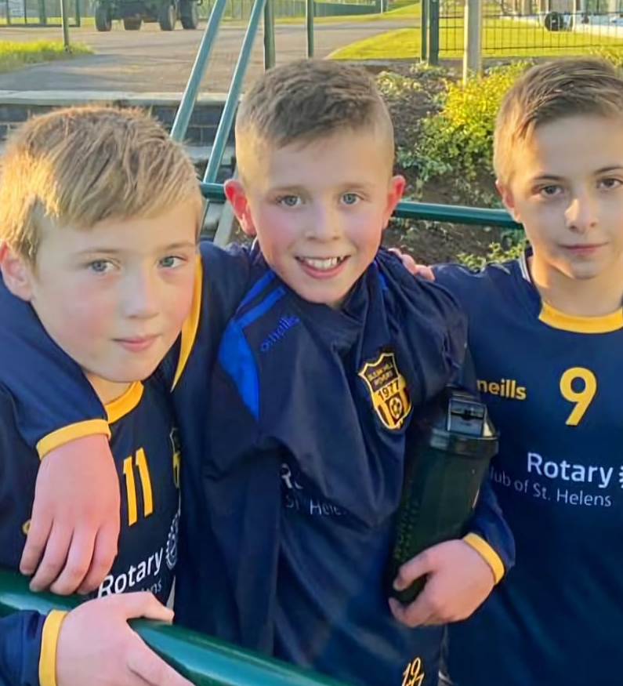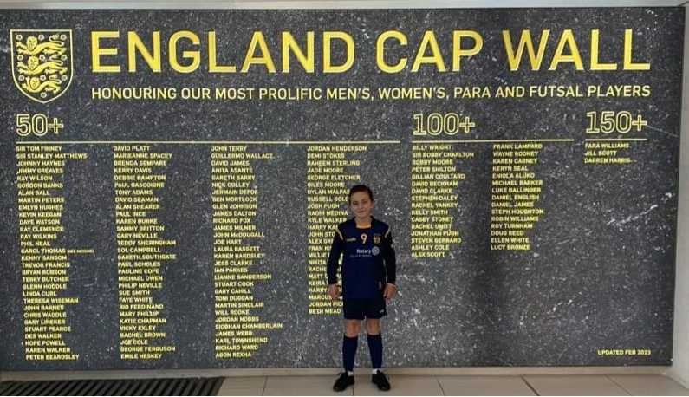

Own Clothes Day – next Friday in return for bottles and chocolate!
The PFA would be grateful for donations of chocolate for the Christmas Bingo taking place on Thursday 30th November and bottles for the Christmas fair.
PFA events:
Thursday 30th November - Christmas Bingo 6:30pm Parish Hall
Friday 1st December - Christmas light switch on 4:30pm in school hall
Friday 8th December - Christmas Fair 3-5pm Parish Hall


Break time snacks
Children can bring a healthy snack of fruit or toast to school for break time. However, as a healthy school please do not send in any chocolate or sugary snacks. Infants can also choose to have a piece of fruit each day.
A reminder that water bottles must contain water only, no juice.
Nut free school
We have several children in school with nut allergies so please do not include cereal bars or other products that could contain nuts in children’s packed lunches or as snacks.
Thank you.

Christmas Dinner

Mrs Finney will be serving her tasty, Christmas Dinner on Wednesday 13th December. If your child normally has a packed lunch but would like to have a school meal on Christmas Dinner Day, a survey will be available on School Spider next week for you to complete. The traditional Christmas dinner consists of turkey, chipolata sausage, stuffing, roast potatoes, broccoli and gravy followed by frosted chocolate cake. The lunch costs £2.60 and can then be paid for via School Money once you have completed the request on School Spider. All children who have a hot dinner already will get a Christmas dinner so you do not need to complete the School Spider survey.

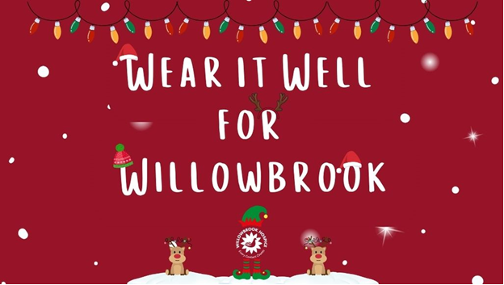
Wear it well for Willowbrook
As the season of giving is upon us, we continue to think about others who are in need. We invite you to support one of our local charities, Willowbrook Hospice. On Christmas dinner day, Wednesday 13 December, children can add a touch of festive cheer to their uniforms while also giving back to their community. Children can add festive headwear to their standard uniform and donate a small amount of £1 towards Willowbrook Hospice.


Christmas Jumper Day – Friday 8th December
Children grow so quickly that often a Christmas jumper is only worn a couple of times before a child has outgrown it. To help reduce costs at what is a very expensive time of year we would like to be able to offer pre-loved Christmas Jumpers from the school foyer. If you have a Christmas jumper in good condition, please could you send it into school, washed and with a hanger – these will then be available to take from the school foyer for a small donation. Thank you.

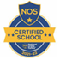
This week’s flyer from National Online Safety is about: “What parents & carers need to know about Smart TVs.”





St Julie’s Awards of the Week

 | Star for showing Unity | Book explorer | Marvellous mathematician
Reception | Teddy | Ezra | Blake
Year 1 | Samantha | Isaac | Sophie P
Year 2 | Alba | Ali | Kayla
Year 3 | Fraser | Ben F | Sofia R
Year 4 | Zachary | Jasmine | Alivia
Year 5 | Teddie C | Gracie | Ollie
Year 6 | Jack | Rosemary | Albie

Attendance
Excellent attendance at school is important to allow a child to fulfil their potential. I am confident in your support in ensuring that your child strives for 100% attendance each week.
Holidays during term time will not be authorised.
Each week we will report on attendance figures for each year group.

Year Group | % Attendance for w/e 17.11.23
Year R | 98.18
Year 1 | 98.57
Year 2 | 98.29
Year 3 | 90.86
Year 4 | 96.00
Year 5 | 96.67
Year 6 | 95.88

Well done to Year 1 who had the highest attendance this week.
Our whole school attendance this week is 96.35%

School Meals increase
From 1st November St Helens Council school meals have increased to £2.60 per meal.

Diary w/c 20.11.2023

Monday 8am Gymnastics Year 1, 2, 3
New intake for September 2024 look around school 2pm
Y1/Y2/KS2 Multi-sports club 3:20 – 4:15
Y5/6 Young Voices choir 3:20 - 4:15

Tuesday KS2 Multi-sports club 3:20 – 4:15

Wednesday 8am Gymnastics Year 4, 5, 6
Y1/Y2 Computing club 3:20 - 4:15
Y3/Y4 Lego/Construction club 3:20 - 4:15

Thursday Y5/Y4 Class Mass 9:20am – in church

Friday Own clothes day for donations to Christmas fair – bottles or/and chocolate
Y6 Viking experience day at Tatton Park

Further dates for your Diary
Monday 27 November - Apple of my eye cookery session Year 4
Monday 27 November - School photographer
Wednesday 29 November - Y3 Meet the Archaeologist afternoon
Thursday 30 November – PFA Christmas Bingo (Parish Hall)
Friday 1 December - Year 5 Forest School
Friday 1 December - PFA Christmas light switch on at school
Tuesday 5 December - Visit to Eccleston Library – Stone Age
Wednesday 6 December - Year 4 Carols and strings performance
Thursday 7 December - Eccleston Library tree lighting: Year 4 choir
Thursday 7 December - Year 6 Carols
Thursday 7 December - Y4 Sacramental programme session 3 after school
Friday 8 December - Christmas Jumper day and Santa Dash
Friday 8 December - PFA Christmas Fair (Parish Hall)
Monday 11 December - Year 3 Carols
Tuesday 12 December - Year 5 carols
Wednesday 13 December - Christmas Dinner day
Wednesday 13 December - Wear it well for Willowbrook – Christmas headwear for £1 donation
Wednesday 13 December - Year 1 Carols
Thursday 14 December - Reception class Carols
Thursday 14 December - Y4 First Forgiveness in St Julie’s Church 5pm
Monday 18 December - Junior Christmas Party day
Monday 18 December - Christmas Crafts after school club Y1 to Y6
Tuesday 19 December - Infant Christmas party day
Wednesday 20 December - Nativity Service in church to be led by Y2 2pm
Thursday 21 December - School closes for Christmas break.

Primary School Admissions
The website is now open for parents who wish to apply online: www.sthelens.gov.uk/admissions
Children who turn 5 between 1 September 2024 and 31 August 2025 are eligible to apply for a place in primary school. The deadline for submission of primary school applications is 15 January 2024. The Archdiocese have asked us to remind parents seeking a reception class place at our school, even if you have a sibling in the school, of the need for baptism prior to application and to take prompt action if baptism has not already taken place.

“A caring family school, where we learn, grow and walk in the footsteps of Jesus.”

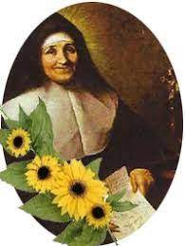

St Julie pray for us, protect us and bless us.

