
Christmas is coming!
Next week we will take delivery of THREE wonderful Christmas trees generously gifted by AK Bathrooms (see flyer in book bags today) marking the start of a most exciting time for the children in school. The tree in the school hall will be for the children to decorate with their Christmas wishes and there will be one that can be seen at each gate which will be lit for friends and family to enjoy at drop off and pick up times.
The official switch on will take place on Friday 1st December at 4:30pm. Please come along to enjoy the singing around the tree. The PFA will be selling seasonal refreshments and selling raffle tickets – so don’t forget to bring your wallet!


School Photographs – next Monday, 27th November
The school photographer will be coming into school on Monday 27th November to take photographs of the children. All children will have their photo taken for our school Sims system. The photographer will take individual photographs of each child and also group photos of siblings but you are not obliged to purchase a photograph.
Proof copies of the photographs along with an order form will be sent home as soon as they are available.

Little Church – there will be NO LITTLE CHURCH on Sunday the 26^{th of} November, but it will be back on Sunday 3rd December.

PFA events:
Thursday 30th November - Christmas Bingo, doors open 6pm, Eyes Down 6:30pm Parish Hall
Friday 1st December - Christmas light switch on 4:30pm in school hall
Friday 8th December - Christmas Fair 3-5pm Parish Hall
St Julie’s PFA are now selling School Uniform (pre-loved) Online. Please click on the QR code in the attachment/flyer emailed with this bulletin to take you to the shop. If you need anything in particular email friendsstjuliePFA@gmail.com

Holiday Activities and Food Programme
The Holiday Activities and Food (HAF) programme is aimed at providing nutritious food and enriching activities for primary and secondary school aged children who are eligible for benefit related free school meals during the Easter, Summer and Christmas school holidays for children and young people aged 4 – 18 years who are eligible for and receiving benefits-related free school meals (FSM), and their families. Children and young people who are in receipt of a support plan via Early Help, Child In Need, Children We look after, EHCP or receives additional hours at school then they are also eligible for the HAF programme.
Throughout the Winter holidays eligible children and young people can access a variety of free activity sessions and all of these sessions will include a nutritious meal.
For more information on the exciting activities and opportunities that are available, dates and times please follow the link below or call Central Link Children’s Centre on 01744 673445.
https://www.sthelens.gov.uk/article/4060/Holiday-activities-and-food-programme
We are requesting that parents/carers book their child’s place for the Winter holiday activities as soon as possible, as numbers are limited (each provider can provide full details of their available sessions upon request). Please contact the delivery partner directly to book a place. Activity links will go live at 2.00pm on Tuesday 12th December 2023. The sessions are fully funded by the Department for Education (DfE).
Minnie Vinnie’s
On Monday this week, some of our Year 3 and Year 4 Minnie Vinnie’s went along to De La Salle for the launch of the SVP Christmas Card competition. The children had the opportunity to meet Minnie Vinnies from other schools and had great fun getting into the Christmas spirit by making Christmas cards supported by the SVP Youth Group at De La Salle, many of whom were previously pupils at St Julie’s.

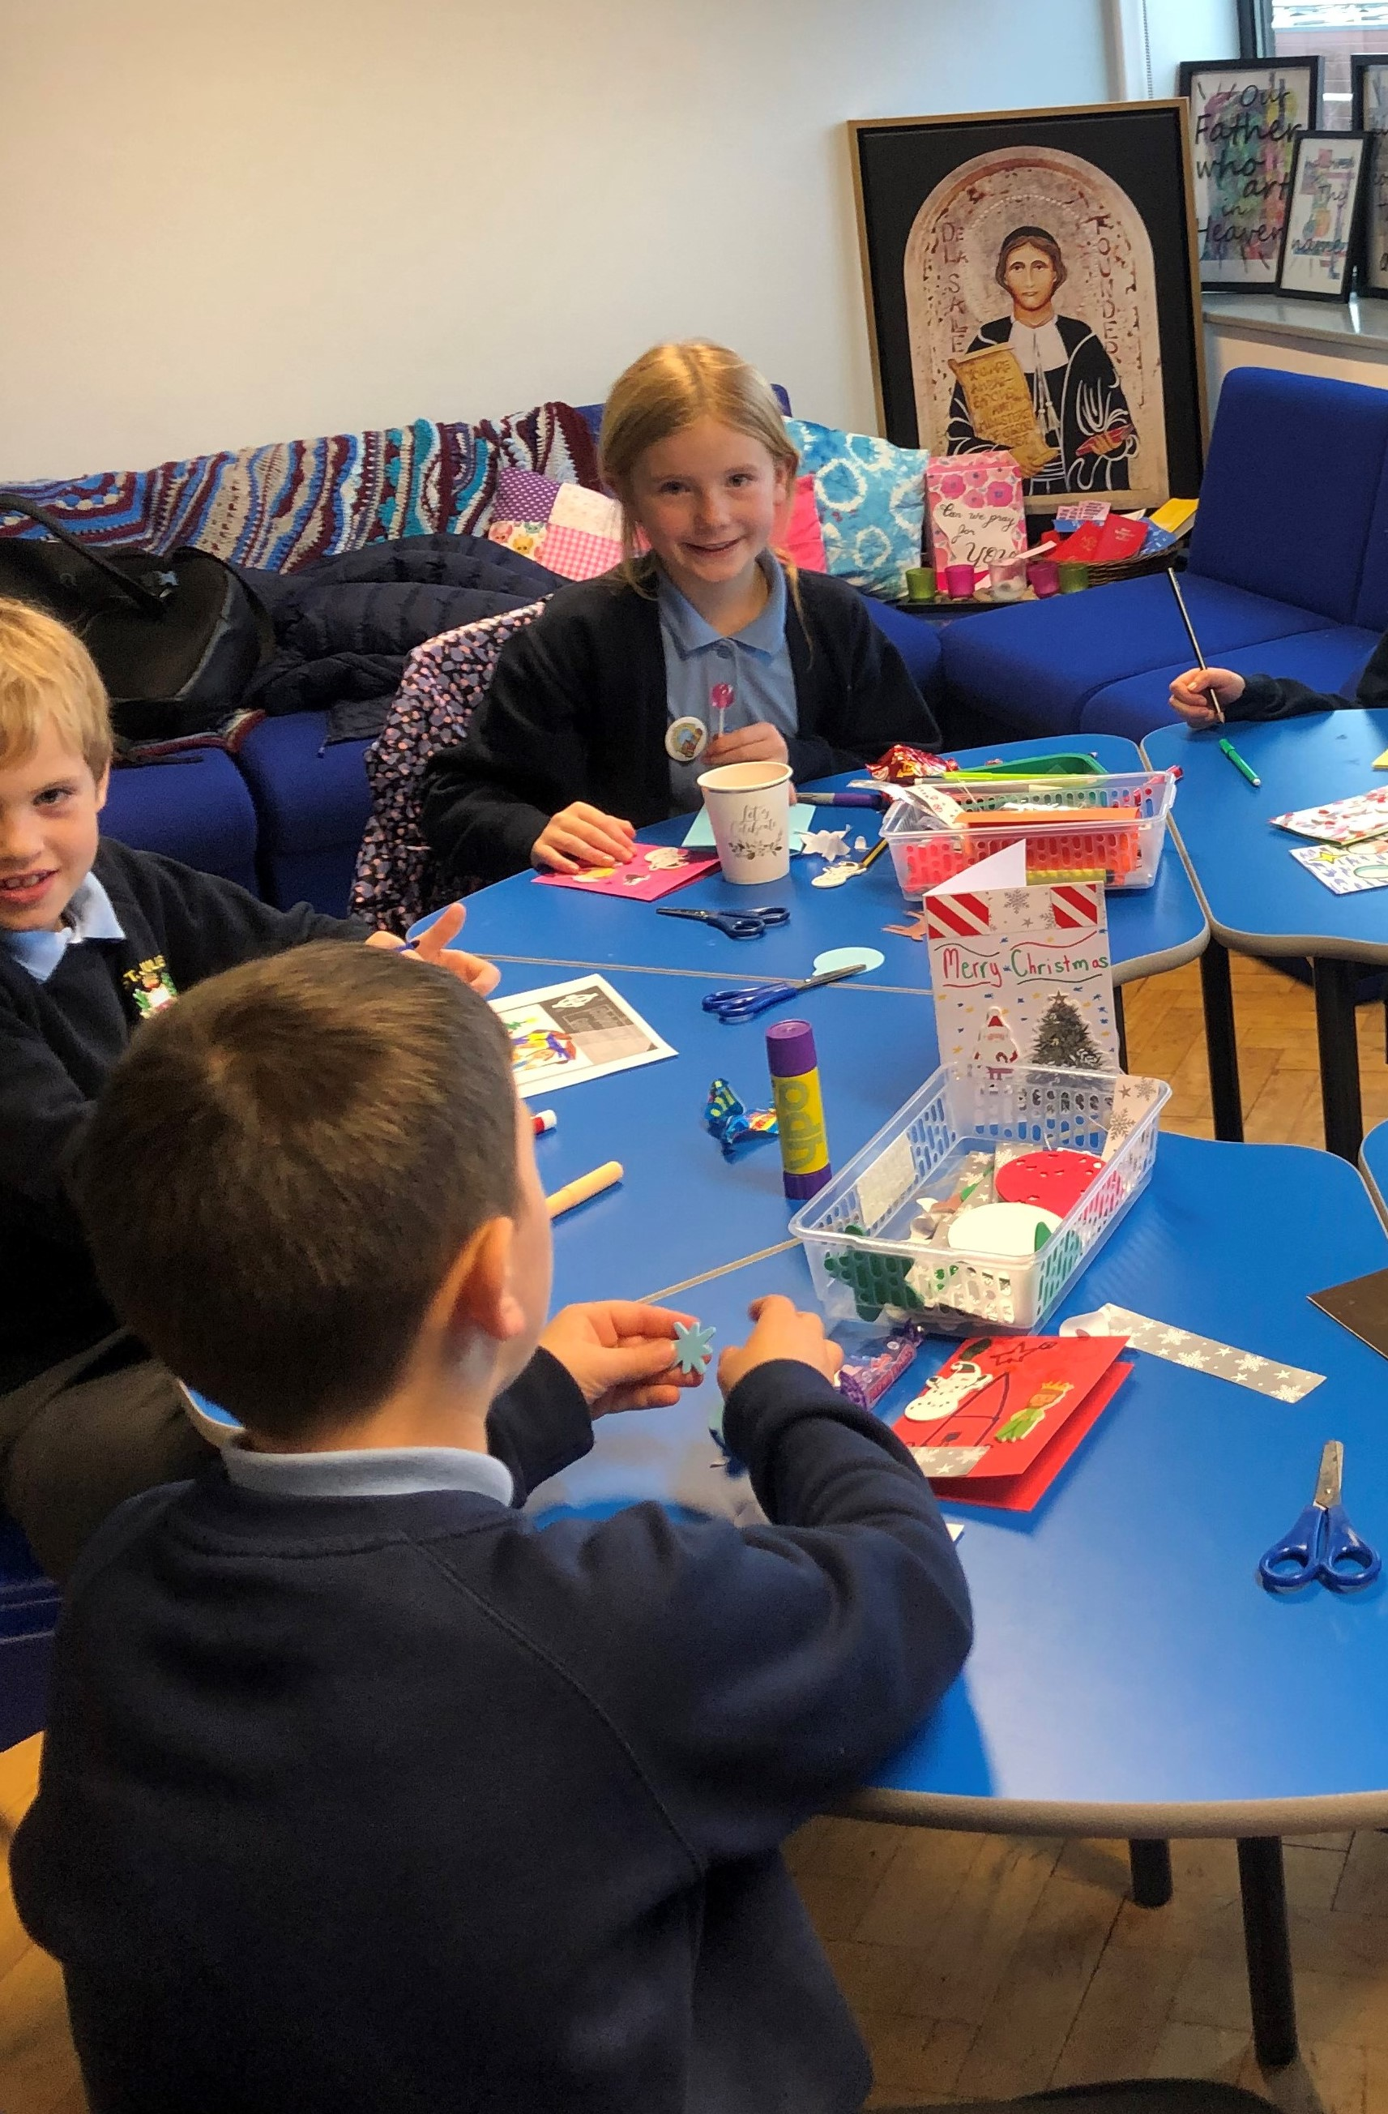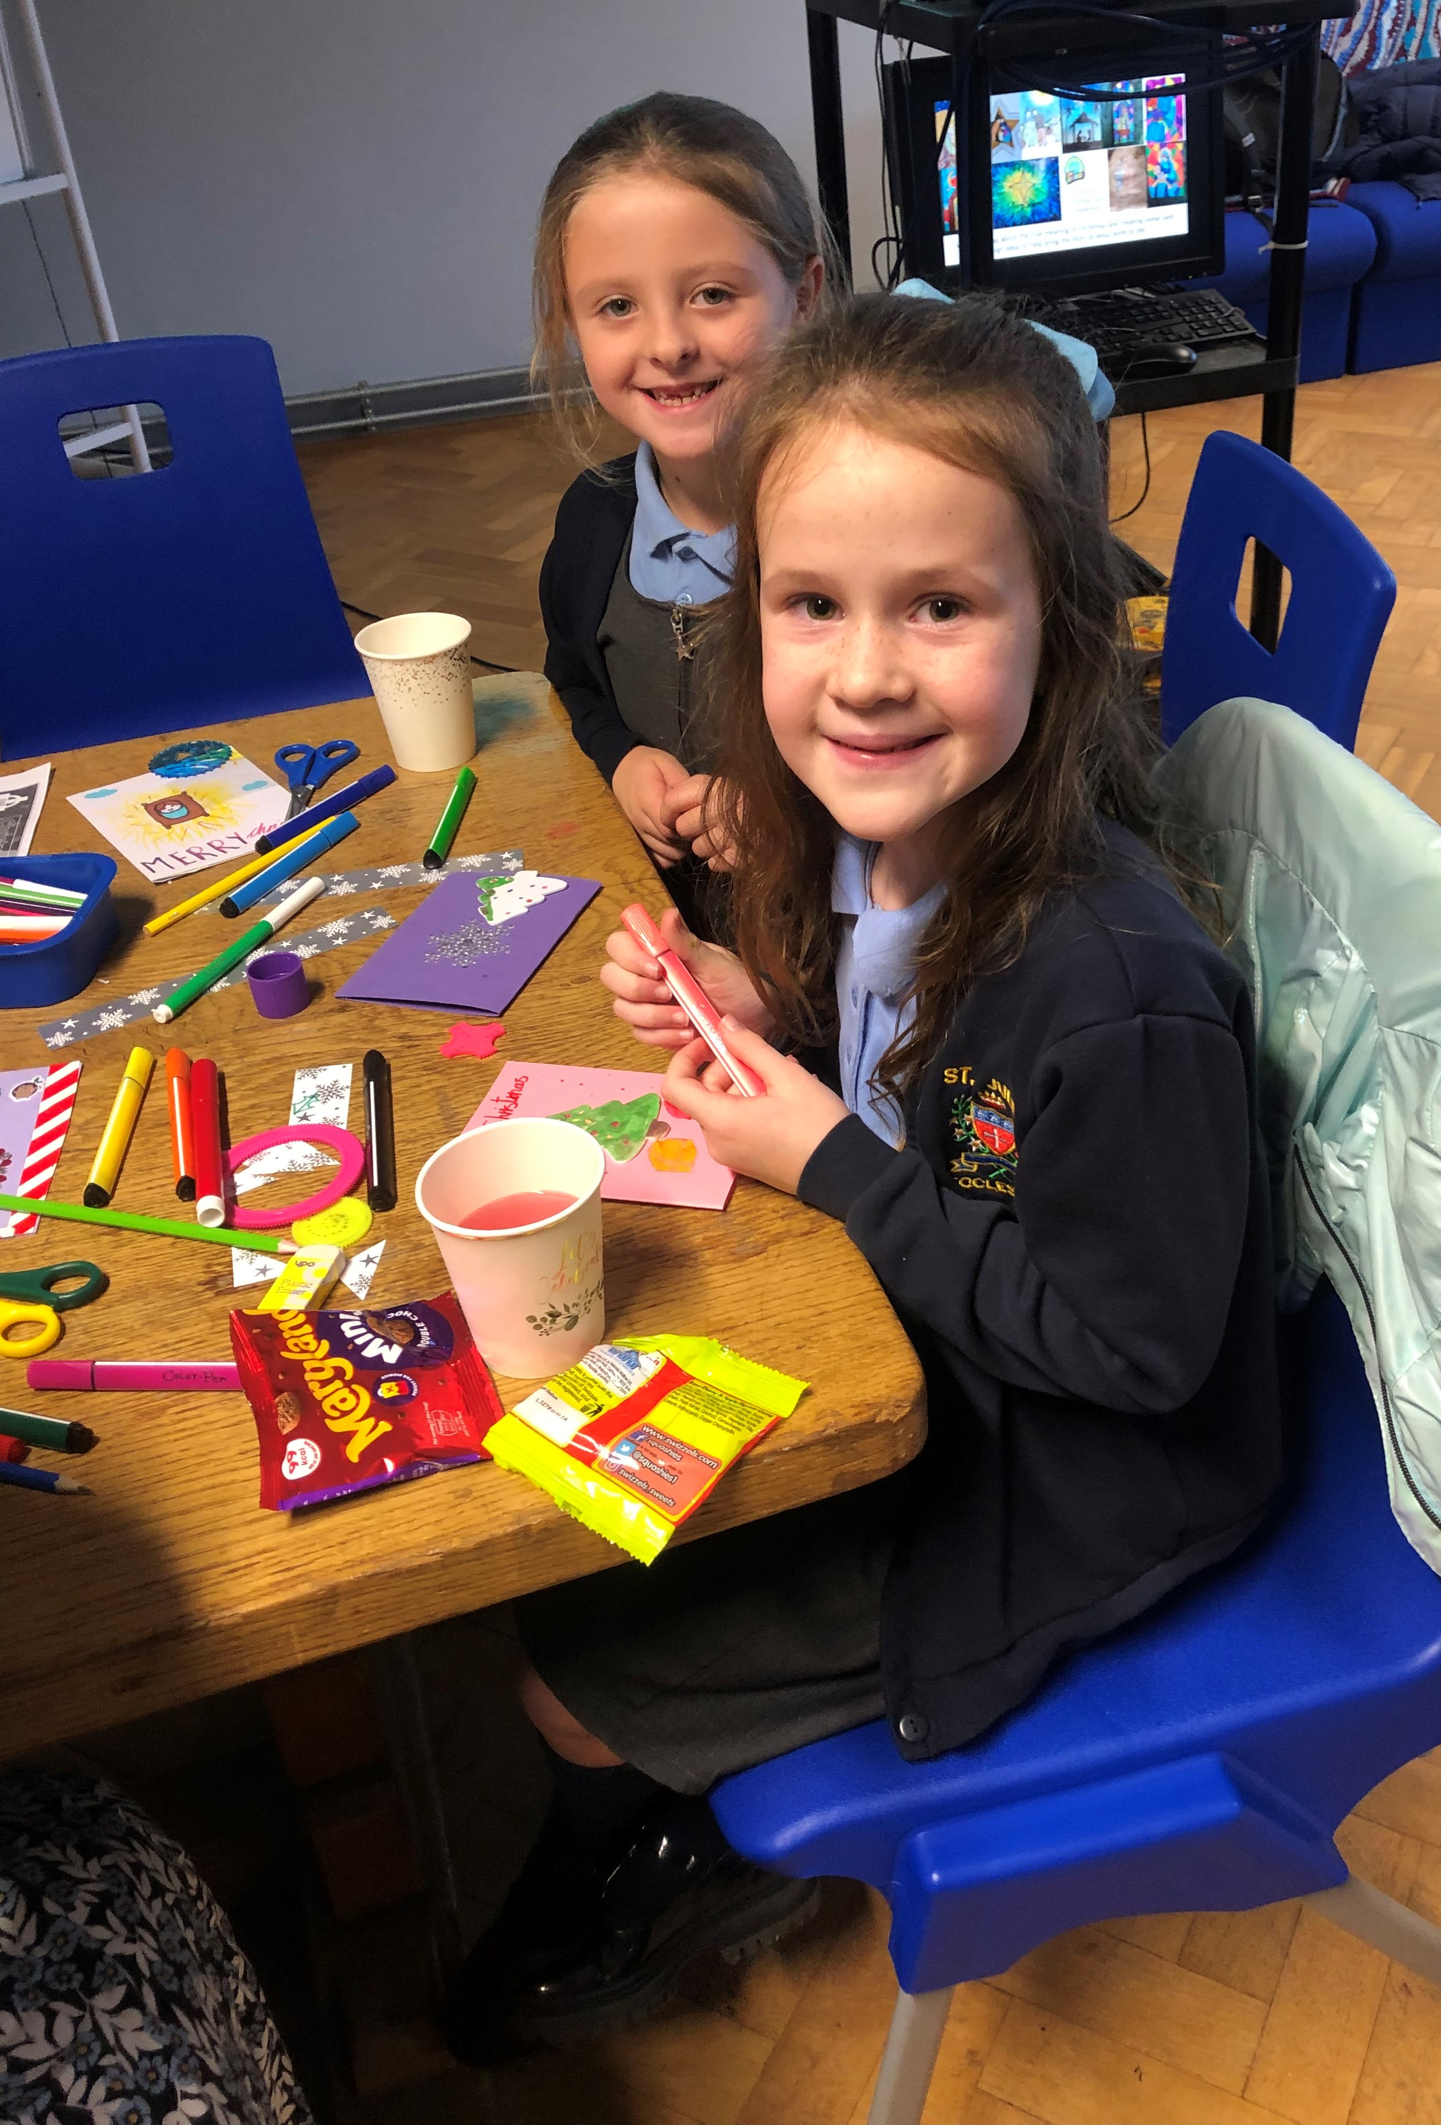


St Julie’s school has a history of supporting Our Warm Welcome in providing support for the refugees in St Helens. We call upon your kindness and in support of our Live Simply mission of living in solidarity with people in poverty to ask if you could help in the weeks leading up to Christmas by donating the following items:
Second hand coats for all ages, children and adults.
MEN’S SHOES.
Suitacases
Please send any donations into school and they will be collected by Our Warm Welcome. Thank you.


Christmas Party Lunch – information for if your child has a packed lunch BUT would like to have a Christmas Party Box on Party day.
ALL children on hot dinners will receive a Christmas Party Box
On Party day, the 18th December for Juniors and 19th December for Infants, children can have a Party Box lunch consisting of: cheese, tuna or ham sandwich, sausage roll, Pombears, a shortbread Christmas tree and a carton drink.
If any Junior child who normally has a packed lunch would like to have a Christmas Party Box, please pay £2.60 online via School Money by Friday 9th December. If your child is in the infants, there is no charge but we ask that you let us know via the School Spider survey from next Monday, for catering purposes. Deadline for orders is Friday 9th December.
Once again, if your child already has hot dinners you do not need to do anything!

Yorkshire Building Society Money Minds sessions
Since half-term each Junior class has worked with representatives from Yorkshire Building Society on age-appropriate sessions about managing money and finances. The children have learnt more about money in the real world and how this affects planning a party, how saving up in a building society pays interest and keeps their money safe, as well as looking at costs for holidays. Thank you to the team who delivered the sessions for us – they commented on how good the children’s maths skills are.

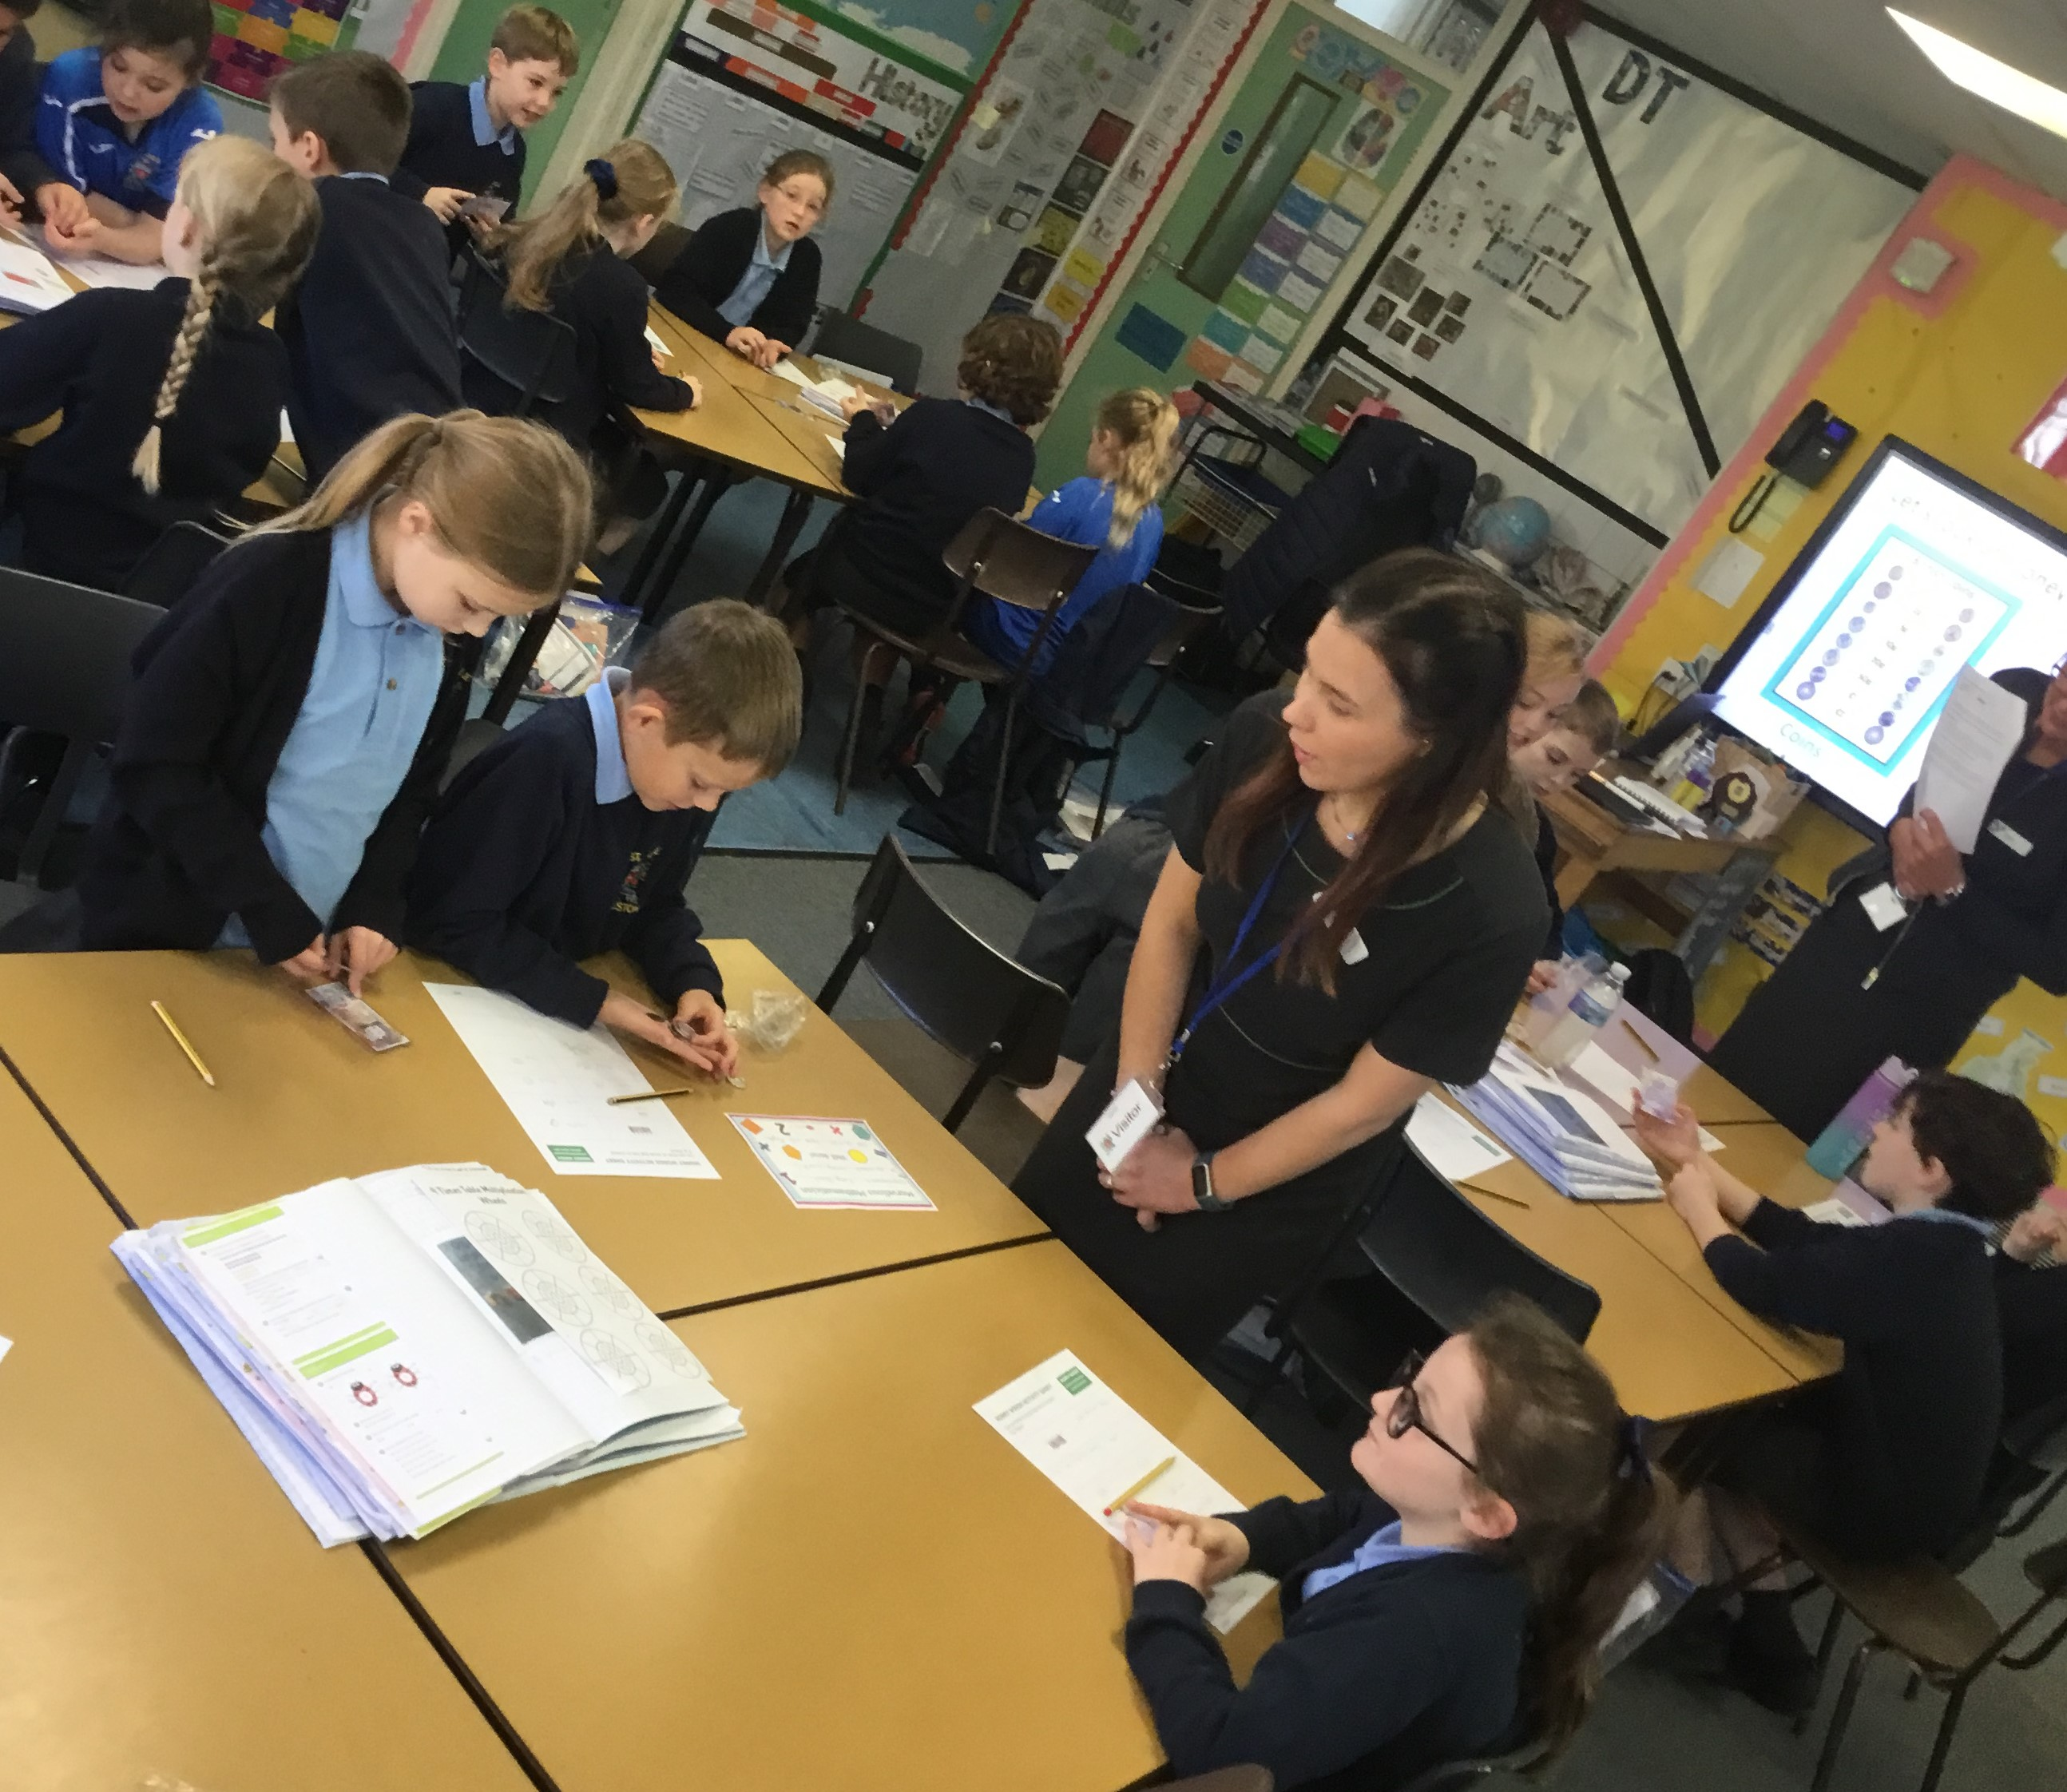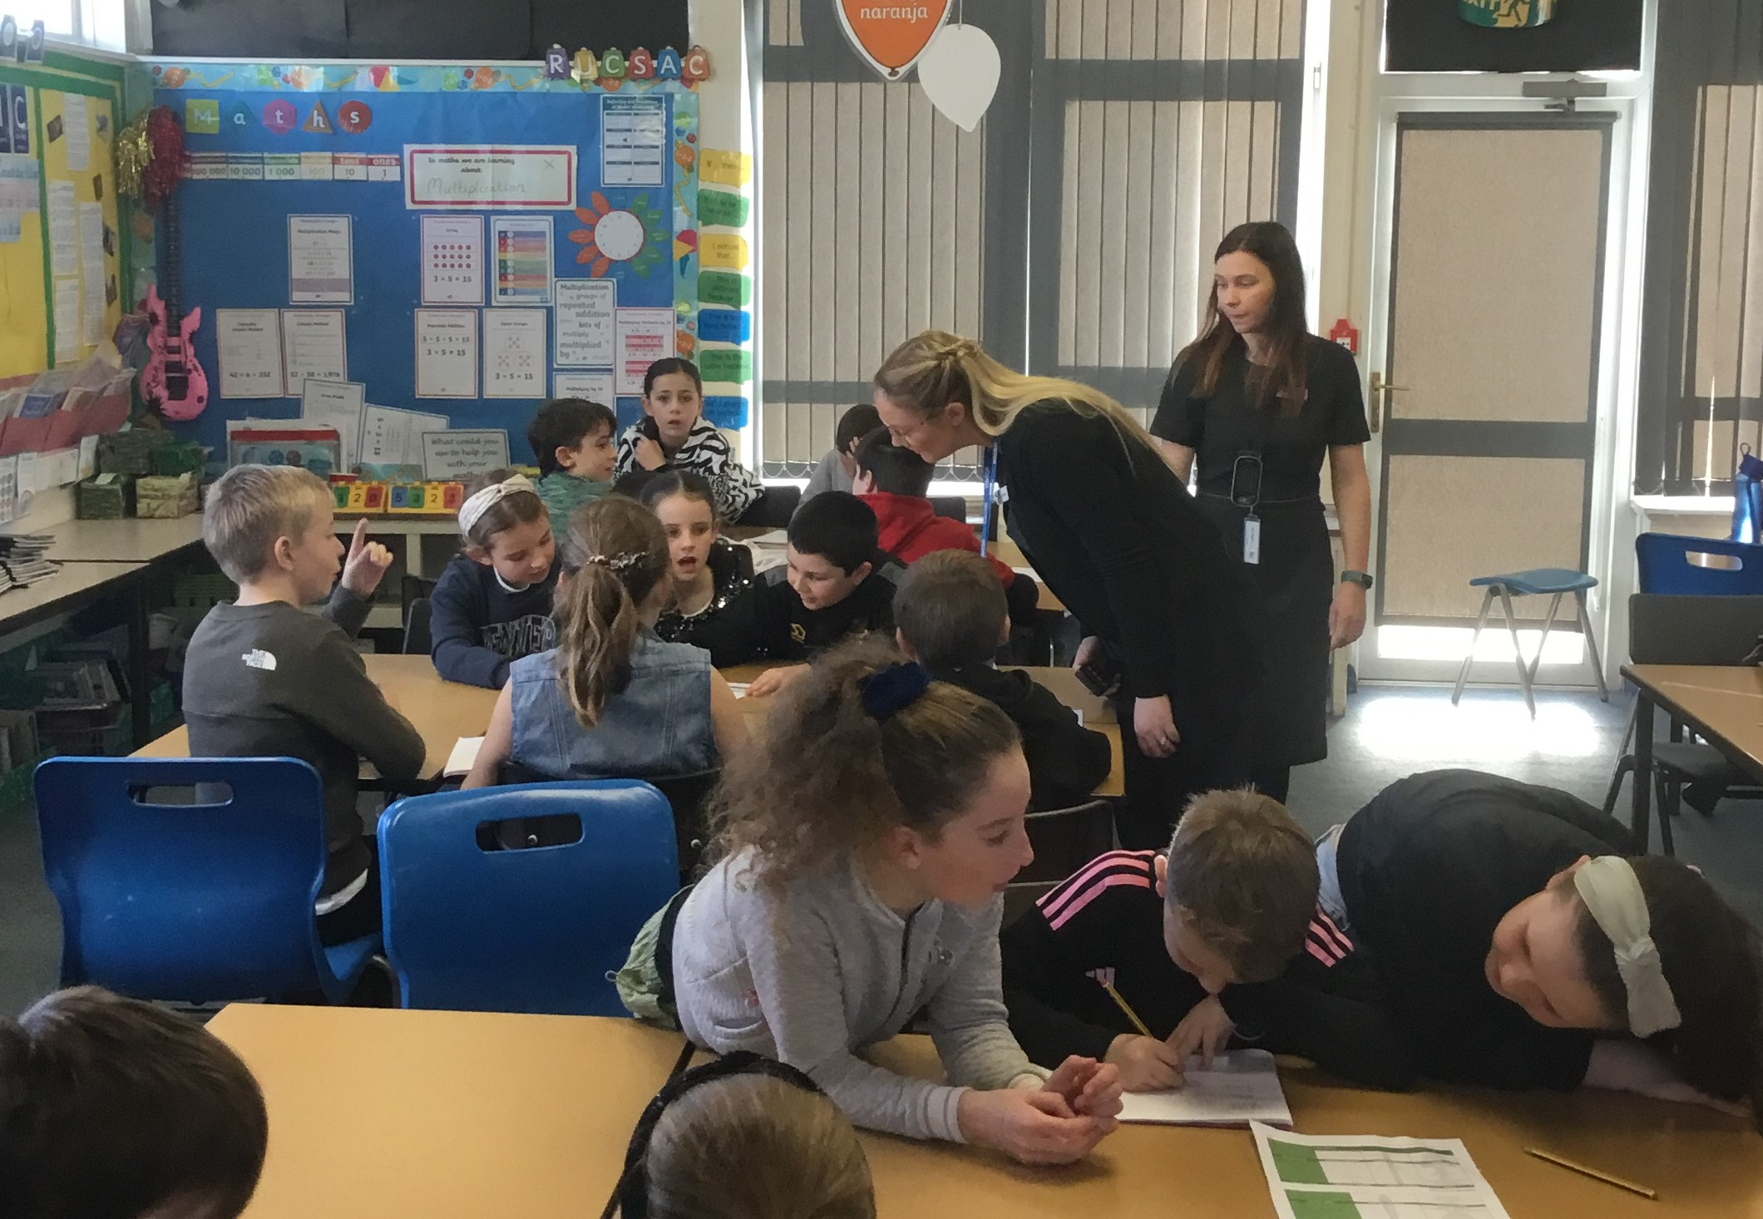

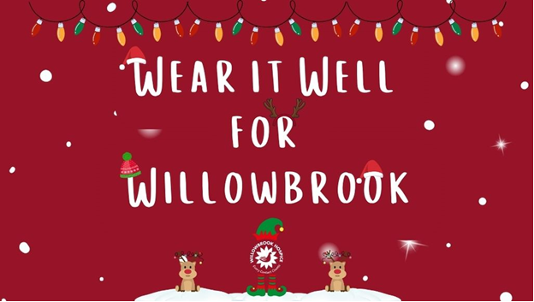
Wear it well for Willowbrook
As the season of giving is upon us, we continue to think about others who are in need. We invite you to support one of our local charities, Willowbrook Hospice. On Christmas dinner day, Wednesday 13 December, children can add a touch of festive cheer to their uniforms while also giving back to their community. Children can add festive headwear to their standard uniform and donate a small amount of £1 towards Willowbrook Hospice.


Christmas Jumper Day – Donations of pre-loved jumpers
To help reduce costs at what is a very expensive time of year we would like to be able to offer pre-loved Christmas Jumpers from the school foyer. If you have a Christmas jumper in good condition, please could you send it into school, washed and with a hanger – these will then be available to take from the school foyer for a small donation. Thank you.

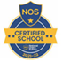
This week’s flyer from National Online Safety is about: “Top tips for safer online shopping on Black Friday and Cyber Monday.”




St Julie’s Awards of the Week

 | Star for showing Unity | Book explorer | Marvellous mathematician
Reception | Grace | Leya | Daniel
Year 1 | Matthew | Austin | Elliott
Year 2 | Daisy | Gia | Isaac
Year 3 | Lucas W | William | Darcey
Year 4 | Max | Imogen | Luca P
Year 5 | Lexi-Mai | Robert F | Luca B

Attendance
Excellent attendance at school is important to allow a child to fulfil their potential. I am confident in your support in ensuring that your child strives for 100% attendance each week.
Holidays during term time will not be authorised.
Each week we will report on attendance figures for each year group.

Year Group | % Attendance for w/e 24.11.23
Year R | 92.73
Year 1 | 96.07
Year 2 | 94.86
Year 3 | 90.29
Year 4 | 96.86
Year 5 | 96.39
Year 6 | 97.65

Well done to Year 6 who had the highest attendance this week.
Our whole school attendance this week is 94.98%

Diary w/c 27.11.2023

Monday 8am Gymnastics Year 1, 2, 3
School photographer
Y1/Y2/KS2 Multi-sports club 3:20 – 4:15
Y5/6 Young Voices choir 3:20 - 4:15

Tuesday KS2 Multi-sports club 3:20 – 4:15

Wednesday 8am Gymnastics Year 4, 5, 6
Y3 Meet the Archaeologist afternoon
Y1/Y2 Computing club 3:20 - 4:15
Y3/Y4 Lego/Construction club 3:20 - 4:15

Thursday PFA Christmas Bingo (Parish Hall)

Friday Year 5 Forest School
PFA Christmas light switch on at school

Further dates for your Diary
Tuesday 5 December - Visit to Eccleston Library – Stone Age
Wednesday 6 December - Year 4 Carols and strings performance
Thursday 7 December - Eccleston Library tree lighting: Year 4 choir
Thursday 7 December - Year 6 Carols
Thursday 7 December - Y4 Sacramental programme session 3 after school
Friday 8 December - Christmas Jumper day and Santa Dash
Friday 8 December - PFA Christmas Fair (Parish Hall)
Monday 11 December - Year 3 Carols
Tuesday 12 December - Year 5 carols
Wednesday 13 December - Christmas Dinner day
Wednesday 13 December - Wear it well for Willowbrook – Christmas headwear for £1 donation
Wednesday 13 December - Year 1 Carols
Thursday 14 December - Reception class Carols
Thursday 14 December - Y4 First Forgiveness in St Julie’s Church 5pm
Monday 18 December - Junior Christmas Party day
Monday 18 December - Christmas Crafts after school club Y1 to Y6
Tuesday 19 December - Infant Christmas party day
Wednesday 20 December - Nativity Service in church to be led by Y2 2pm
Thursday 21 December - School closes for Christmas break.

Primary School Admissions
The website is now open for parents who wish to apply online: www.sthelens.gov.uk/admissions
Children who turn 5 between 1 September 2024 and 31 August 2025 are eligible to apply for a place in primary school. The deadline for submission of primary school applications is 15 January 2024. The Archdiocese have asked us to remind parents seeking a reception class place at our school, even if you have a sibling in the school, of the need for baptism prior to application and to take prompt action if baptism has not already taken place.

“A caring family school, where we learn, grow and walk in the footsteps of Jesus.”


St Julie pray for us, protect us and bless us.



