Eccleston Library tree lighting
Yesterday Year 4 went along to Eccleston library to sing at the annual tree lighting ceremony.
The children sang their hearts out in a festive performance of classic carols and modern Christmas songs.
The mayor and our chair of governors were in attendance and were delighted with the performance, they said that the children were a credit to St Julie’s and brought Christmas joy to the local community. Well done everyone, we are so proud of you all!

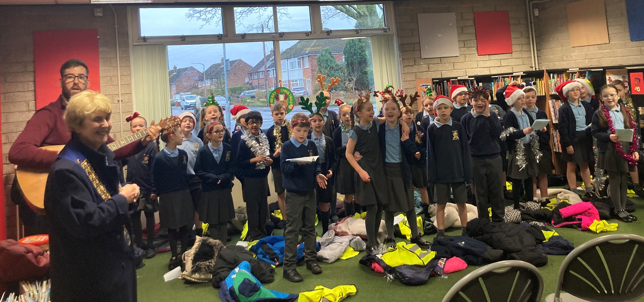


Advent
This Sunday is the second Sunday of Advent and focus on the meaning of ’Peace’ and how we can be peacemakers.

Please see the RE tab on the website for more Advent activities and the RE newsletter.


Christmas carol services
Thank you to those who came to listen to the Year 4 carols and instrumental performance on Wednesday and Year 6 on Thursday. It was wonderful for the children to be able to perform in front of an audience and certainly reminded us all of the true meaning of Christmas.
Next week the remaining classes will each be performing a carol service in the school hall, dates as follows:
Monday 11th December 2:50pm – Year 3
Tuesday 12th December 2:50pm – Year 5
Wednesday 13th December 2:50pm – Year 1
Thursday 14th December 2:50pm - Reception


Year 2 Nativity and Christmas Carol Services
Everyone is invited to join us in St Julie’s Church for the performance of the Nativity by Year 2 on Wednesday 20th December at 2pm. The whole school will be joining in with the Carols and the traditional retelling of the birth of Jesus, bringing us the true meaning of Christmas.


Thank you so much for the donations of coats that we have received. Margaret Markey who is one of our Governors and also supports the Our Warm Welcome charity wanted me to pass onto you what a huge difference your donations made. She was delighted that every coat size she was asked for this week was in the bags collected from school. God always works these little miracles.
We will continue to collect donations during the weeks leading up to Christmas:
Second hand coats for all ages, children and adults.
MEN’S SHOES.
Suitacases


Wear it well for Willowbrook
As the season of giving is upon us, we continue to think about others who are in need. We invite you to support one of our local charities, Willowbrook Hospice. On Christmas dinner day, Wednesday 13 December, children can add a touch of festive cheer to their uniforms while also giving back to their community. Children can add festive headwear to their standard uniform and donate a small amount of £1 towards Willowbrook Hospice.


The Royal British Legion Poppy Appeal
Thank you for supporting the Poppy Appeal – your donations raised £166.89 this year.

CAFOD fundraising during Advent
Each class will be raising money for CAFOD and aiming to buy a World Gift. World Gifts are a way of changing the lives of families and communities by providing a soup kitchen, teaching someone to read, providing chickens so families can produce eggs to eat or sell and many other life changing examples. See the link for further details https://worldgifts.cafod.org.uk/




St Julie’s Awards of the Week

 | Star for showing Unity | Book explorer | Marvellous mathematician
Reception | Nelia | Orlagh
Year 1 | Arthur | Charlotte | Teddy F
Year 2 | Joel | Lennie | Raphie
Year 3 | Teddy H | Lucas W | Jaxon C
Year 4 | Aoife | Lucy | Elissa
Year 5 | Matilda and Bertie | Bonnie | Eva and Elsie
Year 6 | Noah D | Katy | Charlie



Easyfundraising By downloading this app you can collect FREE funds for St Julie’s every time you shop online!
Just visit easyfundraising.org.uk, search for St Julie Catholic Primary PFA and follow the simple steps to sign up. Then start shopping using the links to over 2,000 retailers including Amazon, John Lewis, M&S, Argos, Next, ASOS and many more. Every time you shop, you’ll earn a donation for the school at no additional cost to you! Start donating as you do your Christmas shopping!


Time-keeping
Please ensure children arrive at school in time for the start of the school day. Children must be in class for 8:50am.
At the end of the day, please ensure you are on time for pick-up at 3:20pm.

Attendance
Excellent attendance at school is important to allow a child to fulfil their potential. I am confident in your support in ensuring that your child strives for 100% attendance each week.
Holidays during term time will not be authorised.
Each week we will report on attendance figures for each year group.

Year Group | % Attendance for w/e 08.12.23
Year R | 92.42
Year 1 | 98.57
Year 2 | 94.00
Year 3 | 93.43
Year 4 | 97.43
Year 5 | 97.50
Year 6 | 93.24
Well done to Year 1 who had the highest attendance this week.
Our whole school attendance this week is 95.23%

Diary w/c 11.12.2023

After school clubs have now finished until the new year.
Monday 8am Gymnastics Year 1, 2, 3
Year 3 Carols 2:50pm

Tuesday Year 5 carols 2:50pm
Full Governing Body meeting 5pm

Wednesday 8am Gymnastics Year 4, 5, 6
Wear it well for Willowbrook – Christmas headwear for £1 donation
Christmas Dinner day
Year 1 Carols 2:50pm

Thursday Reception class Carols 2:50pm
Y4 First Forgiveness in St Julie’s Church 5pm

Friday

Further dates for your Diary
Monday 18 December - Junior Christmas Party day
Monday 18 December - Christmas Crafts after school club Y1 to Y6
Tuesday 19 December - Infant Christmas party day
Wednesday 20 December - Nativity Service in church to be led by Y2 2pm
Thursday 21 December - School closes for Christmas break.

January 2024 - Year 6 will begin their swimming lessons and also Bikeability sessions. Please make sure that you have signed up for Bikeability via the link that you have been emailed if you want your child to take part in the session.

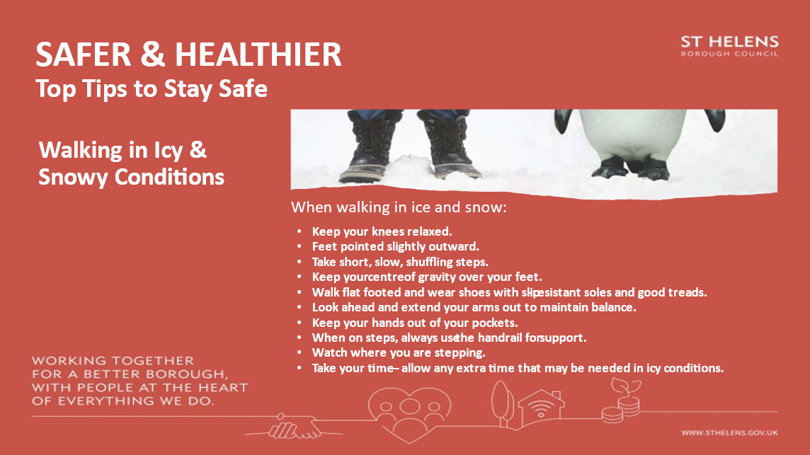

Baptism Courses
For parents/carers who wish to have their child baptised, the following Baptism Courses are available for next year:

BAPTISM COURSES 2024
In all instances the courses take place following that day’s Mass.

January – St Mary’s Lowe House - 21st and 28th

February - St Julies - 4th and 11th

March - Lent/Easter

April – St Mary’s Lowe House - 7th and 14th

May - St Julies - 5th and 12th

June, July and August - no courses

September – St Mary’s Lowe House - 8th and 15th

October - St Julies - 6th and 13th

November – St Mary’s Lowe House - 3rd and 10th

“A caring family school, where we learn, grow and walk in the footsteps of Jesus.”
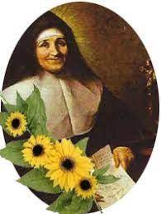

St Julie pray for us, protect us and bless us.



