Dear Parents and Carers,


Fond farewells
Next week we say goodbye to Mrs Dooley after over 20 years of dedicated service to our school community. In her part-time role she has taught many children across the school, touching the hearts of many children and families over her years of loyal service. We wish Mrs Dooley great success in her new adventure as she embarks on a full-time teaching post in January.
Sadly, we also say goodbye to Mrs Owen after 23 years as a much-loved Teaching Assistant at St Julie’s. She too has played an essential role in the education of many, many children and in her pastoral role as our Rainbows assistant has supported many children as a caring listening ear, offering heartfelt guidance and support.
All the staff and governors wish them both much happiness and success in the future, and as part of the St Julie’s family are reassured that they will both keep in touch and be back to see us soon. From January Mrs Johnson, who the children are already familiar with, will be teaching in Year 3 on Thursdays & Fridays.

Sacrament of First Forgiveness
Congratulations to our children in Year 4 who made their first Confession during the service of Reconciliation on Thursday evening, supported by their families. It was a beautiful, reflective service led by Fr Michael as the children took the next step in their sacramental journey. Thank you to the staff and catechists who supported during the service.
Mass at St Julie’s Church is at 9:30am every Sunday.


Bambinelli Sunday
Bambinelli is Italian for the figure of Jesus in your Christmas Crib. Traditionally they are brought to Mass for a blessing during Advent. You are invited to bring your baby Jesus from your home crib to 9.30am Mass on Sunday morning at St Julie’s this Sunday,17th December, for a special blessing during the Mass.


Christmas Party Days
A reminder that Monday is Christmas Party day for the Juniors and Tuesday is Christmas Party day for the infants. The children should come to school dressed in their party clothes but please remember that they will still be playing out at break and lunchtime so should be warmly dressed and have sensible footwear. Health and safety rules around not wearing jewellery and hair being tied back still apply.
Party Lunch Boxes will be served at lunchtime to those who have ordered them.

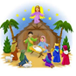
Year 2 Nativity and Christmas Carol Services
Everyone is invited to join us in St Julie’s Church for the performance of the Nativity by Year 2 on Wednesday 20th December at 2pm. The whole school will be joining in with the Carols and the traditional retelling of the birth of Jesus, bringing us the true meaning of Christmas. The PFA will also be selling tea and coffee afterwards in the Church Hall.

Year 2 Forest School Reminder – Thursday 21st December – children to wear own clothes and wellies or old trainers.


We have been quite overwhelmed by number of donations of coats that we have received. Your generosity will make such a difference to so many people this Christmas and during the cold winter. Many, many thanks to everyone.


CAFOD fundraising during Advent
Each class will be raising money for CAFOD and aiming to buy a World Gift. World Gifts are a way of changing the lives of families and communities by providing a soup kitchen, teaching someone to read, providing chickens so families can produce eggs to eat or sell and many other life changing examples. See the link for further details https://worldgifts.cafod.org.uk/


Winter Challenge 2023 – Children’s University
During the Christmas holiday, children can earn credits for Children’s University by completing activities at home. There are activities ranging from baking festive treats to making a Christmas wrapping paper collage. The Challenge sheet is attached with this bulletin or please see the Children’s University tab on the website for details of all the activities and how to submit the work for accreditation. I really enjoyed seeing the wonderful entries from the Autumn challenge and their photos and work is displayed in school!

Holiday Activities and Food Programme
The Holiday Activities and Food (HAF) programme is aimed at providing nutritious food and enriching activities for primary and secondary school aged children who are eligible for benefit related free school meals during the Easter, Summer and Christmas school holidays for children and young people aged 4 – 18 years who are eligible for and receiving benefits-related free school meals (FSM), and their families. Children and young people who are in receipt of a support plan via Early Help, Child In Need, Children We look after, EHCP or receives additional hours at school then they are also eligible for the HAF programme.
Throughout the Winter holidays eligible children and young people can access a variety of free activity sessions and all of these sessions will include a nutritious meal.
For more information on the exciting activities and opportunities that are available, dates and times please follow the link below or call Central Link Children’s Centre on 01744 673445.
https://www.sthelens.gov.uk/article/4060/Holiday-activities-and-food-programme
We are requesting that parents/carers book their child’s place for the Winter holiday activities as soon as possible, as numbers are limited (each provider can provide full details of their available sessions upon request). Please contact the delivery partner directly to book a place. Activity links will go live at 2.00pm on Tuesday 12th December 2023. The sessions are fully funded by the Department for Education (DfE).

Medication – polite reminder: school can only administer prescribed antibiotics if the dose is 4 times daily, we do not administer medication that needs to be taken 3 times daily as this can be regularly given at home.




St Julie’s Awards of the Week

 | Star for showing Unity | Book explorer | Marvellous mathematician
Reception | Whole Class | Stanley D | Bobby O
Year 1 | Lilia S | Sophie P | Henry H
Year 2 | Noah C | Jasmine J | Gia G
Year 3 | Freddie F | Thomas O | Liberty B
Year 4 | Georgia M | Sophia J | Imogen K
Year 5 | Zak T | Thomas K | Tommy D
Year 6 | Lucas P | Anna F | Thomas J



Easyfundraising By downloading this app you can collect FREE funds for St Julie’s every time you shop online!
Just visit easyfundraising.org.uk, search for St Julie Catholic Primary PFA and follow the simple steps to sign up. Then start shopping using the links to over 2,000 retailers including Amazon, John Lewis, M&S, Argos, Next, ASOS and many more. Every time you shop, you’ll earn a donation for the school at no additional cost to you! Start donating as you do your Christmas shopping!


Time-keeping
Please ensure children arrive at school in time for the start of the school day. Children must be in class for 8:50am.
At the end of the day, please ensure you are on time for pick-up at 3:20pm.

Attendance
Excellent attendance at school is important to allow a child to fulfil their potential. I am confident in your support in ensuring that your child strives for 100% attendance each week.
Holidays during term time will not be authorised.
Each week we will report on attendance figures for each year group.

Year Group | % Attendance for w/e 15.12.23
Year R | 99.70
Year 1 | 98.57
Year 2 | 96.00
Year 3 | 96.57
Year 4 | 94.86
Year 5 | 96.94
Year 6 | 95.59
Well done to Year R who had the highest attendance this week.
Our whole school attendance this week is 96.89%

Diary w/c 18.12.2023

Monday Junior Christmas Party day
Christmas Crafts after school club 3:20 – 4:45pm

Tuesday Infant Christmas party day

Wednesday Nativity Service in church to be led by Y2 2pm

Thursday Year 2 Forest School – own clothes and wellies or trainers to be worn.
School closes for Christmas break at 3:20pm.

Further dates for your Diary

January 2024 - Year 6 will begin their swimming lessons and also Bikeability sessions. Please make sure that you have signed up for Bikeability via the link that you have been emailed if you want your child to take part in the free session.

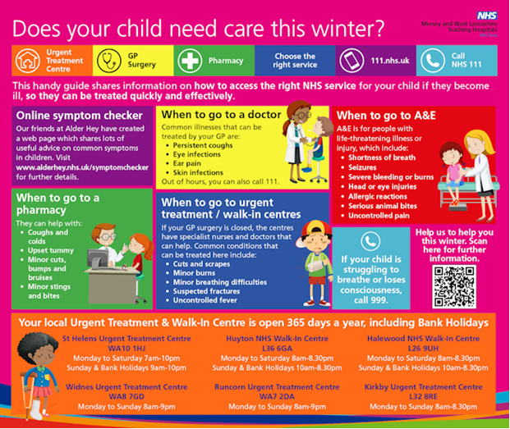

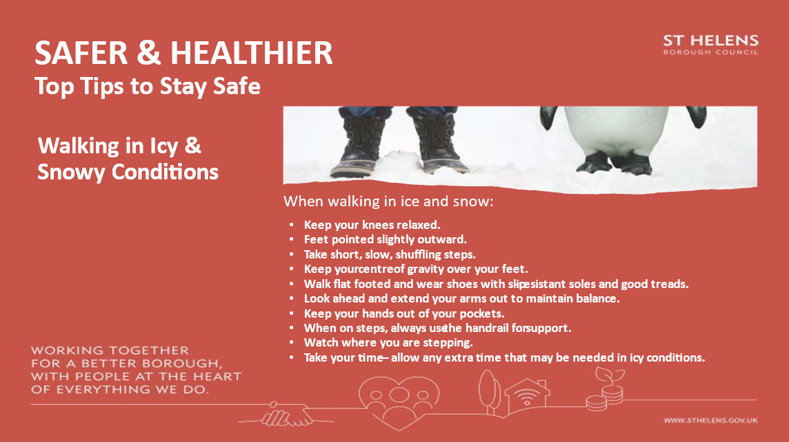

Baptism Courses
For parents/carers who wish to have their child baptised, the following Baptism Courses are available for next year:

BAPTISM COURSES 2024
In all instances the courses take place following that day’s Mass.

January – St Mary’s Lowe House - 21st and 28th

February - St Julies - 4th and 11th

March - Lent/Easter

April – St Mary’s Lowe House - 7th and 14th

May - St Julies - 5th and 12th

June, July and August - no courses

September – St Mary’s Lowe House - 8th and 15th

October - St Julies - 6th and 13th

November – St Mary’s Lowe House - 3rd and 10th

“A caring family school, where we learn, grow and walk in the footsteps of Jesus.”
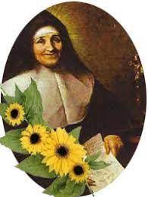

St Julie pray for us, protect us and bless us.



