Dear Parents and Carers,

Nativity
What wonderful performances the children have put on during the past two weeks! They have been so excited to entertain their families in their Carol Services – each one was very different, some showcasing their musical instruments, their acting skills and their poetry. All the children performed with enthusiasm and confidence in front of their audience and raised the roof with their singing.
Thank you to those who joined us in church for our nativity yesterday. Year 2 acted out the nativity beautifully as Daniel H and Lucas C from Year 6 narrated the events of the first Christmas. All the children sang their hearts out creating a wonderful atmosphere, full of emotion and bringing home the true message of Christmas.

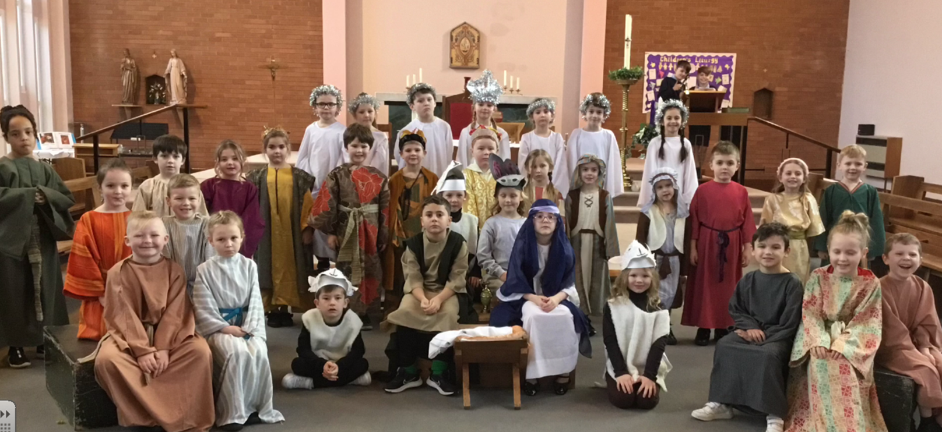


PFA fundraising events this half-term: Thank you for your support during this term. The events held and amounts raised are:

Christmas Bingo - £861
Tree lights switch on - £314
Christmas Fair £1,277

The PFA members would like to wish everyone a Happy Christmas – they will see everyone in the new year with more events.
On behalf of the school I would like to thank the PFA for their time and effort in organising events which I know takes a lot of hard work. Our school needs you and we appreciate all you do.

PFA 100 Club – first winners!
The first draw of the PFA 100 Club took place in Assembly this morning with 3 children each picking a card from the pot. Congratulations to our winners:
1st prize – Jenny Stead
2nd prize – Clare Feeney
3rd prize – Rebecca Barrow

The Golden Table
Each week in assembly a Lunchtime Supervisors Award and Mrs Finney’s Kitchen Award are presented to children who have shown outstanding behaviour and good manners during lunchtime. At the end of each half term their names go into a draw for a Golden Ticket.
Today the winners of this half term’s Golden Tickets were invited to eat their lunch at the Golden table with special Christmas treats. Well done to the children - they certainly enjoyed their gold star treatment.
Thank you to all our lunchtime supervisors and kitchen staff who care for all the children, ensuring they are happy and well-fed at lunchtime.






Fundraising during Advent
Thank you for your generosity towards our fundraising events held during Advent.
£185.45 was raised for CAFOD which will enable us to purchase some of the World Gifts.
On Christmas dinner day we raised £160.06 for Willowbrook Hospice.
Many thanks for all the donations.

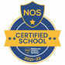

This week’s flyer from National Online Safety is very topical for anyone getting a new device for Christmas: “Top tips for setting up parental controls on new devices.”


Winter Challenge 2023 – Children’s University
During the Christmas holiday, children can earn credits for Children’s University by completing activities at home. There are activities ranging from baking festive treats to making a Christmas wrapping paper collage. The Challenge sheet is attached with this bulletin or please see the Children’s University tab on the website for details of all the activities and how to submit the work for accreditation. I really enjoyed seeing the wonderful entries from the Autumn challenge and their photos and work is displayed in school!



St Julie’s Awards of the Week

 | Star for showing Unity | Book explorer | Marvellous mathematician
Reception | Iris | Oliver | Luke
Year 1 | Rose | Reggie | Florence
Year 2 | All Year 2 for Nativity | Josefina D | Alba
Year 3 | Danielle | Callum | Bobby
Year 4 | Georgia | Max | Veronica
Year 5 | Evie M | Mia F | Henry
Year 6 | Alanna | Noah D | Alice

Attendance
Excellent attendance at school is important to allow a child to fulfil their potential. I am confident in your support in ensuring that your child strives for 100% attendance each week.
Holidays during term time will not be authorised.
Each week we will report on attendance figures for each year group.

Year Group | % Attendance for w/e 21.12.23
Year R | 96.97
Year 1 | 96.43
Year 2 | 95.00
Year 3 | 93.21
Year 4 | 95.00
Year 5 | 98.26
Year 6 | 93.75

Well done to Year 5 who had the highest attendance this week.
Our whole school attendance this week is 95.52%
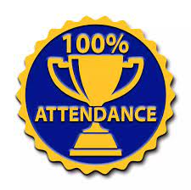

100% attendance certificates for the Autumn term
I was delighted to reward 64 children with a 100% attendance certificate this morning in our final assembly of the term. Congratulations to them for being in school for every morning and afternoon session so far this year.

Diary w/c 08.01.2024

Monday 8am Gymnastics Year 1, 2, 3
Y1/Y2/KS2 Multi-sports club 3:20 – 4:15
Y5/6 Young Voices choir 3:20 - 4:15

Tuesday KS2 table tennis club 3:20 – 4:15

Wednesday 8am Gymnastics Year 4, 5, 6
Y1/Y2 Spanish club 3:20 - 4:15
KS2 Sewing club 3:20 – 4:15

Thursday Y6 swimming lesson
Y4 Sacramental programme session 4 after school
Y1/Y2 Lego/Construction club 3:20 - 4:15
KS2 Dodgeball 3:20 – 4:15
Friday

Further dates for your Diary
Monday 8 January School reopens for Spring term.
Thursday 11 January Year 4 Sacramental meeting 3:20-4:00 session 4
Thursday 18 January Year 4 and Year 5 class Mass in church 9:20am
Friday 19 January Year 6 Bikeability sessions begin
Tuesday 23 January Year 5 Crucial Crew
Thursday 25 January Year 6 and Year 3 class Mass in church 9:20am
Friday 26 January RSPB Big Garden Birdwatch
Thursday 1 February Year 4 Sacramental meeting 3:20-4:00 session 5
Tuesday 6 February Young Voices Concert at MEN Arena
Wednesday 7 February Parents’ Night in school
Thursday 8 February Parents’ Night in school
Friday 9 February School closes for half term break
Monday 19 February School reopens

January 2024 - Year 6 will begin their swimming lessons and also Bikeability sessions. Please make sure that you have signed up for Bikeability via the link that you have been emailed if you want your child to take part in the free session.

All About Family, St Helens magazine.
Please follow the link below for the digital copy of the winter All About Family St Helens magazine. Inside, parents will find advice on;

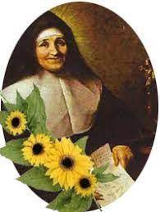
Family Events in the area
New Children's Books
The best Pantos in the area
Swimming Advice
Adult Education
Star Spotters Guide with World Museum
Plus more www.allabout-family.co.uk/st-helens

“A caring family school, where we learn, grow and walk in the footsteps of Jesus.”

St Julie pray for us, protect us and bless us.

The staff and Governors wish you a very Happy and Peaceful Christmas and thank you for all your support throughout the year.



