Dear Parents and Carers,
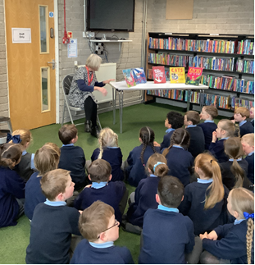

Book Awards St Helens (BASH) 2024
BASH is the popular Book Awards St Helens for Y1 and Y5 children. St Helens Library Service promote reading for pleasure by producing a list of 5 books and offer workshops around these books. The children read the books together in class and then during early March 2024 children vote for their favourite title. The winner is announced during a celebration event at the library.
On Thursday, Year 1 went along to Eccleston Library for their Book BASH workshop and enjoyed giving their reasons for which book they are enjoying the most.

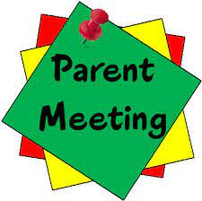
Parents’ Night
Our Spring term parents’ nights will take place on Wednesday 7 and Thursday 8 February. Appointments will be held in school and will be for 10 minutes, including an opportunity to look at your child’s work. We respectfully request that you keep to your allotted 10 minutes; teachers will use a timer to help the evenings run smoothly and avoid parents being kept waiting.
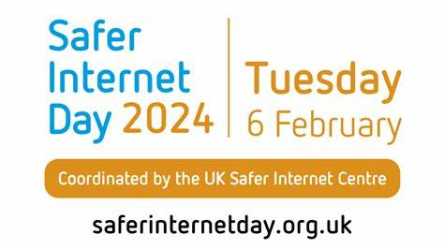

Safer internet day is on Tuesday 6th February.
The theme this year is 'Inspiring change? Making a difference, managing influence and navigating change online'. All children will have lessons and activities during the week exploring this year’s theme.

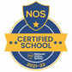


This week’s flyer from National Online Safety supports the Safer Internet Day theme: “What parents and carers need to know about Persuasive Design Online.”

Collective Worship – Year 1
The Year 1 children would like to invite parents and family to join them in celebrating the end of their current RE topic at their Collective Worship on Monday 5th February in their classroom at 2:50pm. Thank you.

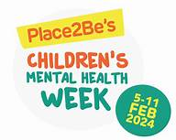
Children's Mental Health Week
Children’s Mental Health Week will take place from 5-11 February 2024. The theme this year is ‘My Voice Matters’.
My Voice Matters is about empowering children and young people by providing them with the tools they need to express themselves.
When we feel empowered, there’s a positive impact on our wellbeing. Children who feel that their voices are heard and can make a difference have a greater sense of community and self-esteem. This year, we want children of all ages, backgrounds and abilities to be empowered to work together to create a positive change for their mental health and wellbeing.
During Children’s Mental Health Week, we want all children and young people to be able to say – and believe - “My Voice Matters.”

The week will start with a Wellbeing Assembly for the whole school on Monday and end with a celebration event on Friday with a carousel of wellbeing activities for all the children to take part in during the morning.

On Friday 9th February, in school we will ‘Dress to Express.’ Children are encouraged to use colour to express themselves by wearing a colourful outfit or an outfit of their choice to express themselves or perhaps one of their interests. Children can wear their favourite colour or choose a range of colours that express how they’re feeling. It is a chance to EXPRESS YOURSELF!


PFA 100 Club – January winners!
The January draw of the PFA 100 Club took place last Friday in Assembly with 3 children each picking a card from the pot. Congratulations to our winners:
1st prize – Maureen Walsh
2nd prize – Steph Ramsden
3rd prize – Caroline Waterhouse



.
St Julie’s Awards of the Week

 | Star for showing resilience | Book explorer | Marvellous mathematician
Reception | Daniel | Isabelle | Jack
Year 1 | Vienna | Elliott | Sophie J
Year 2 | Callum | Lennie | Ivy
Year 3 | Ted | Thomas G | Nuala
Year 4 | Kate | Georgia S | Ryan
Year 5 | Marley | Josie-Mo | Gracie
Year 6 | Grace | Evie | Myla

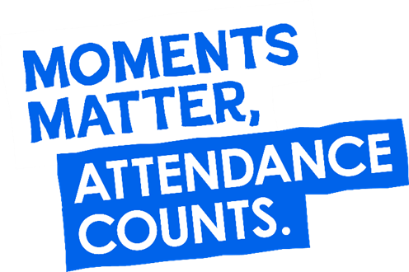
“From the first day of term to the last, the small moments in a school day make a real difference to your child.” #AttendanceCounts
At St Julie’s our attendance is excellent and we know that parents and carers value the education that your children receive. This week you should have received an email from us informing you that the Government is launching a national campaign to remind parents and carers of the importance of school attendance and promoting the importance of being in school, on time, every day.
Useful website Is my child too ill for school? - NHS (www.nhs.uk)

Year Group | % Attendance for w/e 02.02.24
Year R | 94.24
Year 1 | 97.93
Year 2 | 94.86
Year 3 | 98.24
Year 4 | 98.29
Year 5 | 95.71
Year 6 | 95.88
Well done to Year 4 who had the highest attendance this week.
Our whole school attendance this week is 96.45%

Punctuality
Thank you to everyone who has made a great start to the new year and a new term by arriving at school on time. A reminder to make sure that you arrive at the school gates in plenty of time for your child to get to their classroom. Children are expected to be in class by 8.50am. Children arriving after 8:50am will be marked as “Late” in the register.

Diary w/c 05.02.2024

Monday 8am Gymnastics Year 1, 2, 3
Y1/Y2/KS2 Multi-sports club 3:20 – 4:15
Y5/6 Young Voices choir 3:20 - 4:15

Tuesday Year 1 Apple of my eye (rearranged due to illness last week)
Safer Internet Day
Young Voices concert at Manchester Arena
KS2 table tennis club 3:20 – 4:15

Wednesday 8am Gymnastics Year 4, 5, 6
Parents’ Night in school
KS2 Sewing club 3:20 – 4:15 (in Computing suite)

Thursday Y6 swimming lesson
Parents’ Night in school
Y1/Y2 Lego/Construction club 3:20 - 4:15 (in Computing suite)
KS2 Dodgeball 3:20 – 4:15

Friday Dress to express yourself (non-uniform day)
School closes for half term break

Further dates for your Diary
Monday 19 February School reopens
Thursday 22 February Year 4 Sacramental meeting 3:20-4:00 session 5
Wednesday 6 March Year 1 Knowsley Safari Park
Thursday 7 March Year 4 Sacramental meeting 3:20-4:00 session 6
Monday 11 March Science week
Monday 11 March Year 2 Apple of my eye
Monday 18 March Year 3 Apple of my eye
Thursday 28 March Easter Passion Service in church led by Year 5 1:30pm
Thursday 28 March School closes for Spring break
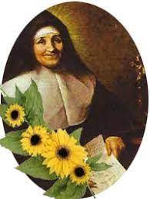
Monday 15 April School reopens
Thursday 18 April Year 5 swimming lessons commence at Queens Park

“A caring family school, where we learn, grow and walk in the footsteps of Jesus.”

St Julie pray for us, protect us and bless us.

