Dear Parents and Carers,

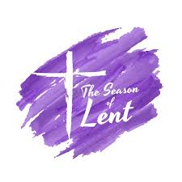
Our Lenten Journey
On the Wednesday of half-term we entered into the holy season of Lent. Please look on the RE pages of our website to see how you can celebrate this special time at home as a family.

Lent is a special time when we remember Jesus' journey into the desert and our walk with Him as we journey to Easter.

Try and give up a few moments of each day to pray, to give thanks and to say "Hello" to God.

Live Simply Lent challenge
As a 'Live Simply' school we would like our school family to take the opportunity of Lent to review our pledge to live more simply and appreciate our world. Please look at the Lent Challenge on the school website and join as we try to live simply.
Over the next few weeks, the staff, children and governors will be reviewing our Live Simply promises. We will be placing our pledges on pebbles in the prayer garden as a reminder of our commitment to creation.
Follow this link for the CAFOD Lenten family calendar:

https://cafod.org.uk/education/for-families/family-lent-calendar


Lent Fund raising
Lent is traditionally a time of fundraising. The whole school will be involved in fundraising activities to support our local charity, Nugent through the Good Shepherd Appeal. On Friday 22nd March there will be an own clothes day in return for a donation to the Good Shepherd Appeal and the Minnie Vinnies will be organising an Easter raffle.
We also see the return of 'Tuna Tuesday' when pupils are asked to donate tins of tuna, which are donated to “Our Warm Welcome”. We are aware that finances are becoming increasingly tight for all and appreciate any donations that can be made.
If you can, please send in a tin of tuna on a Tuesday this half term. Thank you.


Eucharistic Adoration 2024
As part of our Lenten preparation, we would like to invite families to join us in church after school for 20 minutes of quiet prayer and reflection before the Blessed Sacrament. This will be led by different Year Groups and each will follow a distinct theme.

Weds Feb 28th: Y6
Weds March 6th : Y5
Weds March 13th : Y4
Weds March 20th : Y3


This is a family event and children must be accompanied by an adult. Provision will be made for pupils who attend Care Club and would like to participate. We would like as many people as possible to share in this invitation - the side chapel will be available for families with very young children who may find it difficult to be quiet during this period of reflection.

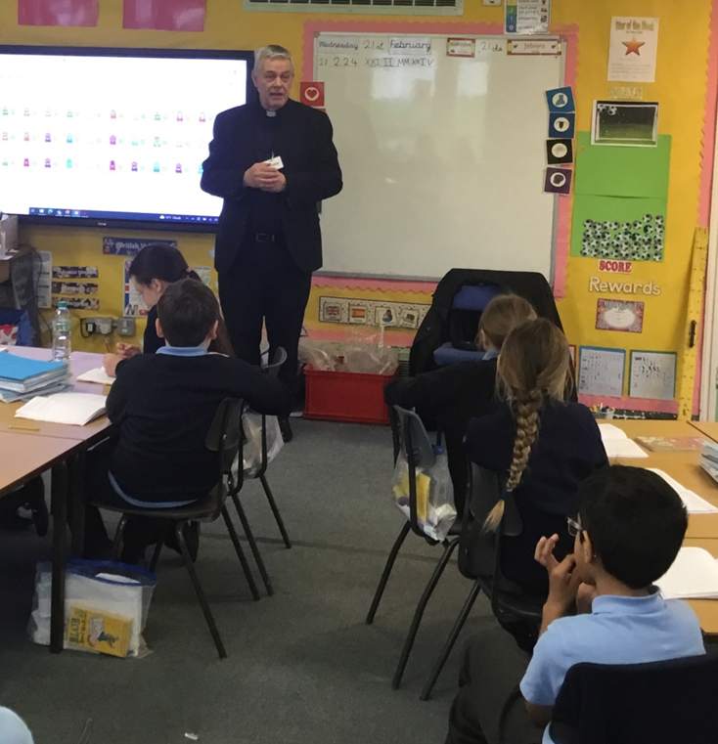
On Wednesday, Y4 had a visit from Fr Michael. They invited him into school as part of the Local Church RE topic focusing on 'Community'. Father told the children about the different roles he has within the parish community other than saying Mass on Sundays. The children were intrigued to find out about how busy Father Michael is, and how many different roles and responsibilities he has to help the community in different ways such as helping children and adults prepare for sacraments and visiting the sick. The children also interviewed Father Michael about his role as a Priest asking some fantastic, inquisitive questions. Father Michael took the time to answer every single question thrown at him, so Year 4 would like to say a huge thank you.
Mass times:
Saturday 6pm at St Thomas of Canterbury
Sunday 9:30am at St Julie
Sunday 11am at Lowe House Church in St Helens


World Book Day

On Thursday 7th March, World Book Day, the children will be thinking about their own favourite authors and can come to school dressed as a book character. (No football kits please) or come in their pyjamas with their favourite bedtime book.
Our Reading Ambassadors have been busy planning events for World Book Day. They will be leading an Assembly on the day to talk about their own favourite books and have asked that we hold a book swap on Thursday, so could each child bring in one book in good condition that they are happy to swap (forever!) for another book. The Reading Ambassadors will be reading to the infants outside at playtime while Year 2 and Year 3 will be visiting Eccleston Library on the day.

St Julie’s Science Week 11th March – 15th March 2024
Amongst the many activities planned for science week, Mrs McCahey our Science Subject Leader, would like to be able to offer the children across school the opportunity to hear about careers that people do that involve science. If you would like to come into school to talk about how you use science in your real-life job, please contact the school office. We would love to be able to inspire our children to take their science learning further and hear about how science can be useful in a future career.


St Julie’s Science Fair
We are delighted to announce our next Science Fair. This has now become a traditional part of St Julie’s Science Week. The event will take place on Tuesday 12th March straight after school.
The children are encouraged to investigate an area of science of particular interest to them at their age-appropriate level and present their findings to the school. Children may submit joint entries. Children are encouraged to present their investigations in a creative way and with some explanation of the science behind their project.

The project is to be prepared at home. We welcome, and encourage, parental support. Please ensure that when helping your child that they have a good understanding of what they are doing and will be able to explain their project to other children and adults in school.
PLEASE NOTE: the science fair will take place at 3.20 in the school hall. Parents/ carers are invited to attend and support children. Investigations will be set up in the hall during the school day. Although staff will be present at the event, they will not be able to stay with individual pupils to support their presentation.

Please complete the entry form sent with this bulletin or available from the school office and return to Mrs McCahey by Friday 8th March.


TT Rockstars Battle – the results!
This was a very close one…
Y4 20,227 points V Y6 20,981 points
Congratulations to the winners – Year 6
Top scorer in Year 6: Alice, Alanna, Seb
Top scorer in Year 4: Jude Q, Molly, India

Y5 3,596 points V Y3 1,134 points
Congratulations to the winners – Year 5
Top scorer in Year 5: Bonnie, Lexi-Mai, Zack T
Top scorer in Year 3: Liberty, Danielle, Harry

Well done to everyone who worked as part of their class team and took part.
The top 3 scorers from each year group received their certificate in assembly this morning.
Year 6 have now challenged the staff!


PFA Spring events
Friday 23rd February - Infant Film afternoon 3:20 – 4:45
Friday 1st March - Junior Film afternoon 3:20 – 5:00



This week’s flyer from National Online Safety is about: “10 top tips on supporting children with self-regulation.”

Mental Health Support Team
Please see that attached flyer for an update about the wellbeing webinars being delivered by the
Mental Health Support Team.

Names in Uniform!
A reminder that all items of school uniform must have your child’s name in them – including PE kit and joggers. As we are halfway through the year, some of the names have faded or washed out. Please check and write over them again. Thank you.
We still have lots of spare uniform available in all sizes for a small donation – see PFA online shop.

ADDvanced Solutions newsletter
Please see the ADDvanced Solutions Community Network flyer attached with this bulletin, “St Helens What’s On Newsletter Spring Term 2 half term 2024.
ADDvanced Solutions Community Network encourages, equips and empowers neurodiverse children, young people and their families, those with specific learning difficulties, SEN and Disability, and associated mental health needs. We have a blended offer of face-to-face and online groups, workshops and learning programmes for parent/carers to better understand and support the needs of their child and for the professionals who support them.


St Julie’s School Values
Whilst the children know that each of our core values helps us to follow in the footsteps of Jesus, each half term we focus particularly on one of the core values. This half term we are thinking about love:
Love is showing kindness and forgiveness to all. We show love towards everyone around us and everything that God has created.



.
St Julie’s Awards of the Week

 | Star of the week for showing love | Book explorer | Marvellous mathematician
Reception | Thomas | Iris | Grace
Year 1 | Florence | Daniel | Joseph
Year 2 | Jacob | Theo | Gia
Year 3 | Sam | Nathaniel | George N
Year 4 | Jasmine | Zachary | Joseph
Year 5 | Bertie | Teddie C | Thomas
Year 6 | Isabella N | Eleanor | Rosemary


“From the first day of term to the last, the small moments in a school day make a real difference to your child.” #AttendanceCounts
At St Julie’s our attendance is excellent and we know that parents and carers value the education that your children receive. This week you should have received an email from us informing you that the Government is launching a national campaign to remind parents and carers of the importance of school attendance and promoting the importance of being in school, on time, every day.
Useful website Is my child too ill for school? - NHS (www.nhs.uk)

Year Group | % Attendance for w/e 23.02.24
Year R | 96.06
Year 1 | 97.59
Year 2 | 100.00
Year 3 | 98.24
Year 4 | 94.57
Year 5 | 97.71
Year 6 | 95.00
Well done to Year 2 who had the highest attendance this week.
Our whole school attendance this week is 97.02%

Diary w/c 26.02.2024

Monday 8am Gymnastics Year 1, 2, 3
Y1/Y2/KS2 Multi-sports club 3:20 – 4:15
Y5/Y6 Drama club 3:20 – 4:15

Tuesday KS2 Football club 3:20 – 4:15

Wednesday 8am Gymnastics Year 4, 5, 6
Year 6 Eucharistic Adoration 3:30 in Church
Year 1 Phonics club 3:20 – 4:15

KS2 Sewing club 3:20 – 4:15

Thursday KS2 Dodgeball 3:20 – 4:15

Friday PFA Junior film night 3:20 – 5:00

Further dates for your Diary
Tuesday 5 March Year 4 trip to Liverpool Philharmonic
Tuesday 5 March Year 5 trip to Manchester Gurdwara
Wednesday 6 March Year 1 Knowsley Safari Park
Wednesday 6 March Year 5 Eucharistic Adoration 3:30 in Church
Thursday 7 March World Book day – dress as a book character or book at bedtime (pyjamas)
Thursday 7 March Year 2 walk to Eccleston Library – am
Thursday 7 March Year 3 walk to Eccleston Library - pm
Thursday 7 March Year 4 Sacramental meeting 3:20-4:00 session 6
Monday 11 March Science week
Monday 11 March Year 2 Apple of my eye
Tuesday 12 March Science fair after school
Wednesday 13 March Year 4 Eucharistic Adoration and Reconciliation
Monday 18 March Year 3 Apple of my eye
Thursday 21 March Year 3 trip to Eureka, Wirral
Friday 22 March Good Shepherd Appeal own clothes day
Wednesday 27 March Easter after school crafts event
Thursday 28 March Easter Passion Service in church led by Year 5 1:30pm
Thursday 28 March School closes for Spring break
Monday 15 April School reopens
Thursday 18 April Year 5 swimming lessons commence at Queens Park
Friday 19 April PFA Infant film evening 3:20 – 4:45
Monday 22 April Year 5 Apple of my eye
Thursday 25 April Year 5 and Year 4 class Mass at St Julie’s church
Friday 26 April PFA Junior film evening
Friday 3 May Bikeability group sessions begin for Year 5
Thursday 9 May Whole school Mass for Feast of the Ascension
Saturday 11 May Frist Holy Communion Mass
Monday 13 May Year 6 SATs begin
Thursday 16 May Year 3 class Mass at St Julie’s church
Saturday 18 May First Holy Communion Mass
Thursday 23 May May Procession led by Year 4 for whole school
Thursday 23 May School closes for Whit holiday
Friday 24 May Staff INSET day
Monday 3 June Staff INSET day
Tuesday 4 June School reopens
Wednesday 5 June Year 6 residential to Colomendy until Friday 7 June
Wednesday 12 June Fun Sports Day in House Teams 1:30pm
Monday 17 June Year 6 Apple of my eye
Friday 21 June PFA Summer gala
Wednesday 26 June Year 1 trip to Manchester Airport
Thursday 27 June 9:30 Mass for SS Peter & Paul and Year 4 Holy Communion celebration
Thursday 18 July Year 6 Leavers’ Celebration event 2:00pm (Parents and grandparents)
Monday 22 July Year 6 Leavers’ Mass 6pm followed by disco in Parish Hall
Tuesday 23 July School closes for Summer

“A caring family school, where we learn, grow and walk in the footsteps of Jesus.”

St Julie pray for us, protect us and bless us.

