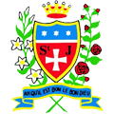

School Games Gymnastics

Congratulations to the Year 4 Gymnastics Squad for their amazing individual and team performances, during the recent School Games event. St Julie’s obtained 3rd place in the competition and demonstrated great teamwork.

Many thanks to Miss Bennett and Mr Royle for their coaching.