**Floppy’s Phonics Weekly Plan** 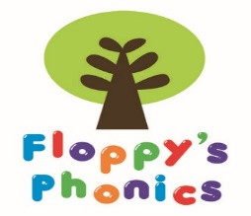

**9.00 a.m – 9.20 a.m. Revisit and Review**

Revise sounds and graphemes using the Flashcards and Frieze

Introduce new sound (Children to do ‘Jazz Hands’)

**Teach My turn- your turn (new sound and words on board)**

Teacher to model new sound while showing large Flashcard eg: ch, ch, ch. Children then repeat ch,ch,ch. Introduce the picture

Teacher to model reading of new sound using a range of words that include the new sound eg: s-n-ai-l, r-ai-n. Children then repeat using fingers for sounding and blending.

Look at Floppy’s Phonics online recap on the sound, picture, words and find the words in the picture

Complete drop and drag activity, children to say the sounds put them in the correct order and then say the whole word.

**9.20 a.m. – 9.45 a.m. Practise and Apply (carousel of activities)**

Practise new and revised sounds and graphemes with the activity sheets

Use the cumulative texts for reading, spelling and writing practice

Sound books to revise the set of sounds and graphemes

**Spelling Time (Using new sound after day 2)**

|  |  |  |
| --- | --- | --- |
| **Tuesday**  **1.**  **2.**  **3.**  **4.**  **5.** | **Thursday**  **1.**  **2.**  **3.**  **4.**  **5.** | **Fri**  Helpful words |
|  |

**Helpful and Alien Words**

Read helpful and alien words each day. Teacher to model putting them into a context sentence at the start of the week. Children to try to do this by the end of the week.

Practise helpful word spellings on Fridays