Dear parents and carers,


Science Week
St Julie’s scientists have had a very busy week! Our annual Science fair was held on Tuesday after school and was once again a huge success. Thank you to all the children who researched, planned and presented their investigations. We were all very impressed by the knowledge the children demonstrated and their confidence in explaining their scientific enquiry to other children and adults in the hall.
Mrs Mccahey is putting together a PowerPoint of all the photographs which will be available to view on the Science page on the website.


Eucharistic Adoration during Lent
During Lent we would like to offer children and their families the opportunity to spend some quiet time of reflection in front of the Eucharist at St Julie’s church. Fr Michael and children from each year group will lead the reflection each week from 3:30 – 4pm. Please take some time out from the hurly burly to come along:
Wednesday 20 March - Y3


Nugent Care “Good Shepherd” Appeal: Fundraising Day Friday 22nd March.
During Lent we are asked to prepare ourselves for the events of Holy Week through prayer, fasting and alms giving. We are conscious of the many families at this time who need our support and the Good Shepherd Appeal helps those in need in our own locality. In school we have spoken about how we can help those in our local area through raising money for the Good Shepherd fund. Next Friday, the children can come to school in their own clothes in return for a donation. Please remember to send your child in with money for the Good Shepherd Appeal on Friday.
As with all non-uniform days, the children still need to abide by health and safety rules so long hair must be tied back, clothing must be appropriate for school (no crop tops)


School Games Competitions - Athletics
Well done to our Year 3 and Year 4 Athletics Team who competed today at Broadway Sports Hall against several schools in St Helens. Congratulations to everyone and well done on representing our school so well!


Easter Craft Session
There will be an after-school Easter Craft session on Wednesday 27th March open to all year groups. These are always popular sessions with the children enjoying making a variety of decorations and gifts to take home. Places can be booked via School Money.


Online Safety
Please be vigilant in checking what children are viewing and ensure that safety settings are activated on all devices that your children use. Be mindful of the age ratings for Social Media platforms and monitor any chat that children are involved in. Remind children that they must be respectful online, just as they would be in person.
Key messages are:
- check age ratings for different apps and games and ensure they are appropriate for your child.
- know your child's passcode to monitor their on-line activity
- make children aware of the dangers such as cyber bullying, CSE, CCE and sexting etc.
- be in the same room as your child when they are accessing the internet
- parents can take any device into an O2 shop where there is a trained person from the NSPCC who can make devices child safe and adjust settings accordingly

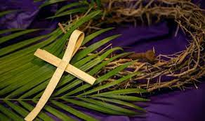
Passion Service
Easter is the most important festival in our Church’s year and so we invite everyone to share the events of the Passion of Our Lord on the final day of the school term.
Please come and join with all the children as Year 5 lead us in retelling and performing the events of Holy Week. In song and prayer we will reflect on the events leading to Jesus’ crucifixion on Good Friday and then the resurrection of Jesus celebrated on Easter Sunday.
The service will be followed by a PFA event in the school hall where cakes and refreshments will be on sale. We will also be grateful for any other donations of cakes for the coffee afternoon.
A polite reminder that, as with all school events, no photographs may be taken and phones should be switched off.


PFA Easter events:
There will be an Easter Bake-off and Cake Sale following the Passion Service on Thursday 28th March. Our panel of experts will be judging, and there will be a prize for the winner of each of the following categories:

Best Easter Cupcake
Best Easter Biscuit
Best Easter Traybake
Most Unique Easter Bake

So get baking and bring your Easter themed homemade goodies to your classroom on the morning of Thursday 28th March.
The bakes will all be on sale, for a donation, after school on the same day (Thursday 28th March). We also welcome all cake donations, whether home baked or not. for the cake sale, but only homemade bakes can be entered into the Bake-Off Competition, thank you for your understanding.

Please ensure there are no nuts, peanut butter or Nutella in any bakes or donated cakes.
Thank you for your support!


Tickets are on sale for the Easter Egg hamper from reception next week.

The next 100 Club draw will be on Thursday 28th March. If you would like to buy a membership please contact/message Tara Kelly 07810 832237.


St Julie’s School Values
Whilst the children know that each of our core values helps us to follow in the footsteps of Jesus, each half term we focus particularly on one of the core values. This half term we are thinking about love:
Love is showing kindness and forgiveness to all. We show love towards everyone around us and everything that God has created.



.
St Julie’s Awards of the Week

 | Star of the week for showing love | Book explorer | Marvellous mathematician
Reception | Jessica | Teddy | Francis
Year 1 | Daniel S | Arthur K | Seb P
Year 2 | Lennie R | Luke H | Noah C
Year 3 | Liberty | Thomas G | James
Year 4 | Xavier | Annabelle B | Thomas B
Year 5 | Phoebe | Archie | Amelia B
Year 6 | Alice | Thomas J | Anna

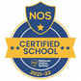

This week’s flyer from National Online Safety is about: “10 top tips for parents and carers: developing healthy sleep patterns.”


“From the first day of term to the last, the small moments in a school day make a real difference to your child.” #AttendanceCounts
At St Julie’s our attendance is excellent and we know that parents and carers value the education that your children receive. This week you should have received an email from us informing you that the Government is launching a national campaign to remind parents and carers of the importance of school attendance and promoting the importance of being in school, on time, every day.

Useful website Is my child too ill for school? - NHS (www.nhs.uk)

Year Group | % Attendance for w/e 15.03.24
Year R | 95.76
Year 1 | 92.76
Year 2 | 97.71
Year 3 | 95.88
Year 4 | 97.14
Year 5 | 96.00
Year 6 | 93.82

Well done to Year 2 who had the highest attendance this week.
Our whole school attendance this week is 95.58%

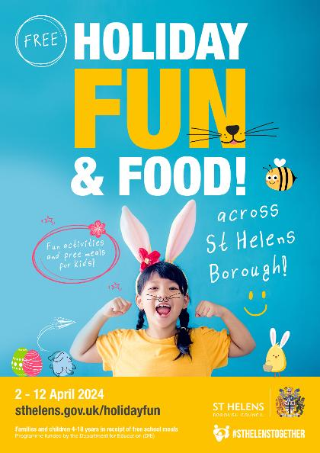
The Holiday Activities and Food (HAF) programme
The Holiday Activities and Food (HAF) programme is aimed at providing nutritious food and enriching activities for primary and secondary school aged children who are eligible for benefit related free school meals during the Easter, Summer and Christmas school holidays for children and young people aged 4 – 18 years who are eligible for and receiving benefits-related free school meals (FSM), and their families. Children and young people who are in receipt of a support plan via Early Help, Child In Need, Children We look after, EHCP or receives additional hours at school then they are also eligible for the HAF programme.
Throughout the Easter holidays eligible children and young people can access a variety of free activity sessions and all of these sessions will include a nutritious meal.
For more information on the exciting activities and opportunities that are available, dates and times please follow the link below or call Central Link Children’s Centre on 01744 673445.
https://www.sthelens.gov.uk/article/4060/Holiday-activities-and-food-programme
We are requesting that parents/carers book their child’s place for the Easter holiday activities as soon as possible, as numbers are limited (each provider can provide full details of their available sessions upon request). Please contact the delivery partner directly to book a place. Activity links will go live at 2.00pm on Monday 18th March 2024.
The sessions are fully funded by the Department for Education (DfE).

Diary w/c 18.03.2024

Monday 8am Gymnastics Year 1, 2, 3
Year 3 Apple of my eye
Reception visit to Windmill Farm
Y1/Y2/KS2 Multi-sports club 3:20 – 4:15
Y5/Y6 Drama club 3:20 – 4:15

Tuesday Tuna Tuesday – donations during Lent
KS2 Football club 3:20 – 4:15

Wednesday 8am Gymnastics Year 4, 5, 6
Year 3 Eucharistic Adoration 3:30 in Church
Year 1 Phonics club 3:20 – 4:15
KS2 Sewing club 3:20 – 4:15

Thursday Year 3 trip to Eureka, Wirral
KS2 Dodgeball 3:20 – 4:15

Friday Good Shepherd Appeal own clothes day

Mass times:
Saturday 6pm at St Thomas of Canterbury
Sunday 9:30am at St Julie
Sunday 11am at Lowe House Church in St Helens

Further dates for your Diary
Wednesday 27 March Easter after school crafts event
Thursday 28 March Easter Passion Service in church led by Year 5 1:30pm
Thursday 28 March PFA Cake Sale – in School hall following the Passion Service

Thursday 28 March School closes for Spring break
Monday 15 April School reopens
Thursday 18 April Year 5 swimming lessons commence at Queens Park
Friday 19 April PFA Infant film evening 3:20 – 4:45
Monday 22 April Year 5 Apple of my eye
Thursday 25 April Year 5 and Year 4 class Mass at St Julie’s church
Friday 26 April PFA Junior film evening
Friday 3 May Bikeability group sessions begin for Year 5
Thursday 9 May Whole school Mass for Feast of the Ascension
Saturday 11 May Frist Holy Communion Mass
Monday 13 May Year 6 SATs begin
Thursday 16 May Year 3 class Mass at St Julie’s church
Saturday 18 May First Holy Communion Mass
Thursday 23 May May Procession led by Year 4 for whole school
Thursday 23 May School closes for Whit holiday
Friday 24 May Staff INSET day
Monday 3 June Staff INSET day
Tuesday 4 June School reopens
Wednesday 5 June Year 6 residential to Colomendy until Friday 7 June
Wednesday 12 June Fun Sports Day in House Teams 1:30pm
Monday 17 June Year 6 Apple of my eye
Friday 21 June PFA Summer gala
Wednesday 26 June Year 1 trip to Manchester Airport
Thursday 27 June 9:30 Mass for SS Peter & Paul and Year 4 Holy Communion celebration
Thursday 18 July Year 6 Leavers’ Celebration event 2:00pm (Parents and grandparents)
Monday 22 July Year 6 Leavers’ Mass 6pm followed by disco in Parish Hall
Tuesday 23 July School closes for Summer

“A caring family school, where we learn, grow and walk in the footsteps of Jesus.”
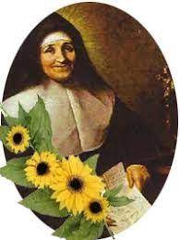
St Julie pray for us, protect us and bless us.

