Dear parents and carers,

As we prepare to enter Holy Week, I would like to thank all those families who have attended the Eucharistic Adoration during Lent; it was wonderful to see so many taking the time out from their busy lives to spend some quiet time of reflection in front of the Eucharist. We hope that this opportunity has helped you on your Lenten journey.
Thank you to all the children who read so confidently, giving us much to think and pray about.

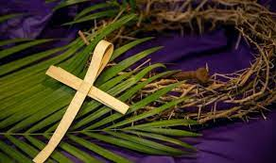
Passion Service
Easter is the most important festival in our Church’s year and so we invite everyone to share the events of the Passion of Our Lord on the final day of the school term.
Please come and join with all the children as Year 5 lead us in retelling and performing the events of Holy Week. In song and prayer we will reflect on the events leading to Jesus’ crucifixion on Good Friday and then the resurrection of Jesus celebrated on Easter Sunday.
The service will be followed by a PFA event in the school hall where cakes and refreshments will be on sale. We will also be grateful for any other donations of cakes for the coffee afternoon.
A polite reminder that, as with all school events, no photographs may be taken and phones should be switched off.

Mass times:
Saturday 6pm at St Thomas of Canterbury
Sunday 9:30am at St Julie - there will be Palm Sunday activities during little church at 9.30 Sunday mass. This will be the last little church before the Easter break - it will resume on the 21st April.
Sunday 11am at Lowe House Church in St Helens


Easter Craft Session
There will be an after-school Easter Craft session on Wednesday 27th March open to all year groups. These are always popular sessions with the children enjoying making a variety of decorations and gifts to take home. Places can be booked via School Money.


PFA Easter events:
There will be an Easter Bake-off and Cake Sale following the Passion Service on Thursday 28th March. Our panel of experts will be judging, and there will be a prize for the winner of each of the following categories:

Best Easter Cupcake
Best Easter Biscuit
Best Easter Traybake
Most Unique Easter Bake

So get baking and bring your Easter themed homemade goodies to your classroom on the morning of Thursday 28th March.
The bakes will all be on sale, for a donation, after school on the same day (Thursday 28th March). We also welcome all cake donations, whether home baked or not. for the cake sale, but only homemade bakes can be entered into the Bake-Off Competition, thank you for your understanding.

Please ensure there are no nuts, peanut butter or Nutella in any bakes or donated cakes.
Thank you for your support!


Tickets are on sale for the Easter Egg hamper from reception next week.

The next 100 Club draw will be on Thursday 28th March. If you would like to buy a membership please contact/message Tara Kelly 07810 832237.

SEND Drop-in session
Mrs Ashcroft will be available between 1:30pm and 3pm on Wednesday 27 March to speak with parents/carers by phone or in person. No appointment necessary, just ring or turn up at the office during the afternoon. However, if you do wish to make a prior appointment then please contact the school office.

Athletics Success!
Last Friday I told you about our Year 3 and Year 4 Athletics Team who competed that day at Broadway Sports Hall against several schools in St Helens and congratulated them on representing our school so well. At that time the results of each event and overall team scores had not been tallied up. I am delighted to tell you that our team came 3rd in the competition and received their bronze medals in assembly this morning – well done everyone.




St Julie’s School Values
Whilst the children know that each of our core values helps us to follow in the footsteps of Jesus, each half term we focus particularly on one of the core values. This half term we are thinking about love:
Love is showing kindness and forgiveness to all. We show love towards everyone around us and everything that God has created.



.
St Julie’s Awards of the Week

 | Star of the week for showing love | Book explorer | Marvellous mathematician
Reception | Orlagh | Olivia | Stanley
Year 1 | Nancy | Matthew | Lilia
Year 2 | Ali | Daniel | Joel
Year 3 | Bobby | Zara | Olly Mc
Year 4 | Phinnaeus | Georgia M | Alice
Year 5 | Marley | Thomas K | Archie
Year 6 | Lucas C | Myla | Olly P

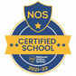

This week’s flyer from National Online Safety is about: “10 top tips for parents and educators: encouraging open conversations at home.”


“From the first day of term to the last, the small moments in a school day make a real difference to your child.” #AttendanceCounts
At St Julie’s our attendance is excellent and we know that parents and carers value the education that your children receive. This week you should have received an email from us informing you that the Government is launching a national campaign to remind parents and carers of the importance of school attendance and promoting the importance of being in school, on time, every day.

Useful website Is my child too ill for school? - NHS (www.nhs.uk)

Year Group | % Attendance for w/e 22.03.24
Year R | 93.64
Year 1 | 96.55
Year 2 | 96.00
Year 3 | 99.12
Year 4 | 95.43
Year 5 | 96.29
Year 6 | 91.76

Well done to Year 3 who had the highest attendance this week.
Our whole school attendance this week is 95.54%

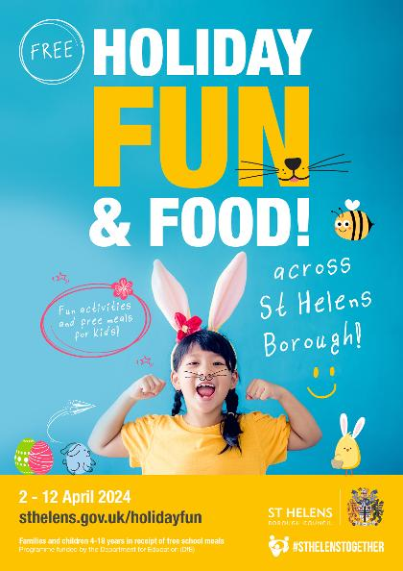
The Holiday Activities and Food (HAF) programme
The Holiday Activities and Food (HAF) programme is aimed at providing nutritious food and enriching activities for primary and secondary school aged children who are eligible for benefit related free school meals during the Easter, Summer and Christmas school holidays for children and young people aged 4 – 18 years who are eligible for and receiving benefits-related free school meals (FSM), and their families. Children and young people who are in receipt of a support plan via Early Help, Child In Need, Children We look after, EHCP or receives additional hours at school then they are also eligible for the HAF programme.
Throughout the Easter holidays eligible children and young people can access a variety of free activity sessions and all of these sessions will include a nutritious meal.
For more information on the exciting activities and opportunities that are available, dates and times please follow the link below or call Central Link Children’s Centre on 01744 673445.
https://www.sthelens.gov.uk/article/4060/Holiday-activities-and-food-programme
We are requesting that parents/carers book their child’s place for the Easter holiday activities as soon as possible, as numbers are limited (each provider can provide full details of their available sessions upon request). Please contact the delivery partner directly to book a place. Activity links will go live at 2.00pm on Monday 18th March 2024.
The sessions are fully funded by the Department for Education (DfE).

Diary w/c 25.03.2024

Monday 8am Gymnastics Year 1, 2, 3
Y1/Y2/KS2 Multi-sports club 3:20 – 4:15
Y5/Y6 Drama club 3:20 – 4:15

Tuesday Tuna Tuesday – final donations during Lent
Year 3 Collective Worship 3pm in the classroom
KS2 Football club 3:20 – 4:15

Wednesday 8am Gymnastics Year 4, 5, 6
SEND drop-in 1:30pm until 3pm
No Phonics or Sewing club
Easter after school crafts event – book by School Money

Thursday Easter Passion Service in church led by Year 5 1:30pm
PFA Cake Sale – in School hall following the Passion Service
KS2 Dodgeball 3:20 – 4:15
School closes for Easter break

Further dates for your Diary
Monday 15 April School reopens
Wednesday 17 April Y2 trip to Norton Priory
Thursday 18 April Year 5 swimming lessons commence at Queens Park
Thursday 18th April Y4 Sacramental programme – session 7 in church at 6pm
Friday 19 April PFA Infant film evening 3:20 – 4:45
Monday 22 April Year 5 Apple of my eye
Thursday 25 April Year 5 and Year 4 class Mass at St Julie’s church 9:20am
Friday 26 April PFA Junior film evening
Thursday 2 May NHS Reception class vision checks
Thursday 2 May Mental health and wellbeing workshop for parents and child Y3/4 3:20pm
Friday 3 May Bikeability group sessions begin for Year 5

Thursday 9 May Whole school Mass for Feast of the Ascension
Saturday 11 May Frist Holy Communion Mass
Monday 13 May Year 6 SATs begin
Thursday 16 May Year 3 class Mass at St Julie’s church
Saturday 18 May First Holy Communion Mass
Thursday 23 May May Procession led by Year 4 for whole school
Thursday 23 May School closes for Whit holiday
Friday 24 May Staff INSET day
Monday 3 June Staff INSET day
Tuesday 4 June School reopens
Wednesday 5 June Year 6 residential to Colomendy until Friday 7 June
w/c 10 June Year 1 Phonic Screening Check and Year 4 Multiplication Tables Check
Monday 17 June Year 6 Apple of my eye
Wednesday 19 June (change of date) Fun Sports Day in House Teams KS2 9:30am KS1/EYFS 1:30pm
Friday 21 June PFA Summer gala
Wednesday 26 June Year 1 trip to Manchester Airport
Thursday 27 June 9:30 Mass for SS Peter & Paul and Year 4 Holy Communion celebration
w/c 1 July Year 6 transition week at De La Salle for those going to that High School
Thursday 4 July Reception class trip to Imagine That!
Thursday 18 July Year 6 Leavers’ Celebration event 2:00pm (Parents and grandparents)
Monday 22 July Year 6 Leavers’ Mass 6pm followed by disco in Parish Hall
Tuesday 23 July School closes for Summer

“A caring family school, where we learn, grow and walk in the footsteps of Jesus.”

St Julie pray for us, protect us and bless us.

