Dear Parents/carers,

Welcome back to school after our 2-week break. We have been blessed with some sunny weather and are excited for the Summer term ahead.


James Ketchell visit
Our summer term got off to an extremely exciting start on Tuesday when we welcomed James Ketchell to school to share some of his adventures from around the world. James has rowed across the Atlantic Ocean, climbed Everest and travelled around the world twice; first using a gyrocopter and then on a bicycle. The children expanded their geography knowledge through learning about some of the places James has visited while also hearing valuable life lessons about facing adversity, showing kindness, resilience, hope and respect. All of the qualities reflected in our own core school values. The children were enthralled by his stories, photos and video clips. Afterwards, many of the children were heard talking about things that they wanted to do, their hopes for the future and things they might like to achieve.

James is currently preparing to embark on his next adventure in September of sailing solo around the world and through on-board technology the children will be able to track his progress on his journey and join some live video chats with him.


Spring is here!
After the Easter break we are hoping to replenish our planters with flowering plants and herbs for the children to care for and to brighten up our environment. If you are visiting a garden centre we would be very grateful if you could buy an extra plant to donate to school for your child’s class planter. Thank you.

Year 2 trip to Norton Priory
Year 2 had an amazing time at Norton Priory on Wednesday on their science-based trip. It began with an exploration of the forest followed by pond dipping. The children had their lunch in the historic Priory and then moved back outside to take part in some worm charming! They all now know the secret of how to make the worms come out of the soil – even when it isn’t raining. The fun and learning continued with a minibeast hunt and the bee waggle game. Back at school the children have written wonderful accounts of their experience and are keen to continue their learning in our school grounds.

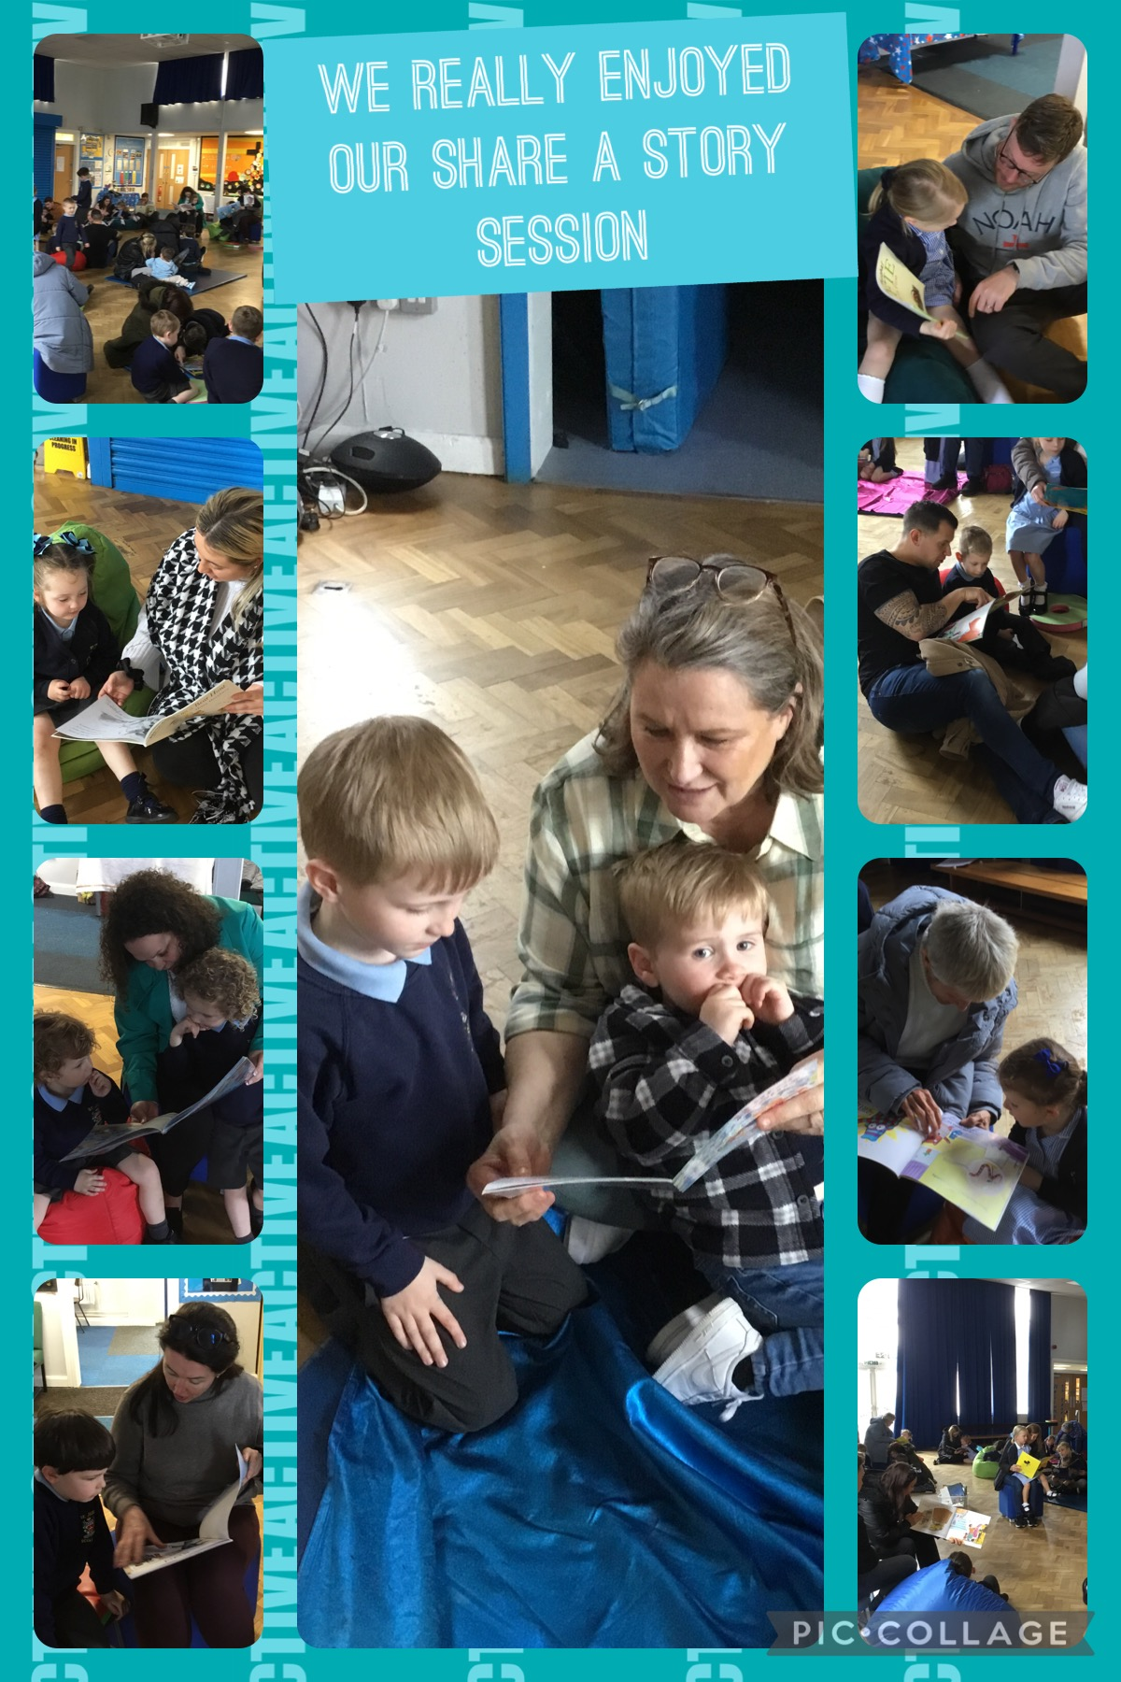

Share a Story sessions
The children of St Julie’s are enthused by their love of books and find great pleasure in their reading. Once again, we would like to invite parents/carers to come into school to share a story – or more – with their child in the school hall.
One adult is invited to come to school via the front entrance on Brooklands Road at 2:40pm to join their child for a cosy reading session. School will provide the books and don’t worry if you can’t make it, there will be school staff around to make sure all children can have a fun reading time.
Further sessions are:
Friday 26th April – Year 5
Wednesday 1st May – Year 1
Thursday 2nd May – Year 2
Friday 3rd May – Year 3
Wednesday 8th May – Year 4
Wednesday 22nd May – Year 6

Payment for school trips and events
A reminder that payment for all trips and events should be made via School Money. We are mindful of the increased cost of so many things that we all face at the moment and with this in mind have tried to reduce the number of paid trips and events for each class throughout the year. However, we also still want to be able to offer children memorable experiences that enrich our curriculum. If payment contributions are not made, unfortunately this impacts greatly on our school budget as the companies concerned still have to be paid. Payment reminders are sent by School Money – please help us to balance our books. Thank you.


St Julie’s School Values
Whilst the children know that each of our core values helps us to follow in the footsteps of Jesus, each half term we focus particularly on one of the core values. This half term we are thinking about honesty:
Honesty is understanding and following the values of right and wrong by walking in the footsteps of Jesus. We are truthful at all times.


.
St Julie’s Awards of the Week

 | Star of the week for showing honesty | Book explorer | Marvellous mathematician
Reception | Toby | Blake Ha | Isabelle
Year 1 | Samantha | Georgie | Lilia
Year 2 | Ali | Zac | Josefina D
Year 3 | Nuala | Dominic | Teddy H
Year 4 | Luca P | Findlay | Florence
Year 5 | Luca B | Elizabeth | Bertie
Year 6 | Rosemary | Atarah | Sophia


“From the first day of term to the last, the small moments in a school day make a real difference to your child.” #AttendanceCounts
At St Julie’s our attendance is excellent and we know that parents and carers value the education that your children receive. This week you should have received an email from us informing you that the Government is launching a national campaign to remind parents and carers of the importance of school attendance and promoting the importance of being in school, on time, every day.

Useful website Is my child too ill for school? - NHS (www.nhs.uk)

Year Group | % Attendance for w/e 19.04.24
Year R | 100.00
Year 1 | 98.28
Year 2 | 96.00
Year 3 | 97.65
Year 4 | 96.29
Year 5 | 96.86
Year 6 | 97.65

Well done to Year R who had the highest attendance this week – 100% fantastic!
Our whole school attendance this week is 97.53%


This week’s flyer from National Online Safety is, “What parents and educators need to know about Energy Drinks.”

Diary w/c 22.04.2024

Monday 8am Gymnastics Year R,1, 2,
Year 5 Apple of my eye
Y1/Y2 Football club 3:20 – 4:15
KS2 Science club 3:20 – 4:15

Tuesday KS2 Multi-sports club 3:20 – 4:15

Wednesday 8am Gymnastics Year 3,4, 5, 6
KS2 Athletics club 3:20 – 4:15
Y1/2 Spanish club 3:20 – 4:15
KS2 Arts & Crafts club 3:20 – 4:15

Thursday Year 5 and Year 4 class Mass at St Julie’s church 9:20am
Year 5 swimming lessons at Queens Park
KS2 Dodgeball 3:20 – 4:15
KS2 Gardening club 3:20 – 4:15
Y1/2 Lego club 3:20 – 4:15

Friday Year 5 Share a Story session 2:40 in school hall
PFA Junior film evening 3:20 – 5:00

Further dates for your Diary
Monday 1 May Year 1 Share a Story session 2:40pm
Thursday 2 May NHS Reception class vision checks
Thursday 2 May Year 2 Share a Story session 2:40pm
Thursday 2 May Mental health and wellbeing workshop for parents and child Y3/4 3:20pm
Friday 3 May Bikeability group sessions begin for Year 5
Friday 3 May Year 3 Share a Story session 2:40pm
Tuesday 7 May Meeting for new intake September 2024 – 5pm in school hall
Wednesday 8 May Year 4 Share a Story session 2:40pm
Thursday 9 May Whole school Mass for Feast of the Ascension
Saturday 11 May Frist Holy Communion Mass
Monday 13 May Year 6 SATs begin
Thursday 16 May Year 3 class Mass at St Julie’s church
Saturday 18 May First Holy Communion Mass
Wednesday 22 May Year 6 Share a Story session 2:40pm
Thursday 23 May May Procession led by Year 4 for whole school
Thursday 23 May School closes for Whit holiday
Friday 24 May Staff INSET day
Monday 3 June Staff INSET day
Tuesday 4 June School reopens
Tuesday 4 June Year 6 transition – De La Salle staff/pupils visit to St Julie’s
Wednesday 5 June Year 6 residential to Colomendy until Friday 7 June
w/c 10 June Year 1 Phonic Screening Check and Year 4 Multiplication Tables Check
Tuesday 11 June Reception class – Song Fest at St Helens Town Hall
Monday 17 June Year 6 Apple of my eye
Wednesday 19 June Children’s University Graduation for KS2 at Liverpool Hope University pm
Friday 21 June PFA Summer gala
Tuesday 25 June (new date) Fun Sports Day in House Teams KS2 9:30am KS1/EYFS 1:30pm
Wednesday 26 June Year 1 trip to Manchester Airport
Thursday 27 June 9:30 Mass for SS Peter & Paul and Year 4 Holy Communion celebration
w/c 1 July Year 6 transition week at De La Salle for those going to that High School
Monday 1 July Year 4 trip to Chester
Thursday 4 July Reception class trip to Imagine That!
Tuesday 8 July Reserve date for Sports day in the event of bad weather
Thursday 18 July Year 6 Leavers’ Celebration event 2:00pm (Parents and grandparents)
Monday 22 July Year 6 Leavers’ Mass 6pm followed by disco in Parish Hall
Tuesday 23 July School closes for Summer

“A caring family school, where we learn, grow and walk in the footsteps of Jesus.”

St Julie pray for us, protect us and bless us.

