Year 3 and 4 Saints Rugby Festival
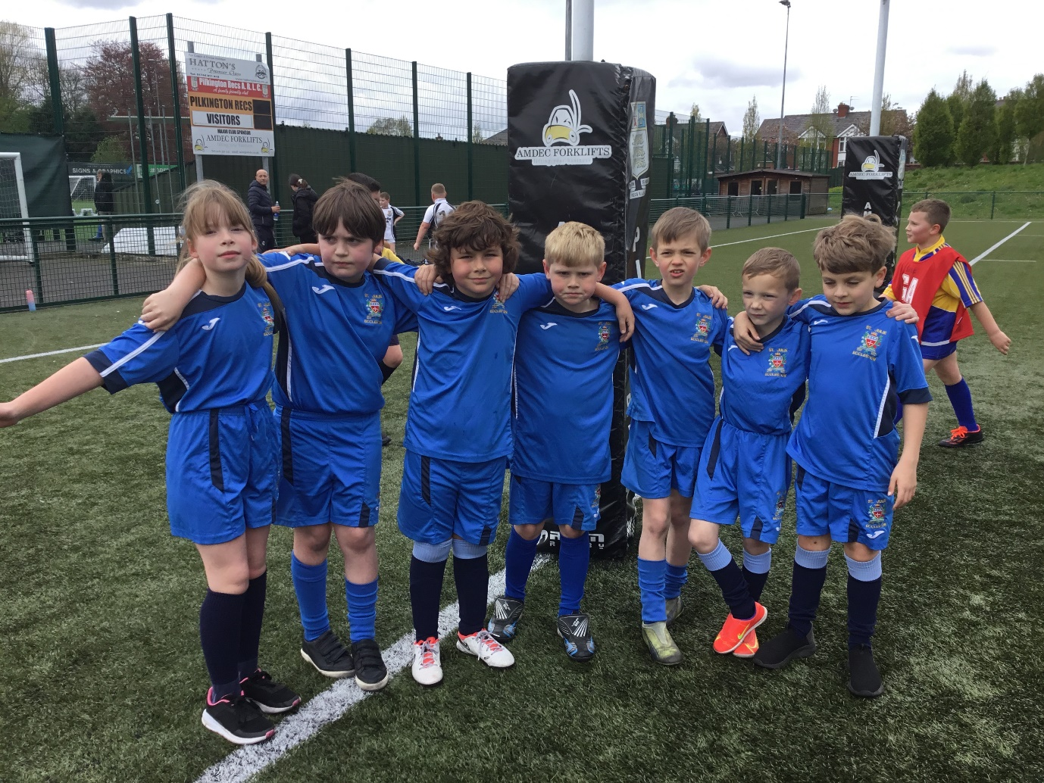

Congratulations to the Year 3 and 4 children for their amazing team effort, during the Saints Rugby Festival at Ruskin Drive. They showed great team spirit and resilience during the day.

Well done everyone!

