St Julie Catholic Primary School Reading Newsletter Summer 2023 
Produced by our Reading Ambassadors
Welcome to our Summer Reading Newsletter, a place to find out what we are doing to promote a love of reading as well as recommendations from book loving teachers and children!

In this issue, we will be sharing books which can support our children as they move to their new classes or to secondary school. We have also included some fun reading challenges for over the school holidays.

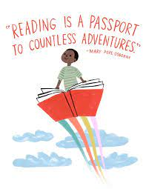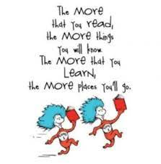 | Books our Reading Ambassadors think you should look out for in our Libraries:
 | EYFS/KS1 Library  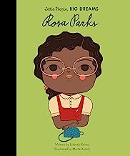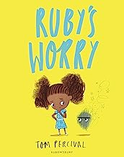 | KS2 Library  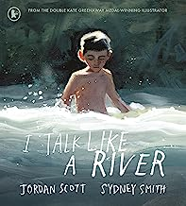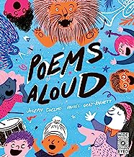
Books we have been enjoying together in class this term

EYFS  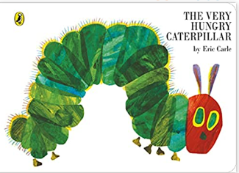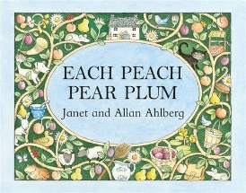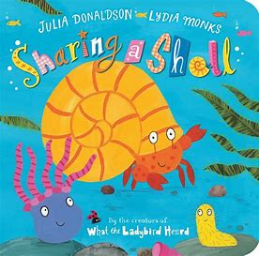 | Year 1  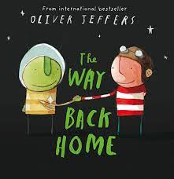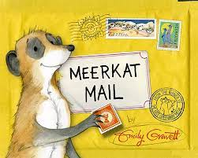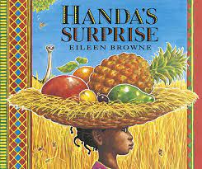
Year 2  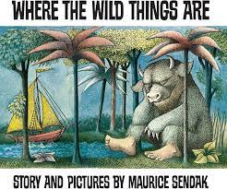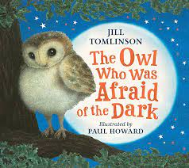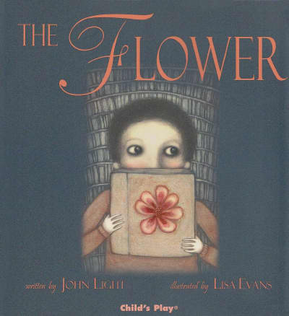 | Year 3  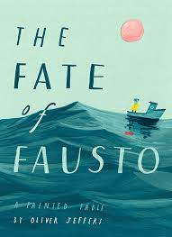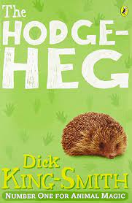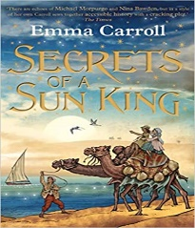
Year 4  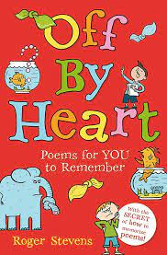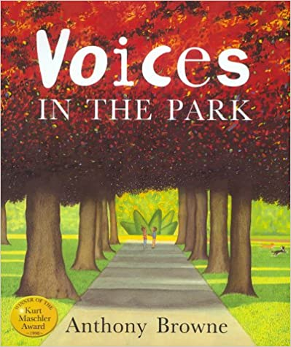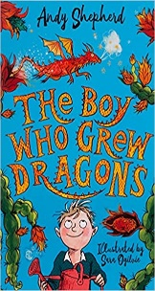 | Year 5  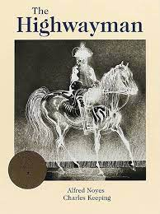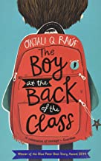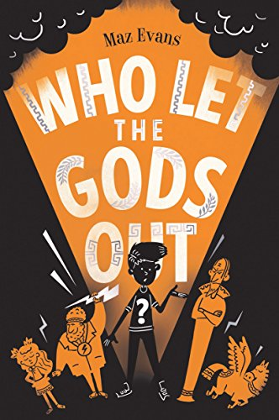
Year 6  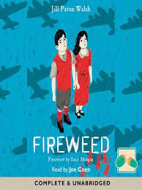  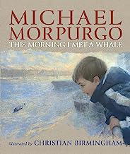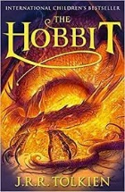 | 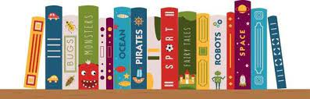
What’s Been This Happening This Term at St Julie’s?
Reading Boat  We have had so much fun enjoying the lovely weather this term and reading in our brand-new Reading Boat  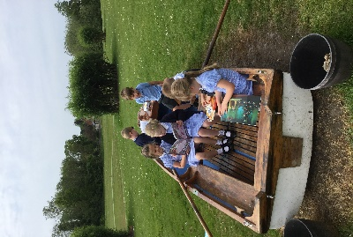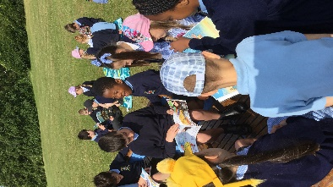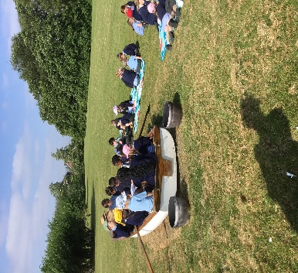 | Visit to Eccleston Library  As part of Refugee Week Year 3 visited Eccleston Library. They tried pomegranate seeds as they had enjoyed reading a segment from ‘The Boy at the Back of the Class.’  They discussed what a refugee was and things that they could do for others  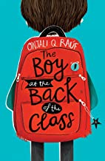  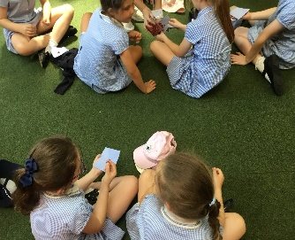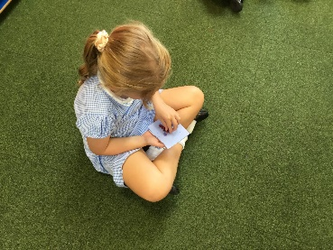
Transition
Moving to a new class with a new teacher can sometimes be unsettling for children. They may experience a range of emotions and not understand why.  ‘Feelings’, cleverly designed and sensitively illustrated, is a wonderful book to explore the world of feelings. It examines emotions from sadness to jealousy, loneliness to excitement, through simple lines of verse and empathetic drawings. We all feel these things, is the message; feelings are strong and real, but they come and go.  Moving to a New Class  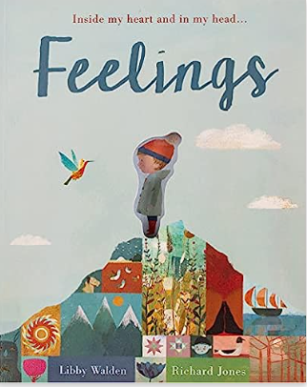 | 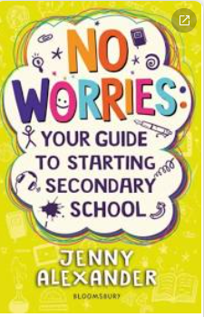  Moving to a New School  This term we say goodbye to our awesome Year 6 class as they set off on their journey to secondary school. ‘No Worries’ is the ultimate secondary school survival guide, with tips, quizzes and jokes to help children prepare. Starting secondary school is a bit like going on a safari – it’s a great big adventure but sometimes, before you go, you get a touch of the ‘what ifs’.  You may be feeling anxious or stressed about leaving primary school. No Worries is full of information about going up from primary school to secondary school and covers all the big worries and anxieties.
Staff Reading Interviews
Our Reading Ambassador Lucy in Year 5 spoke with Mrs Kernick:  What is your favourite book for KS1?  The Day the Crayons Quit  What genre is this book?  Fiction    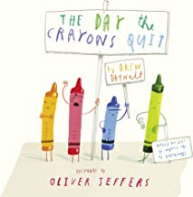  Why do you recommend this book?  The children really enjoy listening to this story and it has lots of different characters. When you are reading the story, you can do lots of different voices for the characters and this make it interesting for the children | Our Reading Ambassador Amelie in Year 5 spoke with Miss Pratt:    What is your favourite KS2 book?  The Secrets of the Sun King  Do you prefer fiction or non-fiction books?  Fiction  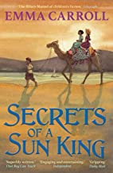  Where is your favourite place to read and why?  In the garden on a sun lounger because it’s warm and relaxing
Summer Holidays
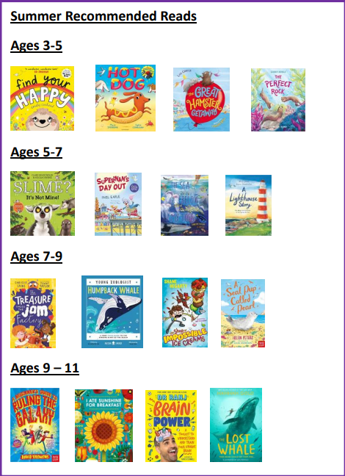 | We invite you to encourage your children to take up the Summer Reading Challenge. It’s the UK’s biggest reading for pleasure programme for children aged 4 to 11, delivered via public libraries. Children can sign up at their local library from July 10^{th.}  Last year, in St Helens, over 1500 children joined the Challenge and we would like to beat that number this year!  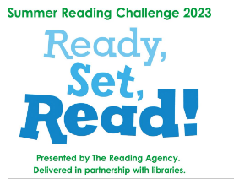  How it works:  · Children sign up at any library in St Helens and receive a collector folder as well as a tote bag with a free book.  · They borrow 6 books of their choice during the summer, collecting special stickers.  · Library staff and volunteers help children to discover new books that suit their interests and reading level and run a programme of free themed activities in the library.  · Children who complete the Challenge are presented with a certificate.  · Children can take part online, too! www.summerreadingchallenge.org.uk.  F For further details contact your local library.  Would you like to be in our Reading Newsletter?  From September we would like the children to have an active part in our reading newsletters. Over the Summer it would be great if you could take pictures of yourselves completing our Summer Reading Challenges.  Children can also send in book reviews of any books they have read over the summer. They just need to tell us what the book was about and why they liked it. Please send these through to the school email address and I will publish some reviews in the first Reading Newsletter for Autumn 2023.  Have your say! Tell me what you would like to see on the Reading Newsletter. Is it more information on different types of books, how to support your child when reading or maybe just some fun stuff? Please send your ideas through to the school email for the next reading newsletter.

