
Dear Parents/carers,

We are so proud of the determination and focus with which our Year 6 children have approached their SATs this week. Each, and everyone of them did their very best and we can’t ask any more of them than that. They are the big brothers and sisters in our school family, and the rest of the children supported them well this week while they sat their tests. Now they have lots of exciting events to look forward to for the rest of the summer term…
Well done everyone!

Year 6 Residential
For the parents of those children going to Colomendy after half-term, there will be an information meeting in school on Tuesday 21st May at 5pm.


Year 4 First Holy Communion
Our thoughts and prayers are with the second half of our Year 4 children and their families who after months of preparation take another step along their faith journey as they make their First Holy Communion tomorrow.
Families should be seated in their allocated bench by 9:45am ready for the Mass to start at 10am.

There will be a collection for the Parish of St Julie’s during the Mass so please bring along a donation.

A reminder that Sunday Mass is at 9:30am at St Julie’s Parish Church every week – Fr Michael would love to see our children at the Mass with their families.

Congratulations to the Year 4 children who made their First Holy Communion last week. It was a wonderful family celebration: the children read and sang beautifully. I am sure that in the future, the day will be a cherished memory for all of them.

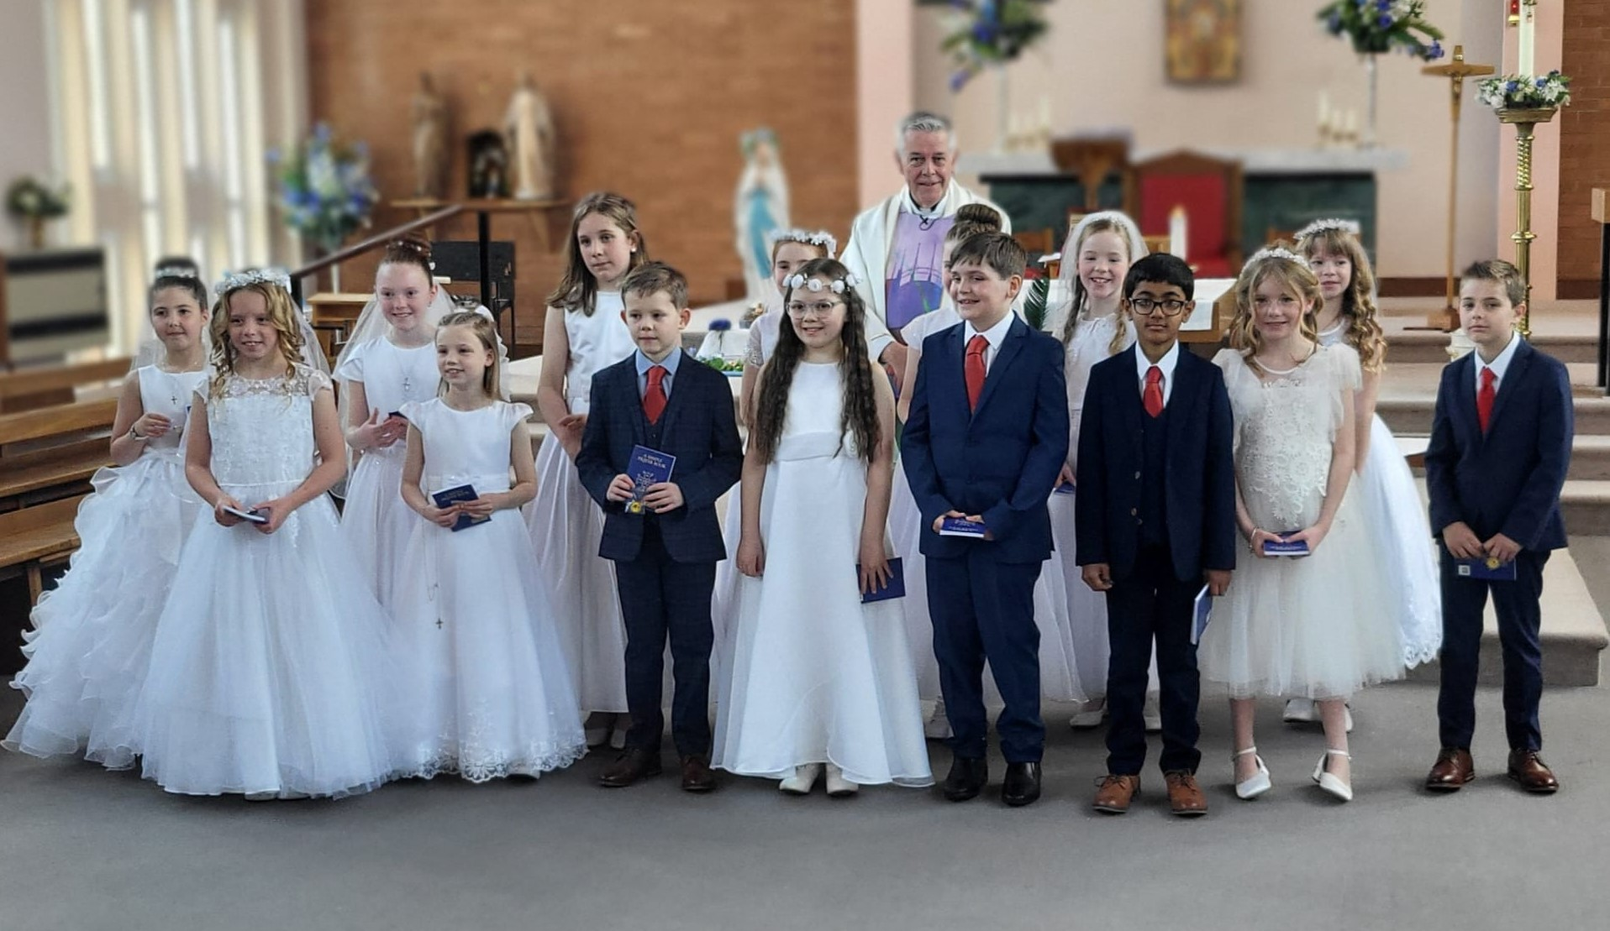

The photographer will be in school on Monday 20 May to take individual photos of the children in Year 4 in their Holy Communion clothes, and a class photo. Children in Year 4 should come into school wearing their Holy Communion clothes and will be photographed first. Please send in their uniform to change into after the photograph has been taken and a bag/holder for their Communion clothes.


School class photos: Year 6 and Reception class photo
The photographer will be in school on Monday 20 May to take a class photo of our Reception class and our Year 6 class as a memory of their first and last year at St Julie’s.


May Procession – Thursday 23rd May 2024
We are excited to bring back one of the most beautiful traditions of honouring Mary – The May Procession. Once registers have been taken on the morning of Thursday 23rd May, each class will gather on the playground to process behind our school banner up to Church for a special Mass. The Year 4 children will lead the procession wearing their Holy Communion clothes. Family and friends are warmly invited to join us in church for Mass at 9:30am.
We ask that Junior children bring in Rosary Beads to school as soon as possible and leave them in school until the date of the procession, as they will carry them with them.
We also ask that, if possible, the children in Year 6 (our leavers) and Year 4 (our First Communicants) bring in some flowers to lay before the statue of Our Lady. Once in church, we will crown Mary with flowers.
When the Mass has finished, we ask that people remain in church until the children have all processed out of the church and then join the procession, if you wish, as the children walk down to school via Brooklands Road. Refreshments will then be available in the school hall.

School grounds
A reminder that children must not play on the equipment in the school grounds, the boat or in the trees after school when there is no teacher there to supervise them. We ask that parents and carers please leave the grounds so that gates can be closed for security. Thank you.



St Julie’s School Values
Whilst the children know that each of our core values helps us to follow in the footsteps of Jesus, each half term we focus particularly on one of the core values. This half term we are thinking about honesty:
Honesty is understanding and following the values of right and wrong by walking in the footsteps of Jesus. We are truthful at all times.


.
St Julie’s Awards of the Week

 | Star of the week for showing honesty | Book explorer | Marvellous mathematician
Reception | Neve | Myles | Evie
Year 1 | Sophie P | Georgie W | Austin
Year 2 | Thea W | Amaya | Ivy
Year 3 | George | Sam | Ted A
Year 4 | Alissa | Teddy B | Georgia M
Year 5 | Poppy T | Eva | Phoebe
Year 6 | All of Year 6 for their effort, resilience and determination in their tests this week.


“From the first day of term to the last, the small moments in a school day make a real difference to your child.” #AttendanceCounts
At St Julie’s our attendance is excellent and we know that parents and carers value the education that your children receive. This week you should have received an email from us informing you that the Government is launching a national campaign to remind parents and carers of the importance of school attendance and promoting the importance of being in school, on time, every day.

Useful website Is my child too ill for school? - NHS (www.nhs.uk)

Year Group | % Attendance for w/e 17.05.24
Year R | 99.70
Year 1 | 99.31
Year 2 | 95.14
Year 3 | 95.88
Year 4 | 94.29
Year 5 | 97.71
Year 6 | 100.0

Well done to Year 6 who had the highest attendance this week – 100% fantastic!
Our whole school attendance this week is 97.43%


This week’s flyer from National Online Safety is, “What parents and educators need to know about School Avoidance.”

Diary w/c 20.05.2024

Monday 8am Gymnastics Year R,1, 2,
Photographer for Year 4 Holy Communion, class photos Reception and Year 6
Bikeability Y5
Road safety talks for YR, Y1 and Y2
Y1/Y2 Football club 3:20 – 4:15
KS2 Science club 3:20 – 4:15

Tuesday Bikeability Y5
Road Safety talks for Y3 and Y4
KS2 Multi-sports club 3:20 – 4:15


Wednesday 8am Gymnastics Year 3,4, 5, 6
Bikeability Y5
Year 6 Share a Story session 2:40pm
KS2 Athletics club 3:20 – 4:15
Y1/2 Spanish club 3:20 – 4:15
KS2 Arts & Crafts club 3:20 – 4:15

Thursday May Procession led by Year 4 for whole school
Year 5 swimming lessons at Queens Park
KS2 Dodgeball 3:20 – 4:15
Lost In Music 3:20 – 4:30
School closes for Whit holiday

Friday Staff INSET day

Further dates for your Diary
Monday 3 June Staff INSET day
Tuesday 4 June School reopens
Tuesday 4 June Year 6 transition – De La Salle staff/pupils visit to St Julie’s
Wednesday 5 June Year 6 residential to Colomendy until Friday 7 June
w/c 10 June Year 1 Phonic Screening Check and Year 4 Multiplication Tables Check
Tuesday 11 June Reception class – Song Fest at St Helens Town Hall
Monday 17 June Year 6 Apple of my eye
Wednesday 19 June Children’s University Graduation for KS2 at Liverpool Hope University pm
Friday 21 June PFA Summer gala
Tuesday 25 June Fun Sports Day in House Teams KS2 9:30am KS1/EYFS 1:30pm
Wednesday 26 June Year 1 trip to Manchester Airport
Thursday 27 June 9:30 Mass for SS Peter & Paul and Year 4 Holy Communion celebration
w/c 1 July Year 6 transition week at De La Salle for those going to that High School
Monday 1 July Year 4 trip to Chester
Thursday 4 July Reception class trip to Imagine That!
Tuesday 9 July Reserve date for Sports day in the event of bad weather
Thursday 18 July Year 6 Leavers’ Celebration event 2:00pm (Parents and grandparents)

Monday 22 July Year 6 Leavers’ Mass 6pm followed by disco in Parish Hall
Tuesday 23 July School closes for Summer

“A caring family school, where we learn, grow and walk in the footsteps of Jesus.”
St Julie pray for us, protect us and bless us.

