Dear Parents/carers,

Congratulations to the Year 4 children who made their First Holy Communion last week. It was a wonderful family celebration: the children read and sang beautifully. I am sure that in the future, the day will be a cherished memory for all of them.

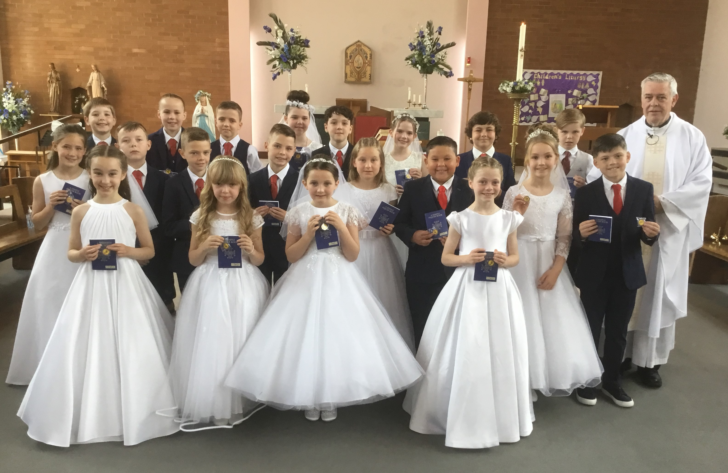

A reminder that Sunday Mass is at 9:30am at St Julie’s Parish Church every week – Fr Michael would love to see our children at the Mass with their families.

May Procession
This morning’s May procession in honour of Our Lady was a wonderful event to end our half term. It was a very moving moment as the children processed into church with their Rosary beads and flowers singing Ave Maria in front of the waiting congregation. Our Year 4 Holy Communicants followed behind Fr Michael and our St Julie’s banner - wearing their Holy Communion clothes they laid flowers before the statue of Mary at the side of the altar.
They were then followed by our Year 6 children who also laid flowers in thanks for their time at St Julie’s. The children read confidently and the singing was joyous. Lucas and India from Year 4 had the honour of placing the crown of flowers on Mary during the Mass. Fr Michael spoke to the children about the significance of the Rosary and how it helps us to remember the special events in Mary’s life as the mother of Jesus. He then led us in a decade of the Rosary with the children responding as they followed with their Rosary beads.
Although the rain and wind prevented us from processing along the roads as we had planned, our first May Procession for many years was a memory to treasure. Thank you to everyone who was able to share this with us today.

Happily, the sun was shining earlier in the week when the Reception class gathered in the Marian Prayer Garden to give praise to Mary. They placed their reflection stones and the giant Rosary beads that they had made and sang their hearts out. Use the QR code to hear the children sing Ave Maria or visit the RE tab of the Reception Class page on our website.

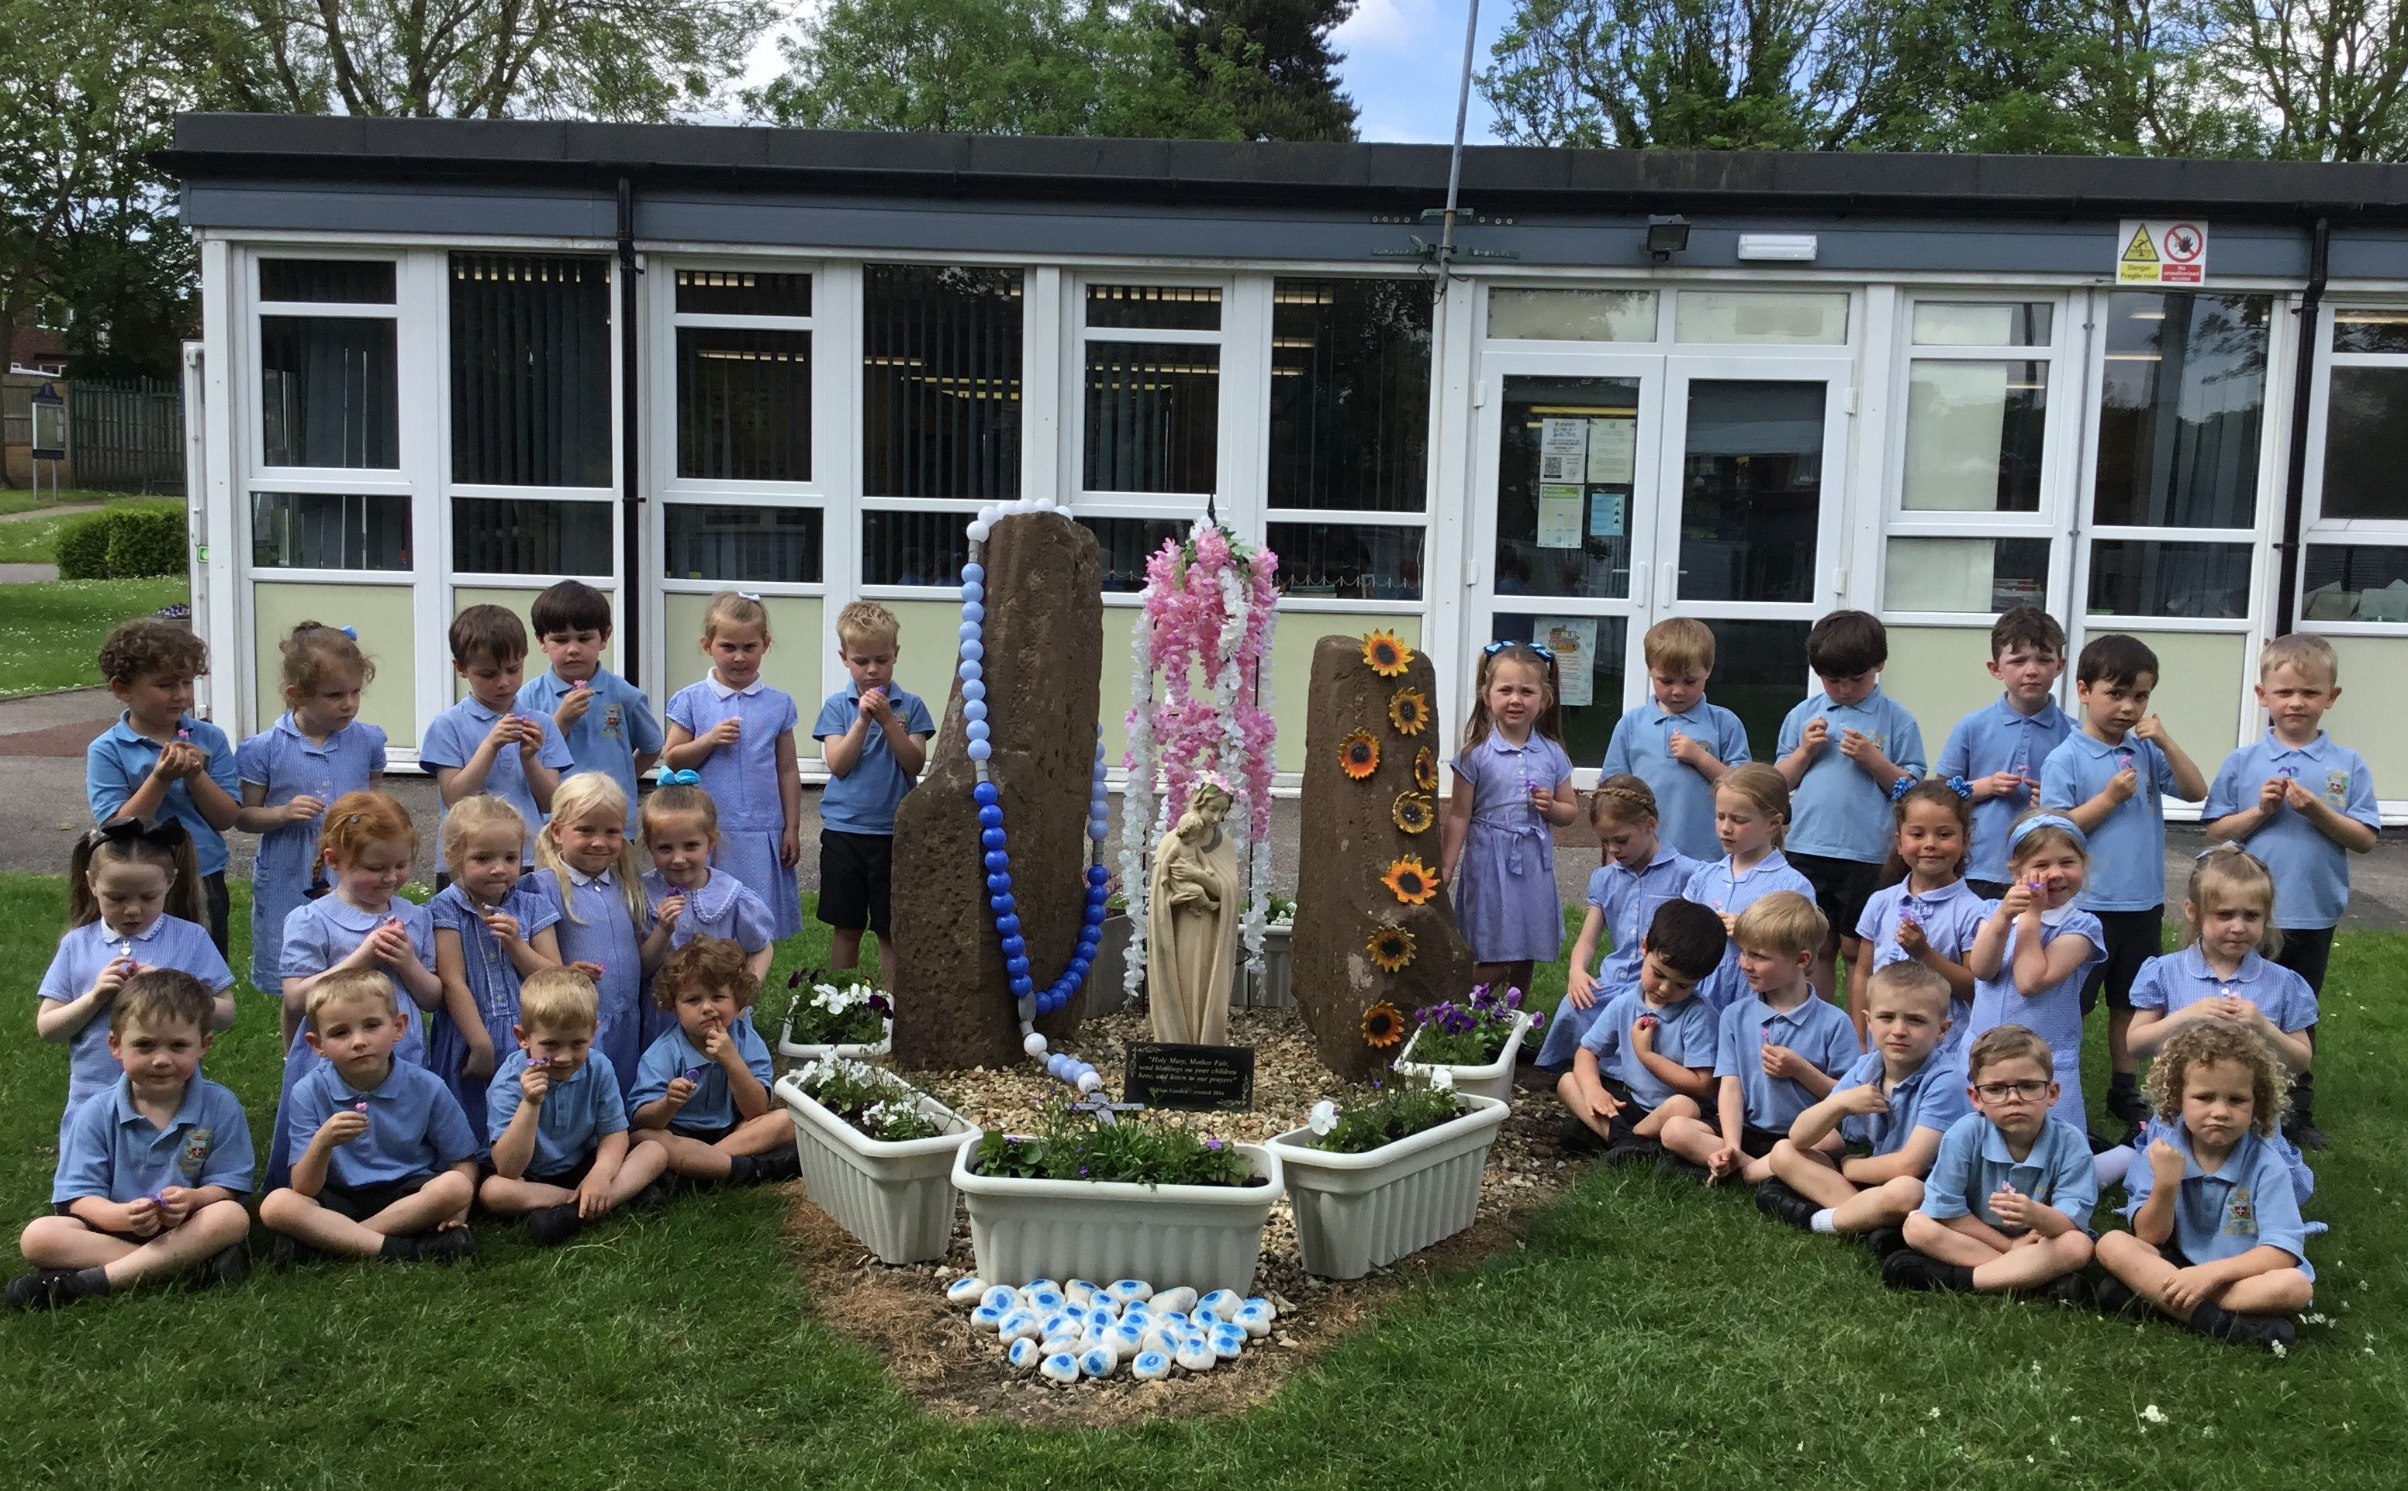

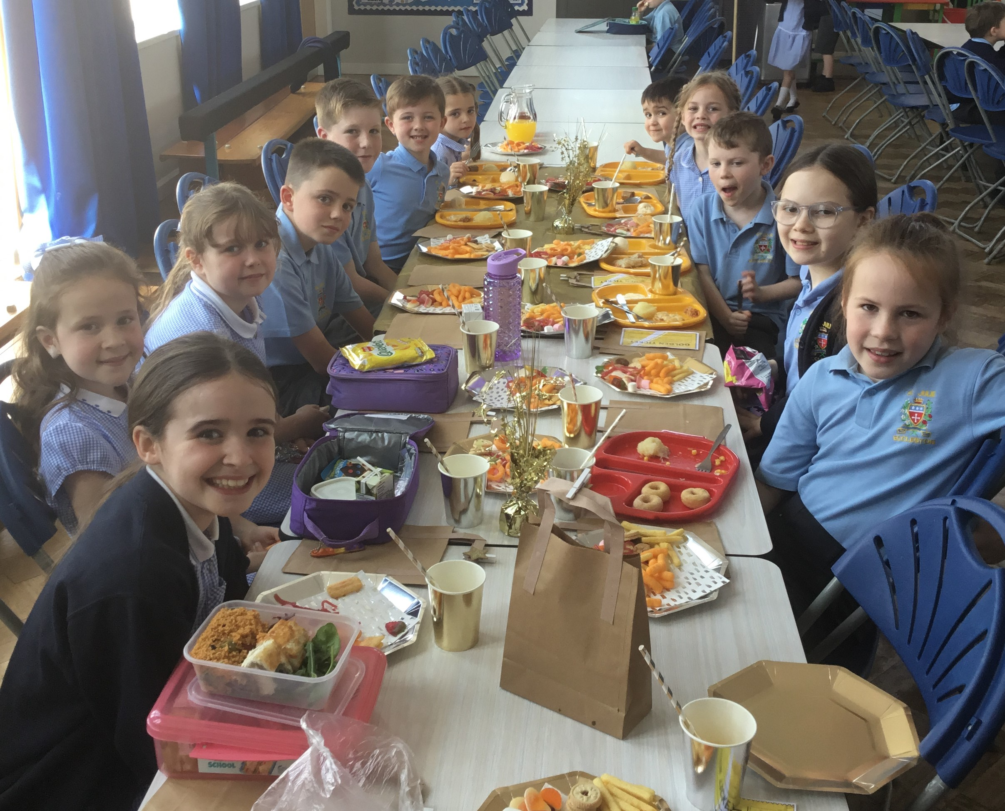
The Golden Table
We marked the end of the half term with our Golden Table celebration this week.
Each week in assembly a Lunchtime Supervisors Award and Mrs Finney’s Kitchen Award are presented to children who have shown outstanding behaviour and good manners during lunchtime. At the end of each half term their names go into a draw for a Golden Ticket.
On Tuesday the winners of this half term’s Golden Tickets were invited to eat their lunch at the Summer themed Golden table with special treats. Well done to the children - they certainly enjoyed their gold star treatment.
Thank you to all our lunchtime supervisors and kitchen staff who care for all the children, ensuring they are happy and well-fed at lunchtime.

Children’s University Graduation ceremony – Wednesday 19th June at Hope University Chapel

We are thrilled to be taking all of our Junior children to Hope University for the children’s University Graduation. Together we will be celebrating the many achievements our children have gained over the past year, including their participation in school clubs, holiday challenges and other enrichment activities in school like Forest Schools, Cookery etc.
2 guests per child can attend the Graduation which will be held in Hope Chapel, Hope Park campus in Childwall, Liverpool. Guests can arrive from 1pm for a 1:30pm start. Letters with full details will be sent out after half term but please save the date if you can.
A flyer with the Summer half term challenges has been sent with this bulletin. Please encourage your child/ren to complete as many as they can and send in their evidence after the break.


Merseyside Woman of Year nomination
One of the Y1 mums Leanne Hobin has been nominated as a finalist for Merseyside Woman of Year for all her amazing work with Merseyside Police, raising awareness for baby loss and creating, developing and running
St Helens Bees Netball Club (we have quite a few St Julie's pupils involved in the club).
If you would like to vote please follow the link
https://merseysidewomenoftheyear.co.uk/finalists-2024/152/ you can place one vote each day till voting closes on 2nd June.
Nomination video: https://youtu.be/YOKM6DXZKp0?si=yKVnjm2mukp4DWAP

Pre-loved St Julie’s uniform
Before you spend money ordering uniform for September, don’t forget that the PFA have many items of school uniform available in the school foyer and more online. If you can, a small donation of any amount would be useful for school funds.

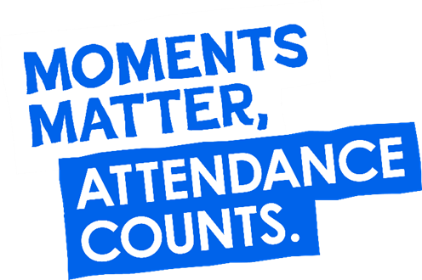
“From the first day of term to the last, the small moments in a school day make a real difference to your child.” #AttendanceCounts
At St Julie’s our attendance is excellent and we know that parents and carers value the education that your children receive. This week you should have received an email from us informing you that the Government is launching a national campaign to remind parents and carers of the importance of school attendance and promoting the importance of being in school, on time, every day.

Useful website Is my child too ill for school? - NHS (www.nhs.uk)

Year Group | % Attendance for w/e 23.05.24
Year R | 94.32
Year 1 | 92.24
Year 2 | 95.36
Year 3 | 94.12
Year 4 | 88.93
Year 5 | 92.14
Year 6 | 94.12

Well done to Year 2 who had the highest attendance this week – 100% fantastic!
Our whole school attendance this week is 93.03%

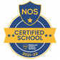
This week’s flyer from National Online Safety is, “Encouraging Healthy Friendships.”

Diary w/c 03.06.2024

Monday INSET day

Tuesday School re-opens
Year 6 transition – De La Salle staff/pupils visit to St Julie’s
KS2 Football club 3:20 – 4:15


Wednesday Year 6 residential to Colomendy until Friday 7 June
Judo club 3:20 – 4:15
KS2 Athletics club 3:20 – 4:15
Y1/2 Spanish club 3:20 – 4:15
KS2 Arts & Crafts club 3:20 – 4:15
Y1/2 Arts & Crafts club 3:20 – 4:15

Thursday KS2 Dodgeball 3:20 – 4:15
Lost In Music 3:20 – 4:30
YR Arts & Crafts club 3:20 – 4:15

Friday Year 6 return from Colomendy
Year 5 Bikeability
Year 2 trip to Edge Hill University: Teddy Bears’ Hospital

Further dates for your Diary
w/c 10 June Year 1 Phonic Screening Check and Year 4 Multiplication Tables Check
Tuesday 11 June Reception class – Song Fest at St Helens Town Hall
Monday 17 June Year 6 Apple of my eye
Wednesday 19 June Children’s University Graduation for KS2 at Liverpool Hope University pm
Friday 21 June PFA Summer gala
Tuesday 25 June Fun Sports Day in House Teams KS2 9:30am KS1/EYFS 1:30pm
Wednesday 26 June Year 1 trip to Manchester Airport
Thursday 27 June 9:30 Mass for SS Peter & Paul and Year 4 Holy Communion celebration
w/c 1 July Year 6 transition week at De La Salle for those going to that High School
Monday 1 July Year 4 trip to Chester
Thursday 4 July Reception class trip to Imagine That!
Tuesday 9 July Reserve date for Sports day in the event of bad weather
Thursday 18 July Year 6 Leavers’ Celebration event 2:00pm (Parents and grandparents)
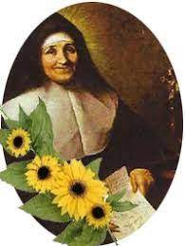
Monday 22 July Year 6 Leavers’ Mass 6pm followed by disco in Parish Hall
Tuesday 23 July School closes for Summer

“A caring family school, where we learn, grow and walk in the footsteps of Jesus.”
St Julie pray for us, protect us and bless us.

