High 5 Netball
School Games Event
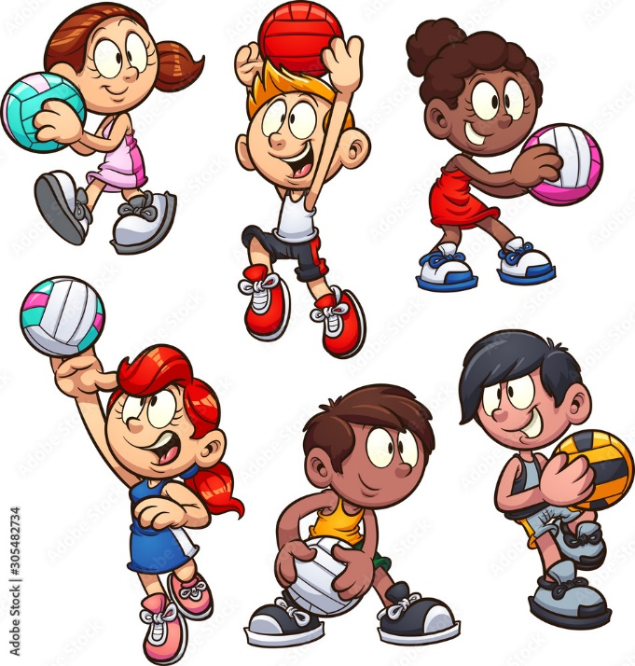
Congratulations to the Year 6 Netball Squad today for their outstanding performance at Rainford High School. St Julie’s excelled in every match and worked well as a team. Their great determination, positivity and of course “their skills” ensured that they reached the final against St Anne’s. I am extremely proud to say that they won this match and are now the winners of the 2024 St Helens School Games Netball Competition.

Well done Alice, Myla, Alanna, Atarah, Poppy, Seb and Lucas!
You were all AMAZING!!!

