Dear Parents/carers,

Year 6 Residential
The Year 6 children who went to Kingswood’s Colomendy had a fabulous time last week. They faced their fears on the 3G swing, Jacob’s Ladder and Climbing and showed great team spirit in working together in the Crate Stacking, Buggy Build and many more challenging activities. They thoroughly enjoyed their time spent with friends and telling jokes around the campfire. Thank you to our dedicated staff who have looked after them so well while they were away from home.

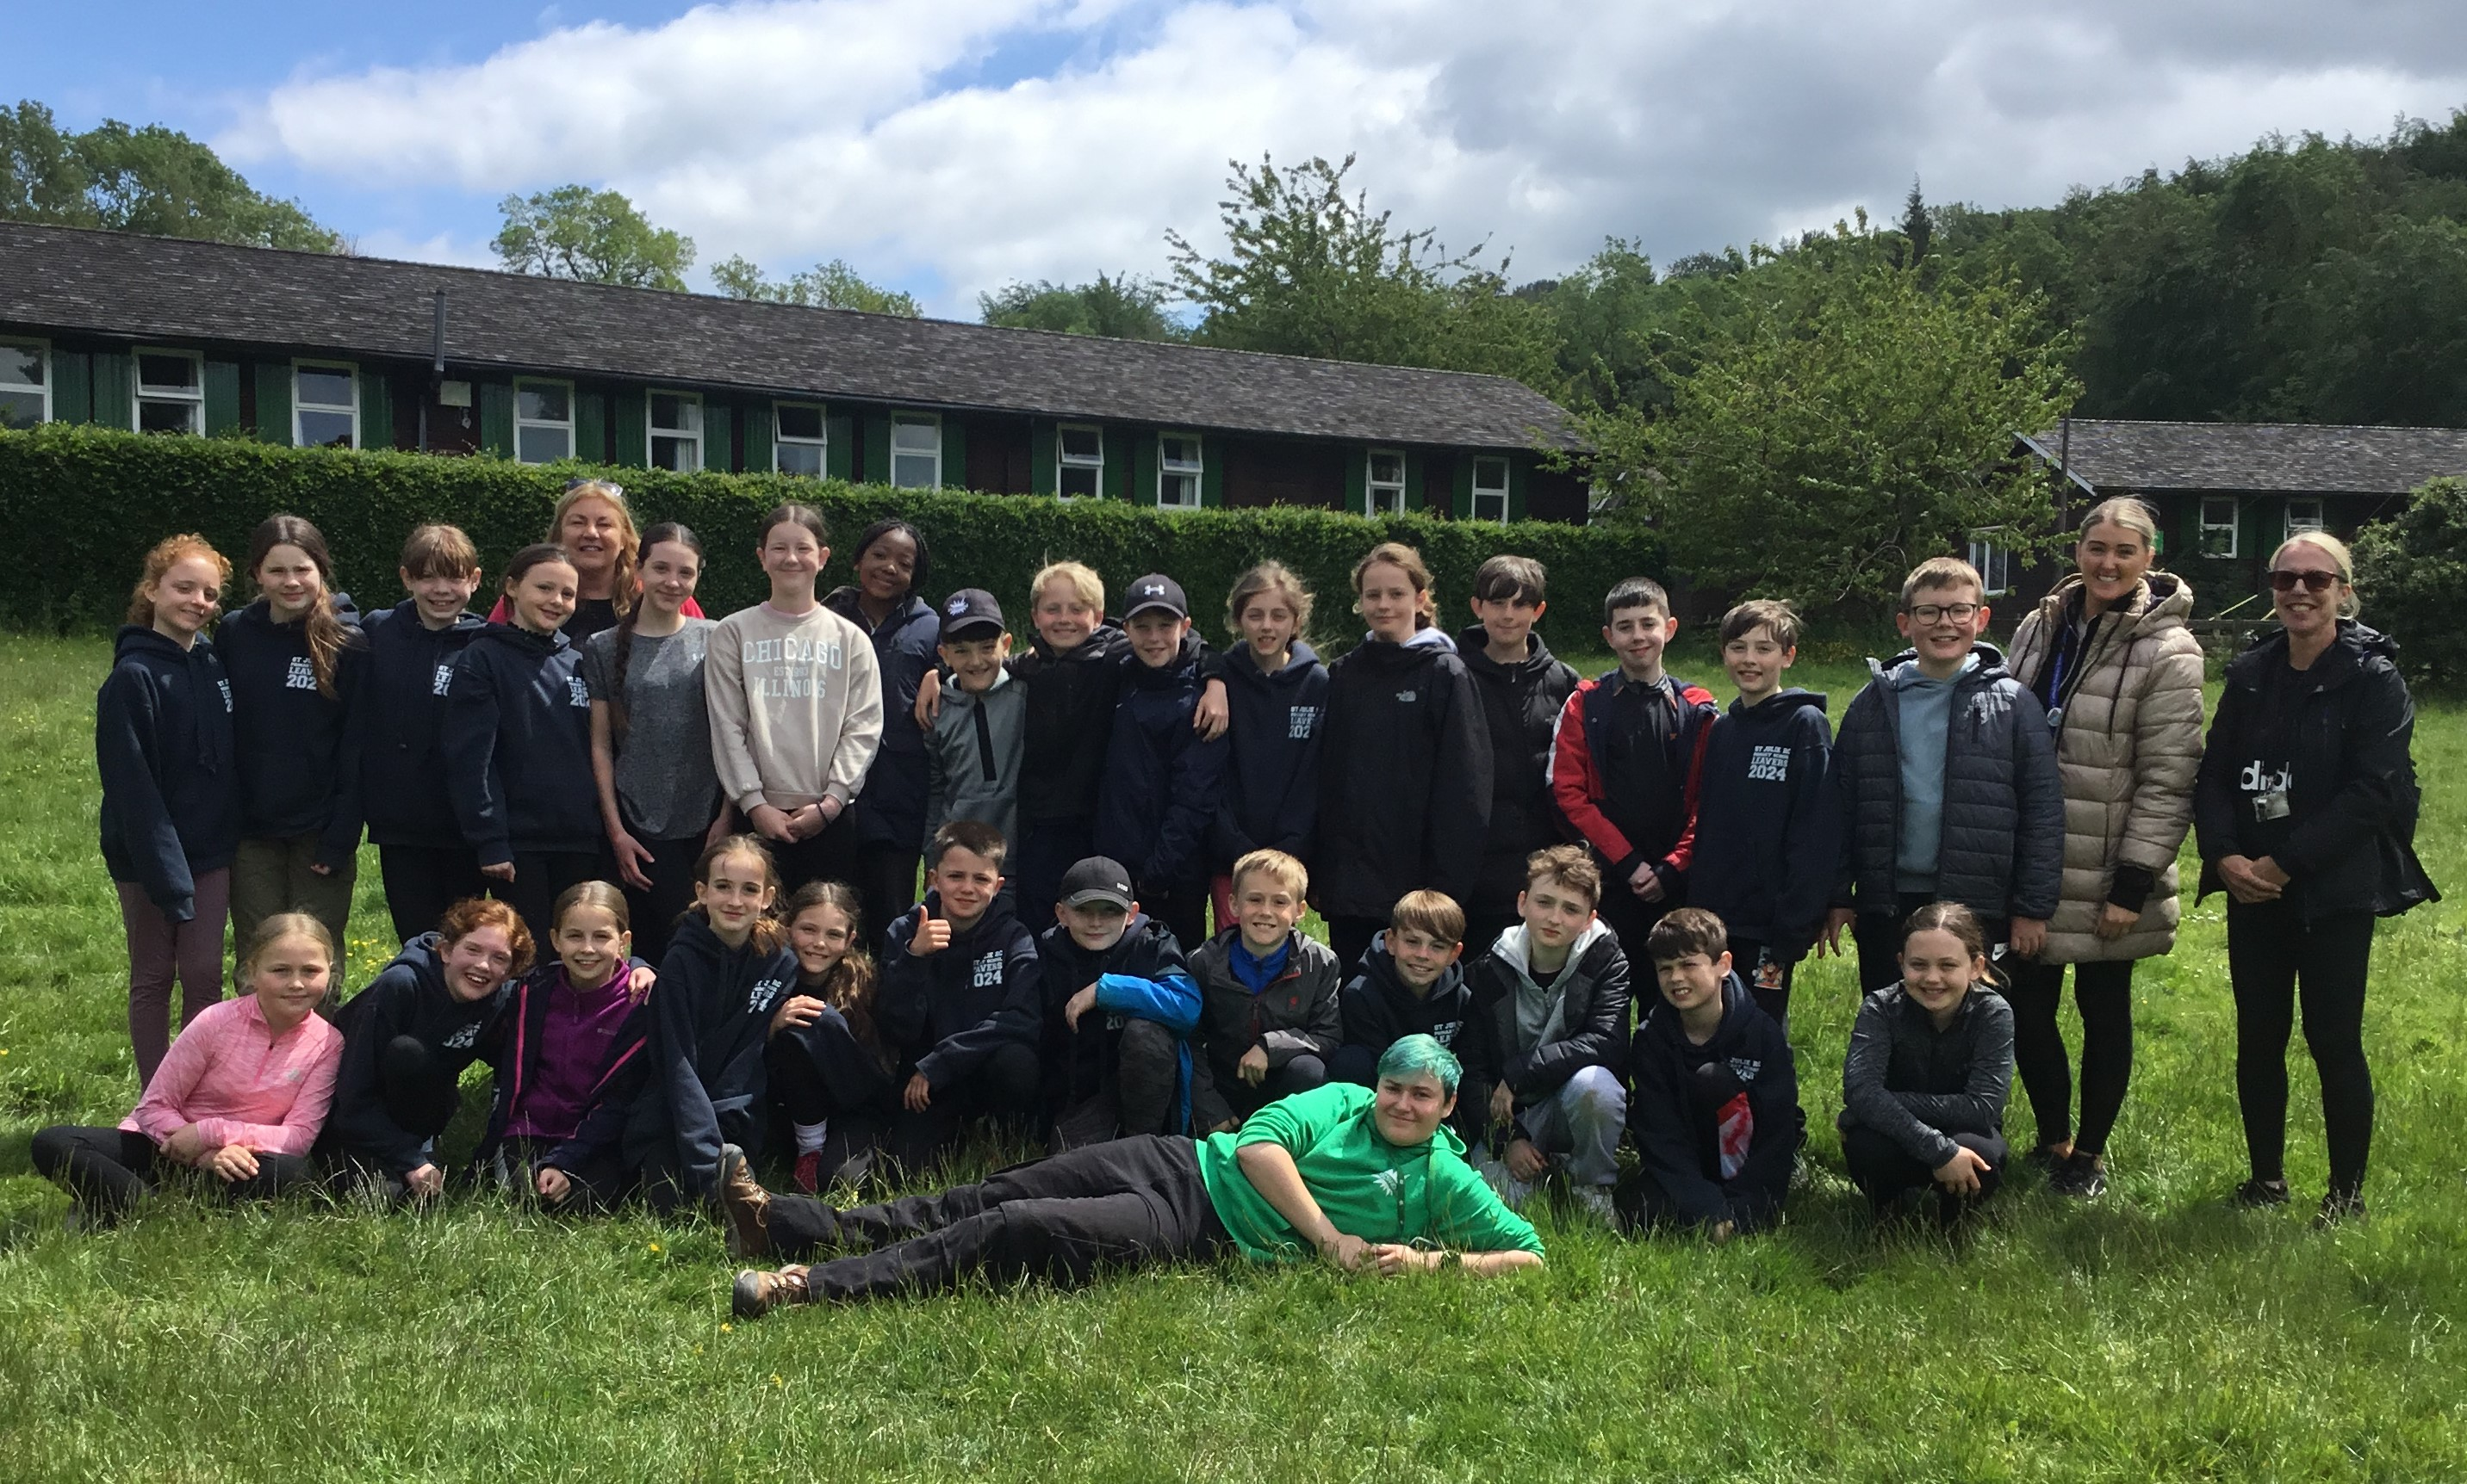

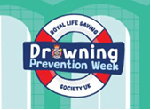
Drowning Prevention Week
Drowning Prevention Week is from 15th - 22nd June. Our Sports Ambassadors have been drawing attention to this and thought it a good idea to take a photograph wearing life jackets in our boat. (See photograph below). They helped to promote water safety during the KS2 assembly on Thursday.
This morning the RNLI delivered a presentation to KS2 and then KS1. They talked about the RNLI and the role of Lifeguards in keeping people safe. Some of the children got to dress up as a Lifeguard and Crew Member.

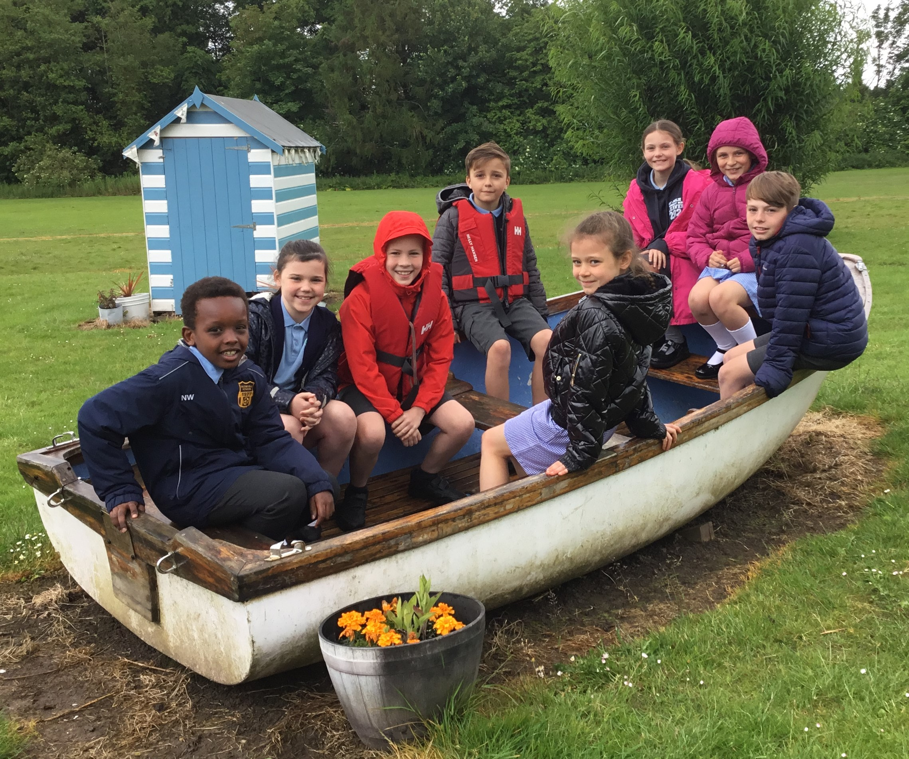

Children’s University Graduation ceremony – Wednesday 19th June at Hope University Chapel

We are thrilled to be taking all of our Junior children to Hope University for the children’s University Graduation. Together we will be celebrating the many achievements our children have gained over the past year, including their participation in school clubs, holiday challenges and other enrichment activities in school like Forest Schools, Cookery etc.
2 guests per child can attend the Graduation which will be held in Hope Chapel, Hope Park campus in Childwall, Liverpool. Guests can arrive from 1pm for a 1:30pm start.


PFA Summer Gala – postponed
Unfortunately, the PFA have had to postpone the Summer Gala until further notice. The decision was made due to the current difficulties with parking on the church car park and poor weather forecast.

Pre-loved St Julie’s uniform
Before you spend money ordering uniform for September, don’t forget that the PFA have many items of school uniform available in the school foyer and more online. If you can, a small donation of any amount would be useful for school funds.

RNLI
A big thank you to Tony Banks, the volunteer from the RNLI who came to school this morning to talk to the children about water safety. He gave some important messages about how to keep safe and the dangers associated with all bodies of water. Please spend some time with your child about what they learned in the session.

Wraparound care
A School Spider survey was emailed this week concerning before and after school provision. As you know currently St Julie’s Care Club (a private provider) runs a club in the church hall.
Governors are evaluating the possible provision of school based wraparound care and are mindful of the increase in cost that parents of the privately run club have faced. In the current economic climate, we are aware of the financial pressures on families and those on our school too so we are looking at how it could be possible for school to provide its own Care Club if there is sufficient demand.
Please complete the survey by Monday if you haven’t already done so.

Refugee Week
Next week is refugee week when we think about the plight of people fleeing their war-torn homelands.
During Lent, we collected tuna to donate to our St Helens charity, Our Warm Welcome. Minnie Vinnies were delighted to hand over the many, many tins donated.
Next week, we would be grateful for donations of another dried food that the charity have great need for – Basmati rice. Please send in your donations of Basmati rice on any day. Thank you.

St Julie’s Parish Garden Party
St Julie’s Parish are holding a Garden Party on Sunday 30th June- 2pm.- 4.30pm A ticket for one Adult Afternoon Tea, with entertainment is £10. One child accompanying an Adult is free. Further children £2.00 each.
Mrs Piedot will be selling tickets on Wednesday afternoon after school in the school hall. Please bring where possible the correct cash on the day of sale.

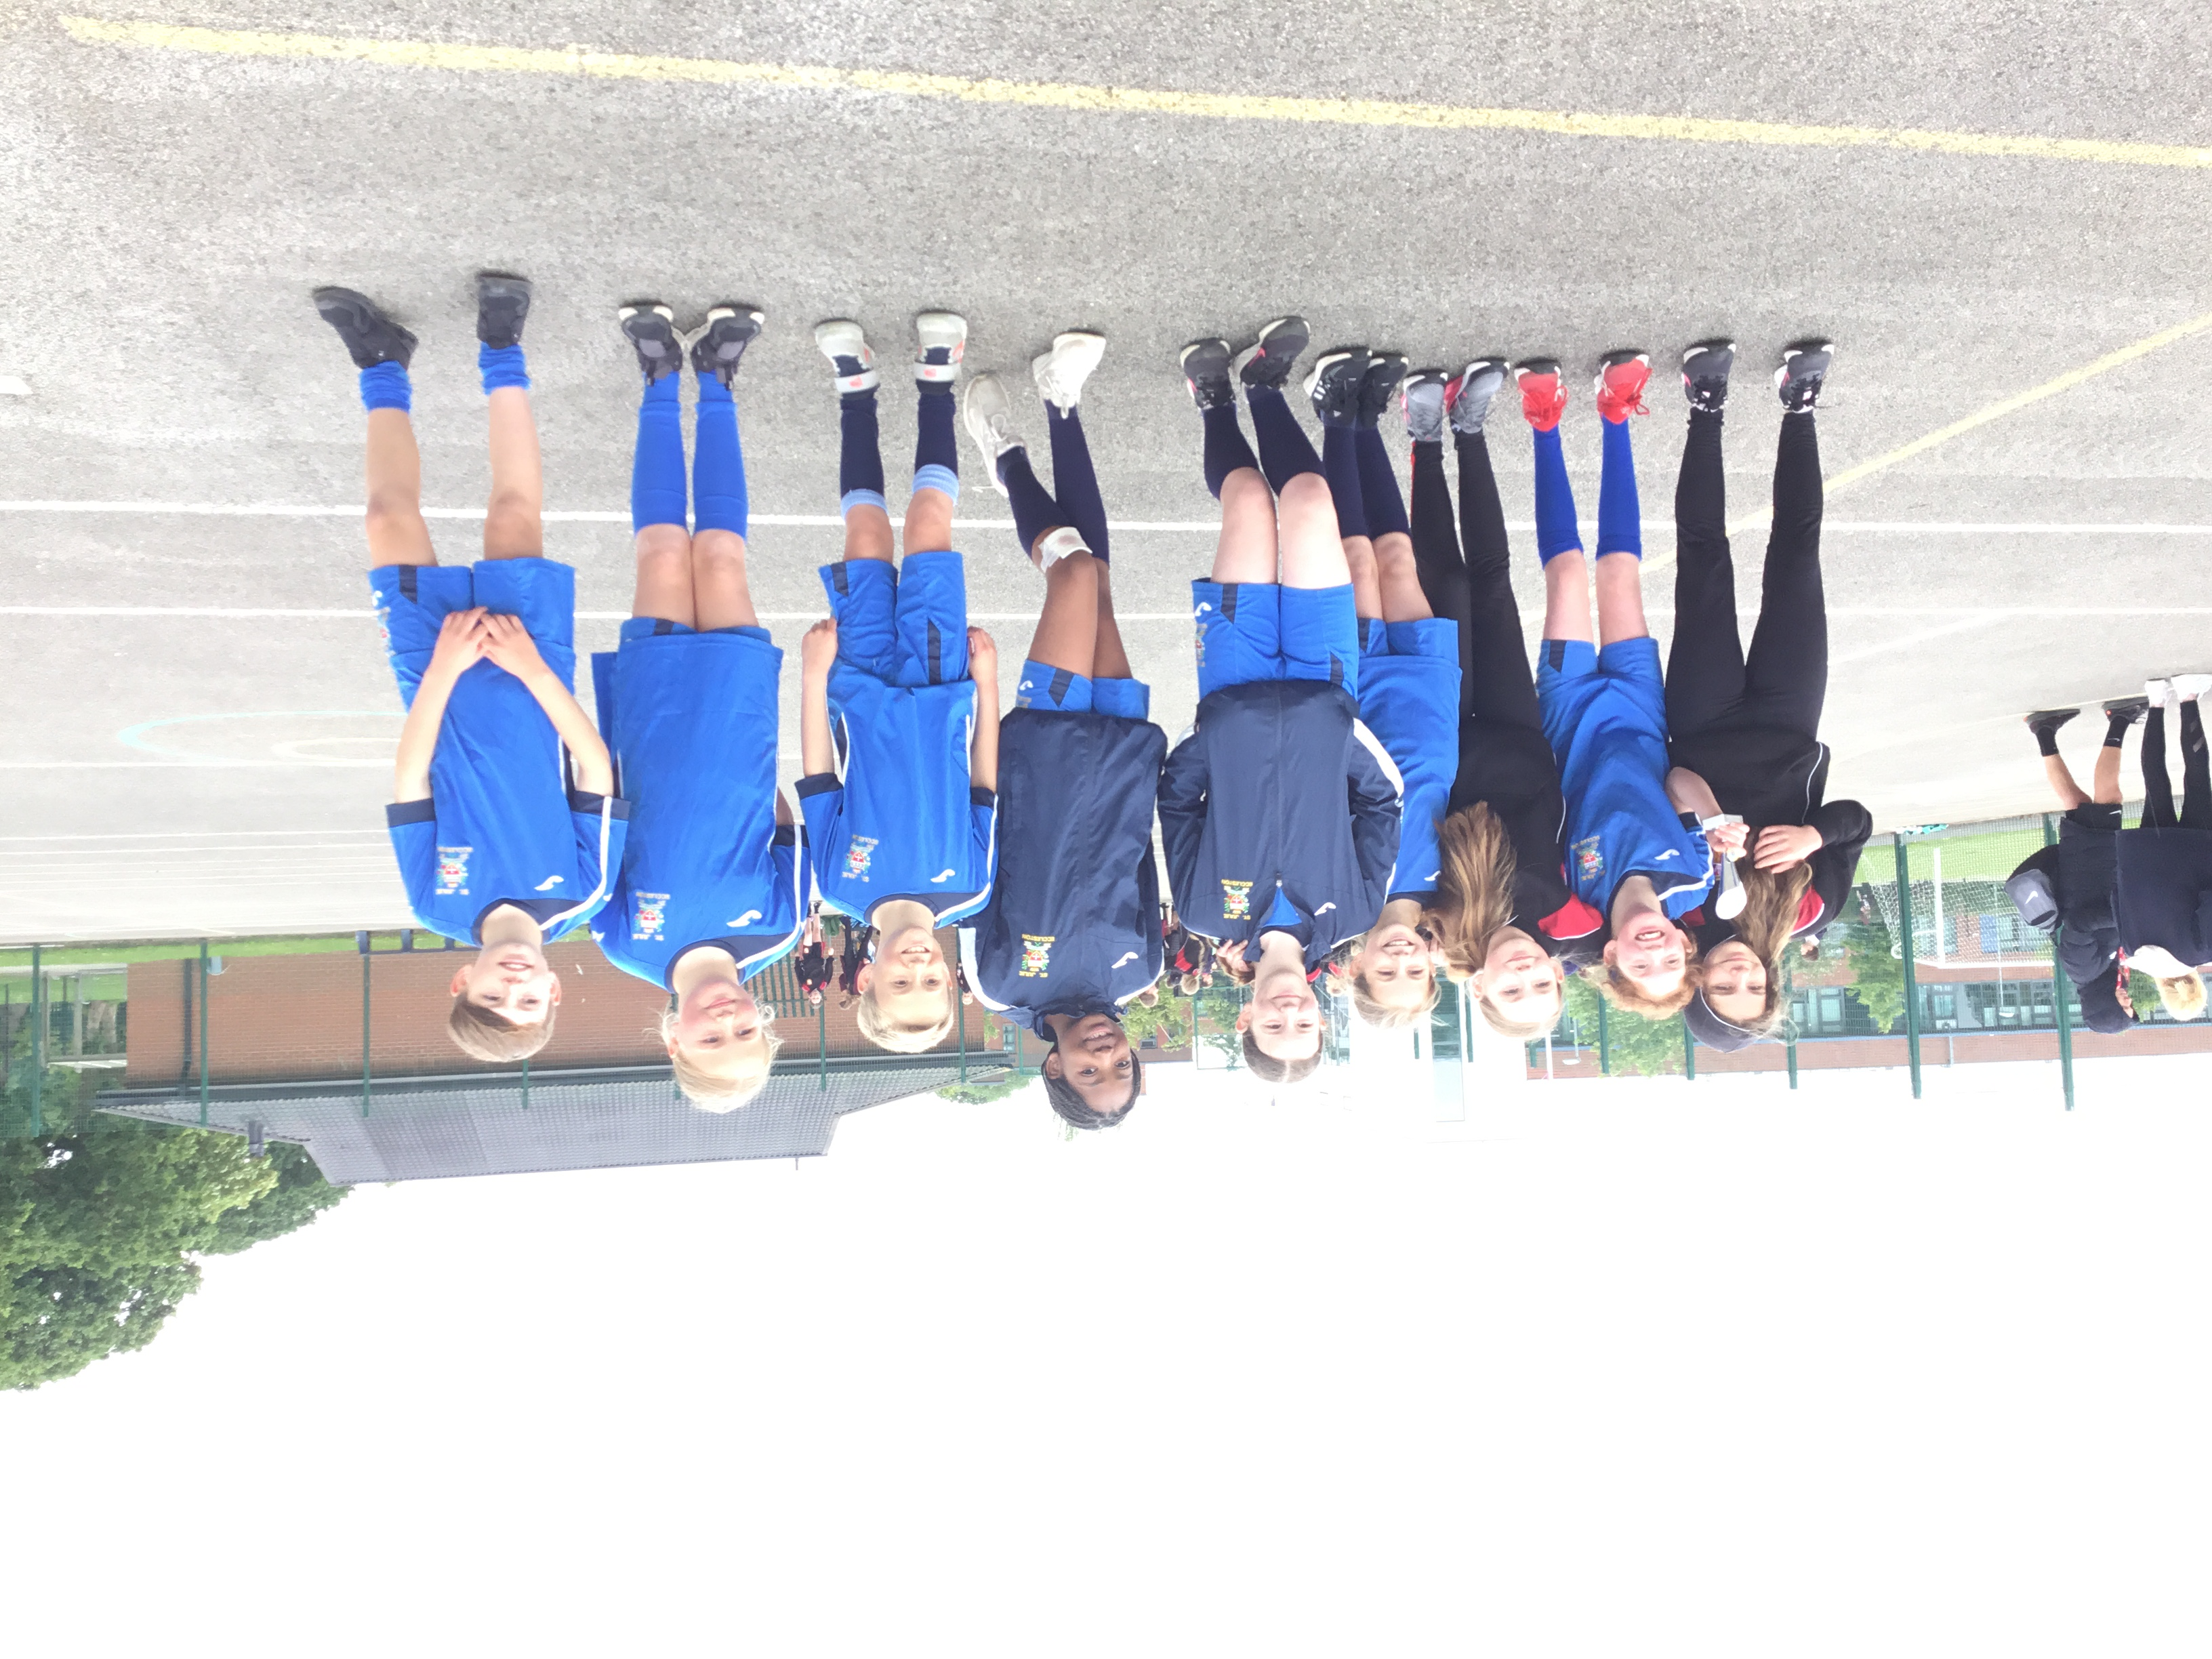

Congratulations to our Year 6 squad who competed in a Netball competition at Rainford High this week. They played a total of 6 games, winning them all. The squad preformed with great skill resulting in them coming 1st overall. A fantastic achievement for all the children. We are so proud of you all!


This week’s flyer from National Online Safety is, “10 Top Tips for parents and educators: Fair play and friendly competition.”


“From the first day of term to the last, the small moments in a school day make a real difference to your child.” #AttendanceCounts
At St Julie’s our attendance is excellent and we know that parents and carers value the education that your children receive. This week you should have received an email from us informing you that the Government is launching a national campaign to remind parents and carers of the importance of school attendance and promoting the importance of being in school, on time, every day.

Useful website Is my child too ill for school? - NHS (www.nhs.uk)

Year Group | % Attendance for w/e 14.06.24
Year R | 99.09
Year 1 | 97.59
Year 2 | 93.43
Year 3 | 100.00
Year 4 | 97.43
Year 5 | 96.00
Year 6 | 95.88

Well done to Year 3 who had the highest attendance this week.
Our whole school attendance this week is 97.06%



St Julie’s Awards of the Week

 | Star of the week for showing hope | Book explorer | Marvellous mathematician
Reception | Theo | Thomas | Oliver
Year 1 | Elliott | Easton | Sophie P
Year 2 | Thea W & Logan | Gia | River
Year 3 | Callum | Liberty-Rose | Darcey
Year 4 | Elissa | Harrison | Max
Year 5 | Mia F | Isla | Sophia
Year 6 | Noah G | Kai | Seb

Diary w/c 17.06.2024

Monday 8am Gymnastics
Year 6 Apple of my eye
KS2 Football club 3:20 – 4:15
KS2 Forest School club 3:20 – 4:15
KS2 Crest Science Award 3:20 – 4:15

Tuesday KS2 Football club 3:20 – 4:15

Wednesday Children’s University Graduation for KS2 at Liverpool Hope University pm

KS2 Athletics club 3:20 – 4:15
KS2 Arts & Crafts club 3:20 – 4:15
Y1/2 Arts & Crafts club 3:20 – 4:15
Judo club 3:20 – 4:15

Thursday Lost In Music 3:20 – 4:15
YR Arts & Crafts club 3:20 – 4:15
Friday

Further dates for your Diary
Monday 24 June Year 4 Apple of my eye
Tuesday 25 June Fun Sports Day in House Teams KS2 9:30am KS1/EYFS 1:30pm
Wednesday 26 June Year 1 trip to Manchester Airport
Thursday 27 June 9:30 Mass for SS Peter & Paul and Year 4 Holy Communion celebration
w/c 1 July Year 6 transition week at De La Salle for those going to that High School
Monday 1 July Year 4 trip to Chester
Tuesday 2 July Transition morning for each class
Thursday 4 July Reception class trip to Imagine That!
Thursday 4 July Year 3 visit to Eccleston Library – Summer Reading Challenge
Tuesday 9 July Reserve date for Sports day in the event of bad weather
Wednesday 10 July Altru Drama workshops for Junior classes in school
Thursday 11 July Year 2 Forest School day
Thursday 11 July 9:30-10:30 Teddy Bear’s Picnic for new intake for Sept 24
Thursday 11 July End of year drop-in Open Evening from 3:20pm until 4:15pm
Wednesday 17 July Year 3 trip to Liverpool World Museum
Wednesday 17 July Year 2 class collective worship 3pm
Thursday 18 July Year 6 Leavers’ Celebration event 2:00pm (Parents and grandparents)

Monday 22 July Year 6 Leavers’ Mass 6pm followed by disco in Parish Hall
Tuesday 23 July School closes for Summer

“A caring family school, where we learn, grow and walk in the footsteps of Jesus.”

St Julie pray for us, protect us and bless us.

