Dear Parents/carers,

Children’s University Graduation ceremony

On Wednesday we celebrated the achievements of all of our Junior children at the Children’s University graduation held at Liverpool Hope University. It was a wonderful afternoon shared with parents, grandparents and friends.
Together we celebrated the many achievements our children have gained over the past year, including their participation in school clubs, holiday challenges and other enrichment activities in school like Forest Schools, Cookery etc.
We begin again collecting credits for all the extra-curricular activities the children do. If your child attends a club out of school, and it is recognised by Children’s University, they can use a passport to get a signature/stamp every time they attend. Next year I will collect in the Passports and add the credits to the school log. The more points earned, the higher the award gained. Children can earn points from Year 1 onwards but the children only begin to go to the Awards Ceremony in Year 3. Passports can be purchased by contacting the school office.

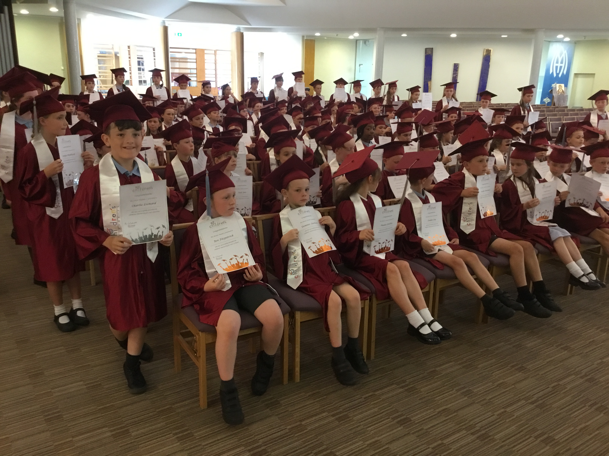

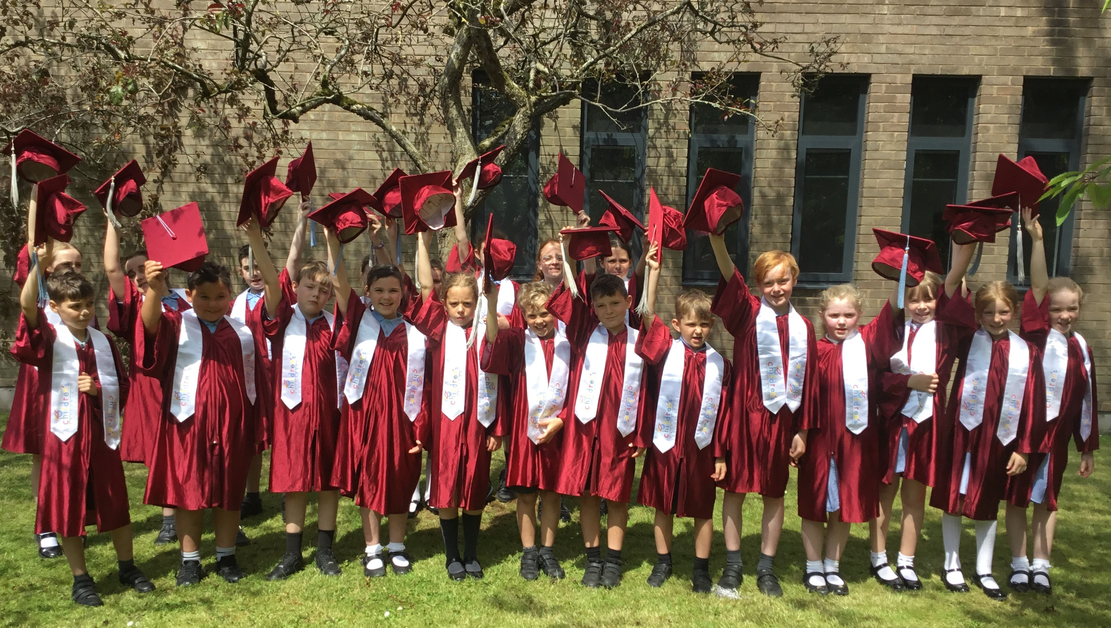

Netball Merseyside Finals
Last week we told you about our Year 6 squad who competed in a Netball competition at Rainford High. They played a total of 6 games, winning them all, resulting in them coming 1st overall. We have since been informed by St Helens School Games that this means that the team have qualified for the Merseyside Finals at Wavertree next Wednesday. Good luck #Team St Julie’s!

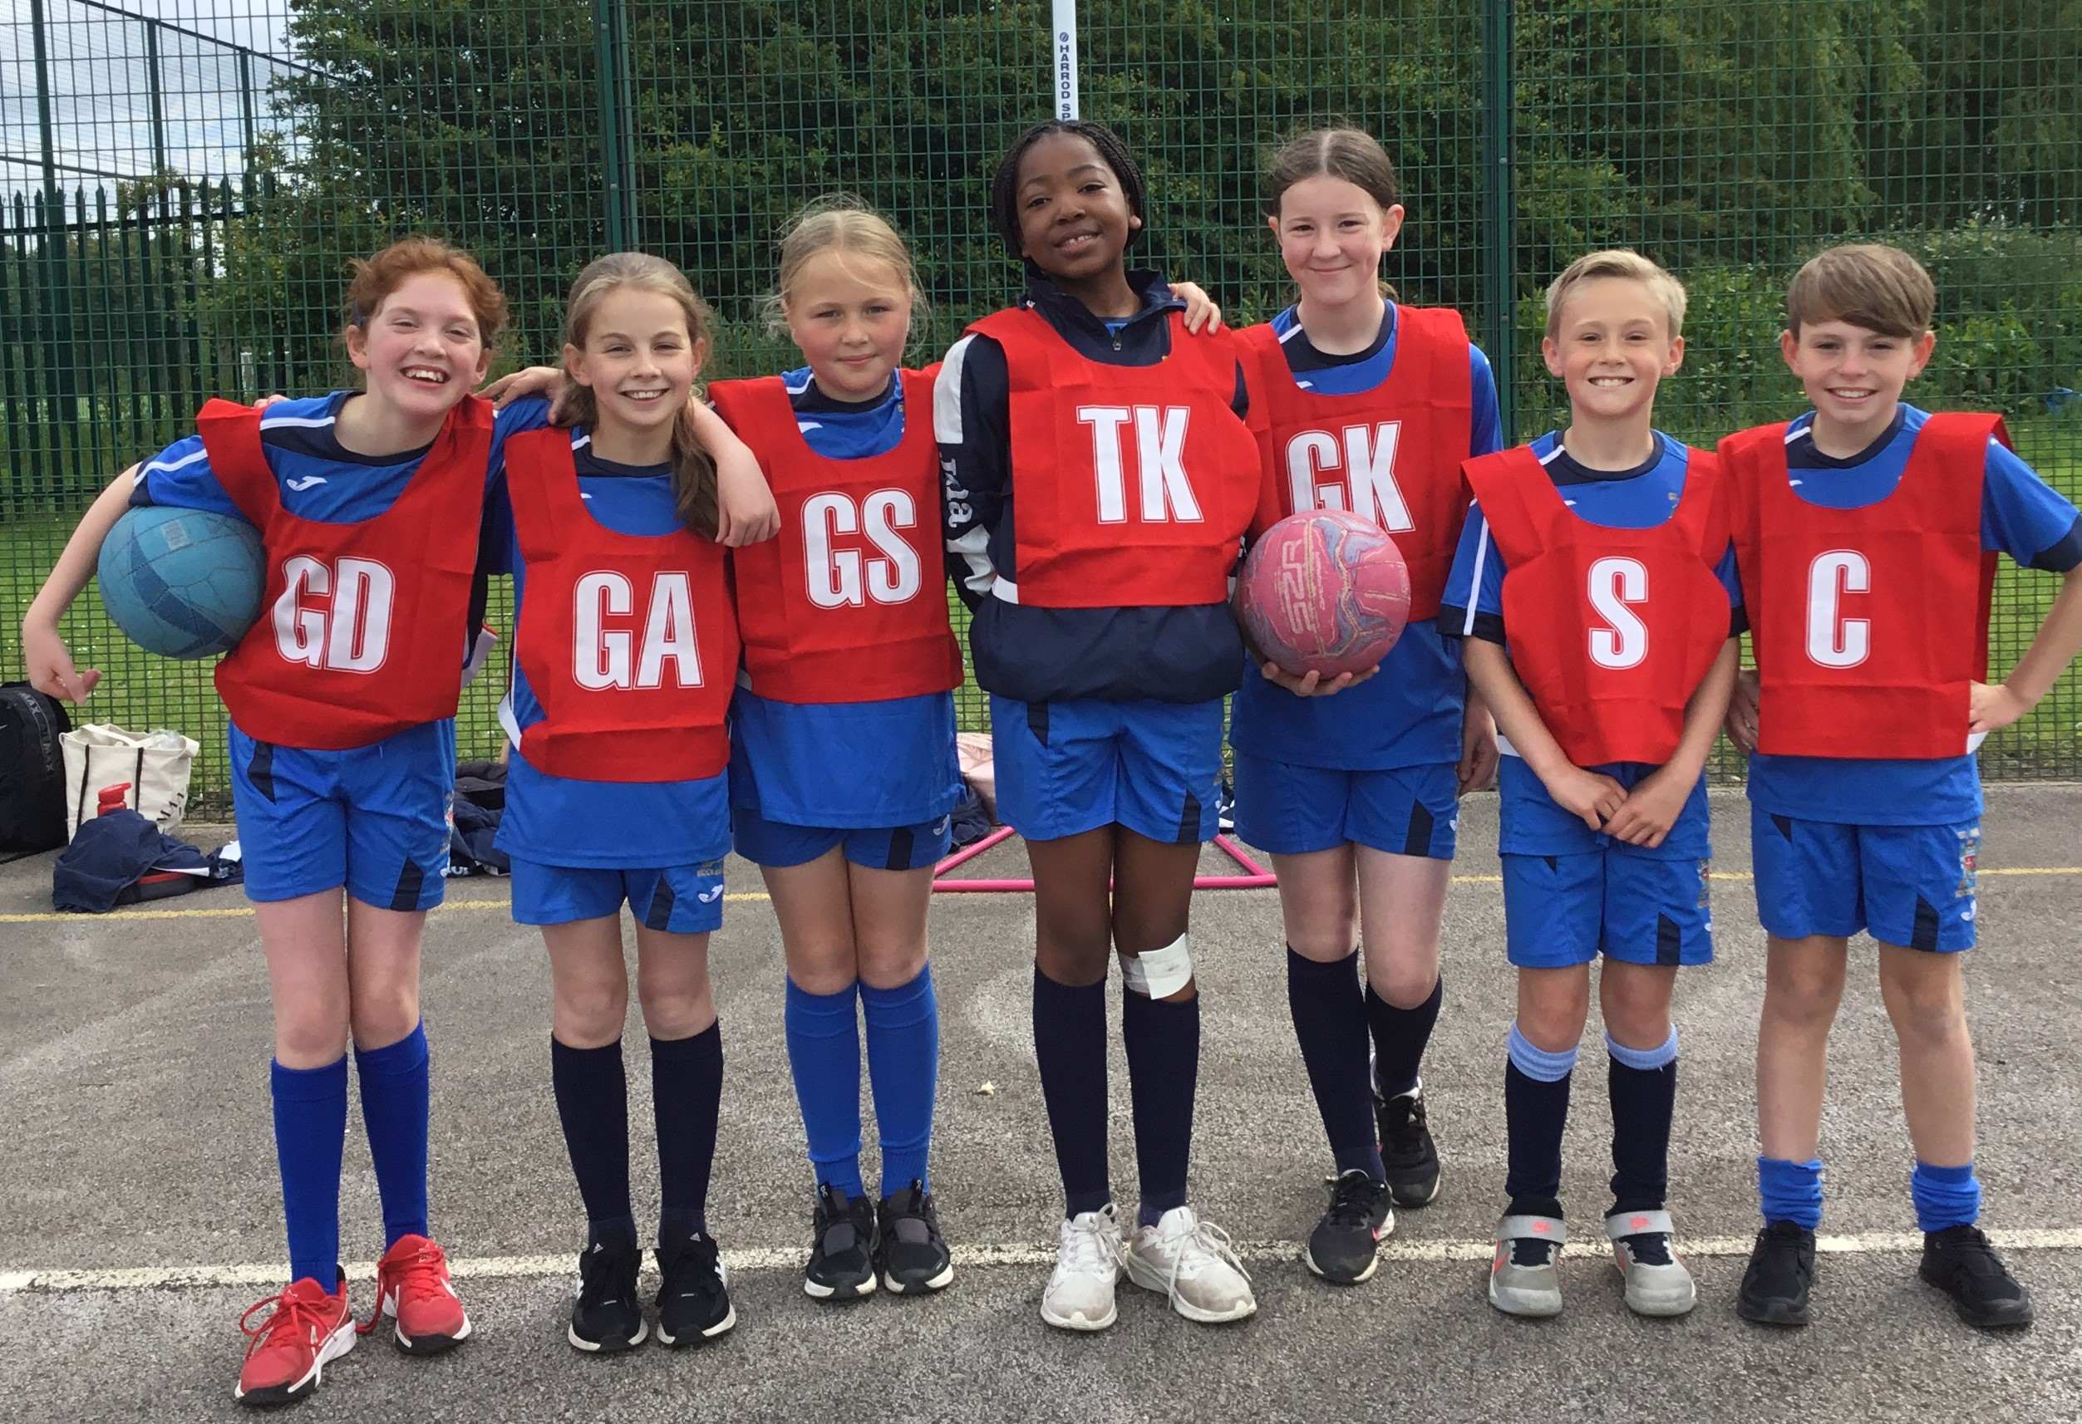

Refugee Week – Thank you for the donations of Basmati Rice sent in this week for the St Helens charity, Our Warm Welcome. If you have not yet sent in a donation we will carry on accepting donations next week before our Minnie Vinnies in Year 3 and Year 4 hand over the donations.


Celebration Sports Day
The Sports Council have been busy planning our annual Sports Celebration Day with Mrs Clayton. There will be a carousel of traditional sports and games, completed by each house team. The focus is to be on teamwork and fun as the house teams rotate through the activities. Parents are welcome to attend with the Junior event in the morning starting at 9:30am and Infants in the afternoon at 1:30pm.
To follow the event, you need to find your child – by their House Team colour – and then follow them around as they move through the activities. If a grandparent is coming along, please tell them the colour of your child’s House Team.

Euro 2024 Day!

Keeping with the sports theme…
The Geography Ambassadors have decided that they would like our stock of school Atlases for both KS1 and KS2 to be updated. To help raise some funds to put towards this we have decided to invite the children to come to school next Friday, 28th June, wearing the colours of their favourite country from the Euros football competition that is currently taking place (sports kits will be allowed on this day). We are also asking them to come to school with one fact about their chosen country that they can share with their class and be able to locate the country on a European map. To take part we ask for a donation of £2 that will contribute towards the cost of our new resources. Payment via School Money from Monday.

Year 6 Mini-enterprise
Year 6 have been organising a mini-enterprise as part of their PSHE lessons and will be holding an event on Thursday 27th June. There will be a mixture games for children to join in with including, Penalty Shootout, Lucky Dip, Name the Teddy, Catch the Mouse and stalls selling bracelets, bookmarks and much more.
The children will have an opportunity to take part during the school day so please send them in with some coins in an envelope with their name on. The enterprise will then continue after school for parents to join in too.
See flyer sent with this bulletin.


This week’s flyer from National Online Safety is, “10 Top Tips for parents and educators: Promoting Physical Wellbeing”


“From the first day of term to the last, the small moments in a school day make a real difference to your child.” #AttendanceCounts
At St Julie’s our attendance is excellent and we know that parents and carers value the education that your children receive. This week you should have received an email from us informing you that the Government is launching a national campaign to remind parents and carers of the importance of school attendance and promoting the importance of being in school, on time, every day.

Useful website Is my child too ill for school? - NHS (www.nhs.uk)

Year Group | % Attendance for w/e 21.06.24
Year R | 96.67
Year 1 | 92.76
Year 2 | 90.29
Year 3 | 98.53
Year 4 | 95.14
Year 5 | 95.71
Year 6 | 97.94

Well done to Year 3 who had the highest attendance this week.
Our whole school attendance this week is 95.29%





St Julie’s Awards of the Week

 | Star of the week for showing hope | Book explorer | Marvellous mathematician
Reception | Olivia | Luke | Teddy
Year 1 | Lilia | Daniel SM | Florence L Sophie P
Year 2 | Brooke W Theia C | Lennie | Thea W
Year 3 | Hattie | Sam | Thomas G
Year 4 | Sophia J | Aveah | Molly
Year 5 | Tommy D | Zak P | Robert F
Year 6 | Sophia S | Lucas P | Katy C

Pre-loved St Julie’s uniform
Before you spend money ordering uniform for September, don’t forget that the PFA have many items of school uniform available in the school foyer and more online. If you can, a small donation of any amount would be useful for school funds.



Diary w/c 24.06.2024

Monday 8am Gymnastics
Year 4 Apple of my eye
KS2 Football club 3:20 – 4:15
KS2 Forest School club 3:20 – 4:15
KS2 Crest Science Award 3:20 – 4:15

Tuesday Fun Sports Day in House Teams KS2 9:30am KS1/EYFS 1:30pm
KS2 Football club 3:20 – 4:15

Wednesday Year 1 trip to Manchester Airport
KS2 Athletics club 3:20 – 4:15
KS2 Arts & Crafts club 3:20 – 4:15
Y1/2 Arts & Crafts club 3:20 – 4:15
Judo club 3:20 – 4:15

Thursday 9:30 Mass for SS Peter & Paul and Year 4 Holy Communion celebration
Y6 Enterprise (stalls: children bring money)
NO LOST IN MUSIC
YR Arts & Crafts club 3:20 – 4:15

Friday Year 4 Forest School
Euro 2024 day (sports kits for £2 donation on School Money)

Further dates for your Diary
w/c 1 July Year 6 transition week at De La Salle for those going to that High School
Monday 1 July Year 4 trip to Chester
Tuesday 2 July Transition morning for each class
Thursday 4 July Reception class trip to Imagine That!
Thursday 4 July Year 3 visit to Eccleston Library – Summer Reading Challenge
Thursday 4 July Year 4 Class Collective Worship 3pm
Tuesday 9 July Year 1 Forest School
Wednesday 10 July Altru Drama workshops for Junior classes in school
Thursday 11 July Year 2 Forest School day
Thursday 11 July 9:30-10:30 Teddy Bear’s Picnic for new intake for Sept 24
Thursday 11 July Year 1 Class Collective Worship 3pm
Thursday 11 July End of year drop-in Open Evening from 3:20pm until 4:15pm
Monday 15 July Year 5 Forest School
Wednesday 17 July Year 3 trip to Liverpool World Museum
Wednesday 17 July Year 6 Sports Celebration at Ruskin Drive
Wednesday 17 July Year 2 Class collective worship 3pm
Thursday 18 July Year 6 Leavers’ Celebration event 2:00pm (Parents and grandparents)
Monday 22 July Year 6 Leavers’ Mass 6pm followed by disco in Parish Hall
Tuesday 23 July School closes for Summer



“A caring family school, where we learn, grow and walk in the footsteps of Jesus.”

St Julie pray for us, protect us and bless us.

